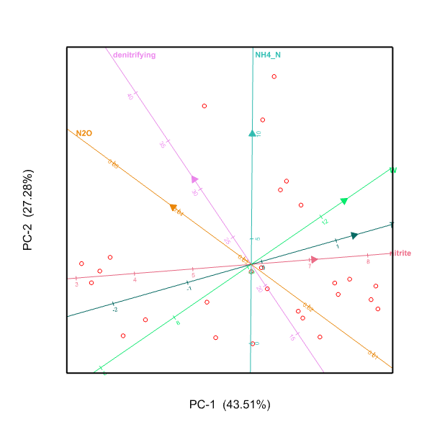
Figure S1 Principal component analysis of soil factors influencing N₂O emission flux at soil depths 0-100 mm. The loadings of soil factors are shown as vectors. W is soil water content, T soil temperature, NH4-N soil nitrogen as ammonium concentration NH₄⁺-N concentration, nitrite represents the number of nitrosobacteria and denitrifying represents the number of denitrifying bacteria. (n=27)

