ELECTRONIC SUPPLEMENTARY MATERIAL - TABLES
Raw data, context tie index scores, ELAN templates, R code, and video examples of facial and manual gestures can be found in the online supplement.
Husbandry Information: The chimpanzees at the Los Angeles Zoo are housed in a large, multi-section enclosure, which includes a naturalistic-looking outdoor area in which all data were taken (main exhibit space, approximately 3500m²), indoor off-exhibit sleeping quarters, and a supplementary on-exhibit artificial-looking outdoor area (used for husbandry purposes). Enrichment items are provided to the chimpanzees on a daily basis, which includes nesting materials and foraging activities. The chimpanzees were fed fresh produce three times per day (9:30, 12:30, and 16:00) and were in their display area during this time. Chimpanzees could choose not to go out to the main exhibit in the morning if they wanted, in which case they would have access to the indoor and supplemental outdoor areas throughout the day. Thus, not all individuals were present for every observation. The chimpanzees had ad libitum access to water and even food since uneaten produce from each meal was still present when the next feeding began.

TABLE S1. A list of all chimpanzees who were housed at the Los Angeles Zoo during the current study (from 2017 to 2019).
Name | Birth Date | Birthplace | Age Group
Pandora | 03/05/1967 | Los Angeles Zoo | Adult
Nan | 12/12/1979 | Los Angeles Zoo | Adult
Regina | 10/23/1983 | Los Angeles Zoo | Adult
Julie | 03/28/1986 | Other Zoo | Adult
Gracie | 01/26/1987 | Los Angeles Zoo | Adult
Shaun | 07/08/1988 | Los Angeles Zoo | Adult
Jerrard | 02/20/1990 | Los Angeles Zoo | Adult
Yoshiko | 07/02/1990 | Los Angeles Zoo | Adult
Glenn | 04/21/1994 | Los Angeles Zoo | Adult
Jean | 05/06/1999 | Los Angeles Zoo | Adult
Ben | 07/31/2002 | Other Zoo | Adult
Jake | 06/14/1999 | Los Angeles Zoo | Adult
Zoe | 08/09/1999 | Research Lab | Adult
Zuri | 07/23/2012 | Los Angeles Zoo | Infant
Uki | 03/08/2013 | Los Angeles Zoo | Infant
Kima | 04/22/2013 | Los Angeles Zoo | Infant
Oliver | 08/23/2014 | Los Angeles Zoo | Infant
Johari | 10/27/2014 | Los Angeles Zoo | Infant

TABLE S2. Inter-observer reliability scores for all variables of interest in this study based on percentage of agreement. Percentages in parentheses indicate changes in agreement after modifications were made to the dataset.
Variable Name | Variable Type | Percentage of Agreement
Facial Signal Type | Categorical | 74.83%
Gesture Type | Categorical | 48.52% (65.56%)
Recipient ID | Categorical | 94.07%
Receiver Attention | Binary | 75.93%
Mechanical Effectiveness | Binary | 92.96%
Response Waiting  (At End of Signal) | Binary | 71.48%
Response Waiting  (While Persisting) | Binary | 71.48%
Response Waiting  (Overall) | Binary | 77.78%
Persistence | Binary | 80.37%
Elaboration | Binary | 81.48%
Immediate Interaction Outcome | Binary | 84.07%
Final Interaction Outcome | Binary | 86.00%
Presumed Goal | Binary | 96.00%

FIGURE S1. A chart of the two main matrilines at the Los Angeles Zoo. This figure illustrates genetic relatedness amongst chimpanzees incorporated into this project. Females are in green and males are in blue.
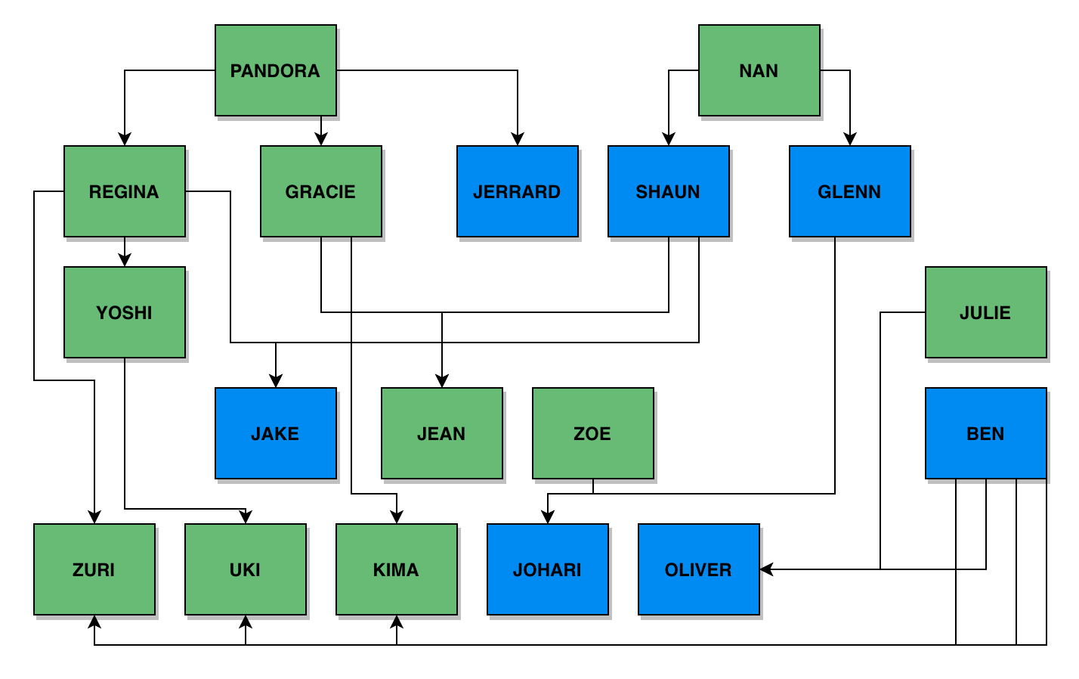

FIGURE S2. An image of a portion of the chimpanzee enclosure at the Los Angeles Zoo. This represents less than ½ of the total on-exhibit space where the data were taken. Photo credit: Brittany Florkiewicz.
