**Supplementary file**

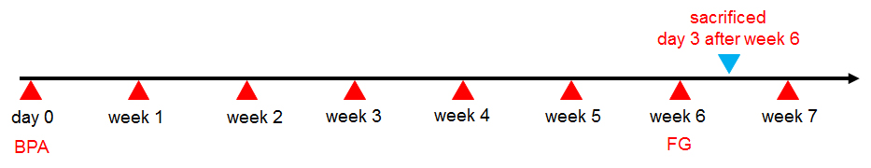

**Supplementary Figure 1:** The time point of fluorogold injection and sacrificed in rats. Three rats were randomly selected from each group at 6 weeks postoperatively. Then, these rats received FG injection and then received 3 days anti-infection treatment. Subsequently, the rats were subjected to cardiac perfusion using 4% paraformaldehyde.

C:\Users\super\Desktop\GF20191224170再次润色\c-17.tif

**Supplementary Figure 2**: The original picture of Figure 5 F in the manuscript, which shows the FG nerve retrograde labeling of anterior horn motoneurons of the C5-C8 segments in control group.

C:\Users\super\Desktop\GF20191224170再次润色\b-12.tif

**Supplementary Figure 3**: The original picture of Figure 5 G in the manuscript, which shows the FG nerve retrograde labeling of anterior horn motoneurons of the C5-C8 segments in blank hydrogel group.

C:\Users\super\Desktop\GF20191224170再次润色\D-4.tif

**Supplementary Figure 4**: The original picture of Figure 5 H in the manuscript, which shows the FG nerve retrograde labeling of anterior horn motoneurons of the C5-C8 segments in NEP1-40 group.

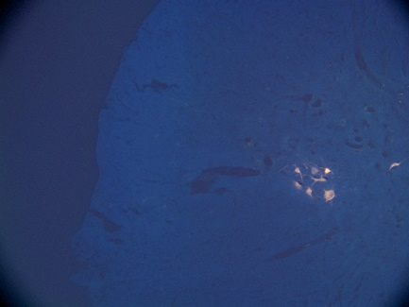

**Supplementary Figure 5:** The original picture of Figure 5 I in the manuscript, which shows the FG nerve retrograde labeling of anterior horn motoneurons of the C5-C8 segments in NEPl-40-loaded hydrogel group.