Supplementary Table S5. Ancestral rearrangement of adhesins compared to the reference Helicobacter pylori (strain 26695). The ancestral orders A60 to A117 are shown in the phylogeny of Figure S2. The adhesins are represented from 1 to 10 and their orientation in the genome is represented by plus/plus (+) or plus/minus (-).

ANCESTRAL ARRANGEMENT OF ADHESINS
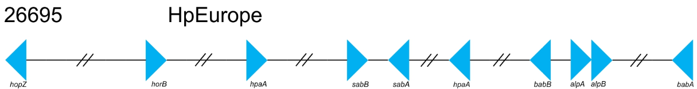

-1
2
3
4
-5
-6
-7
-10
8 9
A60 | -1 2 3 4 -5 -6 -7 8 9 -10 | A88 | -1 2 -3 4 -5 -6 -10 8 9 -7
A61 | -1 7 2 -10 -9 -8 -3 4 -5 -6 | A89 | -1 2 -3 -4 -5 -6 -10 8 9 -7
A62 | -1 2 3 -4 -5 -6 -9 -8 10 -7 | A91
A63 | -1 2 3 4 5 6 -10 8 9 -7 | A90 | -1 2 -3 -9 -8 10 6 5 4 -7
A64 |  | A92 | -1 2 3 4 -5 6 -10 8 9 -7
A65 |  | A94
A68 |  | A93 | -1 2 3 -9 -8 7 6 5 -4 -10
A69 |  | A95 | 1 2 3 4 5 6 -10 8 9 -7
A71 |  | A96 | -1 2 -3 4 -5 -6 -10 8 9 -7
A66 | 1 2 3 4 5 6 -10 8 9 -7 | A97 | -1 2 -3 -4 -5 -6 -10 8 9 -7
A67 | -1 -2 3 4 5 6 -10 8 9 -7 | A98 | -1 2 -5 -4 -3 -10 8 9 -6 -7
A70 | -1 2 3 4 5 6 7 -9 -8 10 | A99 | 7 -9 -8 10 -6 -5 -4 -3 -2 -1
A72 | -1 2 3 4 5 -10 8 9 -6 -7 | A100 | 1 2 -5 -4 -3 -10 8 9 -6 -7
A73 |  | A101 | -1 2 -3 -4 -5 -6 -10 7 8 9
A74 |  | A102 | -1 2 -3 -4 -5 -6 7 8 9 -10
A75 | -1 2 3 4 5 6 -9 -8 10 -7 | A103 | -1 2 3 4 5 6 7 8 9 -10
A76 | -1 2 3 4 5 6 -9 -8 7 -10 | A104 | 1 2 -5 -4 -3 -10 8 9 -6 -7
A78 |  | A105 | -1 -2 3 4 5 -10 8 9 -6 -7
A77 | -1 2 3 4 5 6 -7 8 9 -10 | A106 | -1 -2 -3 -4 -5 -6 -10 8 9 -7
A79 |  | A107 | -1 -2 -7 -9 -8 10 6 5 4 3
A80 |  | A108 | 10 -9 -8 -7 -6 -5 -4 -3 -2 1
A81 | -1 2 3 4 5 6 7 8 9 10 | A109 | -1 7 2 -10 8 9 -3 -4 -5 -6
A82 | -1 -2 3 -9 -8 10 -6 -5 -4 -7 | A110 | -1 7 2 -10 -9 -8 -3 4 -5 -6
A83 | -1 2 3 4 -5 -6 -7 8 9 -10 | A111 | -1 7 2 -10 8 9 -3 4 -5 -6
A84 |  | A112 | -1 -2 -3 -4 -5 -6 -10 8 9 7
A85 | -1 2 3 4 -5 -6 -10 8 9 -7 | A113 | -1 2 3 -10 4 -5 -6 -7 8 9
A87 |  | A114 | -2 1 3 -10 -4 -5 -6 -7 8 9
A86 | -1 2 3 -4 -5 -6 -10 8 9 -7 | A115 | -2 -4 -5 -6 -7 8 9 10 -3 -1
 |  | A117 | 2 -5 -4 -3 -10 8 9 -6 -7 1

