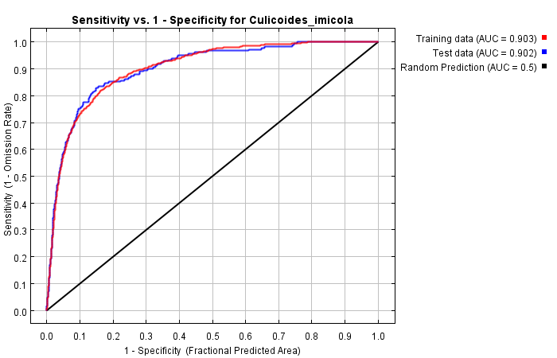
Figure S1 ROC curve of the current C.imicola distribution model.

Table S1 Variable contributions in MaxEnt model of current C.imicola distribution
Variable |  | Percent contribution (%) | Permutation importance (%)
bio_4 | Temperature seasonality | 30.3 | 46.4
bio_19 | Precipitation of coldest quarter | 29.5 | 10
bio_8 | Mean temperature of wettest quarter | 16.5 | 7.4
bio_14 | Precipitation of driest month | 9.5 | 6.6
bio_9 | Mean temperature of driest quarter | 6 | 15.8
bio_13 | Precipitation of wettest month | 5.7 | 8
bio_18 | Precipitation of warmest quarter | 1.4 | 1
bio_15 | Precipitation seasonality | 0.7 | 2.7
bio_2 | Mean diurnal range | 0.5 | 2.2

