808-1-19-tif-M

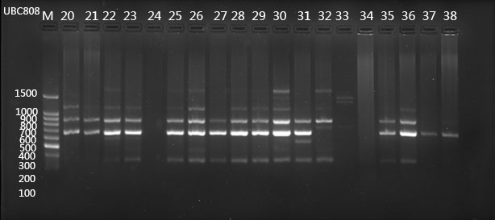

**Fig. S1 ISSR-PCR electrophoretic maps of *A. villosum* populations with primer UBC808**