Supplementary Materials

Figure S1. The selection algorithm of study participants
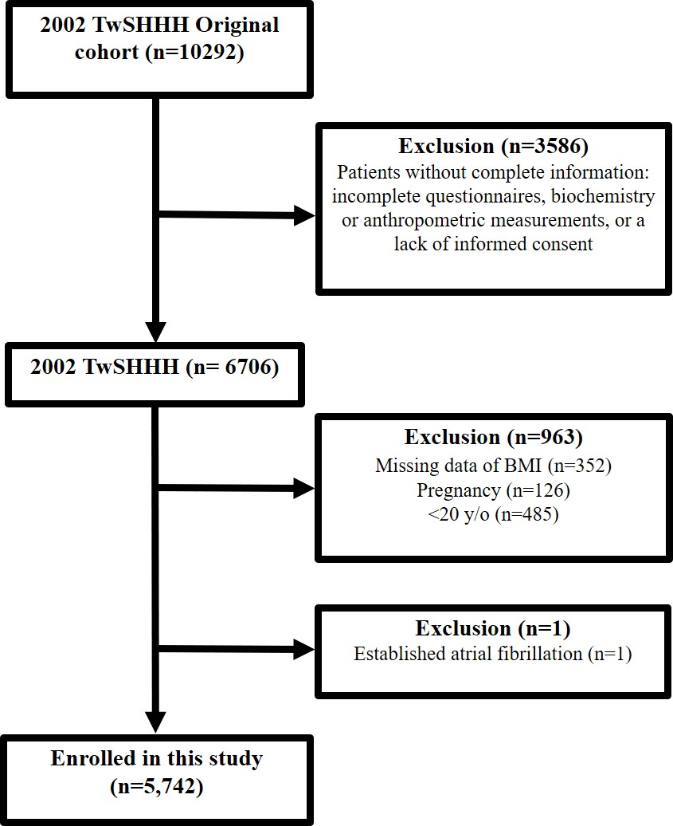
Abbreviations: TwSHHH, Taiwanese Survey on Hypertension, Hyperglycemia, and Hyperlipidemia; BMI, body mass index.

Table S1. The ICD-9 and ICD-10 codes of outcome measurement
Diagnosis | ICD-9 | ICD-10
Atrial fibrillation | 427.31 | I48.0, I48.2, I48.91, I48.1, I48.9, I48
Atrial flutter | 427.32 | I48.3, I48.4, I48.92
ICD-9: International Classification of Diseases-9th revision; ICD-10: International Classification of Diseases-10th revision

