Supplemental Information
Supplemental Figure 1: Images documenting how the measurements were taken for intertegular distance (A) and head capsule width (B), as shown for Osmia lignaria. ITD was measured from the anterior, medial edge of one tegula to the same location on the other tegula. Head capsule width was measured on the posterior edge of the compound eyes, from one lateral margin of the head to the other.
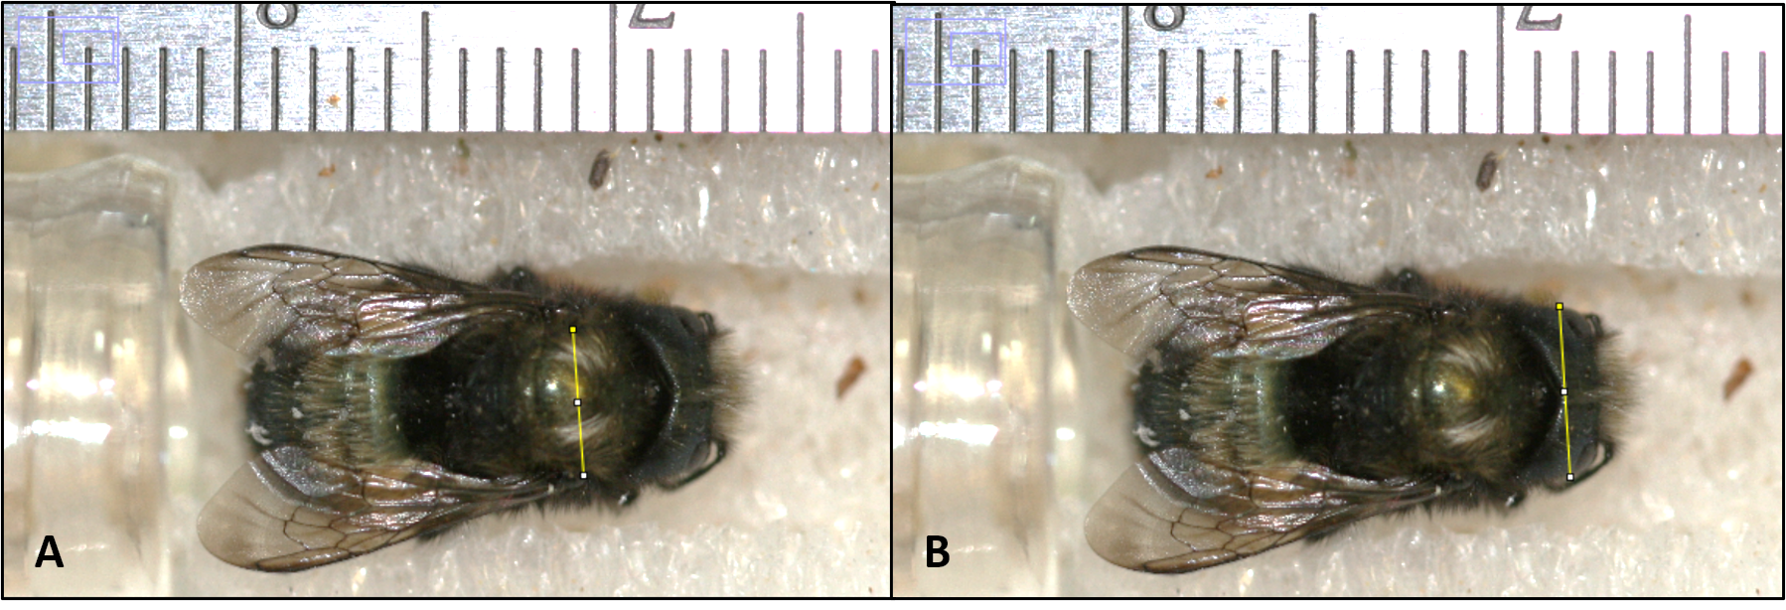

Supplemental Figure 2: Osmia lignaria pairs plot showing the relationship between all variables (intertegular distance = ITD, fresh weight, dry weight, and head capsule width = HCW) and the residual qqplots of normality of all selected models between each pair.
