Supplementary Information
A
B
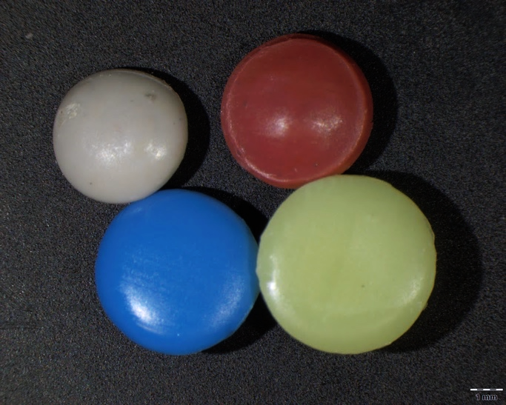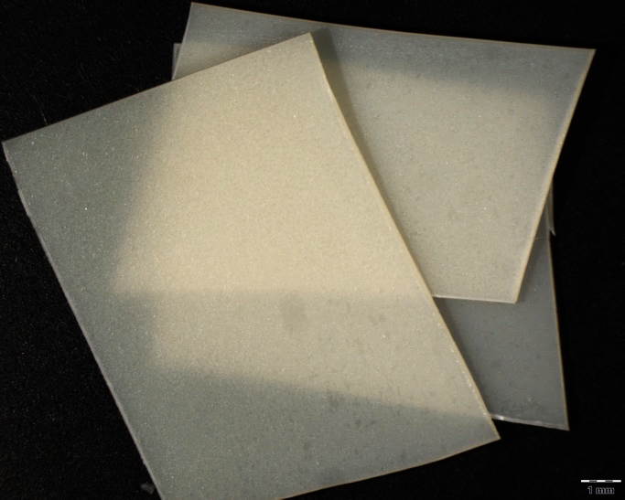
1 mm
1 mm
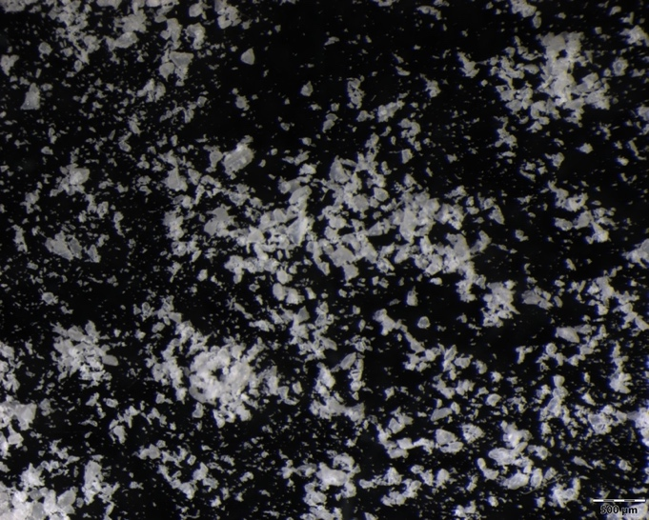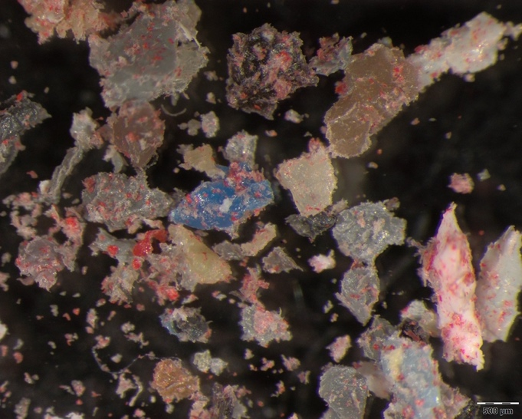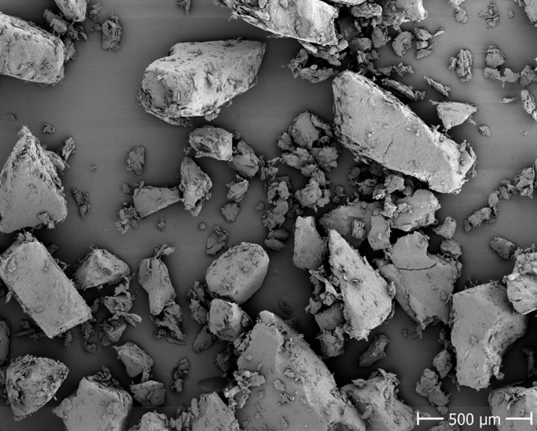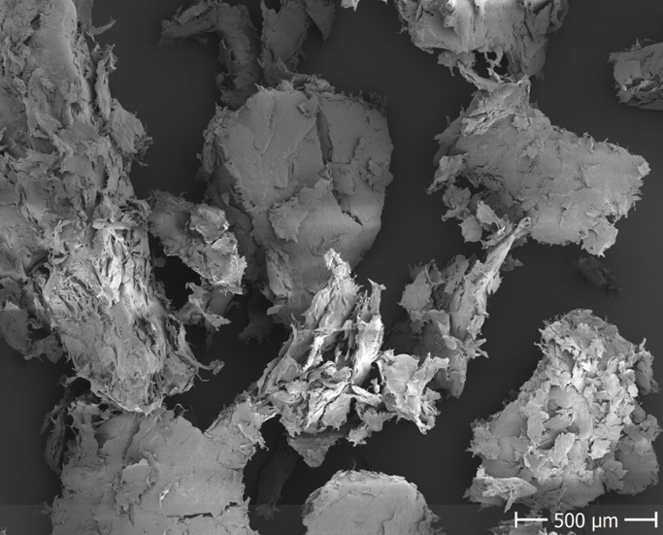
C
D
E
F
500 µm
500 µm
500 µm
500 µm
Figure S1: Stereo microscopy (A, B, C and D) and scanning electron microscopy (SEM) images (E, F) of the plastics’ original states (A, B) and the MPs (C, D, E, F). LDPE-R is displayed on the left side and the SB foil is displayed on the right side.

Table S1: Physico-chemical parameters (mean ± SD) for all behavioral experiments with Neocaridina palmata.
Experiment | pH | Temperature  [°C] | O₂ saturation  [%] | Conductivity ª  [µS cm⁻¹] | NH₄⁺  [mg L⁻¹] | CaCO₃  [mg L⁻¹]
LDPE-R | 7.65 ± 0.13 | 23.3 ± 0.17 | 97.3 ± 2.35 | 544 ± 28.3 | 0.96 ± 0.70 | 93.6 ± 10.2
LDPE-R UV | 7.63 ± 0.07 | 23.7 ± 0.41 | 99.0 ± 2.12 | 513 ± 22.9 | 0.54 ± 0.30 | 87.7 ± 0.30
SB foil | 7.61 ± 0.06 | 23.1 ± 0.28 | 98.6 ± 1.05 | 537 ± 41.9 | 0.97 ± 0.92 | 108 ± 10.1
SB foil UV | 7.67 ± 0.06 | 23.1 ± 0.29 | 98.1 ± 1.06 | 569 ± 48.7 | 0.80 ± 0.71 | 100 ± 9.00
Mean | 7.64 ± 0.08 | 23.3 ± 0.29 | 98.3 ± 1.65 | 541 ± 35.5 | 0.82 ± 0.66 | 97.3 ± 7.40
ª Conductivity values of the positive control (NaCl) are not included since they would highly increase the mean.

Figure S2: Preliminary test. Mobility rate [%] after 5-, 10-, 15- and 20-min video recordings for Neocaridina palmata individuals in pure test medium. No significant differences were detected with repeated-measures one-way ANOVA and Tukey’s multiple comparison test (α = 0.05). n = 7.

B
A
Figure S3: Top view of the experimental setup with the grouped replicates (arenas) (A) and the calibration pattern (B) that was recorded prior to the behavioral tracking with Neocaridina palmata.

Table S2: Body length [mm] (mean ± SD), relative sex ratio (male ♂ : female ♀) and number of moltings (mean ± SD) in the behavioral experiments with Neocaridina palmata. Individuals exposed to sodium chloride as well as individuals that died during the 14-days exposure period are not included in this table.
Experiment | Body length [mm] | Sex ratio (♂:♀) | Number of moltings
LDPE-R | 13.7 ± 1.58 | 36:64 | 1.34 ± 0.54
LDPE-R UV | 12.5 ± 0.99 | 54:46 | 1.45 ± 0.53
SB foil | 12.0 ± 1.04 | 51:49 | 1.26 ± 0.48
SB foil UV | 12.2 ± 1.02 | 55:45 | 1.29 ± 0.49
Mean | 12.6 ± 1.16 | 49:51 | 1.34 ± 0.51

Table S3: Microtox assay. EC₂₀ values [mg EQs well⁻¹] (mean ± SEM) of the raw material (LDPE-R pellets and SB foil) compared to the milled and sieved MPs. The latter is displayed in Figure 1 in the main part. The data of the raw materials are from Klein et al. (2021a) (LDPE-R pellets) and unpublished data (SB foil).
 | EC₂₀ ± SEM [mg EQs well⁻¹]
 | unweathered | UV-treated
LDPE-R pellets | 15.5 ± 2.68 | 13.1 ± 4.02
LDPE-R MPs | 3.48 ± 0.08 | 2.97 ± 0.43
SB foil | 4.94 ± 0.53 | 2.57 ± 0.14
SB foil MPs | 12.2 ± 2.06 | 14.0 ± 1.13
Figure S4: Locomotor behavior. Number of frozen events (median with min–max) of Neocaridina palmata exposed to the leachable chemicals from unweathered and UV-treated MP samples as well as to 4.5 g L⁻¹ of sodium chloride (positive control) on day 1, 3, 7 and 14. Tested concentrations ranged from 0.4 to 15.6 g L⁻¹ of MP-equivalents (EQs) for both the LDPE-R and SB foil. Treatments with extinct (crosses) individuals are displayed on day 7 and 14 in the positive control treatments. n = 7–8 for MP-EQs treatments, n = 1–8 for positive control.

A
B
Figure S5: Filtered solutions of the duplicates of leached LDPE-R MPs prior to the solid-phase extraction (A) and all enriched extracts (including the SB foil MPs) after the solid-phase extraction (B).

Figure S6: Linear regressions of the moved distance [m] of all N. palmata individuals (95%-CI) per exposure day (left) and MP-EQs concentration [g L⁻¹] for 1–14 days of exposure (right).

References
Klein K, Hof D, Dombrowski A, Schweyen P, Dierkes G, Ternes T, Schulte-Oehlmann U, Oehlmann J. 2021a. Enhanced in vitro toxicity of plastic leachates after UV irradiation. Water Research 199:117203. DOI: https://doi.org/10.1016/j.watres.2021.117203.

