Examples of a single experimental replicate used in pathogenicity tests 4, 7 and 10 days post inoculation (dpi).

1. Inoculation tests with detached leaves of the Gala apple cultivar. The codes next to each leaf are isolate codes. Isolates of *Alternaria arborescens* are shown in red and isolates of *Alternaria alternata* in purple.
2. Inoculation tests with detached leaves of the Golden Delicious apple cultivar. The codes next to each leaf are isolate codes. Isolates of *Alternaria arborescens* are shown in red and isolates of *Alternaria alternata* in purple.

Pathogenicity tests were performed by inoculation of unwounded abaxial leaf surfaces with 10 µL of conidial suspensions (concentration of 1x105 conidia/mL). An experimental replicate consisted of one strain inoculated on five different leaves (placed in five different plastic boxes) per cultivar.

1. 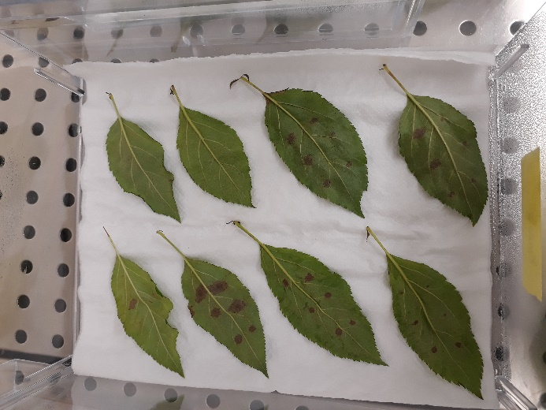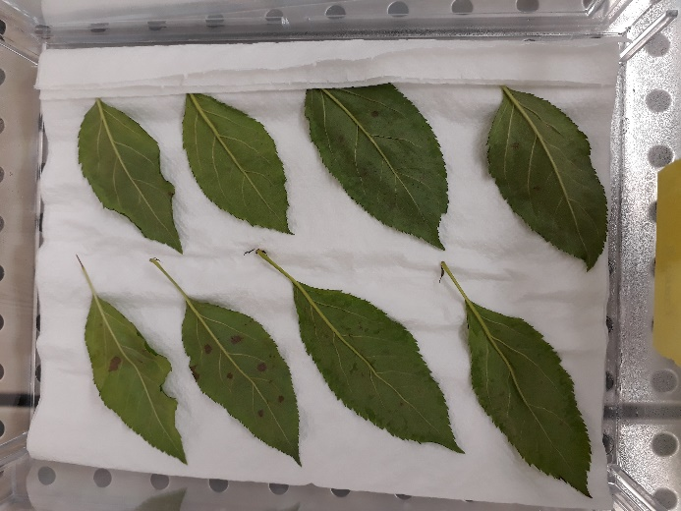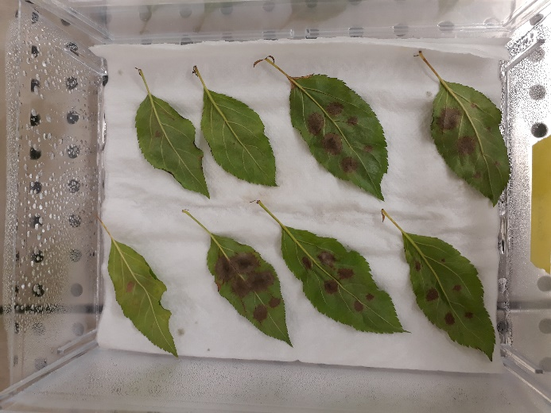Gala cultivar

**LSVM1443**

**16_489a5x**

**16_489b1a**

**LSVM75**

7 dpi

**16_489b3a**

**16_490b4a**

**16_497bc**

Water control

10 dpi

4 dpi

**16_489b3a**

**16_490b4a**

**16_497bc**

Water control

**LSVM1443**

**16_489a5x**

**16_489b1a**

**LSVM75**

**LSVM1443**

**16_489a5x**

**16_489b1a**

**16_489b3a**

**16_490b4a**

**16_497bc**

Water control

**LSVM75**

1. 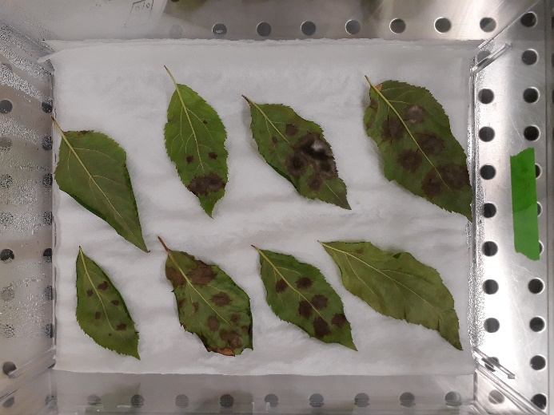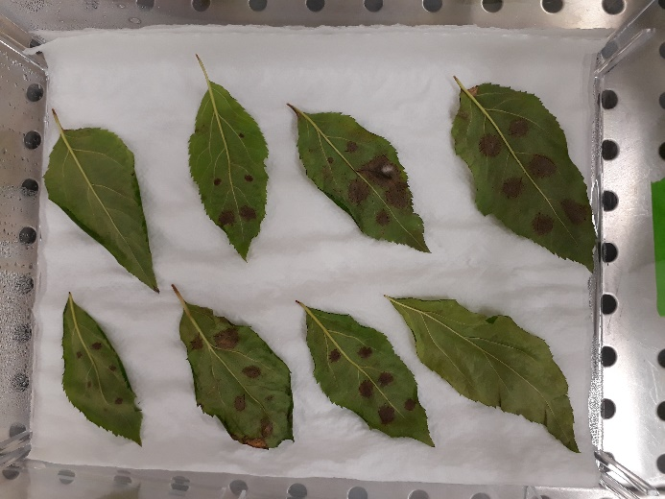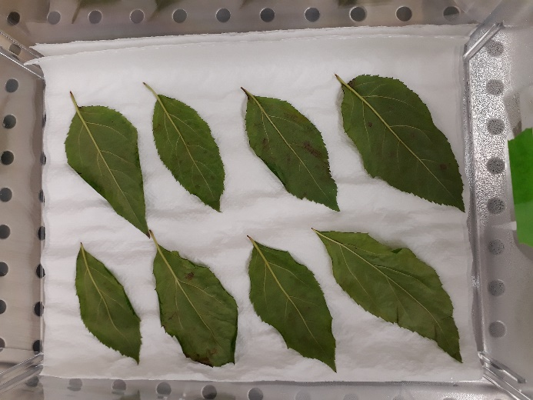Golden Delicious cultivar

7 dpi

10 dpi

**PL_Nov_Li**

**LSVM1451**

**FERA648**

**17_520**

**16_491a3a**

Water control

**21_17_Pomme4_2**

**PL_Nov_Li**

**LSVM1451**

**FERA648**

**21_17_Pomme4_2**

**17_520**

**16_491a3a**

**Golden D. 2b**

Water control

**PL_Nov_Li**

**LSVM1451**

**FERA648**

**21_17_Pomme4_2**

**17_520**

**16_491a3a**

**Golden D. 2b**

Water control

4 dpi