Supplementary material
Fernández Carbonell, M., Boman, M., & Laukka, P. (2021). Comparing supervised and unsupervised methods in multimodal emotion recognition.

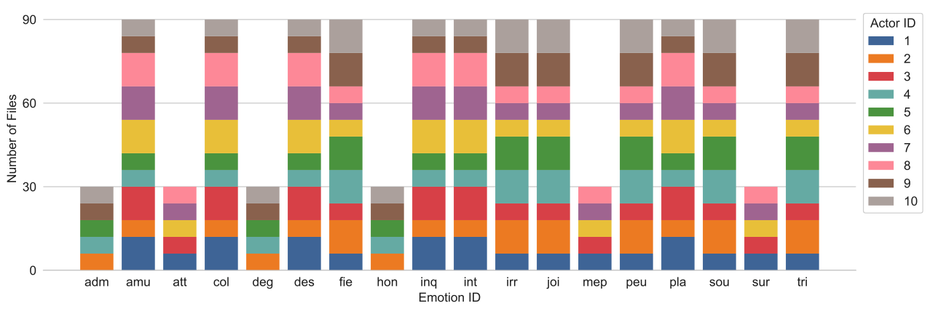
Figure S1. Number of files per emotion ID and actor ID. Female actors: 2, 6, 7, 9, and 10. Male actors: 1, 3, 4, 5, and 8.

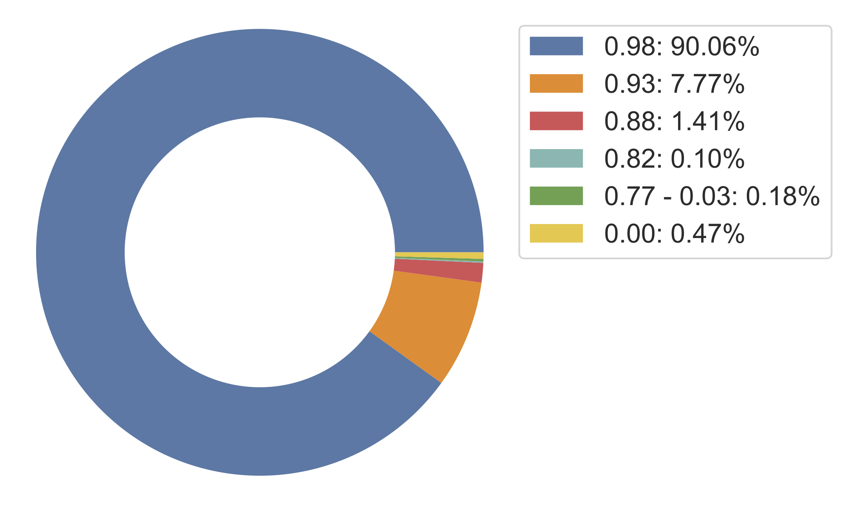

Figure S2. Distribution of the confidence rates of Facial Action Unit detection, provided by the OpenFace toolkit.

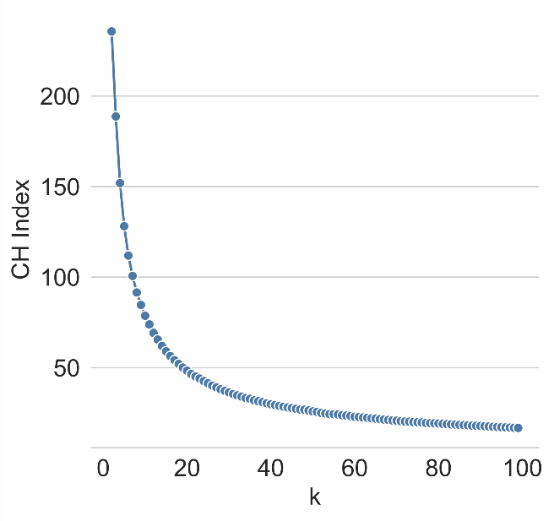 | 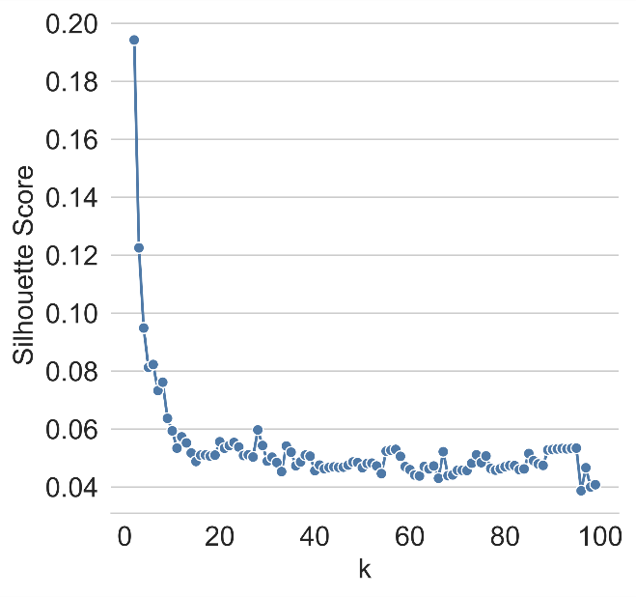
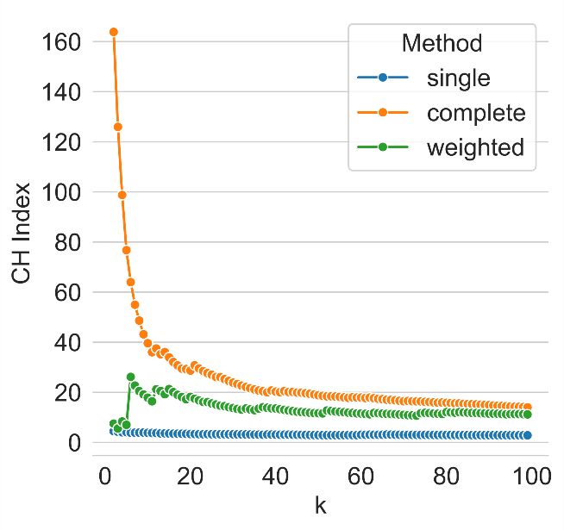 | 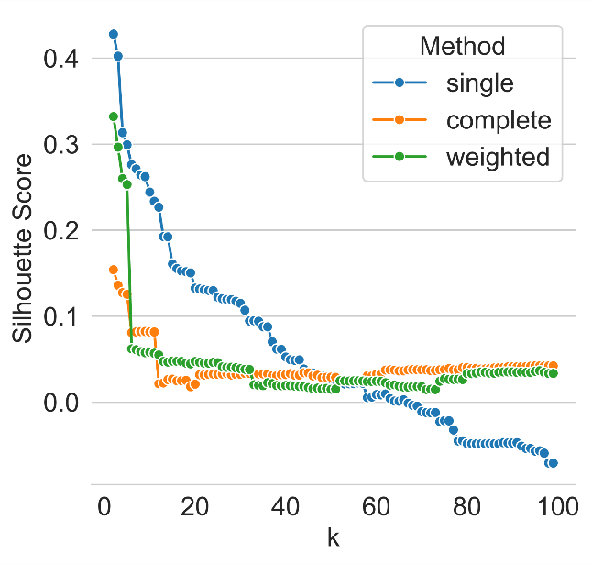
Figure S3. k-Means (top) and hierarchical clustering (bottom) before dimensionality reduction. Number of clusters estimated by using CH index (left) and silhouette score (right), where k ∈ {2, ..., 100}.

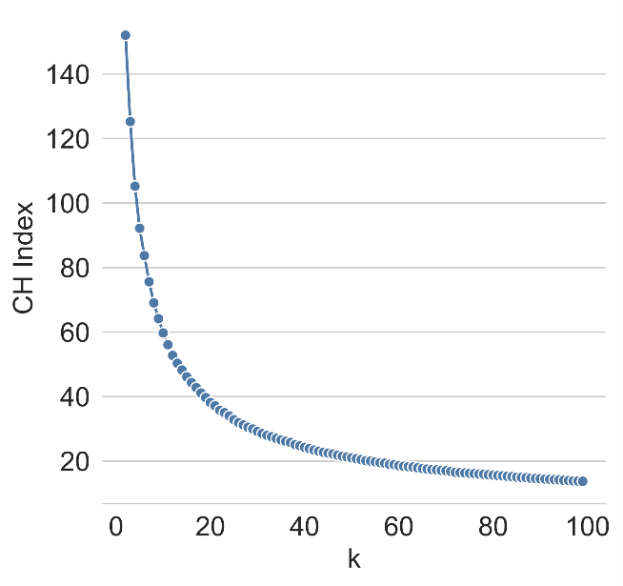 | 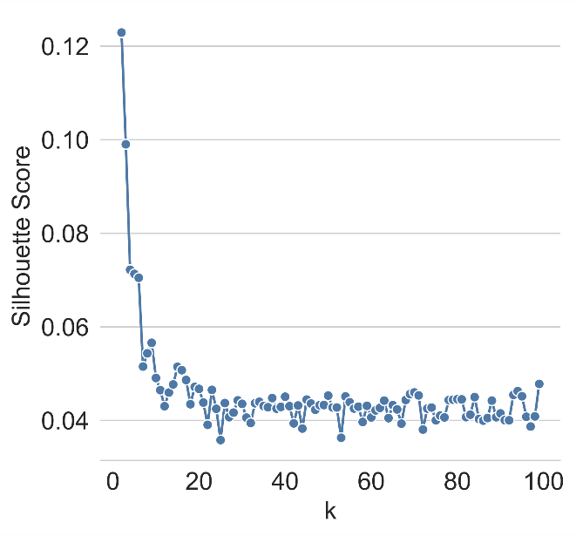
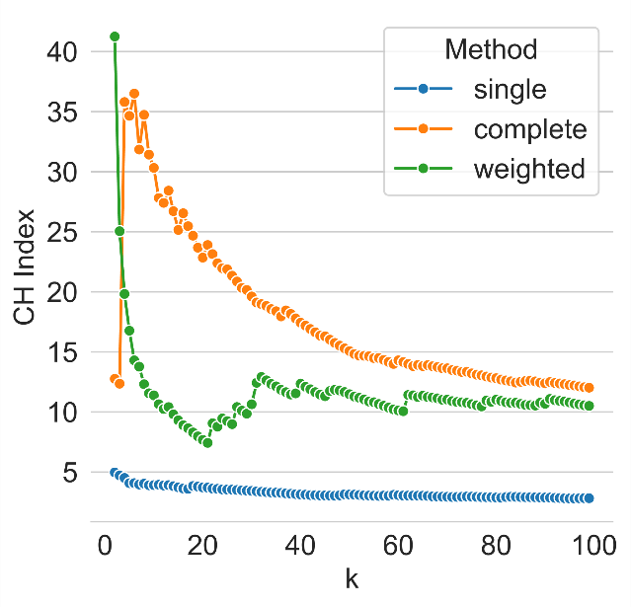 | 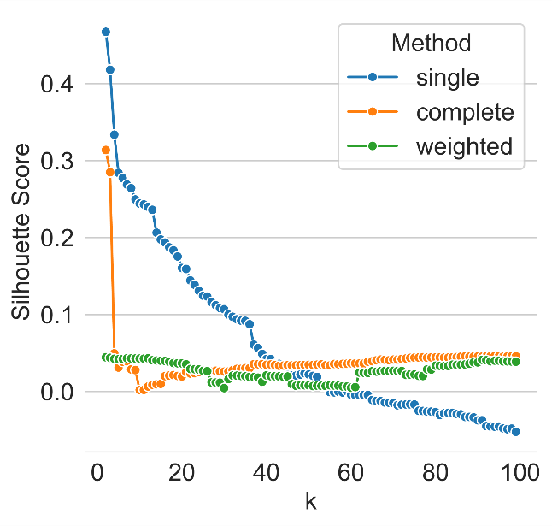
Figure S4. k-Means (top) and hierarchical clustering (bottom) after dimensionality reduction. Number of clusters estimated as before.

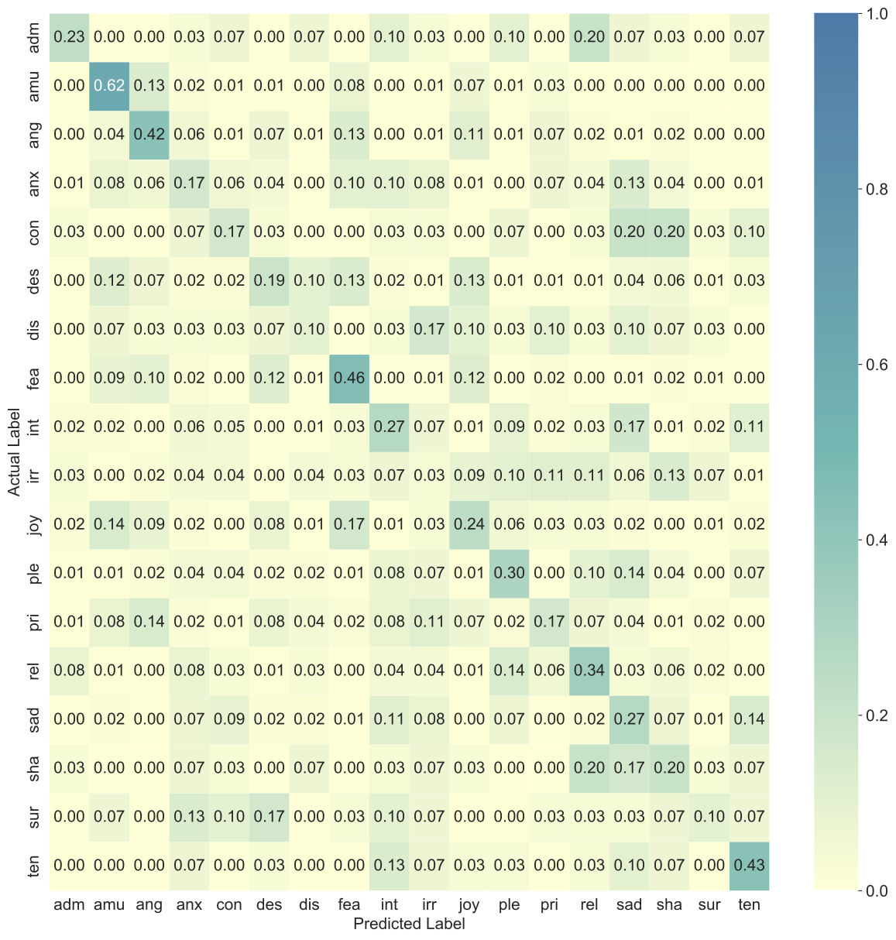
Figure S5. Unimodality (Audio - eGeMAPS): Elastic net normalized confusion matrix for the validation set.

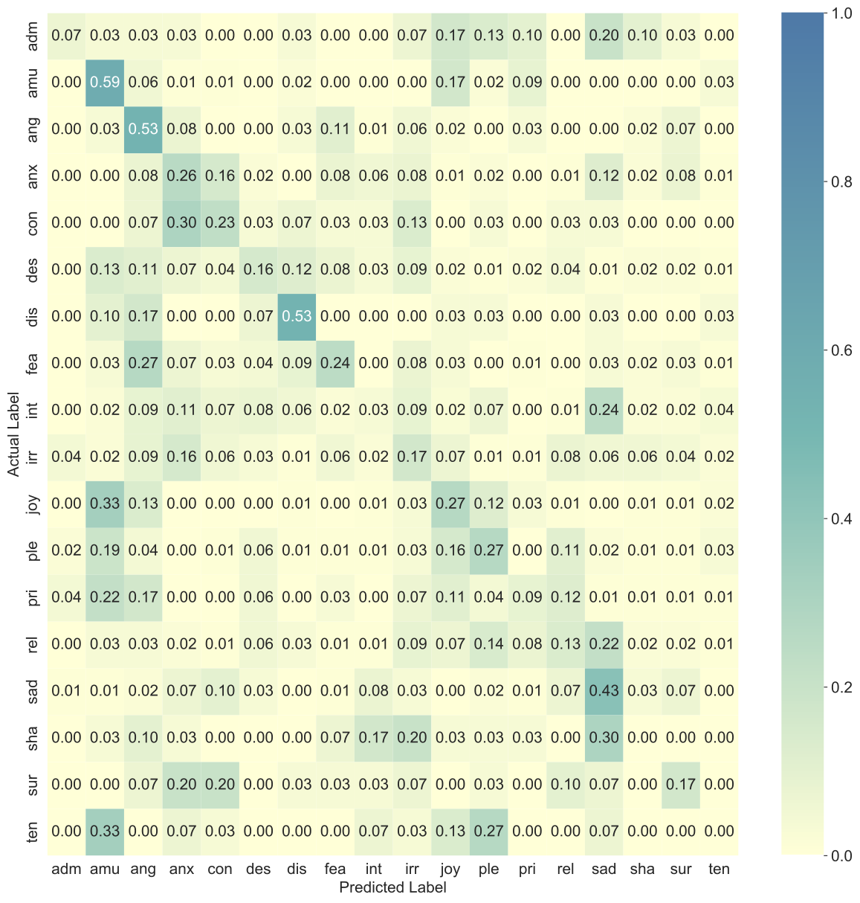
Figure S6. Unimodality (Video - AUs): Random forest normalized confusion matrix for the validation set.

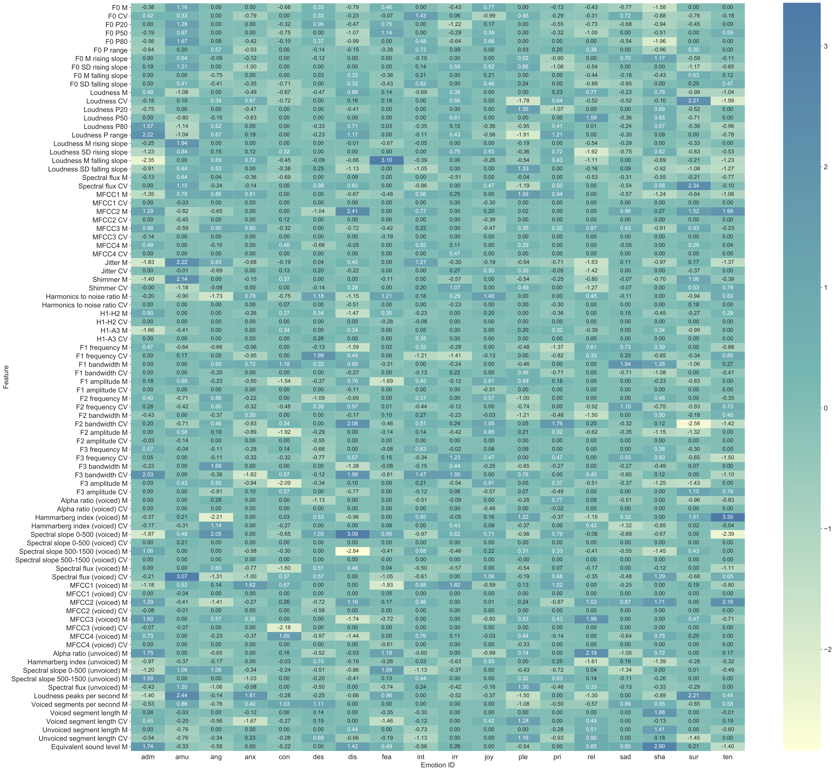
Figure S7. Feature importance (eGeMAPS) for classification of each emotion for the best performing audio classifier (Elastic Net).
Note. Functionals: M = arithmetic mean, CV = coefficient of variation, P20 = 20th percentile, P50 = 50th percentile, P80 = 80th percentile, P range = range of 20th to 80th percentile, M/SD rising slope = mean/standard deviation of the slope of rising signal parts, M/SD falling slope = mean/standard deviation of signal parts with falling slope.
Features: voiced/unvoiced = feature was based on voiced/unvoiced regions only; F0 = logarithmic F0 on a semitone frequency scale; jitter = deviations in individual consecutive F0 period lengths; F1/F2/F3 frequency/bandwidth = centre frequency/bandwidth of the first, second, and third formants; loudness = estimate of perceived signal intensity from an auditory spectrum; harmonics to noise ratio = relation of energy in harmonic components to energy in noise-like components; shimmer = difference of the peak amplitudes of consecutive F0 periods; equivalent sound level = logarithmic average sound pressure level; alpha ratio = ratio of the summed energy from 50-1000 Hz and 1-5 kHz; Hammarberg index = ratio of the strongest energy peak in the 0-2 kHz region to the strongest peak in the 2–5 kHz region; spectral slope 0-500/500-1500 = linear regression slope of the logarithmic power spectrum within the two given bands; spectral flux = difference of the spectra of two consecutive frames; F1/F2/F3 amplitude = first, second, and third formant relative energy; MFCC 1-4 = Mel-Frequency Cepstral Coefficients 1-4; H1-H2 = ratio of energy of the first F0 harmonic to the energy of the second F0 harmonic; H1-A3 = ratio of energy of the first F0 harmonic to the energy of the highest harmonic in the third formant range; loudness peaks per second = number of loudness peaks per second; voiced/unvoiced segments per second = number of continuous voiced/unvoiced regions per second; voiced/unvoiced segment length = length of continuous voiced/unvoiced regions.

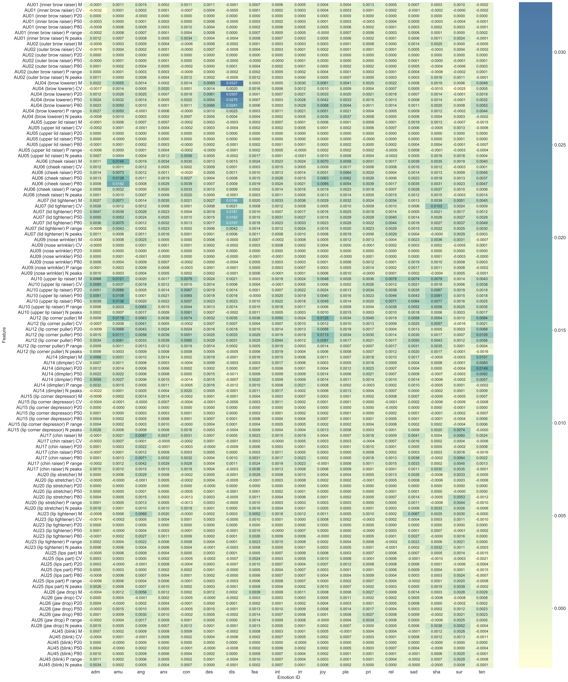

Figure S8. Feature importance (Facial Action Units and functionals) for classification of each emotion for the best performing video classifier (Random Forest).
Note. Functionals: M = arithmetic mean, CV = coefficient of variation, P20 = 20th percentile, P50 = 50th percentile, P80 = 80th percentile, P range = range of 20th to 80th percentile, N peaks = number of peaks.

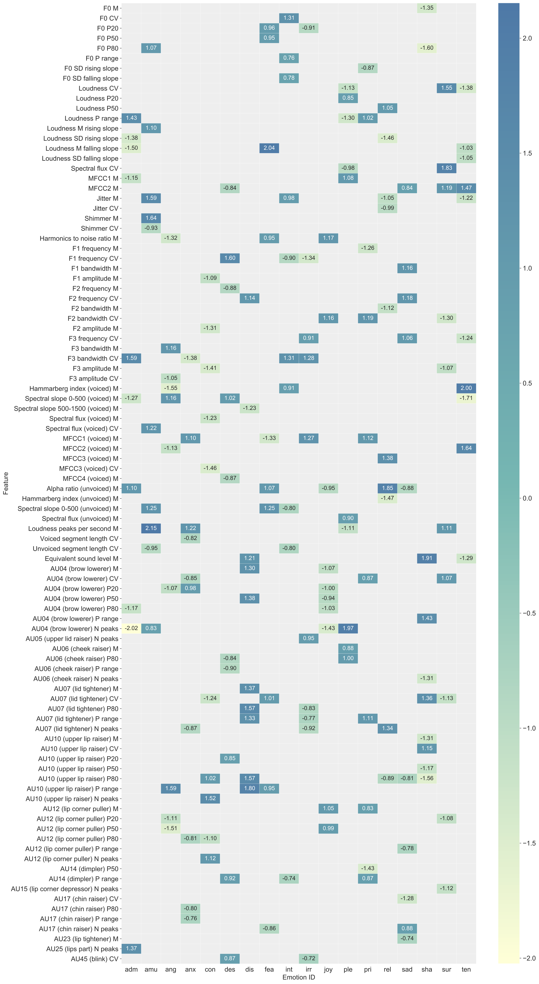
Figure S9. Summary of the most important audio and video features for classification of each emotion for the best performing early fusion multimodal classifier. See Figure S10 for a complete list that includes all features.
Note. Functionals: M = arithmetic mean, CV = coefficient of variation, P20 = 20th percentile, P50 = 50th percentile, P80 = 80th percentile, P range = range of 20th to 80th percentile, M/SD rising slope = mean/standard deviation of the slope of rising signal parts, M/SD falling slope = mean/standard deviation of signal parts with falling slope, N peaks = number of peaks.
Audio features: voiced/unvoiced = feature was based on voiced/unvoiced regions only; F0 = logarithmic F0 on a semitone frequency scale; jitter = deviations in individual consecutive F0 period lengths; F1/F2/F3 frequency/bandwidth = centre frequency/bandwidth of the first, second, and third formants; loudness = estimate of perceived signal intensity from an auditory spectrum; harmonics to noise ratio = relation of energy in harmonic components to energy in noise-like components; shimmer = difference of the peak amplitudes of consecutive F0 periods; equivalent sound level = logarithmic average sound pressure level; alpha ratio = ratio of the summed energy from 50-1000 Hz and 1-5 kHz; Hammarberg index = ratio of the strongest energy peak in the 0-2 kHz region to the strongest peak in the 2–5 kHz region; spectral slope 0-500/500-1500 = linear regression slope of the logarithmic power spectrum within the two given bands; spectral flux = difference of the spectra of two consecutive frames; F1/F2/F3 amplitude = first, second, and third formant relative energy; MFCC 1-4 = Mel-Frequency Cepstral Coefficients 1-4; H1-H2 = ratio of energy of the first F0 harmonic to the energy of the second F0 harmonic; H1-A3 = ratio of energy of the first F0 harmonic to the energy of the highest harmonic in the third formant range; loudness peaks per second = number of loudness peaks per second; voiced/unvoiced segments per second = number of continuous voiced/unvoiced regions per second; voiced/unvoiced segment length = length of continuous voiced/unvoiced regions.
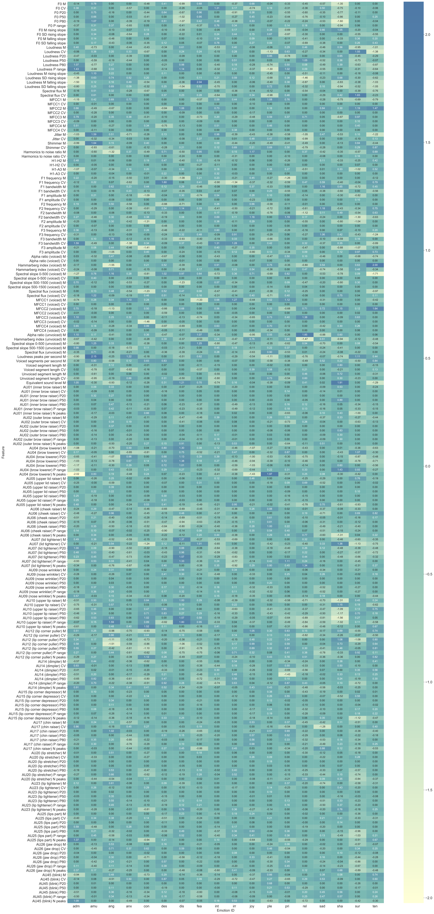
Figure S10. Summary of audio and video feature importance for classification of each emotion for the best performing early fusion multimodal classifier.
Note. Functionals: M = arithmetic mean, CV = coefficient of variation, P20 = 20th percentile, P50 = 50th percentile, P80 = 80th percentile, P range = range of 20th to 80th percentile, M/SD rising slope = mean/standard deviation of the slope of rising signal parts, M/SD falling slope = mean/standard deviation of signal parts with falling slope, N peaks = number of peaks.
Audio features: voiced/unvoiced = feature was based on voiced/unvoiced regions only; F0 = logarithmic F0 on a semitone frequency scale; jitter = deviations in individual consecutive F0 period lengths; F1/F2/F3 frequency/bandwidth = centre frequency/bandwidth of the first, second, and third formants; loudness = estimate of perceived signal intensity from an auditory spectrum; harmonics to noise ratio = relation of energy in harmonic components to energy in noise-like components; shimmer = difference of the peak amplitudes of consecutive F0 periods; equivalent sound level = logarithmic average sound pressure level; alpha ratio = ratio of the summed energy from 50-1000 Hz and 1-5 kHz; Hammarberg index = ratio of the strongest energy peak in the 0-2 kHz region to the strongest peak in the 2–5 kHz region; spectral slope 0-500/500-1500 = linear regression slope of the logarithmic power spectrum within the two given bands; spectral flux = difference of the spectra of two consecutive frames; F1/F2/F3 amplitude = first, second, and third formant relative energy; MFCC 1-4 = Mel-Frequency Cepstral Coefficients 1-4; H1-H2 = ratio of energy of the first F0 harmonic to the energy of the second F0 harmonic; H1-A3 = ratio of energy of the first F0 harmonic to the energy of the highest harmonic in the third formant range; loudness peaks per second = number of loudness peaks per second; voiced/unvoiced segments per second = number of continuous voiced/unvoiced regions per second; voiced/unvoiced segment length = length of continuous voiced/unvoiced regions.

