X-ray diffraction and theoretical study of the transition 2H-3R polytypes in Nb_{1+x}Se₂ (0< x <0.1)

Mohamed Sidoumo¹, Soumia Merazka², Adrian Gómez Herrero³, Mohammed Kars²*, Thierry Roisnel⁴

¹ Université Blida1, Département de Physique, Laboratoire de physique théorique et interaction rayonnement matière Bp 270 Route de Soumaa Blida, Algérie.
² Université des Sciences et de la Technologie Houari-Boumediene, Faculté de Chimie, Laboratoire Sciences des matériaux, Bp 32 El-Alia Bab-Ezzouar, Algérie.
³ Centro de Microscopia Electrónica, Universidad Complutense, 28040 Madrid, Spain.
⁴ Centre de Diffractométrie X, Sciences Chimiques de Rennes, UMR 66226 CNRS Université de Rennes1 Campus de Beaulieu, Avenue du Général Leclerc, France.

Corresponding Author:
Mohammed Kars
Université des Sciences et de la Technologie Houari-Boumediene, Faculté de Chimie, Laboratoire Sciences des matériaux, Bp 32 El-Alia Bab-Ezzouar, Algérie.
Email address: mkarsdz@yahoo.fr

Table S1 Atomic coordinates and equivalent isotropic displacement parameters (Å²) for the 2H-Nb_{1.031}Se₂, 3R-Nb_{1.071}Se₂, 3R-Nb_{1.085}Se₂ polytypes.

Polytype | Atom | Wyckoff | x | y | z | U_{ed} | Occupancy
2H-Nb_{1.031}Se₂ | Nb1  Nb2  Se | 2b  2a  4f | 0  0  1/3 | 0  0  2/3 | 0.25  0  0.1173(3) | 0.0053(16)  0.0053(16)  0.0065(17) | 0.960(2)  0.073(13)
3R-Nb_{1.071}Se₂ | Nb1  Nb2  Se1  Se2 | 3a  3a  3a  3a | 0  0  1/3  1/3 | 0  0  2/3  2/3 | 0.0014(8)  0.8158(12)  -0.0874(8)  0.0896(8) | 0.0094(4)  0.0094(4)  0.0099(4)  0.0129(5) | 1  0.071(8)
3R-Nb_{1.085}Se₂ | Nb1  Nb2  Se1  Se2 | 3a  3a  3a  3a | 1/3  1/3  2/3  2/3 | 2/3  2/3  1/3  1/3 | 0.5123(6)  0.3343(13)  0.4237(6)  0.6009(5) | 0.0078(11)  0.0078(11)  0.0093(10)  0.0132(12) | 0.960(2)  0.119(13)
U_{eq} is defined as one-third of the trace of the orthogonalized U_{ij} tensors.

Table S2 Anisotropic displacement parameters for the 2H-Nb_{1.031}Se₂, 3R-Nb_{1.071}Se₂, 3R-Nb_{1.085}Se₂ polytypes.

Polytype | Atoms | U₁₁ | U₂₂ | U₃₃ | U₁₂ | U₁₃ | U₂₃
2H-Nb_{1.031}Se₂ | Nb1  Nb2  Se | 0.003(2)  0.003(2)  0.005(2) | 0.003(2)  0.003(2)  0.005(2) | 0.009(3)  0.009(3)  0.010(3) | 0.0017(10)  0.0017(10)  0.0024(10) | 0  0  0 | 0  0  0
3R-Nb_{1.071}Se₂ | Nb1  Nb2  Se1  Se2 | 0.0111(4)  0.0103(4)  0.0084(14)  0.0088(4) | 0.0111(4)  0.0103(4)  0.0084(14)  0.0088(4) | 0.0146(5)  0.0134(5)  0.0114(17)  0.0117(5) | 0.0056(2)  0.0052(2)  0.0042(7)  0.00439(19) | 0  0  0  0 | 0  0  0  0
3R-Nb_{1.085}Se₂ | Nb1  Nb2  Se1  Se2 | 0.0034(13)  0.0034(13)  0.0037(12)  0.0102(16) | 0.0034(13)  0.0034(13)  0.0037(12)  0.0102(16) | 0.0166(17)  0.0166(17)  0.020(2)  0.0191(18) | 0.0017(7)  0.0017(7)  0.0018(6)  0.0051(8) | 0  0  0  0 | 0  0  0  0

Table S3 Selected bond distances (Å) for the 2H-Nb_{1.031}Se₂, 3R-Nb_{1.071}Se₂, 3R-Nb_{1.085}Se₂ polytypes. The distortion δ (Å) is the difference between the longest and shortest Nb-Se bond distance.

Polytype | Nb-Se | Distances (Å) | Nb-Nb | Distances (Å)
2H-Nb_{1.031}Se₂ | Nb1-Se (x3)  Nb1-Se (x3)  δ | 2.477(2)  2.597(2)  0.12 | Nb-Nb  Nb1-Nb2 | 3.4475(9)  3.1425(6)
3R-Nb_{1.071}Se₂ | Nb1-Se1 (x3)  Nb1-Se2 (x3)  δ  Nb2-Se1 (x3)  Nb2-Se2 (x3)  δ | 2.601(14)  2.594(14)  0.007  2.698(16)  2.288(12)  0.41 | Nb-Nb  Nb1-Nb2 | 3.4512 (8)  3.42 (2)  3.49(2)
3R-Nb_{1.085}Se₂ | Nb1-Se1 (x3)  Nb1-Se2 (x3)  δ  Nb2-Se1 (x3)  Nb2-Se2 (x3)  δ | 2.608(10)  2.608(9)  0  2.621(14)  2.362(11)  0.259 | Nb-Nb  Nb1-Nb2 | 3.4670 (8)  3.36 (2)

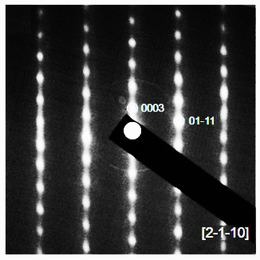

Figure 1S [2–1-10] zone axis SAED pattern of 3R-Nb_{1.085}Se₂, showing diffuse intensity along c* axis, assigned to short-range ordering of extra Nb2 atoms and vacancies.

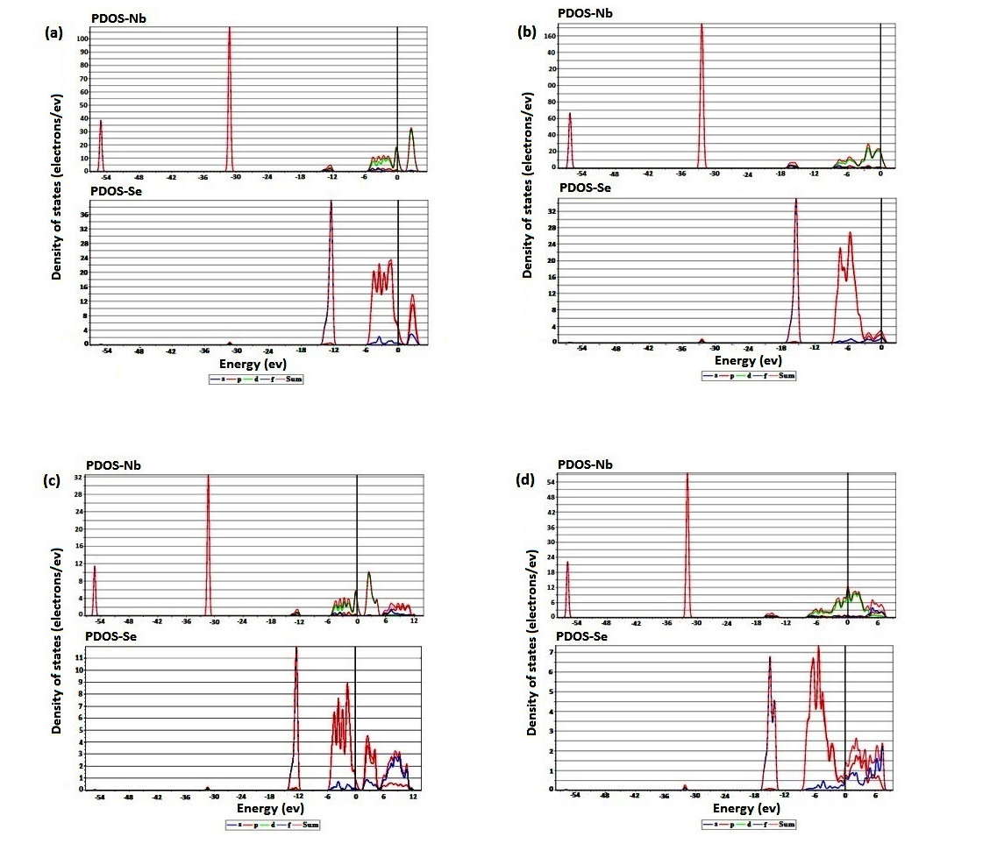
Figure 2S Partial DOS of (A) 2H-NbSe₂, (B) 2H-Nb_{1.1}Se₂, (C) 3R-NbSe₂, (D) 3R-Nb_{1.1}Se₂.

