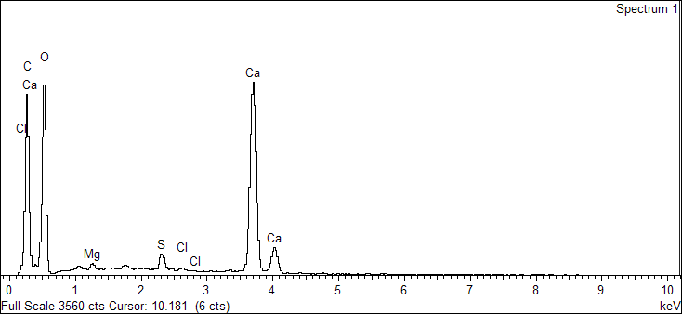

Spectrum processing :

Peak possibly omitted : 1.750 keV

Processing option : All elements analyzed (Normalised)

Number of iterations = 5

Standard :

C CaCO3 1-Jun-1999 12:00 AM

O SiO2 1-Jun-1999 12:00 AM

Mg MgO 1-Jun-1999 12:00 AM

S FeS2 1-Jun-1999 12:00 AM

Cl KCl 1-Jun-1999 12:00 AM

Ca Wollastonite 1-Jun-1999 12:00 AM

|  |  |  |  |
| --- | --- | --- | --- |
| Element | Weight% | Atomic% |  |
|  |  |  |  |
| C K | 25.00 | 36.00 |  |
| O K | 48.28 | 52.21 |  |
| Mg K | 0.38 | 0.27 |  |
| S K | 1.23 | 0.66 |  |
| Cl K | 0.27 | 0.13 |  |
| Ca K | 24.84 | 10.72 |  |
|  |  |  |  |
| Totals | 100.00 |  |  |

Sample: 2020.L.0002-1_A

Type: Default

ID:

7/8/2020 3:29:54 PM

Ibrahim

