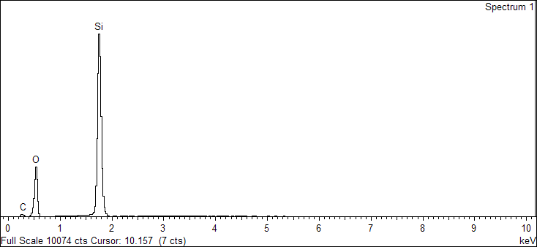

Spectrum processing :

No peaks omitted

Processing option : All elements analyzed (Normalised)

Number of iterations = 4

Standard :

C CaCO3 1-Jun-1999 12:00 AM

O SiO2 1-Jun-1999 12:00 AM

Si SiO2 1-Jun-1999 12:00 AM

|  |  |  |  |
| --- | --- | --- | --- |
| Element | Weight% | Atomic% |  |
|  |  |  |  |
| C K | 8.84 | 14.47 |  |
| O K | 41.01 | 50.41 |  |
| Si K | 50.15 | 35.12 |  |
|  |  |  |  |
| Totals | 100.00 |  |  |

Sample: 2020.L.0002-2_B 2

Type: Default

ID:

7/8/2020 3:42:33 PM

Ibrahim

