8/4/2020 12:03:53 PM

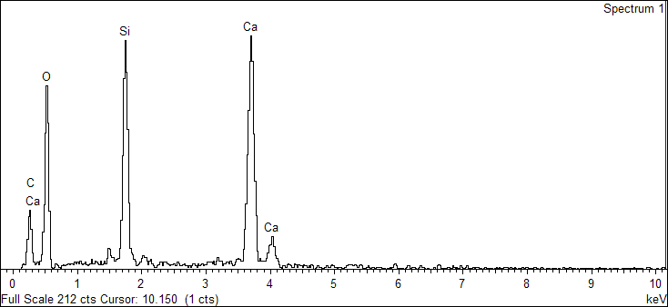

Spectrum processing :

No peaks omitted

Processing option : All elements analyzed (Normalised)

Number of iterations = 3

Standard :

C CaCO3 1-Jun-1999 12:00 AM

O SiO2 1-Jun-1999 12:00 AM

Si SiO2 1-Jun-1999 12:00 AM

Ca Wollastonite 1-Jun-1999 12:00 AM

|  |  |  |  |
| --- | --- | --- | --- |
| Element | Weight% | Atomic% |  |
|  |  |  |  |
| C K | 10.86 | 17.94 |  |
| O K | 47.20 | 58.54 |  |
| Si K | 13.02 | 9.20 |  |
| Ca K | 28.92 | 14.32 |  |
|  |  |  |  |
| Totals | 100.00 |  |  |

Sample: 2020.L.0002-4_D_R 2

Type: Default

ID:

8/4/2020 12:04:09 PM

Ibrahim



8/4/2020 12:04:43 PM