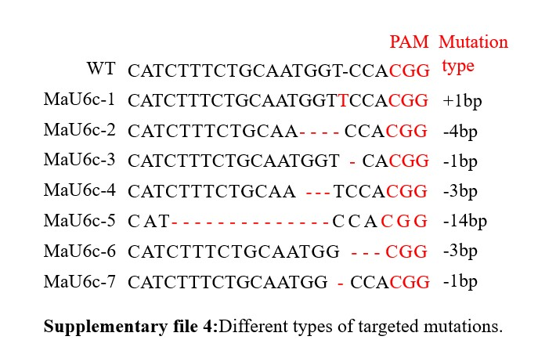
The sgRNA target sequence is shown in figure. Deletions are shown as red dashes, and insertions are denoted with red letters and the mutation types on the right.

