Metabarcoding of the phytotelmata of *Pseudalcantarea grandis* (Bromeliaceae) from an arid zone

José Alan Herrera-García1, Mahinda Martínez1,3, Pilar Zamora-Tavares2,3, Ofelia Vargas-Ponce2,3, Luis Hernández-Sandoval1,3, Fabián Alejandro Rodríguez-Zaragoza 4

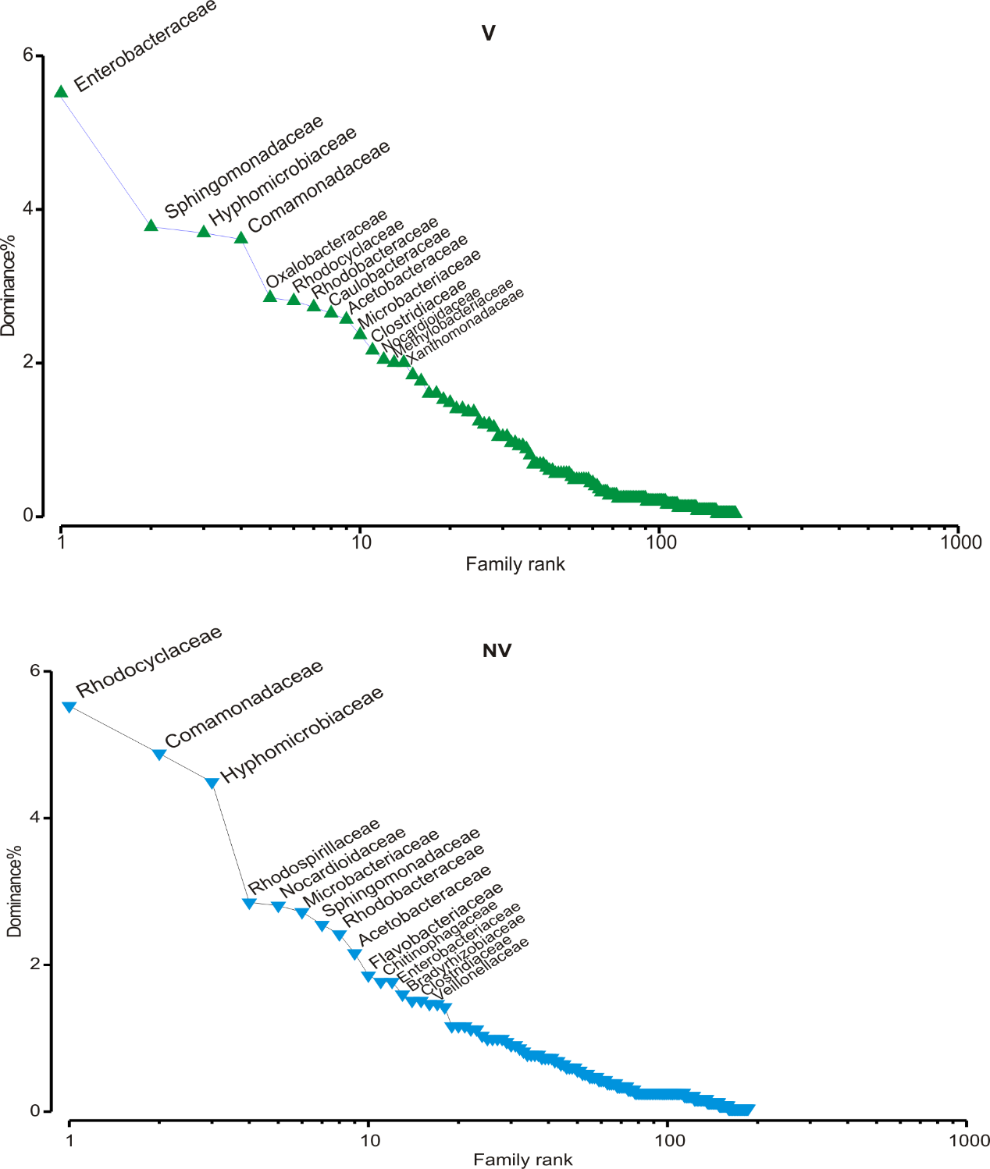

Figure supplementary 1. Rank/abundance curves of bacterial families in vegetated (V) and non-vegetated (NV) sites.