File S4: Conserved domains of PeWNK genes
PeWNK2 protein conserved domains
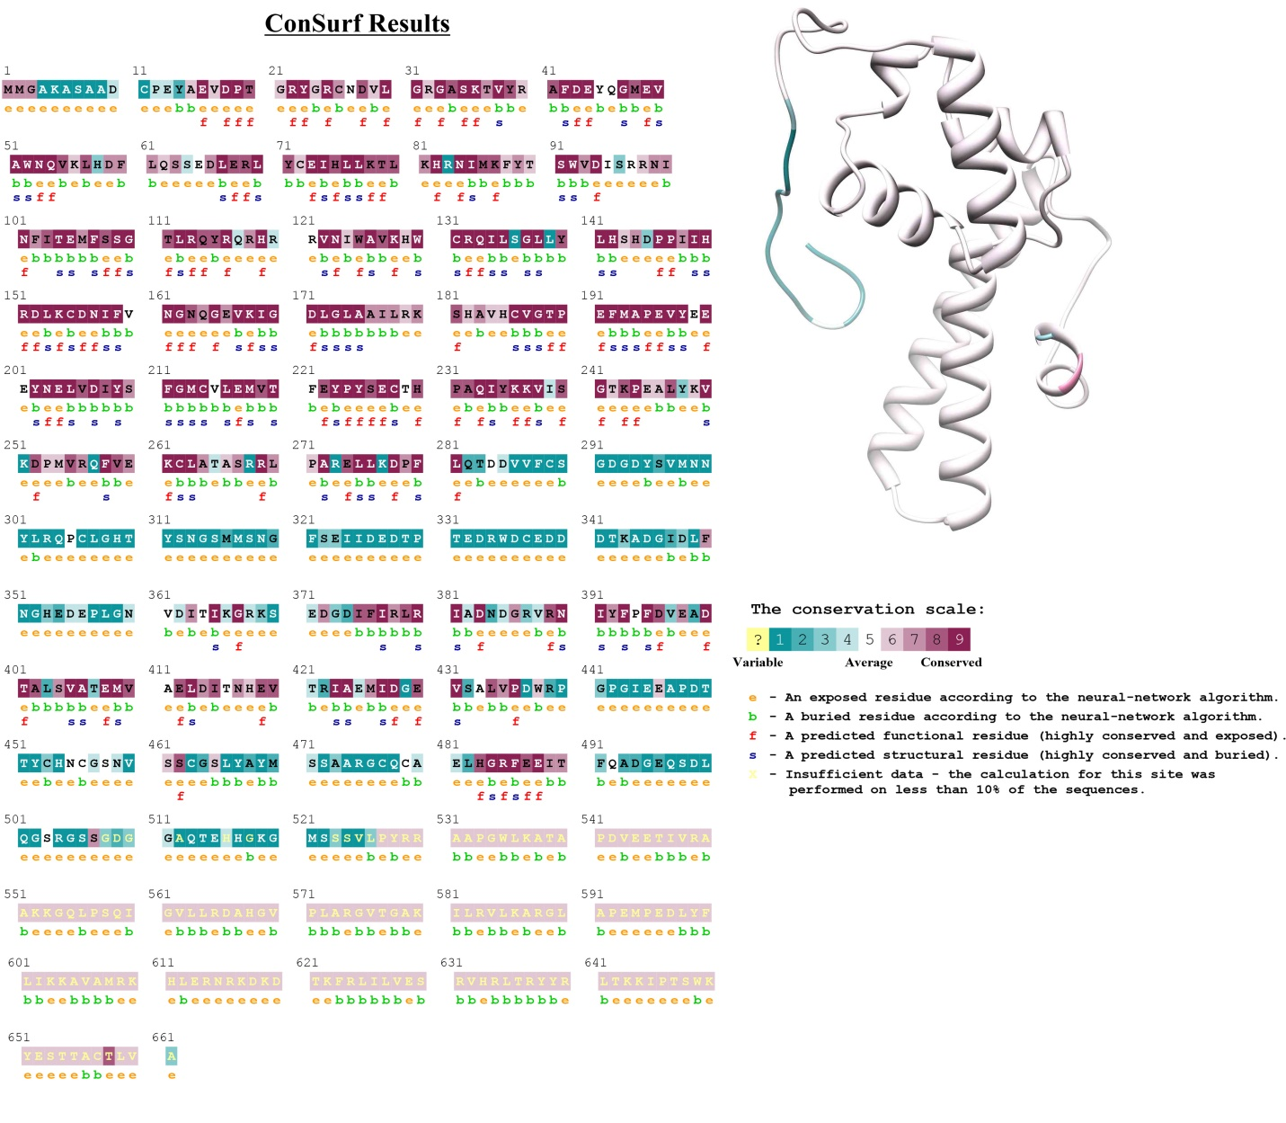

PeWNK3 protein conserved domains
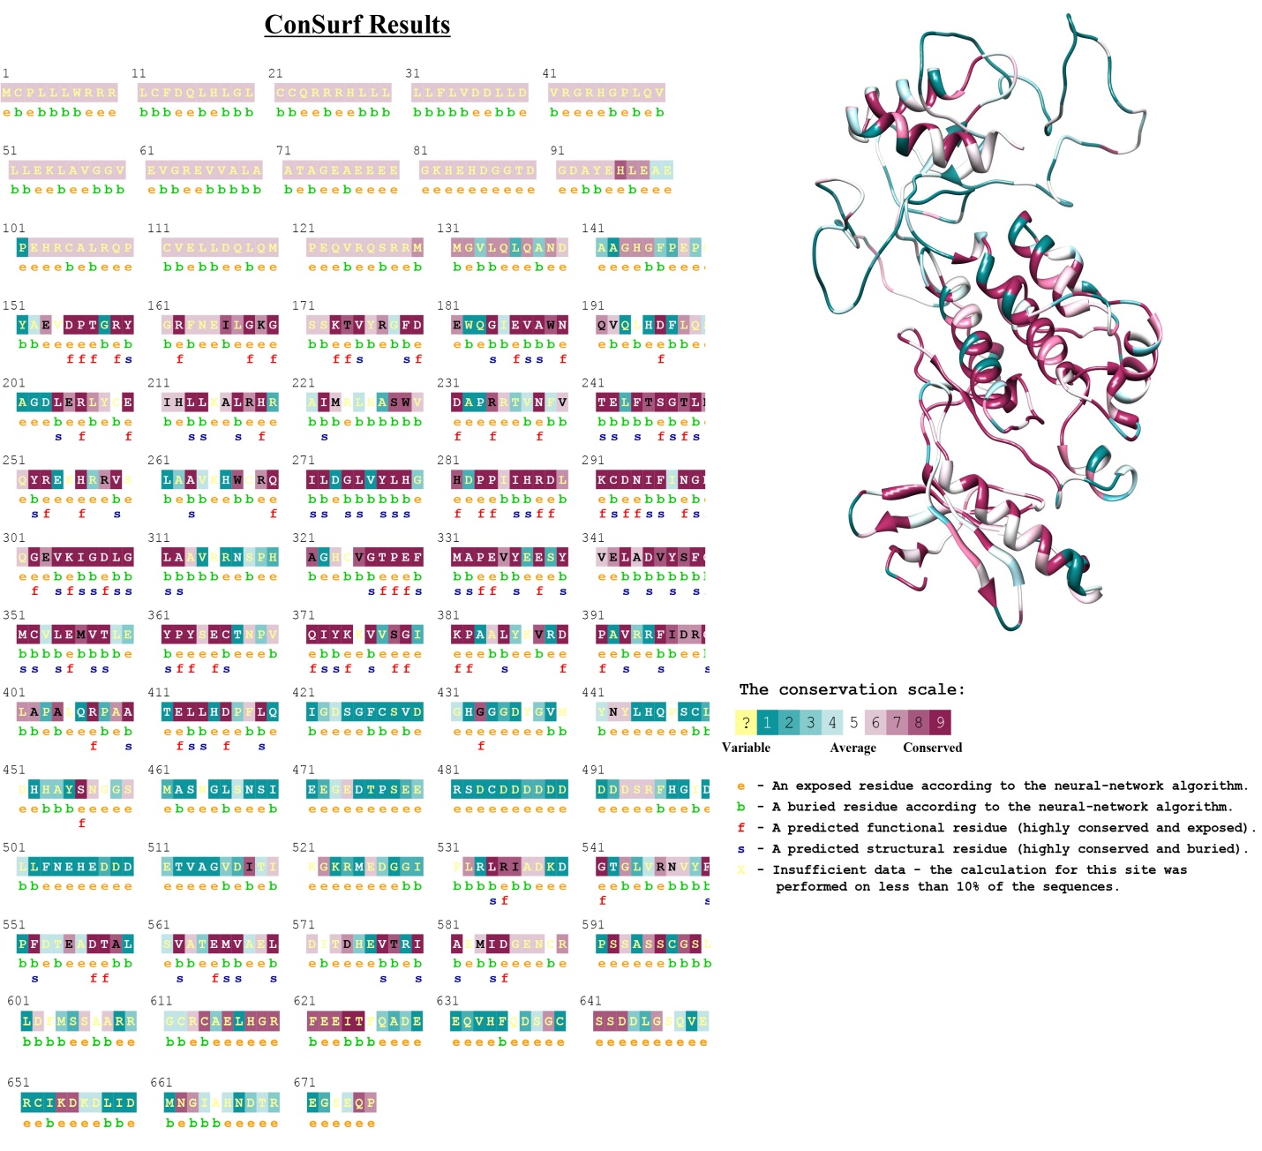

PeWNK4 protein conserved domains

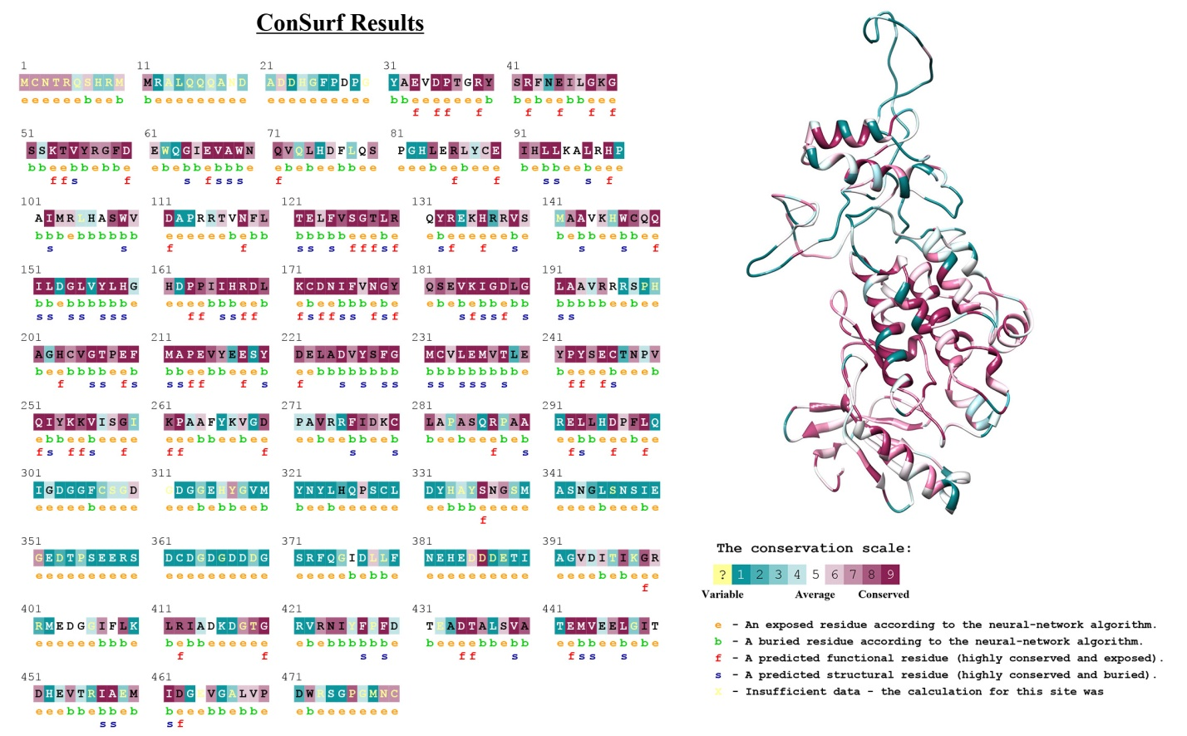

PeWNK5 protein conserved domains
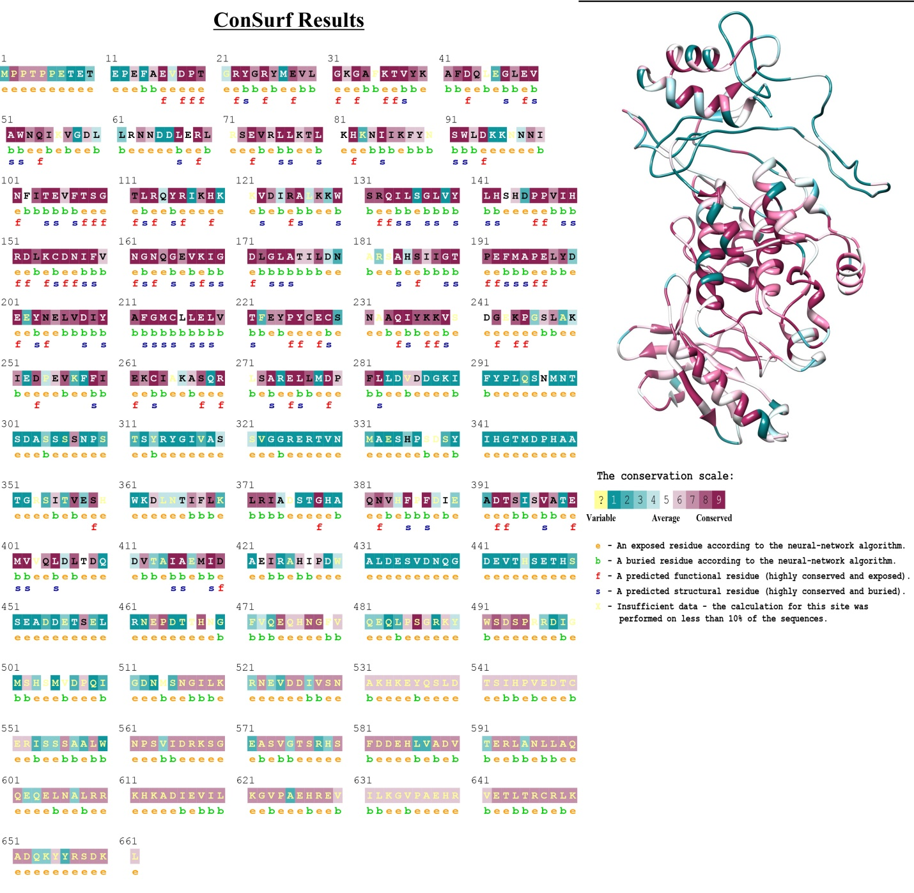

PeWNK6 protein conserved domains
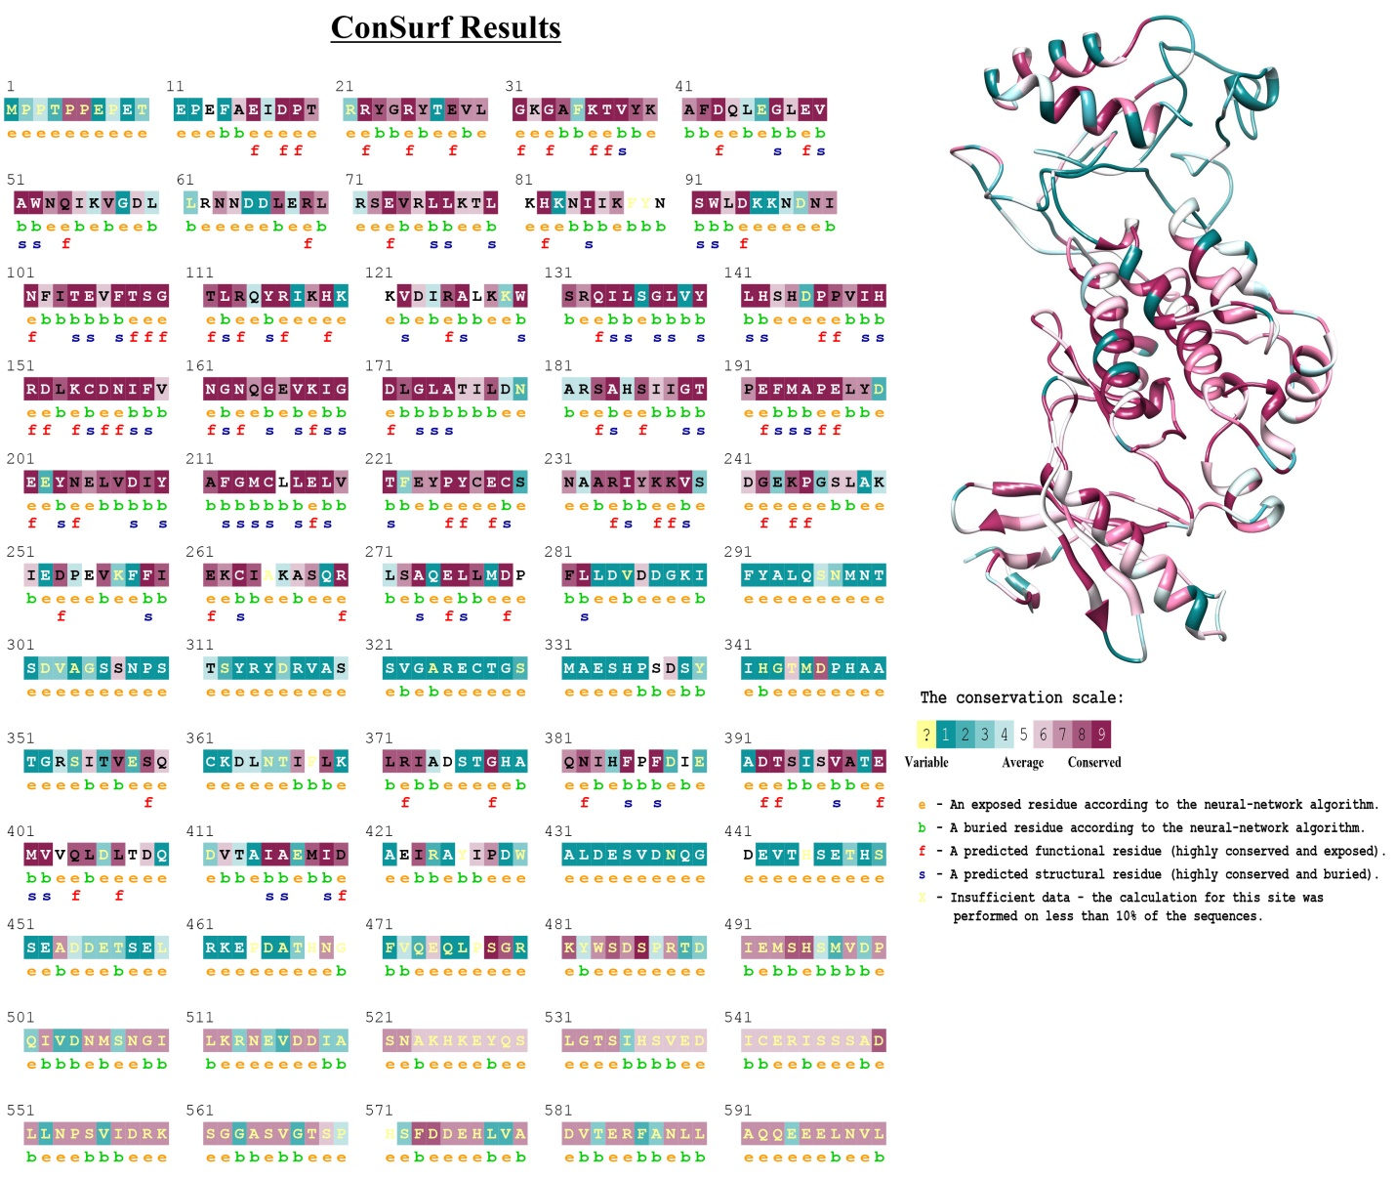

PeWNK7 protein conserved domains
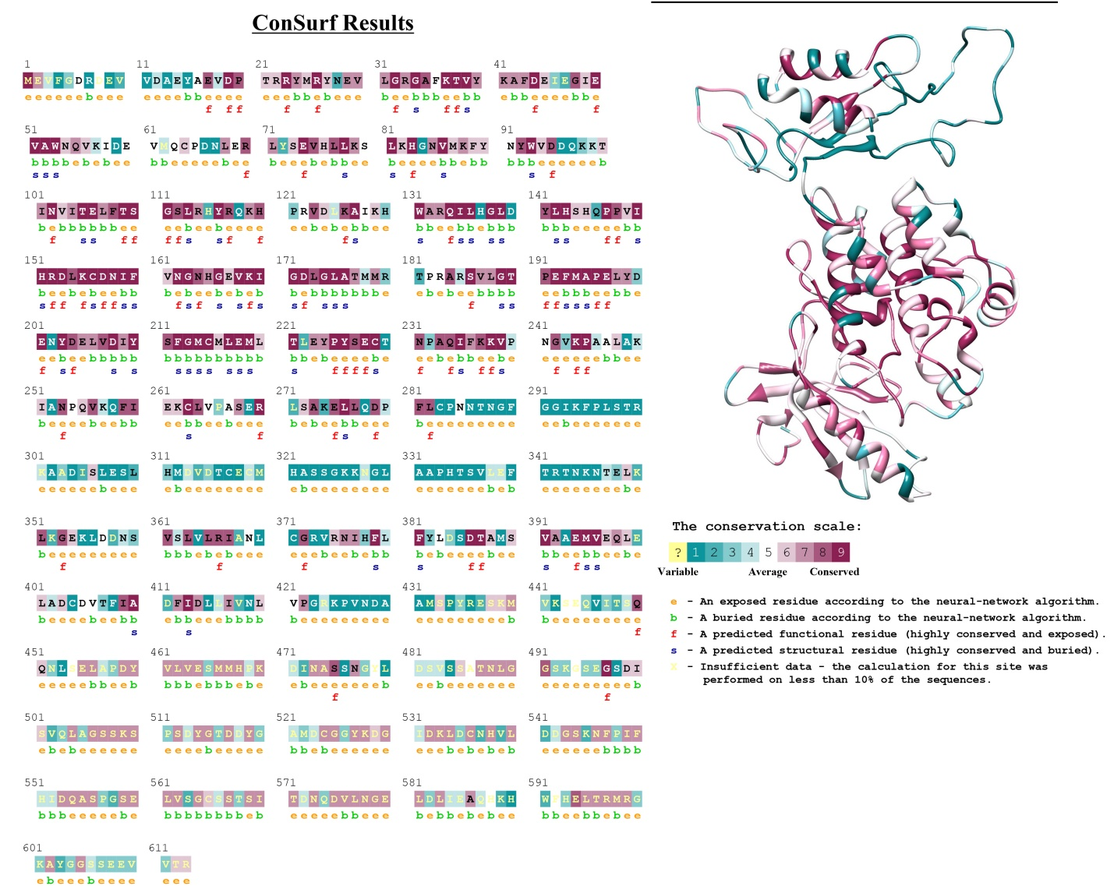

PeWNK8 protein conserved domains
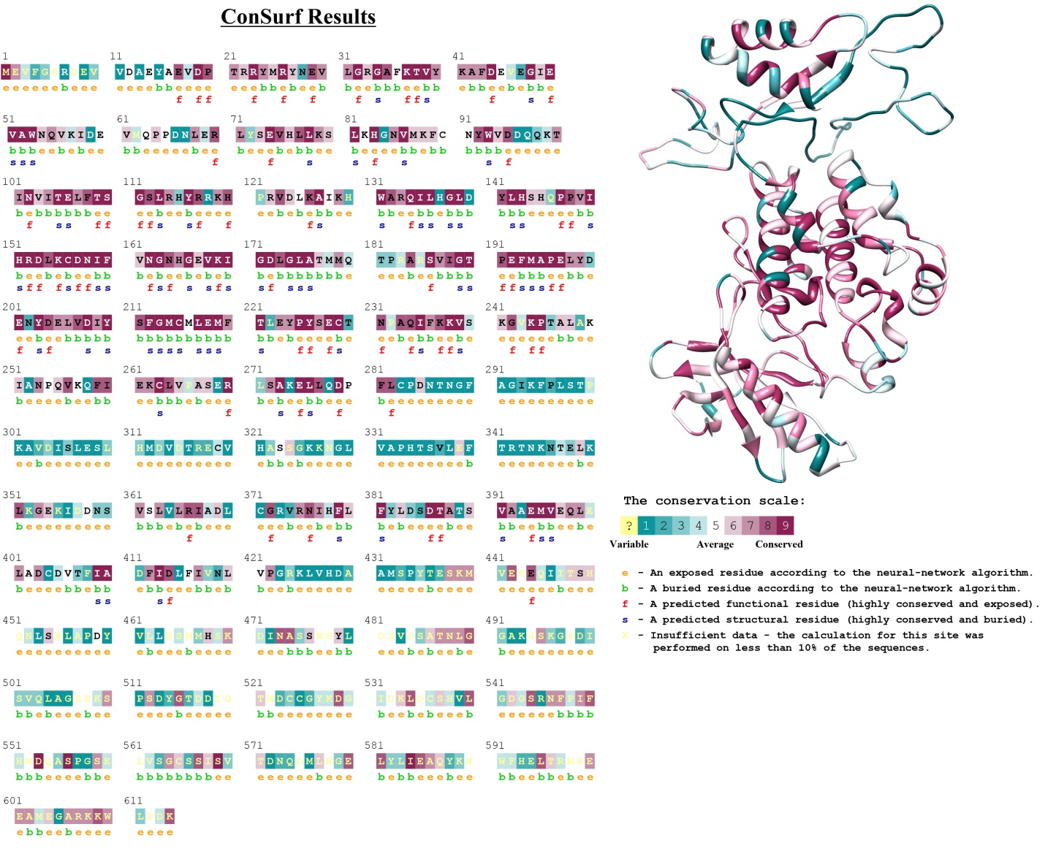

PeWNK9 protein conserved domains
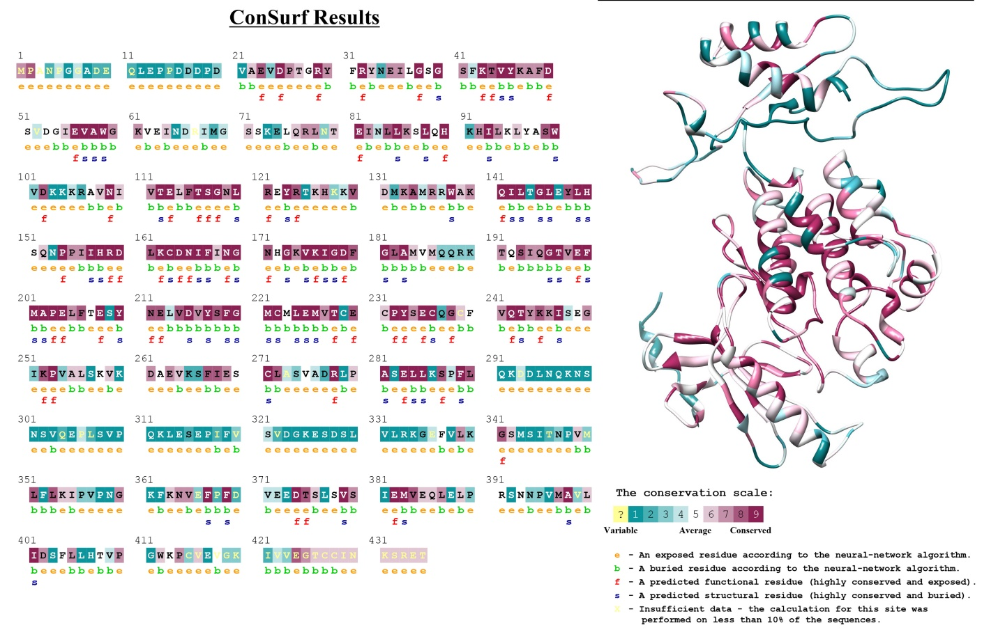

PeWNK10 protein conserved domains
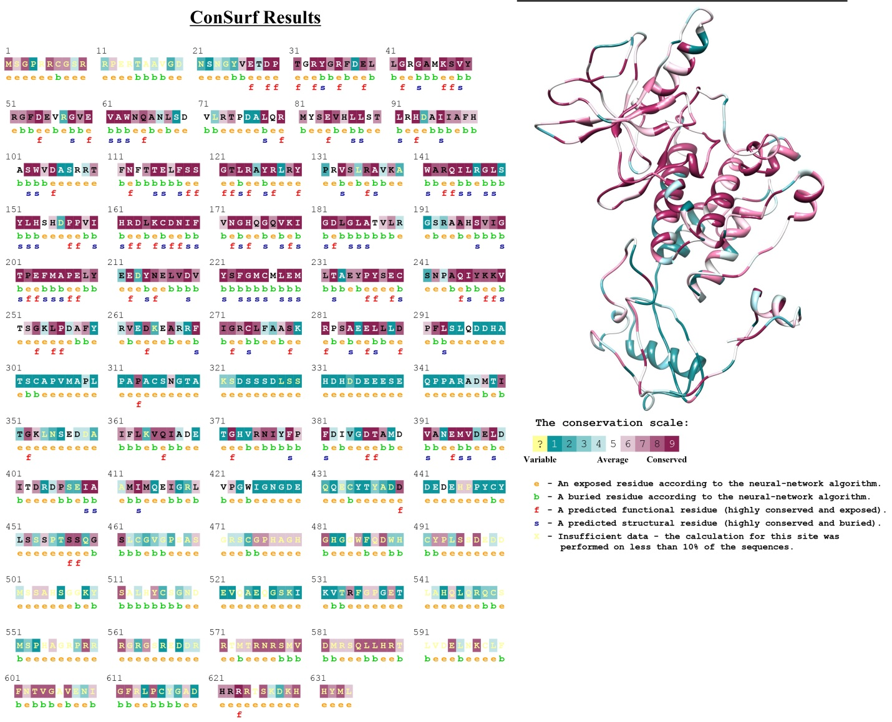

PeWNK11 protein conserved domains

