Supplementary Material for

The shadow model: how and why small choices in spatially explicit species distribution models affect predictions

Christian J. C. Commander*, Lewis A. K. Barnett, Eric J. Ward, Sean C. Anderson, Timothy E. Essington

*Corresponding author: ccommander@fsu.edu

Tables

Table S1. Annual relative sablefish biomass estimates and coefficients of variation (CV) for fine and coarse (4x) prediction surface resolutions.

 | Fine Resolution |  | Coarse Resolution
Year | Relative Biomass | CV | Relative Biomass | CV
2003 | 1.000 | 0.003 | 1.000 | 0.004
2004 | 0.917 | 0.004 | 0.917 | 0.005
2005 | 0.765 | 0.004 | 0.765 | 0.004
2006 | 0.687 | 0.004 | 0.687 | 0.004
2007 | 0.593 | 0.003 | 0.593 | 0.004
2008 | 0.431 | 0.004 | 0.431 | 0.005
2009 | 0.479 | 0.004 | 0.479 | 0.005
2010 | 0.462 | 0.004 | 0.462 | 0.004
2011 | 0.550 | 0.004 | 0.550 | 0.004
2012 | 0.456 | 0.004 | 0.456 | 0.005
2013 | 0.505 | 0.004 | 0.505 | 0.005
2014 | 0.660 | 0.004 | 0.660 | 0.004
2015 | 0.566 | 0.004 | 0.566 | 0.004
2016 | 0.558 | 0.004 | 0.558 | 0.004
2017 | 0.784 | 0.003 | 0.784 | 0.004
2018 | 0.919 | 0.003 | 0.919 | 0.004
Mean |  | 0.0036 |  | 0.0044

Table S2. Sablefish center of gravity (COG) with lower and upper 95% confidence intervals for fine and coarse (4x) prediction surface resolutions.

 | Prediction Grid Resolution
 | Fine | Coarse
Northings (km) | 4532.626 | 4515.091
Northings Lower | 4512.964 | 4489.654
Northings Upper | 4552.289 | 4540.527
Northings Diameter | 39.325 | 50.874
Eastings (km) | 461.699 | 465.792
Eastings Lower | 455.565 | 457.549
Eastings Upper | 467.834 | 474.035
Eastings Diameter | 12.269 | 16.487

Figures

Figure S1. Meshes with 50, 300, and 600 knots. The dots are data observations.
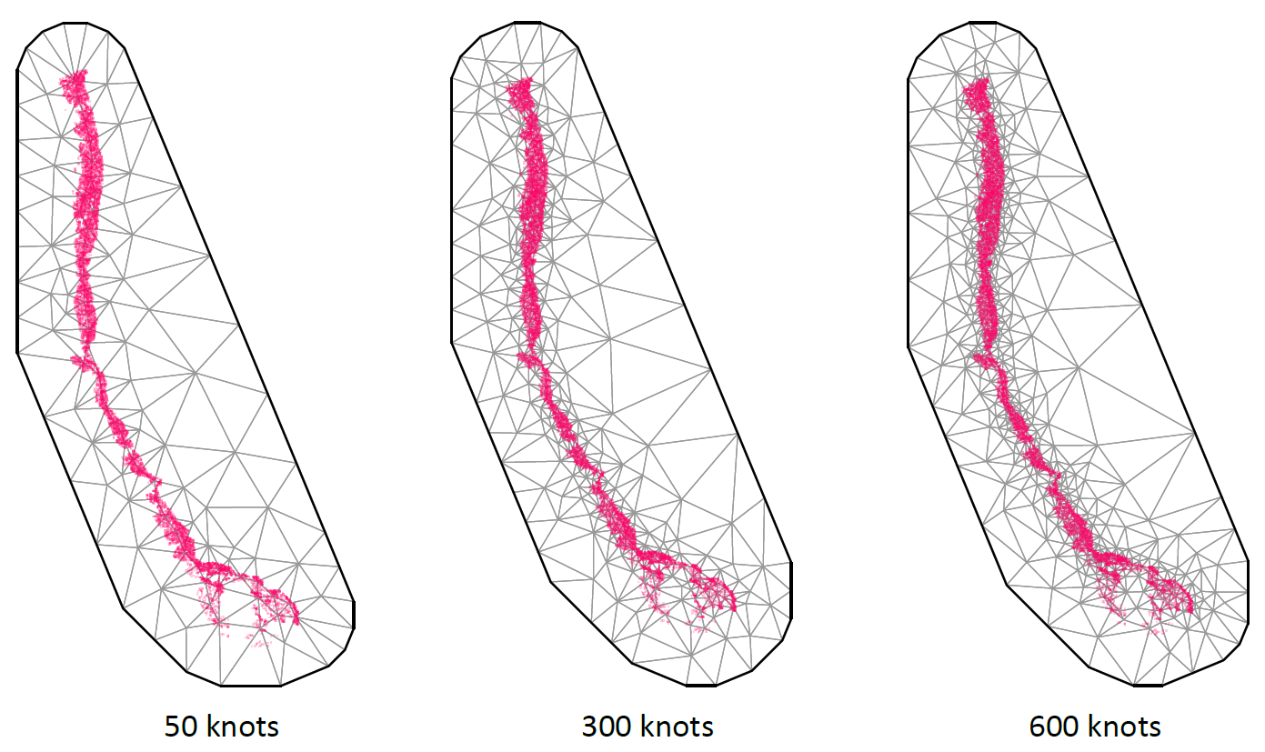

Figure S2. Q-Q plots using simulation-based residuals (DHARMa) comparing a spatial only model, a spatial model with depth covariate, and a spatiotemporal (IID) model with depth covariate.

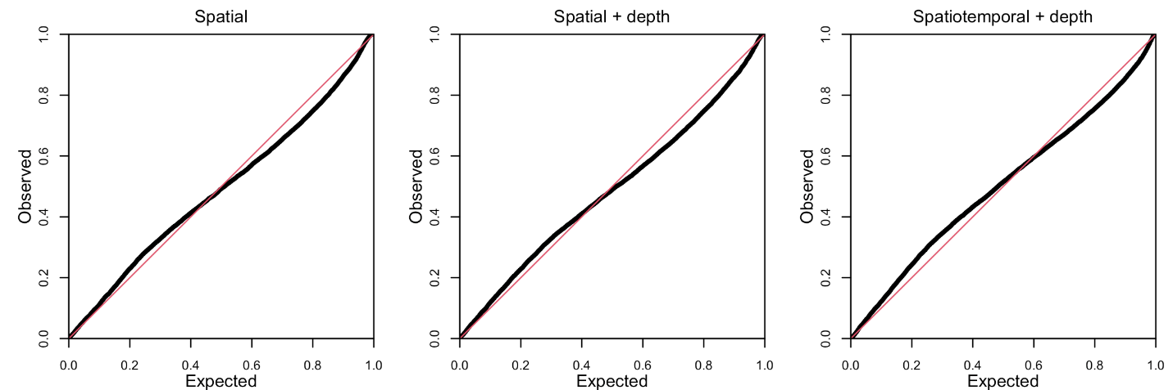

Figure S3. Relative sablefish biomass estimates (standardized to each time series maximum estimate) for each year (with 95% confidence intervals) for fine and coarse (4x) prediction surface resolutions.
