1. PCR of blood clinical samples

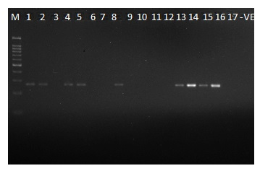

M: GenDirex 100 bp DNA ladder

Lane 1 – 17: Clinical samples of blood

-VE: Non-template control

PCR amplified product : 276 bp size

200

300

100

1. PCR of urine clinical samples

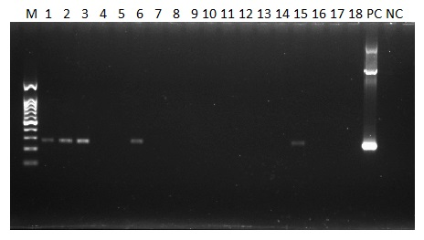

M: GenDirex 100 bp DNA ladder

Lane 1 – 18: Clinical samples of blood

PC: Positive control (*secY* plasmid)

NC: Non-template control

PCR amplified product: 276 bp size

300



100

1. PCR of rat kidney samples

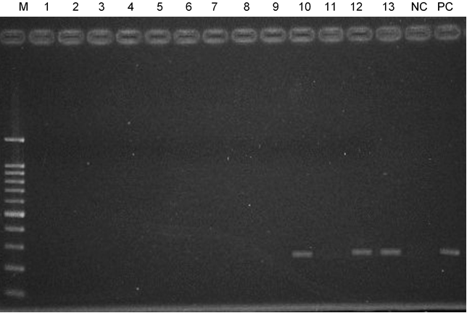

300

100

M: GenDirex 100 bp DNA ladder

Lane 1 – 13: Rat kidney samples

PC: Positive control (DNA from *Leptospira interrogans*)

NC: Non-template control

PCR amplified product: 276 bp size