Supplementary materials

Table S1 Primers used in this study

Primer name | Sequence (5′ to 3′) | Description
MdBBX1-forward | GGGGTACCATGGCGTTGAAGCTTT | cDNA sequence primer
MdBBX1-reverse | GGAATTCAAACGACGGAACGATGC | cDNA sequence primer
MdBBX1-GFP-forward | GCTCTAGAATGGCGTTGAAGCTTTG | cDNA sequence primer
MdBBX1-GFP-reverse | GGGGTACCAAACGACGGAACG | cDNA sequence primer
qMdBBX1-forward | GAGACAGAGTGTTTCATC | qRT-PCR primer
qMdBBX1-reverse | TTGACTTGTTGTAAGGATT | qRT-PCR primer
qMdActin - forward | TGACCGAATGAGCAAGGAAATTACT | qRT-PCR primer
qMdActin - reverse | TACTCAGCTTTGGCAATCCACATC | qRT-PCR primer
qAtGAPDH-forward | TGGTTGATCTCGTTGTGCAGGTC | qRT-PCR primer
qAtGAPDH-reverse | GTCAGCCAAGTCAACAACTCT | qRT-PCR primer
qABI5- forward | ATCCTCTATCTACTCATTG | qRT-PCR primer
qABI5- reverse | CAGAGGAGAATAATAACAAT | qRT-PCR primer
qHY5- forward | ACAGAGTGAAAGACTTGGA | qRT-PCR primer
qHY5- reverse | TGTCTAAGCATCTGGTTCT | qRT-PCR primer
qactin2/8- forward | GGTAAACATTGTGCTCAGTGGTGG | qRT-PCR primer
qactin2/8- forward | AACGACCTTAATCTTCATGCTGC | qRT-PCR primer

Figure. S1 Identification of the transgenic plants of MdBBX1. A. Phenotype of OE₁, OE₂ and OE₃ plants; B. PCR products of transgenic plants; C. qRT-PCR analysis of the expression of MdBBX1 in the leaves of WT and transgenic plants.

Figure. S2 Roots length of WT and OE seedlings in medium containing ABA. The wild type and OE seedlings were grown on MS for 2 days and then were transferred to 1/2 MS medium containing 0.6 µM ABA
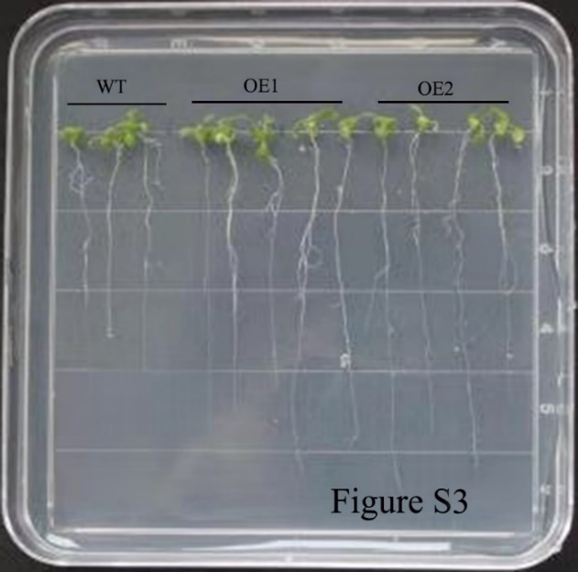

Fig. S3 The homology among MdBBX1, AtBBX1, AtBBX5 and AtBBX21. Only 17%, 36%, 16% homology among MtBBX1, BBX1, BBX5, and BBX21 respectively.

