Fig. S1. Principal coordinate analysis (PCoA) of soil archaeal community in surface (A), middle (B) and deep (C) soil layer among seasons; principal coordinate analysis (PCoA) of soil bacterial community in surface (D), middle (E) and deep (F) soil layer among seasons.
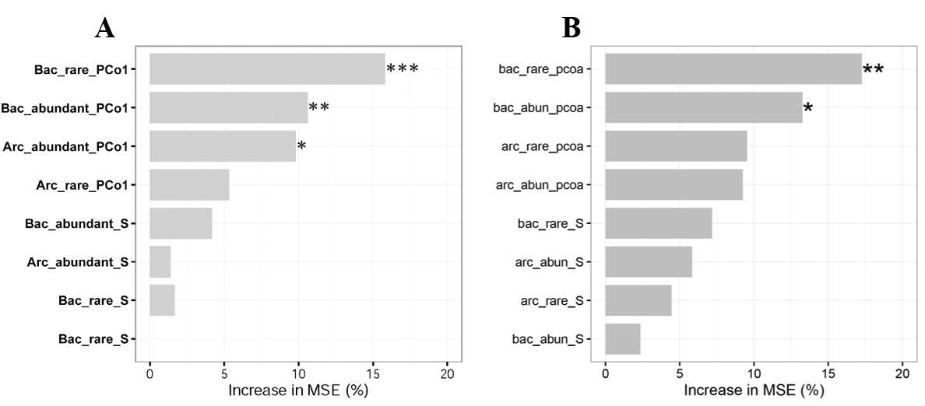
Fig. S2. Random forest mean predictor importance of PCo1 of rare bacterial community (Bac_rare_PCo1), PCo1 of abundant bacterial community (Bac_abundant_PCo1), PCo1 of rare archaeal community (Arc_rare_PCo1), PCo1 of abundant archaeal community (Arc_abundant_PCo1), rare bacterial richness (Bac_rare_S), abundant bacterial richness (Bac_abundant_S), rare archaeal richness (Arc_rare_S), abundant archaeal richness (Arc_abundant_S) on soil fertility index (A) and functional diversity (B). Significance level: P < 0.05, *; P < 0.01, **; P < 0.01, ***.
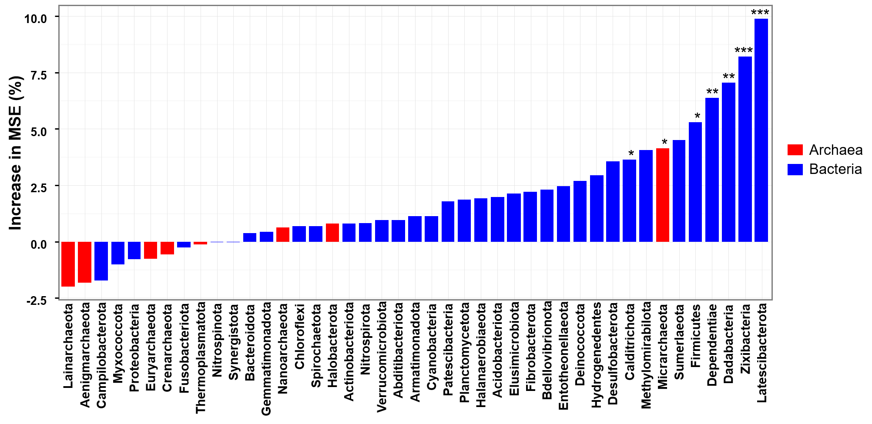
Fig. S3. Random forest mean predictor importance of prokaryotic phyla on soil fertility index. Significance level: P < 0.05, *; P < 0.01, **; P < 0.01, ***. Abbreviations: TC, total carbon; TN, total nitrogen; DOC, dissolved organic carbon; DON, dissolved organic nitrogen; NO3, nitrate; NH4, ammonium; SM, soil moisture.

