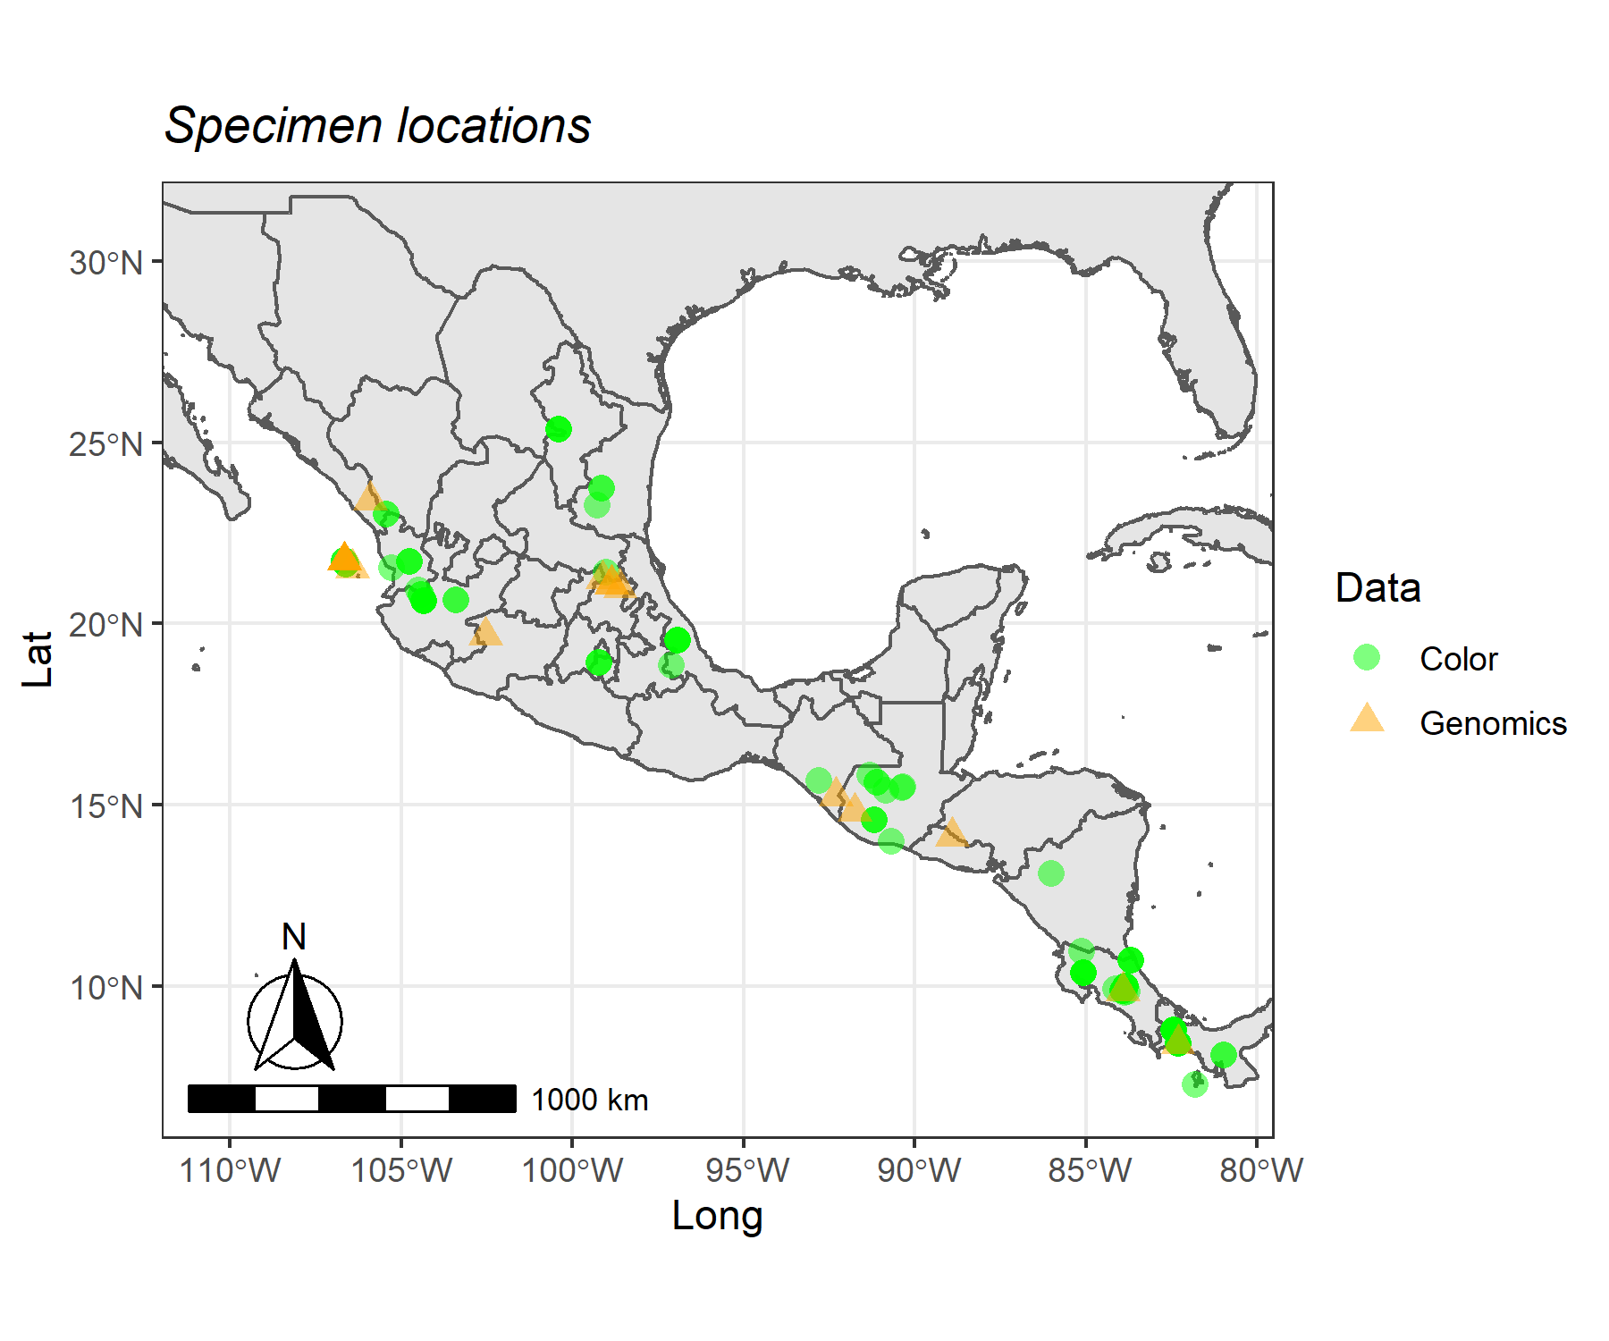

**Figure S1**. Geographic location of studied samples. Samples in green are specimens from which we could only obtain color data, samples in yellow are specimens from which we have genomic data.

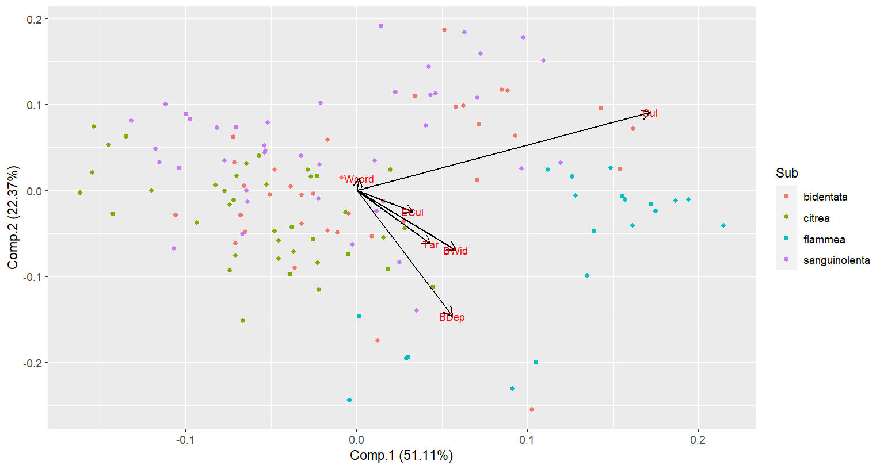

**Figure S2**. PCA of morphological variables. The first two principal components explain 73.48% of variation.