Supplementary File 2

A. R code for site-based abundance model (Beta-Binomial/Poisson mixture model) using count data (Martin et al., 2011).

# packages
library(jagsUI)
library(mcmcOutput)
library(wiqid)

# Create model file
modeltext <- "
model{
for(i in 1:nSites){
N[i] ~ dpois(lambda)

#Beta-Binomial/Poisson mixture model: Martin et al 2011
for(j in 1:nOcc) {
C[i,j] ~ dbin(p[i], N[i])
}
p[i] ~ dbeta(A, B)T(0.01, 0.99) # Truncation (lower, upper)
}

# Priors with different a and b values [0.01,0.01; 5,3; 20,15]
lambda ~ dgamma(20, 15)

#detection of count data
mu1 ~ dunif(0, 1)
theta1 ~ dgamma(10, 2)
A <- mu1 * theta1
B <- (1 - mu1) * theta1

# derived variables p and rho
totalN <- sum(N[])
pAB <- A/(A+B) # derived detection probability
rhoAB <- 1/(A+B+1) # correlation coefficient

}"

writeLines(modeltext, con="dhole_null_model.txt")
# -----------------------------------------------------------

# Read input files
DH <- read.csv("dhole_nwg_count.csv", row.names = 1, comment = "#")

#Number of locations
nC = 27
nSites = nC

#Number of occasions
nOcc = 54

#Data
C <- DH[1:nC, 1:nOcc]

# Run JAGS
wanted <- c("pAB","rhoAB", "totalN", "lambda")
JAGSdata <- list(nSites = nSites, nOcc = nOcc, C = C)
str(JAGSdata)
Nhat <- apply(C[,1:nOcc], 1, max, na.rm=TRUE)+1
#Noc <- rep(1, nO)
#Nall <- c(Nhat, Noc)
inits <- function() list(N = Nhat , mu1 = runif(1))

# Fit data to the model
for(i in 1:100){
iserr <- tryCatch(
jagsOut <- jags(JAGSdata, inits, wanted, "dhole_null_model.txt",
n.chains=5, n.iter=10000, n.adapt=2500, n.burnin=2000, n.thin=1, DIC=TRUE, parallel=TRUE), error=function(e) e)

if(inherits(iserr, "error")){ next }
else {dump("jagsOut","Realdhole_null_model.RData")
break}
}

# Inspect output
plot(jagsOut)

#Tabulate results
mOut <- mcmcOutput(jagsOut)
summary(mOut)
res_tab<-summary(mOut)

B. Model outputs from three scenarios (priors for N set as uninformed, partially informed, or constrained)

B1. Uniformed priors (gamma (0.01, 0.01))

 | Mean | SD | Median | 95% LCI | 95% UCI | R-hat
p | 0.07 | 0.01 | 0.07 | 0.04 | 0.09 | 1.00
rho | 0.10 | 0.02 | 0.10 | 0.06 | 0.14 | 1.00
N | 189.20 | 28.26 | 187.00 | 136.00 | 244.00 | 1.00
lambda | 7.00 | 1.16 | 6.92 | 4.85 | 9.35 | 1.00
deviance | 568.69 | 10.38 | 568.26 | 549.07 | 589.16 | 1.00

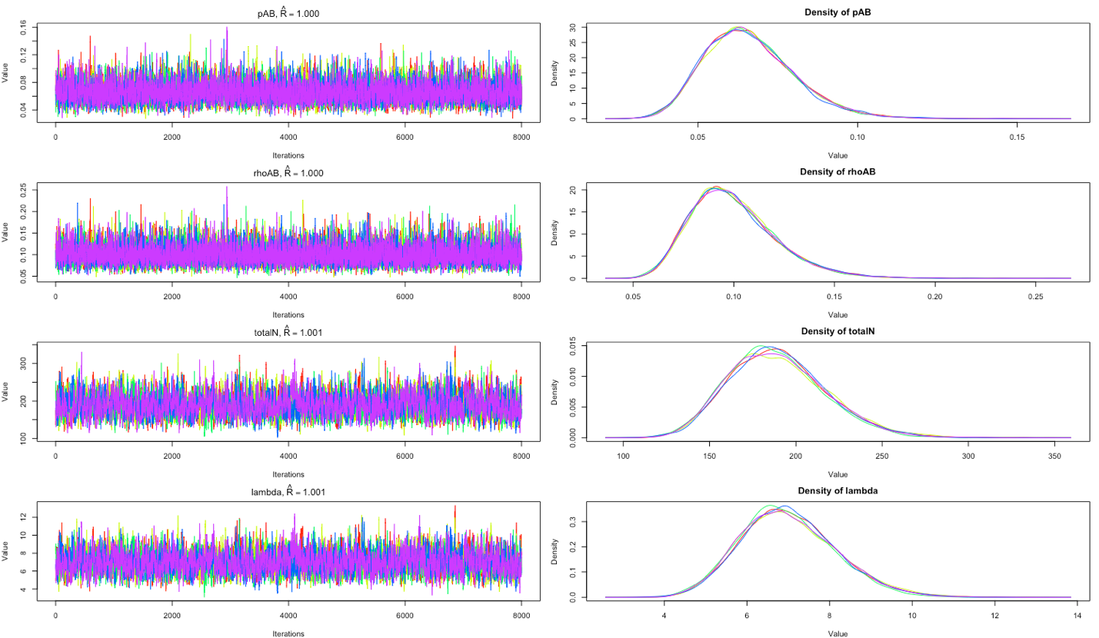

B2. Partially informed priors (gamma (5, 3))

 | Mean | SD | Median | 95% LCI | 95% UCI | R-hat
p | 0.07 | 0.02 | 0.07 | 0.04 | 0.10 | 1.00
rho | 0.10 | 0.02 | 0.10 | 0.06 | 0.15 | 1.00
N | 148.31 | 19.31 | 147.00 | 111.00 | 185.00 | 1.00
lambda | 5.11 | 0.77 | 5.07 | 3.63 | 6.61 | 1.00
deviance | 566.42 | 10.10 | 565.92 | 547.44 | 586.99 | 1.00

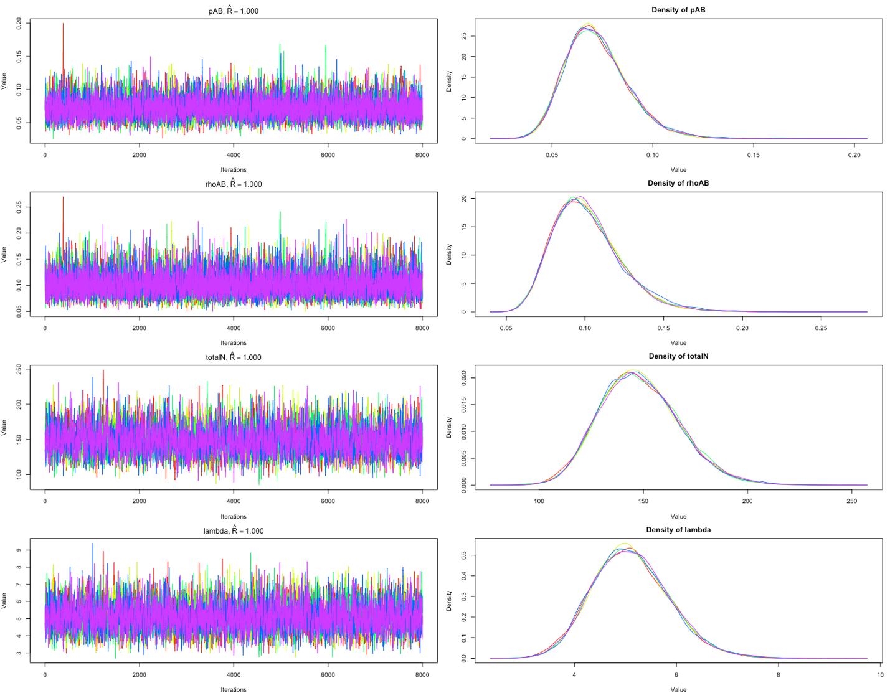

B3. Constrained priors (gamma (20, 15))

 | Mean | SD | Median | 95% LCI | 95% UCI | R-hat
p | 0.09 | 0.02 | 0.08 | 0.05 | 0.13 | 1.00
rho | 0.11 | 0.02 | 0.10 | 0.07 | 0.15 | 1.00
N | 104.68 | 10.17 | 104.00 | 85.00 | 124.00 | 1.00
lambda | 2.97 | 0.36 | 2.96 | 2.28 | 3.67 | 1.00
deviance | 564.80 | 9.75 | 564.49 | 546.22 | 584.25 | 1.00

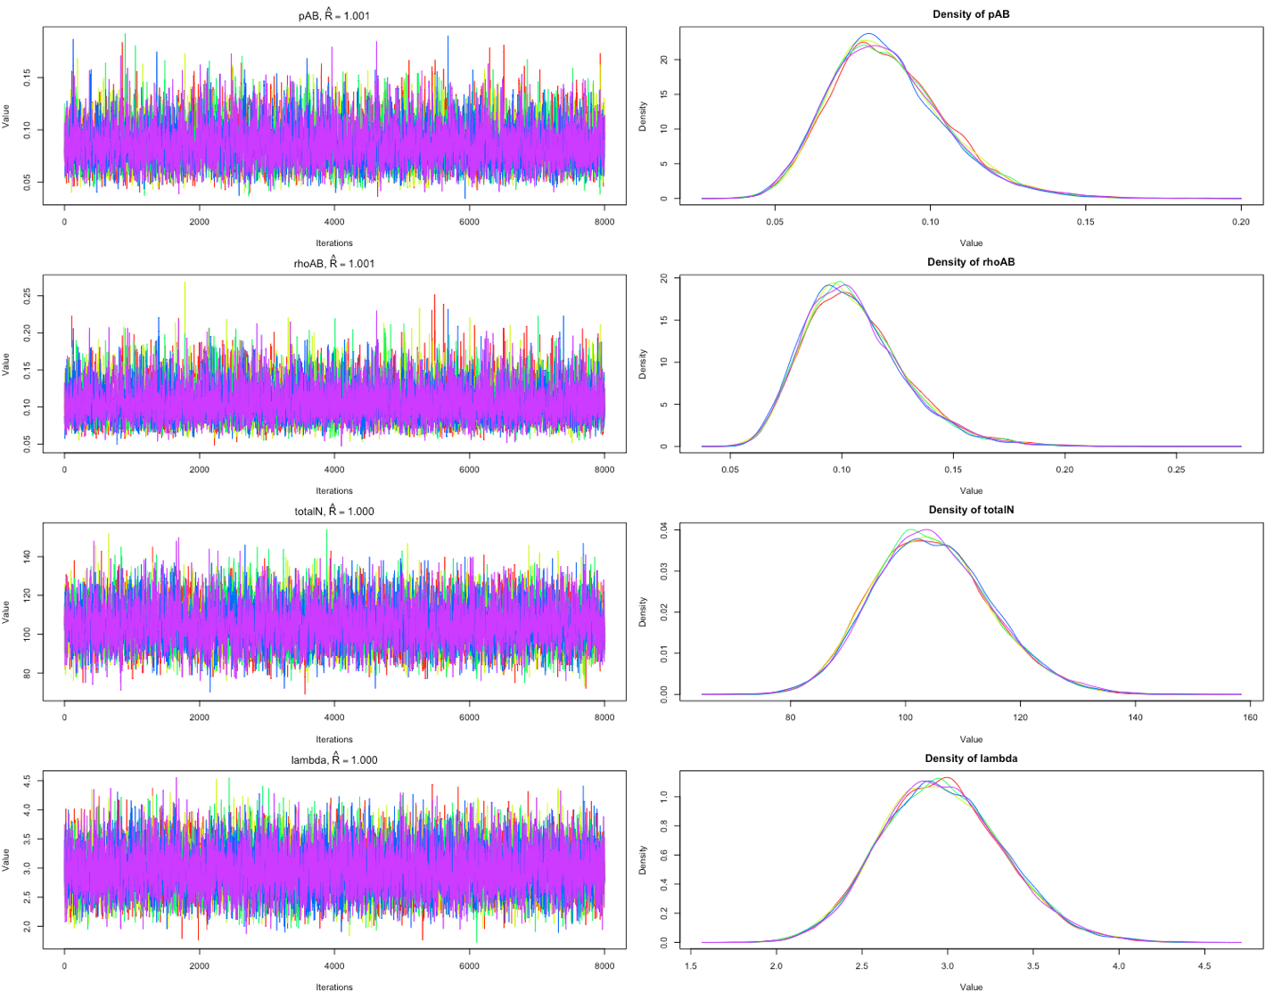

C. R code for Space-to-Event model Following Moeller et al. (2018)

devtools::install_github("annam21/spaceNtime", force = T, build_vignettes = T)

browseVignettes("spaceNtime")

library(spaceNtime)

df <- read.csv("IndiaLeoData.csv")
df <- read.csv("IndiaDholeData.csv")

df$datetime <- as.POSIXct((df$datetime), format="%Y-%m-%d %H:%M:%OS", origin="01-01-1900", tz="UTC")

df$count <- as.numeric(df$count)
df$cam <- as.numeric(df$cam)

deploy1 <- read.csv("DeploymentTime_LargestArea.csv")
deploy2 <- read.csv("DeploymentTime_LargestArea+10%.csv")
deploy3 <- read.csv("DeploymentTime_LargestArea+20%.csv")

deploy$start <- as.POSIXct((deploy$start), format="%Y-%m-%d %H:%M:%OS", origin="01-01-1900", tz="UTC")
deploy$end <- as.POSIXct((deploy$end), format="%Y-%m-%d %H:%M:%OS", origin="01-01-1900", tz="UTC")
deploy$area <- as.numeric(deploy$area)
deploy$cam <- as.numeric(deploy$cam)

study_dates <- as.POSIXct(c("2019-04-05 09:30:00", "2019-05-29 10:01:00"), tz = "GMT")
occ <- build_occ(samp_freq = 1,
samp_length = 1,
study_start = study_dates[1],
study_end = study_dates[2])

# Build encounter history
ste_eh <- ste_build_eh(df, deploy1, occ)

# Estimate abundance
#Study area 361 km2
ste_estN_fn(ste_eh, study_area = 361000000)

D. R code for Time-to-Event model Following Moeller et al. (2018)

devtools::install_github("annam21/spaceNtime", force = T, build_vignettes = T)

browseVignettes("spaceNtime")

library(spaceNtime)

df <- read.csv("IndiaLeoData.csv")
df <- read.csv("IndiaDholeData.csv")

df$datetime <- as.POSIXct((df$datetime), format="%Y-%m-%d %H:%M:%OS", origin="01-01-1900", tz="UTC")
df$count <- as.numeric(df$count)
df$cam <- as.numeric(df$cam)

deploy1 <- read.csv("DeploymentTime_LargestArea.csv")
deploy2 <- read.csv("DeploymentTime_LargestArea+10%.csv")
deploy3 <- read.csv("DeploymentTime_LargestArea+20%.csv")

deploy$start <- as.POSIXct((deploy$start), format="%Y-%m-%d %H:%M:%OS", origin="01-01-1900", tz="UTC")
deploy$end <- as.POSIXct((deploy$end), format="%Y-%m-%d %H:%M:%OS", origin="01-01-1900", tz="UTC")

deploy$area <- as.numeric(deploy$area)
deploy$cam <- as.numeric(deploy$cam)

#Dhole and leopard travel speeds from Habib et al., 2021; Karanth & Sunquist, 2000; Sukmasuang et al., 2020 and Van Cleave et al., 2018.

Leopard travel speeds
Reference | Daily movement Range | Hourly movement range (lps value in model*) | Time to cover 6m camera width
Habib et al., 2021 | 1862 m/day | 77.58 m/hr | 278 sec
Karanth & Sunquist, 2000 | 4800 m/day | 200 m/hr | 108 sec
Van Cleave et al., 2018 | 6345 m/day | 264.37 m/hr | 81.70 sec

Dhole travel speeds
Reference | Daily movement Range | Hourly movement range (lps value in model*) | Time to cover 6m camera width
Habib et al., 2021 | 6384 m/day | 266 m/hr | 81.20 sec
Sukmasuang et al., 2020 | 10200 m/day | 424 m/hr | 50.94 sec
Sukmasuang et al., 2020 | 19000 m/day | 791.7 m/hr | 27.28 sec
*use this value in place of x where it says “per <- tte_samp_per(deploy, lps = x/3600)” in the TTE code
per <- tte_samp_per(deploy1, lps = x/3600)

# Build sampling occasions
study_dates <- as.POSIXct(c("2019-04-05 09:30:00", "2019-05-29 10:01:00"), tz = "GMT")
occ <- tte_build_occ(
per_length = per,
nper = 24,
time_btw = 2 * 3600,
study_start = study_dates[1],
study_end = study_dates[2]
)

# Build encounter history
tte_eh <- tte_build_eh(df, deploy, occ, per)

# Estimate abundance
# Study area: 361 km2
tte_estN_fn(tte_eh, study_area = 361000000)

References
Habib, B., Ghaskadbi, P., Khan, S., Hussain, Z., & Nigam, P. (2021). Not a cakewalk: Insights into movement of large carnivores in human‐dominated landscapes in India. Ecology and Evolution, 11(4), 1653–1666. https://doi.org/10.1002/ece3.7156
Karanth, K. U., & Sunquist, M. E. (2000). Behavioural correlates of predation by tiger (Panthera tigris), leopard (Panthera pardus) and dhole (Cuon alpinus) in Nagarahole, India. Journal of Zoology, 250(2), 255–265. https://doi.org/10.1111/j.1469-7998.2000.tb01076.x
Sukmasuang, R., Suksavate, W., Songsasen, N., Khiowsree, N., Charaspet, K., Pla-ard, M., Chanachai, Y., Thomas, W., & Srinopawan, K. (2020). Home range, movement and habitat selection of dholes (Cuon alpinus) in Khao Yai National Park, Thailand. Biodiversitas Journal of Biological Diversity, 21(12), 5915–5926. https://doi.org/10.13057/biodiv/d211257
Van Cleave, E. K., Bidner, L. R., Ford, A. T., Caillaud, D., Wilmers, C. C., & Isbell, L. A. (2018). Diel patterns of movement activity and habitat use by leopards (Panthera pardus pardus) living in a human-dominated landscape in central Kenya. Biological Conservation, 226(July), 224–237. https://doi.org/10.1016/j.biocon.2018.08.003

