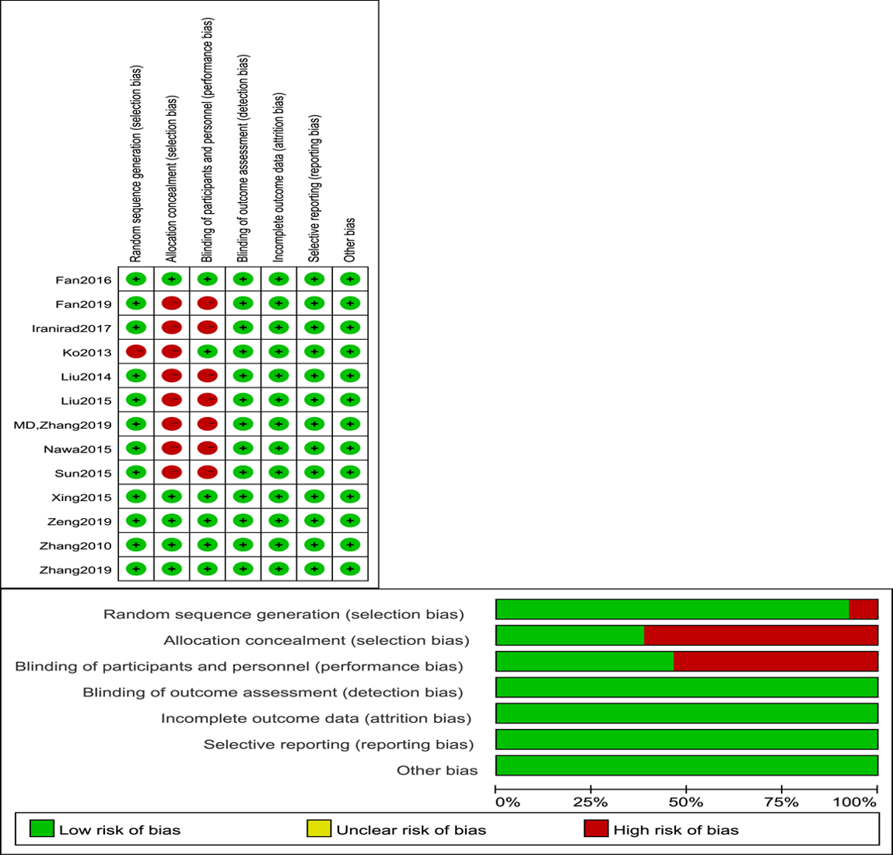

Fig. S1 Risk of bias assessment. The risk bias of included studies was assessed by Cochrane risk-of-bias tool.

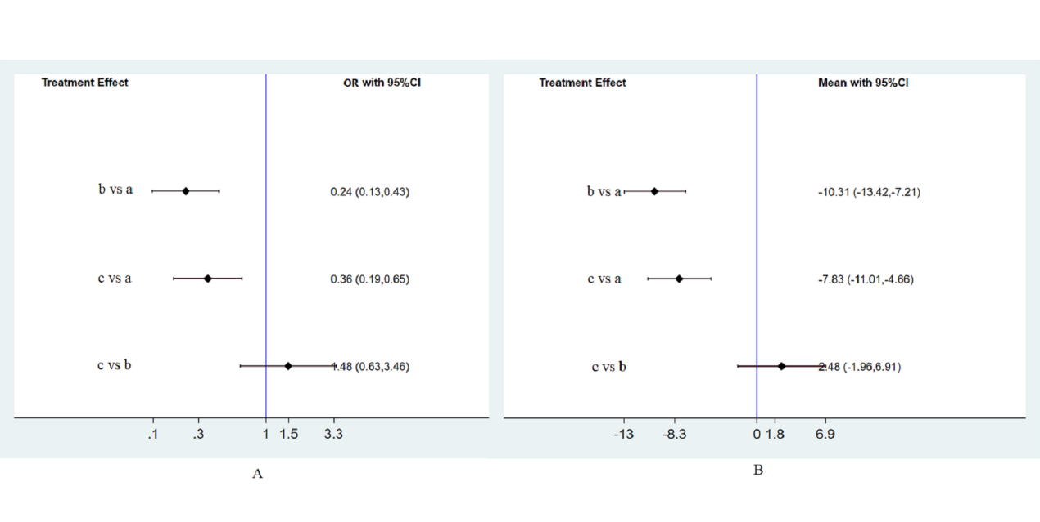

Fig. S2 Forest plots of two kinds treatment courses of double-dose nicorandil. (A) Forest plots of two kinds of treatment courses of double-dose nicorandil for decreasing the occurrence of CIN. (B) Forest plots of network meta-analysis of two kinds of treatment courses of double-dose nicorandil for the efficacy of reducing the change of SCr levels. a=intravenous saline; b=double-dose nicorandil for less than or equal to 24 h; c=double-dose nicorandil for 4-5 days.

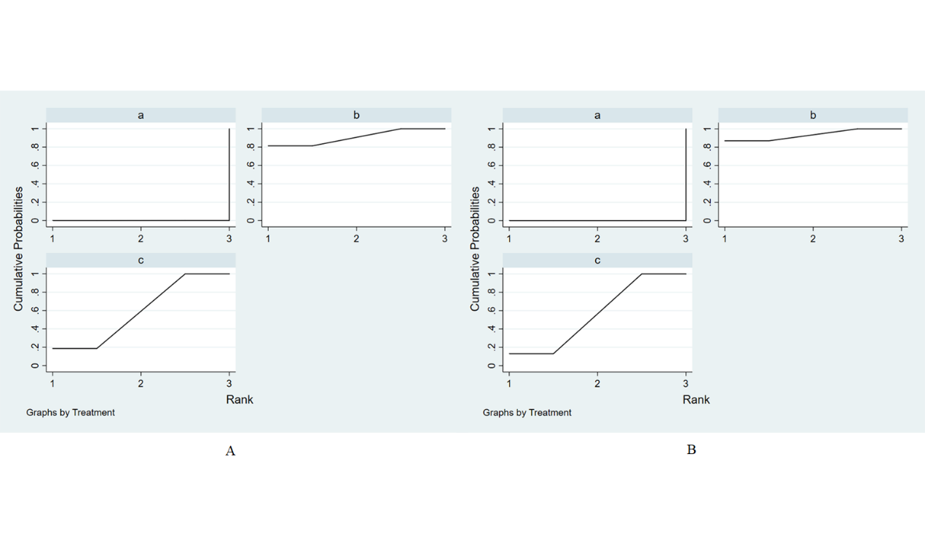

Fig. S3 Thesurface under the cumulative ranking curve (SUCRA) for two kinds of treatment courses of double-dose nicorandil in the study. (A) The SUCRA of two kinds treatment courses of double-dose nicorandil for decreasing the incidence of CIN. (B) The SUCRA of two kinds treatment courses of double-dose nicorandil for the efficacy of reducing the change of SCr levels. a=intravenous saline; b=double-dose nicorandil for less than or equal to 24 h; c=double-dose nicorandil for 4-5 days.

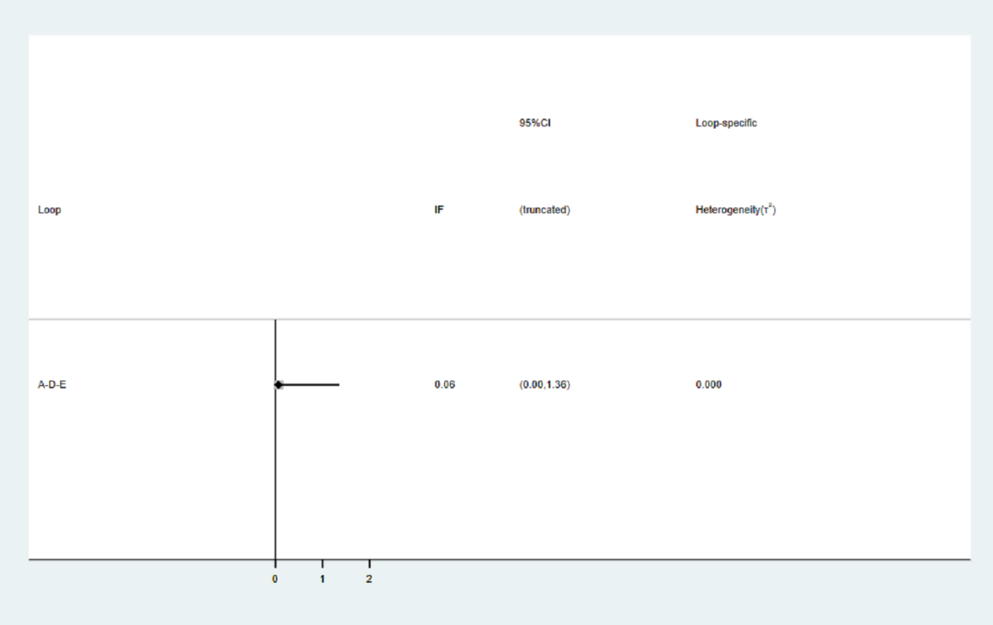

Fig. S4 Loop-specific approach of included study. The loop-specific approach was one method of inconsistency analysis of the included study. A= intravenous saline; D = usual-dose nicorandil; E = double-dose nicorandil.

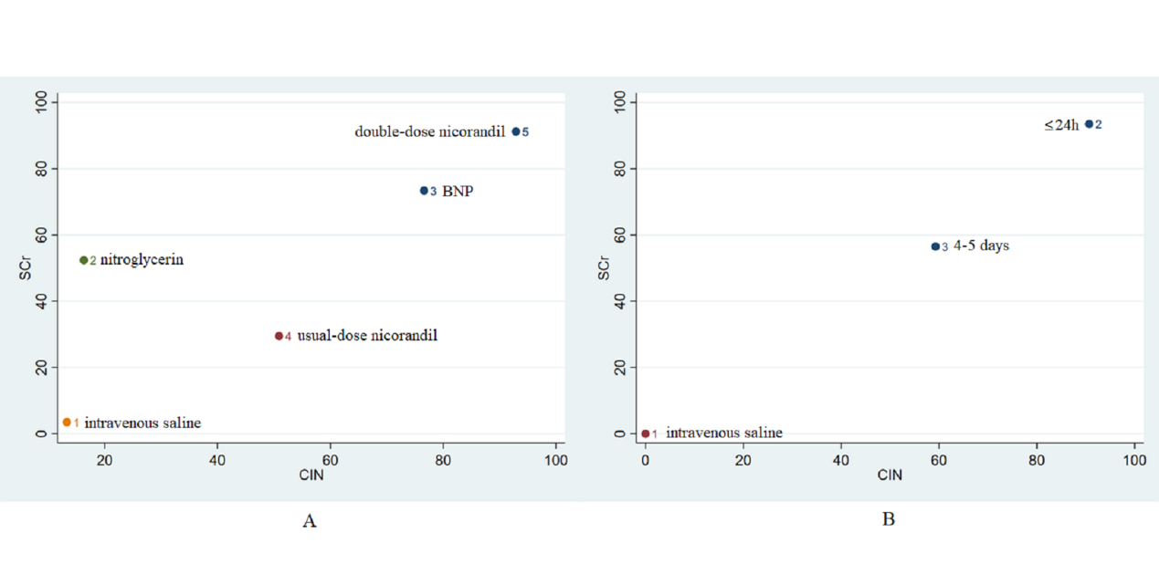

Fig. S5 Clustering analysis of five interventions and two kinds of treatment courses of double-dose nicorandil. (A) Clustering analysis of five interventions for efficacy on the CIN and the change of SCr level. (B) Clustering analysis of two kinds of treatment courses of double-dose nicorandil for efficacy on the CIN and the change of SCr level.