Supplementary Materials

An Issue of Concern: Unique Truncated ORF8 Protein Variants of SARS-CoV-2

Sk. Sarif Hassan¹, Vaishnavi Kodakandla², Elrashdy M. Redwan³, Kenneth Lundstrom⁴, Pabitra Pal Choudhury⁵, Tarek Mohamed Abd El-Aziz⁶, Kazuo Takayama⁷, Ramesh Kandimalla⁸, Amos Lal⁹, A´ngel Serrano-Aroca¹⁰, Gajendra Kumar Azad¹¹, Alaa A. A. Aljabali¹², Giorgio Palu¹³, Gaurav Chauhan¹⁴, Parise Adadi¹⁵, Murtaza Tambuwala¹⁶, Adam M. Brufsky¹⁷, Wagner Baetas-da-Cruz¹⁸, Debmalya Barh¹⁹, Vasco Azevedo²⁰, Nicolas G Bazan²¹, Bruno Silva Andrade²², Raner Jośe Santana Silva²³, and Vladimir N. Uversky^{24,*}

¹ Department of Mathematics, Pingla Thana Mahavidyalaya, Maligram, Paschim Medinipur, 721140, West Bengal, India;
² Department of Life sciences, Sophia College For Women, University of Mumbai, Bhulabhai Desai Road, Mumbai 400026, India;
³ Faculty of Science, Department of Biological Science, King Abdulaziz University, Jeddah 21589, Saudi Arabia;
⁴ PanTherapeutics, Rte de Lavaux 49, CH1095 Lutry, Switzerland;
⁵ Applied Statistics Unit, Indian Statistical Institute, 203 B T Road, Kolkata 700108, India;
⁶ Department of Cellular and Integrative Physiology, University of Texas Health Science Center at San Antonio, 7703 Floyd Curl Dr, San Antonio, TX 78229-3900, USA & Zoology Department, Faculty of Science, Minia University, El-Minia 61519, Egypt;
⁷ Center for iPS Cell Research and Application (CiRA), Kyoto University, Kyoto 6068507, Japan;
⁸ Applied Biology, CSIR-Indian Institute of Chemical Technology, Uppal Road, Tarnaka, Hyderabad, 500007, and Department of Biochemistry, Kakatiya Medical College, Warangal, Telangana, India;
⁹ Division of Pulmonary and Critical Care Medicine, Mayo Clinic, Rochester, Minnesota, USA;
¹⁰ Biomaterials and Bioengineering Lab, Centro de Investigacio´ n Traslacional San Alberto Magno, Universidad Cato´ lica de Valencia San Vicente Ma´rtir, c/Guillem de Castro, 94, 46001 Valencia, Valencia, Spain;
¹¹ Department of Zoology, Patna University, Patna, Bihar, India;
¹² Department of Pharmaceutics and Pharmaceutical Technology, Yarmouk University, Faculty of Pharmacy, Irbid 566, Jordan;
¹³ Department of Molecular Medicine, University of Padova, Via Gabelli 63, 35121, Padova, Italy;
¹⁴ School of Engineering and Sciences, Tecnologico de Monterrey, Av. Eugenio Garza Sada 2501 Sur, 64849 Monterrey, Nuevo Leo´ n, Mexico;
¹⁵ Department of Food Science, University of Otago, Dunedin 9054, New Zealand;
¹⁶ School of Pharmacy and Pharmaceutical Science, Ulster University, Coleraine BT52 1SA, Northern Ireland, UK;
¹⁷ University of Pittsburgh School of Medicine, Department of Medicine, Division of Hematology/Oncology, UPMC Hillman Cancer Center, Pittsburgh, PA, USA;
¹⁸ Translational Laboratory in Molecular Physiology, Centre for Experimental Surgery, College of Medicine, Federal University of Rio de Janeiro (UFRJ), Rio de Janeiro, Brazil;
¹⁹ Centre for Genomics and Applied Gene Technology, Institute of Integrative Omics and 46 Applied Biotechnology (IIOAB), Nonakuri, Purba Medinipur, West Bengal, India, and Departamento de Genetica, Ecologia e Evolucao, Instituto de Cieˆncias Biolo´ gicas, Universidade Federal de Minas Gerais, Belo Horizonte, Brazil;
²⁰ Departamento de Genetica, Ecologia e Evolucao, Instituto de Cieˆncias Biolo´ gicas, Universidade Federal de Minas Gerais, Belo Horizonte, Brazil;
²¹ Neuroscience Center of Excellence, School of Medicine, LSU Health New Orleans, New Orleans, LA 70112, USA
²² Laboratório de Bioinformática e Química Computacional, Departamento de Ciências Biológicas, Universidade Estadual do Sudoeste da Bahia (UESB), Jequié, 45206-190, Brazil
²³ Departamento de Ciencias Biologicas (DCB), Programa de Pos-Graduacao em Genetica e Biologia Molecular (PPGGBM), Universidade Estadual de Santa Cruz (UESC), Rodovia Ilheus-Itabuna, km 16, 45662-900, Ilheus, BA, Brazil
²⁴ Department of Molecular Medicine, Morsani College of Medicine, University of South Florida, Tampa, FL 33612, USA
* Corresponding author: Vladimir N. Uversky; Email address: vuversky@usf.edu

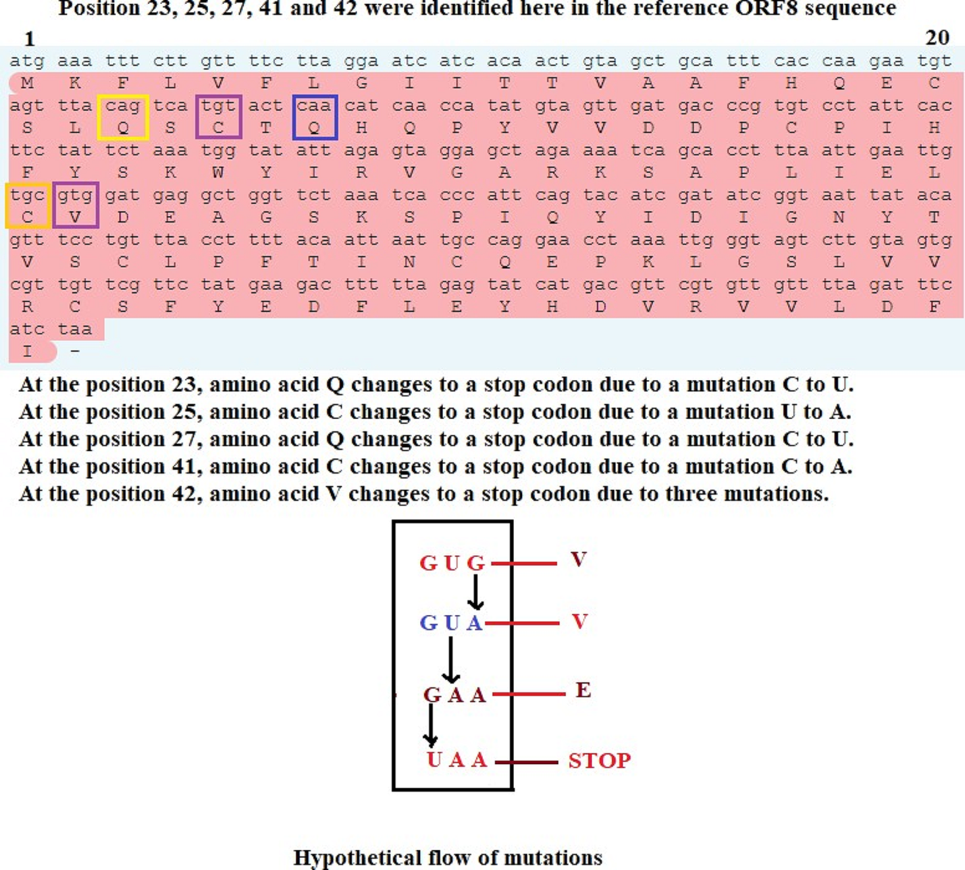

Figure S1. Possible mutations for truncation at 23, 25, 27, 40, and 42 residue positions of ORF8 protein (NC 045512) of SARS-CoV-2.

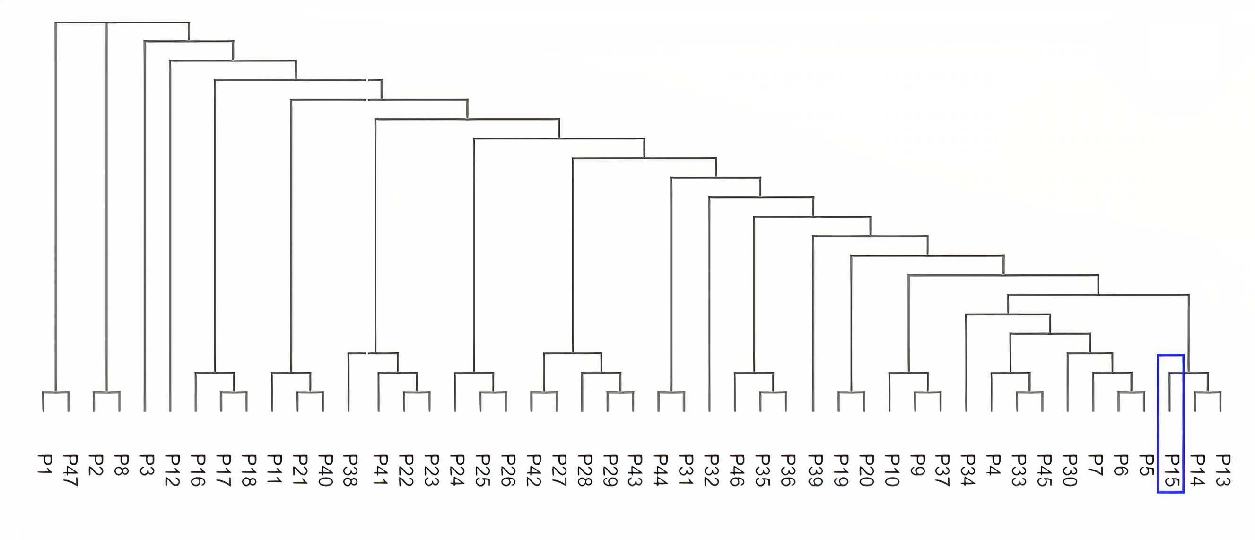
Supplementary Figure S2. Phylogenetic relationship among the unique T-ORF8 proteins.

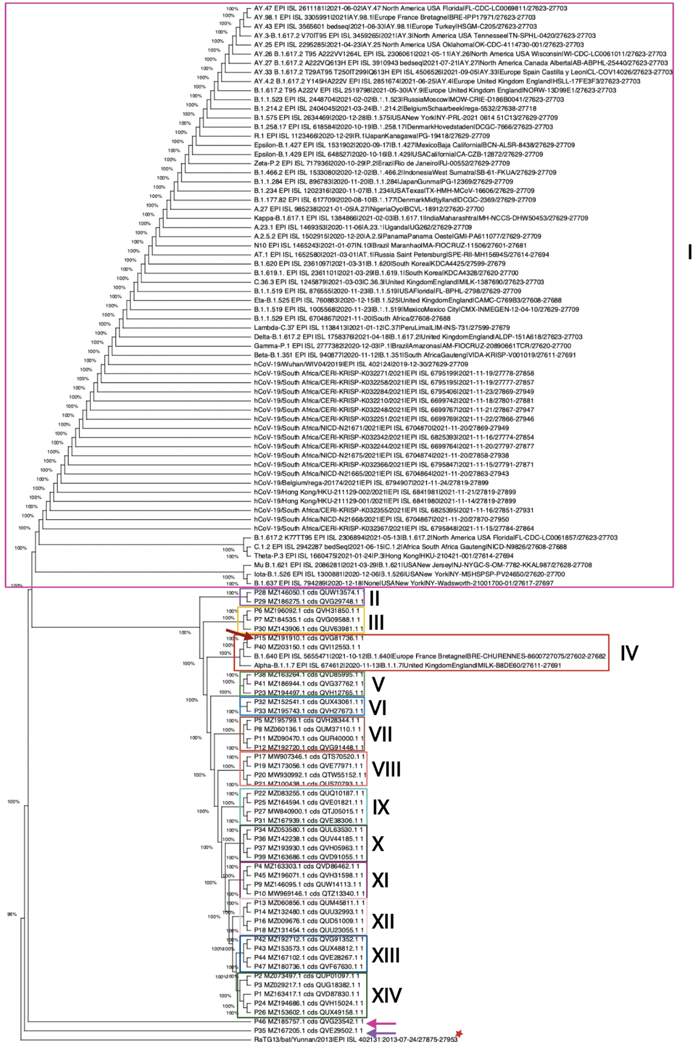

Supplementary Figure S3. Maximum Likelihood phylogenetic tree for the 47 truncated ORF8 and 66 representative ORF8 sequences for different Alpha, Beta, Gamma, Delta, Mu, GH/490R, and Omicron variants, using 500 bootstrap replications and the Hasegawa-Kishino-Yano model. 14 group clades were found and the sequences 15 and 40 are clearly forming a group clade with Alpha and B.1.640 ORF 8 sequences. Sequences 35 and 46 are indicated by marine blue and purple arrows, respectively and sequence 15 is indicated by a red arrow.

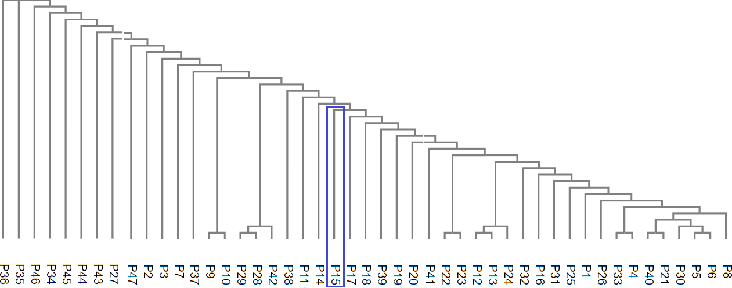

Supplementary Figure S4. Analysis of variability among unique T-ORF8 variants based on polarity: Polarity-based phylogenetic relationships among the unique T-ORF8 proteins.

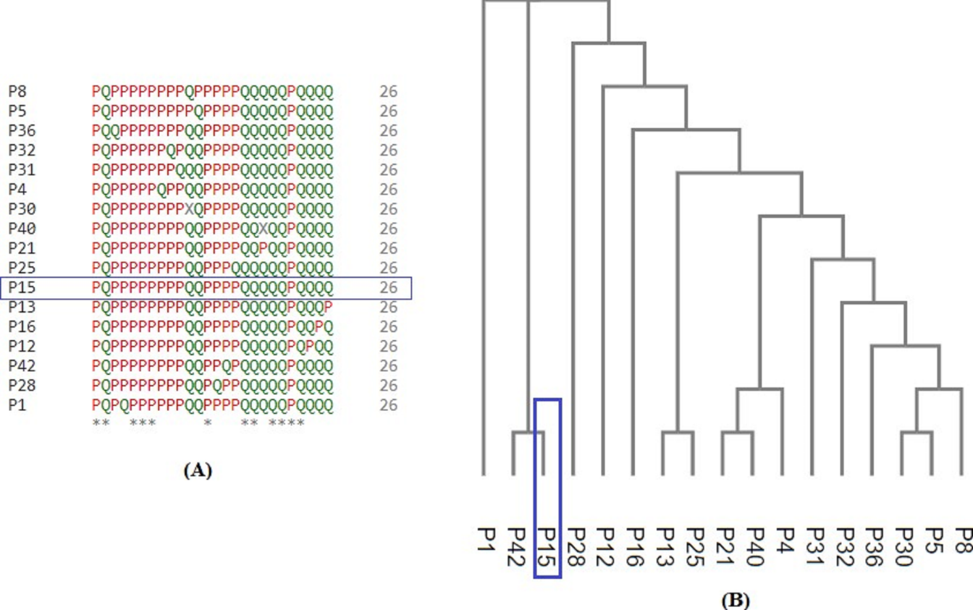
Figure S5. Unique polar/non-polar sequence-based alignment of unique T-ORF8 proteins using the Clustal-Omega and associated phylogenetic relationship. A. multiple sequence alignments of unique T-ORF8, and B. phylogenetic analysis of the same samples.

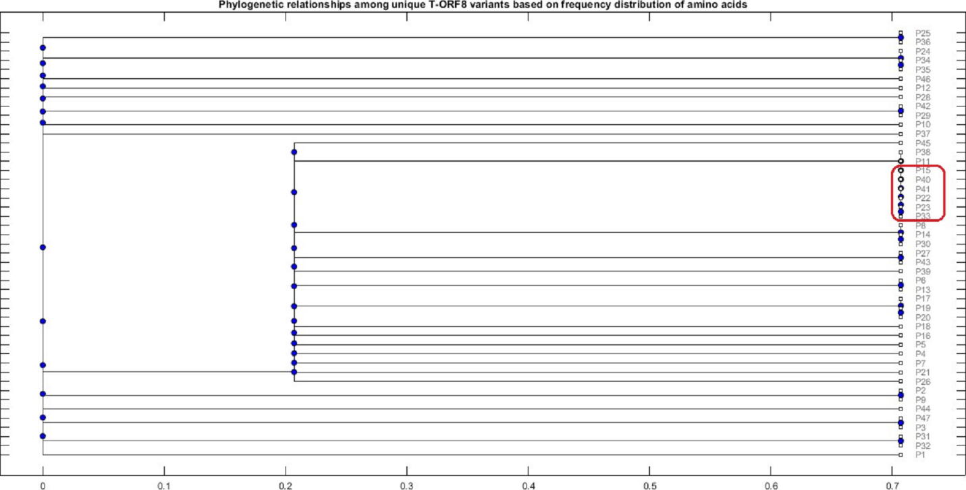

Figure S6. Frequency distribution of amino acids present in the unique T-ORF8 variants and their phylogenetic relationships. The red box highlights the closeness of P15 with P22, P23, P33, P40, and P41 variants.
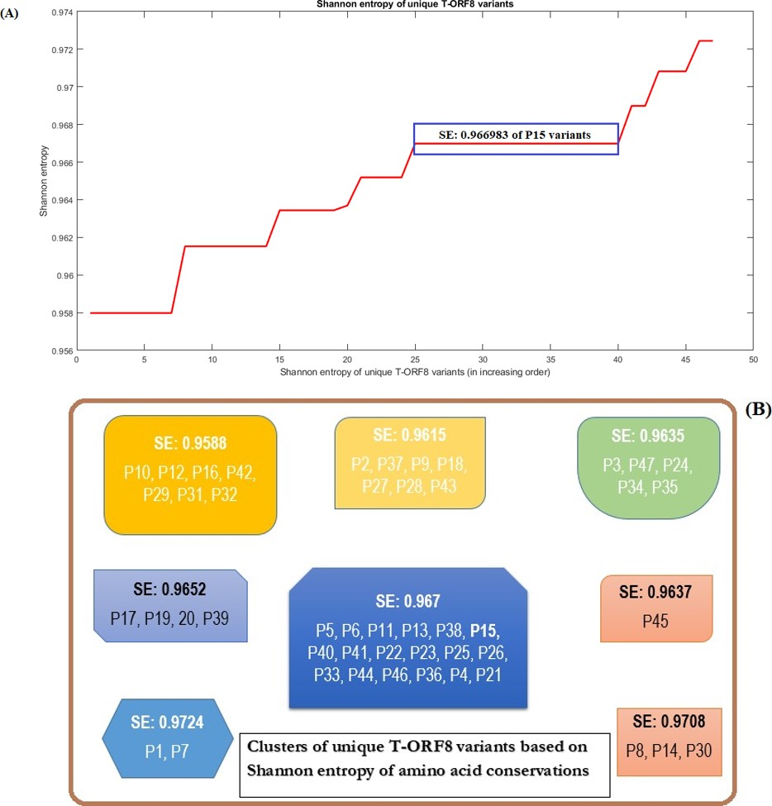

Figure S7. Analysis of T-ORF8 variability: A. Shannon entropy of unique T-ORF8 protein variants (plotted in increasing order), and B. Clusters of T-ORF8 variants based on Shannon entropy. The boxes highlighted in different colors represent clusters of unique T-ORF8 variants.

Supplementary Table S1. List of unique truncated ORF8 proteins and their representative accession IDs

Unique variants of truncated ORF8 proteins (world-wide)
Serial Name | Representative Accession ID | Unique T-ORF8 Sequence
P1 | QVD87830.1 | MKFHVFLGIITTVAAFHQECSLQSCT
P2 | QUP01097.1 | MKFLIFLGIITTVAAFHQECSLQSCT
P3 | QUG18382.1 | MKFLVFFGIITTVAAFHQECSLQSCT
P4 | QVD86462.1 | MKFLVFLEIITTVAAFHQECSLQSCT
P5 | QVH28344.1 | MKFLVFLGIIATVAAFHQECSLQSCT
P6 | QVH31850.1 | MKFLVFLGIIITVAAFHQECSLQSCT
P7 | QVG09588.1 | MKFLVFLGIIKTVAAFHQECSLQSCT
P8 | QUM37110.1 | MKFLVFLGIITPVAAFHQECSLQSCT
P9 | QUW14113.1 | MKFLVFLGIITTIAAFHQECSLQSCT
P10 | QTZ13340.1 | MKFLVFLGIITTLAAFHQECSLQSCT
P11 | QUR40000.1 | MKFLVFLGIITTVAAFHQDCSLQSCT
P12 | QVG91448.1 | MKFLVFLGIITTVAAFHQECSLQLCT
P13 | QUM45811.1 | MKFLVFLGIITTVAAFHQECSLQSCI
P14 | QUU32993.1 | MKFLVFLGIITTVAAFHQECSLQSCN
P15 | QVG81736.1 | MKFLVFLGIITTVAAFHQECSLQSCT
P16 | QUD51009.1 | MKFLVFLGIITTVAAFHQECSLQSFT
P17 | QTS70520.1 | MKFLVFLGIITTVAAFHQECSLQSRT
P18 | QUU23055.1 | MKFLVFLGIITTVAAFHQECSLQSST
P19 | QVE77971.1 | MKFLVFLGIITTVAAFHQERSLQSCT
P20 | QTW55152.1 | MKFLVFLGIITTVAAFHQEYSLQSCT
P21 | QUS70793.1 | MKFLVFLGIITTVAAFHQGCSLQSCT
P22 | QUQ10187.1 | MKFLVFLGIITTVAAFRQECSLQSCT
P23 | QVH12765.1 | MKFLVFLGIITTVAAFYQECSLQSCT
P24 | QVH15024.1 | MKFLVFLGIITTVAALHQECSLQSCT
P25 | QVE01821.1 | MKFLVFLGIITTVAASHQECSLQSCT
P26 | QUX49158.1 | MKFLVFLGIITTVAAVHQECSLQSCT
P27 | QTJ05015.1 | MKFLVFLGIITTVAVFHQECSLQSCT
P28 | QUW13574.1 | MKFLVFLGIITTVSAFHQECSLQSCT
P29 | QVG29748.1 | MKFLVFLGIITTVTAFHQECSLQSCT
P30 | QUV63981.1 | MKFLVFLGIIXTVAAFHQECSLQSCT
P31 | QVE38306.1 | MKFLVFLGITTTVAAFHQECSLQSCT
P32 | QUX43061.1 | MKFLVFLGTITTVAAFHQECSLQSCT
P33 | QVH27673.1 | MKFLVFLRIITTVAAFHQECSLQSCT
P34 | QUL63530.1 | MKFLVLLGIITTVAAFHQECSLQSCT
P35 | QVE29502.1 | MKLLVFLGIITTVAAFHQECSLQSCT
P36 | QUV44185.1 | MKSLVFLGIITTVAAFHQECSLQSCT
P37 | QVH05963.1 | MKFLVFLGIITTAAAFHQECSLQSCT
P38 | QVD85995.1 | MKFLVFLGIITTVAAFDQECSLQSCT
P39 | QVD91055.1 | MKFLVFLGIITTVAAFHQECSLRSCT
P40 | QVI12553.1 | MKFLVFLGIITTVAAFHQXCSLQSCT
P41 | QVG37762.1 | MKFLVFLGIITTVAAFNQECSLQSCT
P42 | QVG91352.1 | MKFLVFLGIITTVATFHQECSLQSCT
P43 | QUX48812.1 | MKFLVFLGIITTVVAFHQECSLQSCT
P44 | QVE28267.1 | MKFLVFLGIMTTVAAFHQECSLQSCT
P45 | QVH31598.1 | MKFLVFLVIITTVAAFHQECSLQSCT
P46 | QVG23542.1 | MKILVFLGIITTVAAFHQECSLQSCT
P47 | QVF67630.1 | MKFFVFLGIITTVAAFHQECSLQSCT
Supplementary Table S2: Collection date, geo-location, frequency of presence and accession ID of the first identified of each unique T-ORF8 variants
Unique T-ORF8 | Frequency of presence | Accession id | Collection date | Geo-location
P1 | 2 | QUI86380.1 | 06-04-2021 | USA: California
P2 | 13 | QTY80195.1 | 13-03-2021 | USA: Ohio
P3 | 1 | QUG18382.1 | 02-04-2021 | USA: Minnesota
P4 | 7 | QSU72470.1 | 12-02-2021 | USA: Florida
P5 | 7 | QTY89054.1 | 18-03-2021 | USA: Tennessee
P6 | 18 | QTF76874.1 | 20-02-2021 | USA: Texas
P7 | 3 | QUM35363.1 | 07-04-2021 | USA: Pennsylvania
P8 | 1 | QUM37110.1 | 08-04-2021 | USA: Michigan
P9 | 1 | QUW14113.1 | 19-04-2021 | USA: Texas
P10 | 1 | QTZ13340.1 | 23-03-2021 | USA: New Jersey
P11 | 1 | QUR40000.1 | 14-04-2021 | USA: Texas
P12 | 2 | QUP81732.1 | 16-04-2021 | USA: Minnesota
P13 | 3 | QUE25142.1 | 29-03-2021 | USA: Minnesota
P14 | 1 | QUU32993.1 | 16-04-2021 | USA: Florida
P15 |  | QUJ17746 | 15-03-2020 | Europe: Poland
P15 |  | QUJ17770 | 15-03-2020 | Europe: Poland
P15 |  | QQH16621 | 31-05-2020 | Asia: Pakistan-Punjab
P15 | 48395 | QRN78390 | 10-12-2020 | Africa: Ghana
P15 |  | QQV29253 | 31-12-2020 | South America: Peru
P15 |  | QMU25282 | 27-05-2020 | USA: Maryland
P15 |  | QMU25294 | 27-05-2020 | USA: Maryland
P16 | 23 | QTG22339.1 | 21-02-2021 | USA: Florida
P17 | 1 | QTS70520.1 | 16-03-2021 | USA: Pennsylvania
P18 | 3 | QUC96581.1 | 29-03-2021 | USA: Illinois
P19 | 4 | QUC99721.1 | 29-03-2021 | USA: Pennsylvania
P20 | 1 | QTW55152.1 | 27-03-2021 | USA: Pennsylvania
P21 | 1 | QUS70793.1 | 15-04-2021 | USA: Georgia
P22 | 1 | QUQ10187.1 | 06-04-2021 | USA: Tennessee
P23 | 24 | QTJ05327.1 | 03-03-2021 | USA: Pennsylvania
P24 |  | QUQ10379.1 | 05-04-2021 | USA: Puerto Rico
P24 | 28 | QUQ37029.1 | 05-04-2021 | USA: Puerto Rico
P24 |  | QUA75771.1 | 05-04-2021 | USA: Puerto Rico
P25 | 16 | QTX01933.1 | 11-03-2021 | USA: Texas
P26 | 2 | QUQ28684.1 | 08-04-2021 | USA: Maryland
P27 | 1 | QTJ05015.1 | 02-03-2021 | USA: Pennsylvania
P28 | 2 | QUQ51956.1 | 07-04-2021 | USA: Missouri
P29 | 19 | QTZ09174.1 | 26-03-2021 | USA: Maryland
P30 | 1 | QUV63981.1 | 11-04-2021 | USA: California
P31 | 7 | QTZ05620.1 | 25-03-2021 | USA: Louisiana
P32 | 5 | QTM88238.1 | 09-03-2021 | USA: Connecticut

Supplementary Table S3. Results of the ELM search for functional motifs in 47 T-ORF8 proteins

T-ORF8 | Elm name | Instances | Position | ELM description | Cell compartment
P1, P5, P6, P7, P9, P10, P11, P14, P15, P22, P23, P24, P26, P30, P32, P34, P35, P37, P38, P41, P44, P46,  P47 | DEG_Nend_UBRbox_1 | MKFH | 1-4 | N-terminal motif that initiates protein degradation by binding to the UBR-box of N-recognins. This N-degron variant comprises N-terminal Arg or Lys as destabilizing residue | cytosol
 | DOC_MAPK_MEF2A_6 | KFHVFLGI | 2-9 | A kinase docking motif that mediates interaction towards the ERK1/2 and p38 subfamilies of MAP kinases | nucleus, cytosol, Transcription factor complex
 | MOD_OFUCOSY | CSLQSC | 20-25 | Site for attachment of a fucose residue to a serine | extracellular
 | MOD_Plk_1 | QECSLQS | 18-24 | Ser/Thr residue phosphorylated by the Plk1 kinase | centralspindlin complex, nucleus,  spindle, gamma-tubulin complex,  midbody, cytosol, kinetochore,  spindle midzone, nuclear condensin complex, cleavage furrow, nucleoplasm, microtubule organizing center
P12, P16, P17, P19 | DEG_Nend_UBRbox_1 | MKFH | 1-4 | N-terminal motif that initiates protein degradation by binding to the UBR-box of N-recognins. This N-degron variant comprises N-terminal Arg or Lys as destabilizing residue | cytosol
 | DOC_MAPK_MEF2A_6 | KFHVFLGI | 2-9 | A kinase docking motif that mediates interaction towards the ERK1/2 and p38 subfamilies of MAP kinases | nucleus, cytosol, Transcription factor complex
 | MOD_Plk_1 | QECSLQS | 18-24 | Ser/Thr residue phosphorylated by the Plk1 kinase | centralspindlin complex, nucleus,  spindle, gamma-tubulin complex,  midbody, cytosol, kinetochore,  spindle midzone, nuclear condensin complex, cleavage furrow, nucleoplasm, microtubule organizing center
P21, P40 | DEG_Nend_UBRbox_1 | MKFH | 1-4 | N-terminal motif that initiates protein degradation by binding to the UBR-box of N-recognins. This N-degron variant comprises N-terminal Arg or Lys as destabilizing residue | cytosol
 | DOC_MAPK_MEF2A_6 | KFHVFLGI | 2-9 | A kinase docking motif that mediates interaction towards the ERK1/2 and p38 subfamilies of MAP kinases | nucleus, cytosol, Transcription factor complex
 | MOD_OFUCOSY | CSLQSC | 20-25 | Site for attachment of a fucose residue to a serine. | extracellular
P2 | DEG_Nend_UBRbox_1 | MKFH | 1-4 | N-terminal motif that initiates protein degradation by binding to the UBR-box of N-recognins. This N-degron variant comprises N-terminal Arg or Lys as destabilizing residue | cytosol
 | DOC_MAPK_MEF2A_6 | KFHVFLGI | 2-9 | A kinase docking motif that mediates interaction towards the ERK1/2 and p38 subfamilies of MAP kinases | nucleus, cytosol, Transcription factor complex
 | DOC_MAPK_NFAT4_5 | KFLIFLGII | 2-10 | An extended D site specifically recognized by the JNK kinases | cytosol, nucleus, protein complex, neuron projection
 | MOD_OFUCOSY | CSLQSC | 20-25 | Site for attachment of a fucose residue to a serine | extracellular
 | MOD_Plk_1 | QECSLQS | 18-24 | Ser/Thr residue phosphorylated by the Plk1 kinase | centralspindlin complex, nucleus, spindle, gamma-tubulin complex, midbody, cytosol, kinetochore, spindle midzone, nuclear condensin complex, cleavage furrow, nucleoplasm, microtubule organizing center
P3 | DEG_Nend_UBRbox_1 | MKFH | 1-4 | N-terminal motif that initiates protein degradation by binding to the UBR-box of N-recognins. This N-degron variant comprises N-terminal Arg or Lys as destabilizing residue | cytosol
 | LIG_Pex14_2 | FLVFF | 3-7 | Fxxx[WF] motifs are present in Pex19 and S. cerevisiae Pex5 cytosolic receptors that bind to peroxisomal membrane docking member, Pex14 | cytosol, peroxisome, glycosome
 | MOD_OFUCOSY | CSLQSC | 20-25 | Site for attachment of a fucose residue to a serine | extracellular
 | MOD_Plk_1 | QECSLQS | 18-24 | Ser/Thr residue phosphorylated by the Plk1 kinase | centralspindlin complex, nucleus,  spindle, gamma-tubulin complex,  midbody, cytosol, kinetochore,  spindle midzone, nuclear condensin complex, cleavage furrow, nucleoplasm, microtubule organizing center
P4 | DEG_Nend_UBRbox_1 | MKFL | 1-4 | N-terminal motif that initiates protein degradation by binding to the UBR-box of N-recognins. This N-degron variant comprises N-terminal Arg or Lys as destabilizing residue | cytosol
 | DOC_MAPK_MEF2A_6 | KFLVFLEI | 2-9 | A kinase docking motif that mediates interaction towards the ERK1/2 and p38 subfamilies of MAP kinases | nucleus, cytosol, Transcription factor complex
 | LIG_APCC_ABBA_1 | FLVFLE | 3-8 | Amphipathic motif that is involved in APC/C inhibition by binding of CDH1/CDC20. In metazoan cyclin A, the motif also acts as a degron, enabling the cyclin's degradation in prometaphase. | spindle pole, nucleus,  cytosol
 | LIG_APCC_ABBAyCdc20_2 | KFLVFLE | 2-8 | Amphipathic motif that binds to yeast Cdc20 and acts as an APC/C degron enabling cyclin Clb5 degradation during mitosis. | not annotated
 | LIG_Clathr_ClatBox_1 | LVFLE | 4-8 | Clathrin box motif found on cargo adaptor proteins, it interacts with the beta propeller structure located at the N-terminus of Clathrin heavy chain. | cytosol, Golgi apparatus,  cytoskeleton, clathrin-coated endocytic vesicle,  Golgi trans-face
 | MOD_OFUCOSY | CSLQSC | 20-25 | Site for attachment of a fucose residue to a serine | extracellular
 | MOD_Plk_1 | QECSLQS | 18-24 | Ser/Thr residue phosphorylated by the Plk1 kinase | centralspindlin complex, nucleus,  spindle, gamma-tubulin complex,  midbody, cytosol, kinetochore,  spindle midzone, nuclear condensin complex, cleavage furrow, nucleoplasm, microtubule organizing center
P8 | DEG_Nend_UBRbox_1 | MKFL | 1-4 | N-terminal motif that initiates protein degradation by binding to the UBR-box of N-recognins. This N-degron variant comprises N-terminal Arg or Lys as destabilizing residue | cytosol
 | DOC_CKS1_1 | IITPVA | 9-14 | Phospho-dependent motif that mediates docking of CDK substrates and regulators to cyclin-CDK-bound Cks1. | cytosol, nucleus
 | DOC_MAPK_MEF2A_6 | KFLVFLEI | 2-9 | A kinase docking motif that mediates interaction towards the ERK1/2 and p38 subfamilies of MAP kinases | nucleus, cytosol, Transcription factor complex
 | DOC_WW_Pin1_4 | GIITPV | 8-13 | The Class IV WW domain interaction motif is recognised primarily by the Pin1 phosphorylation-dependent prolyl isomerase. | cytosol, nucleus
 | MOD_OFUCOSY | CSLQSC | 20-25 | Site for attachment of a fucose residue to a serine | extracellular
 | MOD_Plk_1 | QECSLQS | 18-24 | Ser/Thr residue phosphorylated by the Plk1 kinase | centralspindlin complex, nucleus,  spindle, gamma-tubulin complex,  midbody, cytosol, kinetochore,  spindle midzone, nuclear condensin complex, cleavage furrow, nucleoplasm, microtubule organizing center
 | MOD_ProDKin_1 | GIITPVA | 8-14 | Proline-Directed Kinase (e.g. MAPK) phosphorylation site in higher eukaryotes. | cytosol, nucleus
P13 | DEG_Nend_UBRbox_1 | MKFH | 1-4 | N-terminal motif that initiates protein degradation by binding to the UBR-box of N-recognins. This N-degron variant comprises N-terminal Arg or Lys as destabilizing residue | cytosol
 | DOC_MAPK_MEF2A_6 | KFHVFLGI | 2-9 | A kinase docking motif that mediates interaction towards the ERK1/2 and p38 subfamilies of MAP kinases | nucleus, cytosol, Transcription factor complex
 | LIG_PDZ_Class_1 | SLQSCI | 21-26 | The C-terminal class 1 PDZ-binding motif is classically represented by a pattern like (ST)X(VIL)* | cytosol, internal side of plasma membrane
 | MOD_OFUCOSY | CSLQSC | 20-25 | Site for attachment of a fucose residue to a serine | extracellular
 | MOD_Plk_1 | QECSLQS | 18-24 | Ser/Thr residue phosphorylated by the Plk1 kinase | centralspindlin complex, nucleus, spindle, gamma-tubulin complex, midbody, cytosol, kinetochore, spindle midzone, nuclear condensin complex, cleavage furrow, nucleoplasm, microtubule organizing center
P18 | DEG_Nend_UBRbox_1 | MKFH | 1-4 | N-terminal motif that initiates protein degradation by binding to the UBR-box of N-recognins. This N-degron variant comprises N-terminal Arg or Lys as destabilizing residue | cytosol
 | DOC_MAPK_MEF2A_6 | KFHVFLGI | 2-9 | A kinase docking motif that mediates interaction towards the ERK1/2 and p38 subfamilies of MAP kinases | nucleus, cytosol, Transcription factor complex
 | MOD_GSK3_1 | QECSLQSS | 18-25 | GSK3 phosphorylation recognition site | cytosol, nucleus
 | MOD_Plk_1 | QECSLQS | 18-24 | Ser/Thr residue phosphorylated by the Plk1 kinase | centralspindlin complex, nucleus,  spindle, gamma-tubulin complex,  midbody, cytosol, kinetochore,  spindle midzone, nuclear condensin complex, cleavage furrow, nucleoplasm, microtubule organizing center
P20 | DEG_Nend_UBRbox_1 | MKFH | 1-4 | N-terminal motif that initiates protein degradation by binding to the UBR-box of N-recognins. This N-degron variant comprises N-terminal Arg or Lys as destabilizing residue | cytosol
 | DOC_MAPK_MEF2A_6 | KFHVFLGI | 2-9 | A kinase docking motif that mediates interaction towards the ERK1/2 and p38 subfamilies of MAP kinases | nucleus, cytosol, Transcription factor complex
 | LIG_SH2_STAT3 | YSLQ | 20-23 | YXXQ motif found in the cytoplasmic region of cytokine receptors that bind STAT3 SH2 domain. | cytosol
 | MOD_Plk_1 | QECSLQS | 18-24 | Ser/Thr residue phosphorylated by the Plk1 kinase | centralspindlin complex, nucleus,  spindle, gamma-tubulin complex,  midbody, cytosol, kinetochore,  spindle midzone, nuclear condensin complex, cleavage furrow, nucleoplasm, microtubule organizing center
P25 | DEG_Nend_UBRbox_1 | MKFL | 1-4 | N-terminal motif that initiates protein degradation by binding to the UBR-box of N-recognins. This N-degron variant comprises N-terminal Arg or Lys as destabilizing residue | cytosol
 | DOC_MAPK_MEF2A_6 | KFLVFLGI | 2-9 | A kinase docking motif that mediates interaction towards the ERK1/2 and p38 subfamilies of MAP kinases | nucleus, cytosol, Transcription factor complex
 | LIG_TRAF2_1 | SHQE | 16-19 | Major TRAF2-binding consensus motif. Members of the tumor necrosis factor receptor (TNFR) superfamily initiate intracellular signaling by recruiting the C-domain of the TNFR-associated factors (TRAFs) through their cytoplasmic tails | cytosol
 | MOD_CK2_1 | VAASHQE | 13-19 | Casein kinase 2 (CK2) phosphorylation site | protein kinase CK2 complex,  nucleus, cytosol
 | MOD_GSK3_1 | IITTVAAS | 9-16 | GSK3 phosphorylation recognition site | cytosol, nucleus
 | MOD_OFUCOSY | CSLQSC | 20-25 | Site for attachment of a fucose residue to a serine. | extracellular
 | MOD_Plk_1 | QECSLQS | 18-24 | Ser/Thr residue phosphorylated by the Plk1 kinase | centralspindlin complex, nucleus, spindle, gamma-tubulin complex, midbody, cytosol, kinetochore, spindle midzone, nuclear condensin complex, cleavage furrow, nucleoplasm, microtubule organizing center
P27 | DEG_Nend_UBRbox_1 | MKFH | 1-4 | N-terminal motif that initiates protein degradation by binding to the UBR-box of N-recognins. This N-degron variant comprises N-terminal Arg or Lys as destabilizing residue | cytosol
 | DOC_MAPK_MEF2A_6 | KFHVFLGI | 2-9 | A kinase docking motif that mediates interaction towards the ERK1/2 and p38 subfamilies of MAP kinases | nucleus, cytosol, Transcription factor complex
 | LIG_FHA_1 | ITTVAVF | 10-16 | Phosphothreonine motif binding a subset of FHA domains that show a preference for a large aliphatic amino acid at the pT+3 position. | nucleus
 | MOD_OFUCOSY | CSLQSC | 20-25 | Site for attachment of a fucose residue to a serine | extracellular
 | MOD_Plk_1 | QECSLQS | 18-24 | Ser/Thr residue phosphorylated by the Plk1 kinase | centralspindlin complex, nucleus,  spindle, gamma-tubulin complex,  midbody, cytosol, kinetochore,  spindle midzone, nuclear condensin complex, cleavage furrow, nucleoplasm, microtubule organizing center
P28 | DEG_Nend_UBRbox_1 | MKFL | 1-4 | N-terminal motif that initiates protein degradation by binding to the UBR-box of N-recognins. This N-degron variant comprises N-terminal Arg or Lys as destabilizing residue | cytosol
 | DOC_MAPK_MEF2A_6 | KFLVFLGI | 2-9 | A kinase docking motif that mediates interaction towards the ERK1/2 and p38 subfamilies of MAP kinases | nucleus, cytosol, Transcription factor complex
 | LIG_WD40_WDR5_VDV_2 | TTVSA  TVSA | 11-15  12-15 | Fungi-specific variant of the WDR5-binding motif that binds to a cleft between blades 5 and 6 of the WD40 repeat domain of WDR5, opposite of the Win motif-binding site, to mediate assembly of histone modification complexes. | nucleus, histone methyltransferase complex
 | MOD_GlcNHglycan | VSAF | 13-16 | Glycosaminoglycan attachment site | extracellular,  Golgi apparatus
 | MOD_OFUCOSY | CSLQSC | 20-25 | Site for attachment of a fucose residue to a serine. | extracellular
 | MOD_Plk_1 | QECSLQS | 18-24 | Ser/Thr residue phosphorylated by the Plk1 kinase | centralspindlin complex, nucleus, spindle, gamma-tubulin complex, midbody, cytosol, kinetochore, spindle midzone, nuclear condensin complex, cleavage furrow, nucleoplasm, microtubule organizing center
P29 | DEG_Nend_UBRbox_1 | MKFL | 1-4 | N-terminal motif that initiates protein degradation by binding to the UBR-box of N-recognins. This N-degron variant comprises N-terminal Arg or Lys as destabilizing residue | cytosol
 | DOC_MAPK_MEF2A_6 | KFLVFLGI | 2-9 | A kinase docking motif that mediates interaction towards the ERK1/2 and p38 subfamilies of MAP kinases | nucleus, cytosol, Transcription factor complex
 | LIG_WD40_WDR5_VDV_2 | TTVTA  TVTA | 11-15  12-15 | Fungi-specific variant of the WDR5-binding motif that binds to a cleft between blades 5 and 6 of the WD40 repeat domain of WDR5, opposite of the Win motif-binding site, to mediate assembly of histone modification complexes. | nucleus, histone methyltransferase complex
 | MOD_OFUCOSY | CSLQSC | 20-25 | Site for attachment of a fucose residue to a serine. | extracellular
 | MOD_Plk_1 | QECSLQS | 18-24 | Ser/Thr residue phosphorylated by the Plk1 kinase | centralspindlin complex, nucleus, spindle, gamma-tubulin complex, midbody, cytosol, kinetochore, spindle midzone, nuclear condensin complex, cleavage furrow, nucleoplasm, microtubule organizing center
P31 | DEG_Nend_UBRbox_1 | MKFL | 1-4 | N-terminal motif that initiates protein degradation by binding to the UBR-box of N-recognins. This N-degron variant comprises N-terminal Arg or Lys as destabilizing residue | cytosol
 | DOC_MAPK_MEF2A_6 | KFLVFLGI | 2-9 | A kinase docking motif that mediates interaction towards the ERK1/2 and p38 subfamilies of MAP kinases | nucleus, cytosol, Transcription factor complex
 | LIG_FHA_1 | GITTTVA | 8-14 | Phosphothreonine motif binding a subset of FHA domains that show a preference for a large aliphatic amino acid at the pT+3 position. | nucleus
 | MOD_NEK2_1 | LGITTT | 7-12 | NEK2 phosphorylation motif with preferred Phe, Leu or Met in the -3 position to compensate for less favorable residues in the +1 and +2 position. | centrosome, Ndc80 complex, condensed nuclear chromosome outer kinetochore, cytosol, nucleus
 | MOD_OFUCOSY | CSLQSC | 20-25 | Site for attachment of a fucose residue to a serine. | extracellular
 | MOD_Plk_1 | QECSLQS | 18-24 | Ser/Thr residue phosphorylated by the Plk1 kinase | centralspindlin complex, nucleus, spindle, gamma-tubulin complex, midbody, cytosol, kinetochore, spindle midzone, nuclear condensin complex, cleavage furrow, nucleoplasm, microtubule organizing center
P33 | CLV_PCSK_SKI1_1 | RIITT | 8-12 | Subtilisin/kexin isozyme-1 (SKI1) cleavage site ([RK]-X-[hydrophobic]-[LTKF]-|-X). | endoplasmic reticulum lumen, endoplasmic reticulum, Golgi apparatus,  extracellular
 | DEG_Nend_UBRbox_1 | MKFL | 1-4 | N-terminal motif that initiates protein degradation by binding to the UBR-box of N-recognins. This N-degron variant comprises N-terminal Arg or Lys as destabilizing residue | cytosol
 | DOC_MAPK_MEF2A_6 | KFLVFLGI | 2-9 | A kinase docking motif that mediates interaction towards the ERK1/2 and p38 subfamilies of MAP kinases | nucleus, cytosol, Transcription factor complex
 | LIG_14-3-3_CanoR_1 | RIITTVA | 8-14 | Canonical Arg-containing phospho-motif mediating a strong interaction with 14-3-3 proteins. | Nucleus, internal side of plasma membrane,  cytosol
 | MOD_OFUCOSY | CSLQSC | 20-25 | Site for attachment of a fucose residue to a serine. | extracellular
 | MOD_Plk_1 | QECSLQS | 18-24 | Ser/Thr residue phosphorylated by the Plk1 kinase | centralspindlin complex, nucleus, spindle, gamma-tubulin complex, midbody, cytosol, kinetochore, spindle midzone, nuclear condensin complex, cleavage furrow, nucleoplasm, microtubule organizing center
P36 | DEG_Nend_UBRbox_1 | MKFH | 1-4 | N-terminal motif that initiates protein degradation by binding to the UBR-box of N-recognins. This N-degron variant comprises N-terminal Arg or Lys as destabilizing residue | cytosol
 | DOC_MAPK_MEF2A_6 | KSLVFLGI | 2-9 | A kinase docking motif that mediates interaction towards the ERK1/2 and p38 subfamilies of MAP kinases | nucleus, cytosol, Transcription factor complex
 | LIG_BRCT_BRCA1_1 | KSLVF | 2-6 | Phosphopeptide motif which directly interacts with the BRCT (carboxy-terminal) domain of the Breast Cancer Gene BRCA1 with low affinity | nucleus, BRCA1-BARD1 complex
 | LIG_LIR_Nem_3 | SLVFLGI | 3-9 | Nematode-specific variant of the canonical LIR motif that binds to Atg8 protein family members to mediate processes involved in autophagy. | cytosol,  cytoplasmic side of late endosome membrane
 | MOD_Plk_1 | QECSLQS | 18-24 | Ser/Thr residue phosphorylated by the Plk1 kinase | Central spindlin complex, nucleus,  spindle, gamma-tubulin complex,  midbody, cytosol, kinetochore,  spindle midzone, nuclear condensin complex, cleavage furrow, nucleoplasm, microtubule organizing center
P39 | DEG_Nend_UBRbox_1 | MKFL | 1-4 | N-terminal motif that initiates protein degradation by binding to the UBR-box of N-recognins. This N-degron variant comprises N-terminal Arg or Lys as destabilizing residue | cytosol
 | DOC_MAPK_MEF2A_6 | KFLVFLGI | 2-9 | A kinase docking motif that mediates interaction towards the ERK1/2 and p38 subfamilies of MAP kinases | nucleus, cytosol, Transcription factor complex
 | LIG_14-3-3_CterR_2 | RSCT | 23-26 | C-terminal Arg-containing phospho-motif mediating a strong interaction with 14-3-3 proteins. | nucleus, internal side of plasma membrane, cytosol
 | MOD_OFUCOSY | CSLRSC | 20-25 | Site for attachment of a fucose residue to a serine | extracellular
 | MOD_Plk_1 | QECSLRS | 18-24 | Ser/Thr residue phosphorylated by the Plk1 kinase | centralspindlin complex, nucleus,  spindle, gamma-tubulin complex,  midbody, cytosol, kinetochore,  spindle midzone, nuclear condensin complex, cleavage furrow, nucleoplasm, microtubule organizing center
P42 | DEG_Nend_UBRbox_1 | MKFL | 1-4 | N-terminal motif that initiates protein degradation by binding to the UBR-box of N-recognins. This N-degron variant comprises N-terminal Arg or Lys as destabilizing residue | cytosol
 | DOC_MAPK_MEF2A_6 | KFLVFLGI | 2-9 | A kinase docking motif that mediates interaction towards the ERK1/2 and p38 subfamilies of MAP kinases | nucleus, cytosol, Transcription factor complex
 | MOD_GSK3_1 | GIITTVAT | 8-15 | GSK3 phosphorylation recognition site | cytosol, nucleus
 | MOD_OFUCOSY | CSLQSC | 20-25 | Site for attachment of a fucose residue to a serine | extracellular
 | MOD_Plk_1 | QECSLQS | 18-24 | Ser/Thr residue phosphorylated by the Plk1 kinase | centralspindlin complex, nucleus,  spindle, gamma-tubulin complex,  midbody, cytosol, kinetochore,  spindle midzone, nuclear condensin complex, cleavage furrow, nucleoplasm, microtubule organizing center
P43 | DEG_Nend_UBRbox_1 | MKFL | 1-4 | N-terminal motif that initiates protein degradation by binding to the UBR-box of N-recognins. This N-degron variant comprises N-terminal Arg or Lys as destabilizing residue | cytosol
 | DOC_MAPK_MEF2A_6 | KFLVFLGI | 2-9 | A kinase docking motif that mediates interaction towards the ERK1/2 and p38 subfamilies of MAP kinases | nucleus, cytosol, Transcription factor complex
 | LIG_FHA_1 | IITTVVA | 9-15 | Phosphothreonine motif binding a subset of FHA domains that show a preference for a large aliphatic amino acid at the pT+3 position. | nucleus
 | MOD_OFUCOSY | CSLQSC | 20-25 | Site for attachment of a fucose residue to a serine | extracellular
 | MOD_Plk_1 | QECSLQS | 18-24 | Ser/Thr residue phosphorylated by the Plk1 kinase | centralspindlin complex, nucleus,  spindle, gamma-tubulin complex,  midbody, cytosol, kinetochore,  spindle midzone, nuclear condensin complex, cleavage furrow, nucleoplasm, microtubule organizing center
 | MOD_Plk_4 | IITTVVA | 9-15 | Ser/Thr residue phosphorylated by Plk4 | nucleus, cytosol, SCF ubiquitin ligase complex,  cleavage furrow, centriole,  gamma-tubulin ring complex, centriolar satellite, pericentriolar material
P45 | DEG_Nend_UBRbox_1 | MKFL | 1-4 | N-terminal motif that initiates protein degradation by binding to the UBR-box of N-recognins. This N-degron variant comprises N-terminal Arg or Lys as destabilizing residue | cytosol
 | DOC_MAPK_MEF2A_6 | KFLVFLVI | 2-9 | A kinase docking motif that mediates interaction towards the ERK1/2 and p38 subfamilies of MAP kinases | nucleus, cytosol, Transcription factor complex
 | LIG_SUMO_SIM_par_1 | FLVIITT | 6-12 | Motif for the parallel beta augmentation mode of non-covalent binding to SUMO protein. | PML body, nucleus, nuclear body
 | MOD_OFUCOSY | CSLQSC | 20-25 | Site for attachment of a fucose residue to a serine | extracellular
 | MOD_Plk_1 | QECSLQS | 18-24 | Ser/Thr residue phosphorylated by the Plk1 kinase | centralspindlin complex, nucleus,  spindle, gamma-tubulin complex,  midbody, cytosol, kinetochore,  spindle midzone, nuclear condensin complex, cleavage furrow, nucleoplasm, microtubule organizing center

Supplementary Table S4. Unique polar/non-polar sequence variants of T-ORF8 and their frequencies
Serial name | The unique polar/non-polar sequence of T-ORF8 | Frequency of identical sequence
P1 | PQPQPPPPPPQQPPPPQQQQQPQQQQ | 1
P12 | PQPPPPPPPPQQPPPPQQQQQPQPQQ | 1
P13 | PQPPPPPPPPQQPPPPQQQQQPQQQP | 1
P16 | PQPPPPPPPPQQPPPPQQQQQPQQPQ | 1
P21 | PQPPPPPPPPQQPPPPQQPQQPQQQQ | 1
P25 | PQPPPPPPPPQQPPPQQQQQQPQQQQ | 1
P28 | PQPPPPPPPPQQPQPPQQQQQPQQQQ | 2
P30 | PQPPPPPPPPXQPPPPQQQQQPQQQQ | 1
P31 | PQPPPPPPPQQQPPPPQQQQQPQQQQ | 1
P32 | PQPPPPPPQPQQPPPPQQQQQPQQQQ | 1
P36 | PQQPPPPPPPQQPPPPQQQQQPQQQQ | 1
P4 | PQPPPPPQPPQQPPPPQQQQQPQQQQ | 2
P40 | PQPPPPPPPPQQPPPPQQXQQPQQQQ | 1
P42 | PQPPPPPPPPQQPPQPQQQQQPQQQQ | 1
P15 | PQPPPPPPPPQQPPPPQQQQQPQQQQ | 28
P5 | PQPPPPPPPPPQPPPPQQQQQPQQQQ | 2
P8 | PQPPPPPPPPQPPPPPQQQQQPQQQQ | 1

Supplementary Table S5. Frequency of amino acids present in the 47 unique T-ORF8 variants. (Standard single-letter amino acid codes were used.)

 | A | R | N | D | C | Q | E | G | H | I | L | K | M | F | P | S | T | W | Y | V
P47 | 2 | 0 | 0 | 0 | 2 | 2 | 1 | 1 | 1 | 2 | 2 | 1 | 1 | 4 | 0 | 2 | 3 | 0 | 0 | 2
P1 | 2 | 0 | 0 | 0 | 2 | 2 | 1 | 1 | 2 | 2 | 2 | 1 | 1 | 3 | 0 | 2 | 3 | 0 | 0 | 2
P2 | 2 | 0 | 0 | 0 | 2 | 2 | 1 | 1 | 1 | 3 | 3 | 1 | 1 | 3 | 0 | 2 | 3 | 0 | 0 | 1
P3 | 2 | 0 | 0 | 0 | 2 | 2 | 1 | 1 | 1 | 2 | 2 | 1 | 1 | 4 | 0 | 2 | 3 | 0 | 0 | 2
P4 | 2 | 0 | 0 | 0 | 2 | 2 | 2 | 0 | 1 | 2 | 3 | 1 | 1 | 3 | 0 | 2 | 3 | 0 | 0 | 2
P5 | 3 | 0 | 0 | 0 | 2 | 2 | 1 | 1 | 1 | 2 | 3 | 1 | 1 | 3 | 0 | 2 | 2 | 0 | 0 | 2
P6 | 2 | 0 | 0 | 0 | 2 | 2 | 1 | 1 | 1 | 3 | 3 | 1 | 1 | 3 | 0 | 2 | 2 | 0 | 0 | 2
P7 | 2 | 0 | 0 | 0 | 2 | 2 | 1 | 1 | 1 | 2 | 3 | 2 | 1 | 3 | 0 | 2 | 2 | 0 | 0 | 2
P8 | 2 | 0 | 0 | 0 | 2 | 2 | 1 | 1 | 1 | 2 | 3 | 1 | 1 | 3 | 1 | 2 | 2 | 0 | 0 | 2
P37 | 3 | 0 | 0 | 0 | 2 | 2 | 1 | 1 | 1 | 2 | 3 | 1 | 1 | 3 | 0 | 2 | 3 | 0 | 0 | 1
P9 | 2 | 0 | 0 | 0 | 2 | 2 | 1 | 1 | 1 | 3 | 3 | 1 | 1 | 3 | 0 | 2 | 3 | 0 | 0 | 1
P10 | 2 | 0 | 0 | 0 | 2 | 2 | 1 | 1 | 1 | 2 | 4 | 1 | 1 | 3 | 0 | 2 | 3 | 0 | 0 | 1
P38 | 2 | 0 | 0 | 1 | 2 | 2 | 1 | 1 | 0 | 2 | 3 | 1 | 1 | 3 | 0 | 2 | 3 | 0 | 0 | 2
P11 | 2 | 0 | 0 | 1 | 2 | 2 | 0 | 1 | 1 | 2 | 3 | 1 | 1 | 3 | 0 | 2 | 3 | 0 | 0 | 2
P12 | 2 | 0 | 0 | 0 | 2 | 2 | 1 | 1 | 1 | 2 | 4 | 1 | 1 | 3 | 0 | 1 | 3 | 0 | 0 | 2
P13 | 2 | 0 | 0 | 0 | 2 | 2 | 1 | 1 | 1 | 3 | 3 | 1 | 1 | 3 | 0 | 2 | 2 | 0 | 0 | 2
P14 | 2 | 0 | 1 | 0 | 2 | 2 | 1 | 1 | 1 | 2 | 3 | 1 | 1 | 3 | 0 | 2 | 2 | 0 | 0 | 2
P15 | 2 | 0 | 0 | 0 | 2 | 2 | 1 | 1 | 1 | 2 | 3 | 1 | 1 | 3 | 0 | 2 | 3 | 0 | 0 | 2
P16 | 2 | 0 | 0 | 0 | 1 | 2 | 1 | 1 | 1 | 2 | 3 | 1 | 1 | 4 | 0 | 2 | 3 | 0 | 0 | 2
P17 | 2 | 1 | 0 | 0 | 1 | 2 | 1 | 1 | 1 | 2 | 3 | 1 | 1 | 3 | 0 | 2 | 3 | 0 | 0 | 2
P18 | 2 | 0 | 0 | 0 | 1 | 2 | 1 | 1 | 1 | 2 | 3 | 1 | 1 | 3 | 0 | 3 | 3 | 0 | 0 | 2
P39 | 2 | 1 | 0 | 0 | 2 | 1 | 1 | 1 | 1 | 2 | 3 | 1 | 1 | 3 | 0 | 2 | 3 | 0 | 0 | 2
P19 | 2 | 1 | 0 | 0 | 1 | 2 | 1 | 1 | 1 | 2 | 3 | 1 | 1 | 3 | 0 | 2 | 3 | 0 | 0 | 2
P20 | 2 | 0 | 0 | 0 | 1 | 2 | 1 | 1 | 1 | 2 | 3 | 1 | 1 | 3 | 0 | 2 | 3 | 0 | 1 | 2
P21 | 2 | 0 | 0 | 0 | 2 | 2 | 0 | 2 | 1 | 2 | 3 | 1 | 1 | 3 | 0 | 2 | 3 | 0 | 0 | 2
P40 | 2 | 0 | 0 | 0 | 2 | 2 | 0 | 1 | 1 | 2 | 3 | 1 | 1 | 3 | 0 | 2 | 3 | 0 | 0 | 2
P41 | 2 | 0 | 1 | 0 | 2 | 2 | 1 | 1 | 0 | 2 | 3 | 1 | 1 | 3 | 0 | 2 | 3 | 0 | 0 | 2
P22 | 2 | 1 | 0 | 0 | 2 | 2 | 1 | 1 | 0 | 2 | 3 | 1 | 1 | 3 | 0 | 2 | 3 | 0 | 0 | 2
P23 | 2 | 0 | 0 | 0 | 2 | 2 | 1 | 1 | 0 | 2 | 3 | 1 | 1 | 3 | 0 | 2 | 3 | 0 | 1 | 2
P24 | 2 | 0 | 0 | 0 | 2 | 2 | 1 | 1 | 1 | 2 | 4 | 1 | 1 | 2 | 0 | 2 | 3 | 0 | 0 | 2
P25 | 2 | 0 | 0 | 0 | 2 | 2 | 1 | 1 | 1 | 2 | 3 | 1 | 1 | 2 | 0 | 3 | 3 | 0 | 0 | 2
P26 | 2 | 0 | 0 | 0 | 2 | 2 | 1 | 1 | 1 | 2 | 3 | 1 | 1 | 2 | 0 | 2 | 3 | 0 | 0 | 3
P42 | 1 | 0 | 0 | 0 | 2 | 2 | 1 | 1 | 1 | 2 | 3 | 1 | 1 | 3 | 0 | 2 | 4 | 0 | 0 | 2
P27 | 1 | 0 | 0 | 0 | 2 | 2 | 1 | 1 | 1 | 2 | 3 | 1 | 1 | 3 | 0 | 2 | 3 | 0 | 0 | 3
P28 | 1 | 0 | 0 | 0 | 2 | 2 | 1 | 1 | 1 | 2 | 3 | 1 | 1 | 3 | 0 | 3 | 3 | 0 | 0 | 2
P29 | 1 | 0 | 0 | 0 | 2 | 2 | 1 | 1 | 1 | 2 | 3 | 1 | 1 | 3 | 0 | 2 | 4 | 0 | 0 | 2
P43 | 1 | 0 | 0 | 0 | 2 | 2 | 1 | 1 | 1 | 2 | 3 | 1 | 1 | 3 | 0 | 2 | 3 | 0 | 0 | 3
P30 | 2 | 0 | 0 | 0 | 2 | 2 | 1 | 1 | 1 | 2 | 3 | 1 | 1 | 3 | 0 | 2 | 2 | 0 | 0 | 2
P44 | 2 | 0 | 0 | 0 | 2 | 2 | 1 | 1 | 1 | 1 | 3 | 1 | 2 | 3 | 0 | 2 | 3 | 0 | 0 | 2
P31 | 2 | 0 | 0 | 0 | 2 | 2 | 1 | 1 | 1 | 1 | 3 | 1 | 1 | 3 | 0 | 2 | 4 | 0 | 0 | 2
P32 | 2 | 0 | 0 | 0 | 2 | 2 | 1 | 1 | 1 | 1 | 3 | 1 | 1 | 3 | 0 | 2 | 4 | 0 | 0 | 2
P33 | 2 | 1 | 0 | 0 | 2 | 2 | 1 | 0 | 1 | 2 | 3 | 1 | 1 | 3 | 0 | 2 | 3 | 0 | 0 | 2
P45 | 2 | 0 | 0 | 0 | 2 | 2 | 1 | 0 | 1 | 2 | 3 | 1 | 1 | 3 | 0 | 2 | 3 | 0 | 0 | 3
P34 | 2 | 0 | 0 | 0 | 2 | 2 | 1 | 1 | 1 | 2 | 4 | 1 | 1 | 2 | 0 | 2 | 3 | 0 | 0 | 2
P46 | 2 | 0 | 0 | 0 | 2 | 2 | 1 | 1 | 1 | 3 | 3 | 1 | 1 | 2 | 0 | 2 | 3 | 0 | 0 | 2
P35 | 2 | 0 | 0 | 0 | 2 | 2 | 1 | 1 | 1 | 2 | 4 | 1 | 1 | 2 | 0 | 2 | 3 | 0 | 0 | 2
P36 | 2 | 0 | 0 | 0 | 2 | 2 | 1 | 1 | 1 | 2 | 3 | 1 | 1 | 2 | 0 | 3 | 3 | 0 | 0 | 2

Supplementary Table S6. Euclidean distances calculated for each pair of frequency vectors corresponding to all unique T-ORF8 variants

 | P47 | P1 | P2 | P3 | P4 | P5 | P6 | P7 | P8 | P37 | P9 | P10 | P38 | P11 | P12 | P13 | P14 | P15 | P16 | P17 | P18 | P39 | P19 | P20 | P21 | P40 | P41 | P22 | P23 | P24 | P25 | P26 | P42 | P27 | P28 | P29 | P43 | P30 | P44 | P31 | P32 | P33 | P45 | P34 | P46 | P35 | P36
P47 | 0.00 | 1.41 | 2.00 | 0.00 | 2.00 | 2.00 | 2.00 | 2.00 | 2.00 | 2.00 | 2.00 | 2.45 | 2.00 | 2.00 | 2.45 | 2.00 | 2.00 | 1.41 | 1.41 | 2.00 | 2.00 | 2.00 | 2.00 | 2.00 | 2.00 | 1.73 | 2.00 | 2.00 | 2.00 | 2.83 | 2.45 | 2.45 | 2.00 | 2.00 | 2.00 | 2.00 | 2.00 | 1.73 | 2.00 | 2.00 | 2.00 | 2.00 | 2.00 | 2.83 | 2.45 | 2.83 | 2.45
P1 | 1.41 | 0.00 | 2.00 | 1.41 | 2.00 | 2.00 | 2.00 | 2.00 | 2.00 | 2.00 | 2.00 | 2.45 | 2.45 | 2.00 | 2.45 | 2.00 | 2.00 | 1.41 | 2.00 | 2.00 | 2.00 | 2.00 | 2.00 | 2.00 | 2.00 | 1.73 | 2.45 | 2.45 | 2.45 | 2.45 | 2.00 | 2.00 | 2.00 | 2.00 | 2.00 | 2.00 | 2.00 | 1.73 | 2.00 | 2.00 | 2.00 | 2.00 | 2.00 | 2.45 | 2.00 | 2.45 | 2.00
P2 | 2.00 | 2.00 | 0.00 | 2.00 | 2.00 | 2.00 | 1.41 | 2.00 | 2.00 | 1.41 | 0.00 | 1.41 | 2.00 | 2.00 | 2.00 | 1.41 | 2.00 | 1.41 | 2.00 | 2.00 | 2.00 | 2.00 | 2.00 | 2.00 | 2.00 | 1.73 | 2.00 | 2.00 | 2.00 | 2.00 | 2.00 | 2.45 | 2.00 | 2.45 | 2.00 | 2.00 | 2.45 | 1.73 | 2.45 | 2.45 | 2.45 | 2.00 | 2.45 | 2.00 | 1.41 | 2.00 | 2.00
P3 | 0.00 | 1.41 | 2.00 | 0.00 | 2.00 | 2.00 | 2.00 | 2.00 | 2.00 | 2.00 | 2.00 | 2.45 | 2.00 | 2.00 | 2.45 | 2.00 | 2.00 | 1.41 | 1.41 | 2.00 | 2.00 | 2.00 | 2.00 | 2.00 | 2.00 | 1.73 | 2.00 | 2.00 | 2.00 | 2.83 | 2.45 | 2.45 | 2.00 | 2.00 | 2.00 | 2.00 | 2.00 | 1.73 | 2.00 | 2.00 | 2.00 | 2.00 | 2.00 | 2.83 | 2.45 | 2.83 | 2.45
P4 | 2.00 | 2.00 | 2.00 | 2.00 | 0.00 | 2.00 | 2.00 | 2.00 | 2.00 | 2.00 | 2.00 | 2.00 | 2.00 | 2.45 | 2.00 | 2.00 | 2.00 | 1.41 | 2.00 | 2.00 | 2.00 | 2.00 | 2.00 | 2.00 | 2.83 | 2.24 | 2.00 | 2.00 | 2.00 | 2.00 | 2.00 | 2.00 | 2.00 | 2.00 | 2.00 | 2.00 | 2.00 | 1.73 | 2.00 | 2.00 | 2.00 | 1.41 | 1.41 | 2.00 | 2.00 | 2.00 | 2.00
P5 | 2.00 | 2.00 | 2.00 | 2.00 | 2.00 | 0.00 | 1.41 | 1.41 | 1.41 | 1.41 | 2.00 | 2.00 | 2.00 | 2.00 | 2.00 | 1.41 | 1.41 | 1.41 | 2.00 | 2.00 | 2.00 | 2.00 | 2.00 | 2.00 | 2.00 | 1.73 | 2.00 | 2.00 | 2.00 | 2.00 | 2.00 | 2.00 | 2.83 | 2.45 | 2.45 | 2.83 | 2.45 | 1.00 | 2.00 | 2.45 | 2.45 | 2.00 | 2.00 | 2.00 | 2.00 | 2.00 | 2.00
P6 | 2.00 | 2.00 | 1.41 | 2.00 | 2.00 | 1.41 | 0.00 | 1.41 | 1.41 | 2.00 | 1.41 | 2.00 | 2.00 | 2.00 | 2.00 | 0.00 | 1.41 | 1.41 | 2.00 | 2.00 | 2.00 | 2.00 | 2.00 | 2.00 | 2.00 | 1.73 | 2.00 | 2.00 | 2.00 | 2.00 | 2.00 | 2.00 | 2.45 | 2.00 | 2.00 | 2.45 | 2.00 | 1.00 | 2.45 | 2.83 | 2.83 | 2.00 | 2.00 | 2.00 | 1.41 | 2.00 | 2.00
P7 | 2.00 | 2.00 | 2.00 | 2.00 | 2.00 | 1.41 | 1.41 | 0.00 | 1.41 | 2.00 | 2.00 | 2.00 | 2.00 | 2.00 | 2.00 | 1.41 | 1.41 | 1.41 | 2.00 | 2.00 | 2.00 | 2.00 | 2.00 | 2.00 | 2.00 | 1.73 | 2.00 | 2.00 | 2.00 | 2.00 | 2.00 | 2.00 | 2.45 | 2.00 | 2.00 | 2.45 | 2.00 | 1.00 | 2.00 | 2.45 | 2.45 | 2.00 | 2.00 | 2.00 | 2.00 | 2.00 | 2.00
P8 | 2.00 | 2.00 | 2.00 | 2.00 | 2.00 | 1.41 | 1.41 | 1.41 | 0.00 | 2.00 | 2.00 | 2.00 | 2.00 | 2.00 | 2.00 | 1.41 | 1.41 | 1.41 | 2.00 | 2.00 | 2.00 | 2.00 | 2.00 | 2.00 | 2.00 | 1.73 | 2.00 | 2.00 | 2.00 | 2.00 | 2.00 | 2.00 | 2.45 | 2.00 | 2.00 | 2.45 | 2.00 | 1.00 | 2.00 | 2.45 | 2.45 | 2.00 | 2.00 | 2.00 | 2.00 | 2.00 | 2.00
P37 | 2.00 | 2.00 | 1.41 | 2.00 | 2.00 | 1.41 | 2.00 | 2.00 | 2.00 | 0.00 | 1.41 | 1.41 | 2.00 | 2.00 | 2.00 | 2.00 | 2.00 | 1.41 | 2.00 | 2.00 | 2.00 | 2.00 | 2.00 | 2.00 | 2.00 | 1.73 | 2.00 | 2.00 | 2.00 | 2.00 | 2.00 | 2.45 | 2.45 | 2.83 | 2.45 | 2.45 | 2.83 | 1.73 | 2.00 | 2.00 | 2.00 | 2.00 | 2.45 | 2.00 | 2.00 | 2.00 | 2.00
P9 | 2.00 | 2.00 | 0.00 | 2.00 | 2.00 | 2.00 | 1.41 | 2.00 | 2.00 | 1.41 | 0.00 | 1.41 | 2.00 | 2.00 | 2.00 | 1.41 | 2.00 | 1.41 | 2.00 | 2.00 | 2.00 | 2.00 | 2.00 | 2.00 | 2.00 | 1.73 | 2.00 | 2.00 | 2.00 | 2.00 | 2.00 | 2.45 | 2.00 | 2.45 | 2.00 | 2.00 | 2.45 | 1.73 | 2.45 | 2.45 | 2.45 | 2.00 | 2.45 | 2.00 | 1.41 | 2.00 | 2.00
P10 | 2.45 | 2.45 | 1.41 | 2.45 | 2.00 | 2.00 | 2.00 | 2.00 | 2.00 | 1.41 | 1.41 | 0.00 | 2.00 | 2.00 | 1.41 | 2.00 | 2.00 | 1.41 | 2.00 | 2.00 | 2.00 | 2.00 | 2.00 | 2.00 | 2.00 | 1.73 | 2.00 | 2.00 | 2.00 | 1.41 | 2.00 | 2.45 | 2.00 | 2.45 | 2.00 | 2.00 | 2.45 | 1.73 | 2.00 | 2.00 | 2.00 | 2.00 | 2.45 | 1.41 | 2.00 | 1.41 | 2.00
P38 | 2.00 | 2.45 | 2.00 | 2.00 | 2.00 | 2.00 | 2.00 | 2.00 | 2.00 | 2.00 | 2.00 | 2.00 | 0.00 | 1.41 | 2.00 | 2.00 | 2.00 | 1.41 | 2.00 | 2.00 | 2.00 | 2.00 | 2.00 | 2.00 | 2.00 | 1.73 | 1.41 | 1.41 | 1.41 | 2.00 | 2.00 | 2.00 | 2.00 | 2.00 | 2.00 | 2.00 | 2.00 | 1.73 | 2.00 | 2.00 | 2.00 | 2.00 | 2.00 | 2.00 | 2.00 | 2.00 | 2.00
P11 | 2.00 | 2.00 | 2.00 | 2.00 | 2.45 | 2.00 | 2.00 | 2.00 | 2.00 | 2.00 | 2.00 | 2.00 | 1.41 | 0.00 | 2.00 | 2.00 | 2.00 | 1.41 | 2.00 | 2.00 | 2.00 | 2.00 | 2.00 | 2.00 | 1.41 | 1.00 | 2.00 | 2.00 | 2.00 | 2.00 | 2.00 | 2.00 | 2.00 | 2.00 | 2.00 | 2.00 | 2.00 | 1.73 | 2.00 | 2.00 | 2.00 | 2.00 | 2.00 | 2.00 | 2.00 | 2.00 | 2.00
P12 | 2.45 | 2.45 | 2.00 | 2.45 | 2.00 | 2.00 | 2.00 | 2.00 | 2.00 | 2.00 | 2.00 | 1.41 | 2.00 | 2.00 | 0.00 | 2.00 | 2.00 | 1.41 | 2.00 | 2.00 | 2.45 | 2.00 | 2.00 | 2.00 | 2.00 | 1.73 | 2.00 | 2.00 | 2.00 | 1.41 | 2.45 | 2.00 | 2.00 | 2.00 | 2.45 | 2.00 | 2.00 | 1.73 | 2.00 | 2.00 | 2.00 | 2.00 | 2.00 | 1.41 | 2.00 | 1.41 | 2.45
P13 | 2.00 | 2.00 | 1.41 | 2.00 | 2.00 | 1.41 | 0.00 | 1.41 | 1.41 | 2.00 | 1.41 | 2.00 | 2.00 | 2.00 | 2.00 | 0.00 | 1.41 | 1.41 | 2.00 | 2.00 | 2.00 | 2.00 | 2.00 | 2.00 | 2.00 | 1.73 | 2.00 | 2.00 | 2.00 | 2.00 | 2.00 | 2.00 | 2.45 | 2.00 | 2.00 | 2.45 | 2.00 | 1.00 | 2.45 | 2.83 | 2.83 | 2.00 | 2.00 | 2.00 | 1.41 | 2.00 | 2.00
P14 | 2.00 | 2.00 | 2.00 | 2.00 | 2.00 | 1.41 | 1.41 | 1.41 | 1.41 | 2.00 | 2.00 | 2.00 | 2.00 | 2.00 | 2.00 | 1.41 | 0.00 | 1.41 | 2.00 | 2.00 | 2.00 | 2.00 | 2.00 | 2.00 | 2.00 | 1.73 | 1.41 | 2.00 | 2.00 | 2.00 | 2.00 | 2.00 | 2.45 | 2.00 | 2.00 | 2.45 | 2.00 | 1.00 | 2.00 | 2.45 | 2.45 | 2.00 | 2.00 | 2.00 | 2.00 | 2.00 | 2.00
P15 | 1.41 | 1.41 | 1.41 | 1.41 | 1.41 | 1.41 | 1.41 | 1.41 | 1.41 | 1.41 | 1.41 | 1.41 | 1.41 | 1.41 | 1.41 | 1.41 | 1.41 | 0.00 | 1.41 | 1.41 | 1.41 | 1.41 | 1.41 | 1.41 | 1.41 | 1.00 | 1.41 | 1.41 | 1.41 | 1.41 | 1.41 | 1.41 | 1.41 | 1.41 | 1.41 | 1.41 | 1.41 | 1.00 | 1.41 | 1.41 | 1.41 | 1.41 | 1.41 | 1.41 | 1.41 | 1.41 | 1.41
P16 | 1.41 | 2.00 | 2.00 | 1.41 | 2.00 | 2.00 | 2.00 | 2.00 | 2.00 | 2.00 | 2.00 | 2.00 | 2.00 | 2.00 | 2.00 | 2.00 | 2.00 | 1.41 | 0.00 | 1.41 | 1.41 | 2.00 | 1.41 | 1.41 | 2.00 | 1.73 | 2.00 | 2.00 | 2.00 | 2.45 | 2.45 | 2.45 | 2.00 | 2.00 | 2.00 | 2.00 | 2.00 | 1.73 | 2.00 | 2.00 | 2.00 | 2.00 | 2.00 | 2.45 | 2.45 | 2.45 | 2.45
P17 | 2.00 | 2.00 | 2.00 | 2.00 | 2.00 | 2.00 | 2.00 | 2.00 | 2.00 | 2.00 | 2.00 | 2.00 | 2.00 | 2.00 | 2.00 | 2.00 | 2.00 | 1.41 | 1.41 | 0.00 | 1.41 | 1.41 | 0.00 | 1.41 | 2.00 | 1.73 | 2.00 | 1.41 | 2.00 | 2.00 | 2.00 | 2.00 | 2.00 | 2.00 | 2.00 | 2.00 | 2.00 | 1.73 | 2.00 | 2.00 | 2.00 | 1.41 | 2.00 | 2.00 | 2.00 | 2.00 | 2.00
P18 | 2.00 | 2.00 | 2.00 | 2.00 | 2.00 | 2.00 | 2.00 | 2.00 | 2.00 | 2.00 | 2.00 | 2.00 | 2.00 | 2.00 | 2.45 | 2.00 | 2.00 | 1.41 | 1.41 | 1.41 | 0.00 | 2.00 | 1.41 | 1.41 | 2.00 | 1.73 | 2.00 | 2.00 | 2.00 | 2.00 | 1.41 | 2.00 | 2.00 | 2.00 | 1.41 | 2.00 | 2.00 | 1.73 | 2.00 | 2.00 | 2.00 | 2.00 | 2.00 | 2.00 | 2.00 | 2.00 | 1.41
P39 | 2.00 | 2.00 | 2.00 | 2.00 | 2.00 | 2.00 | 2.00 | 2.00 | 2.00 | 2.00 | 2.00 | 2.00 | 2.00 | 2.00 | 2.00 | 2.00 | 2.00 | 1.41 | 2.00 | 1.41 | 2.00 | 0.00 | 1.41 | 2.00 | 2.00 | 1.73 | 2.00 | 1.41 | 2.00 | 2.00 | 2.00 | 2.00 | 2.00 | 2.00 | 2.00 | 2.00 | 2.00 | 1.73 | 2.00 | 2.00 | 2.00 | 1.41 | 2.00 | 2.00 | 2.00 | 2.00 | 2.00
P19 | 2.00 | 2.00 | 2.00 | 2.00 | 2.00 | 2.00 | 2.00 | 2.00 | 2.00 | 2.00 | 2.00 | 2.00 | 2.00 | 2.00 | 2.00 | 2.00 | 2.00 | 1.41 | 1.41 | 0.00 | 1.41 | 1.41 | 0.00 | 1.41 | 2.00 | 1.73 | 2.00 | 1.41 | 2.00 | 2.00 | 2.00 | 2.00 | 2.00 | 2.00 | 2.00 | 2.00 | 2.00 | 1.73 | 2.00 | 2.00 | 2.00 | 1.41 | 2.00 | 2.00 | 2.00 | 2.00 | 2.00
P20 | 2.00 | 2.00 | 2.00 | 2.00 | 2.00 | 2.00 | 2.00 | 2.00 | 2.00 | 2.00 | 2.00 | 2.00 | 2.00 | 2.00 | 2.00 | 2.00 | 2.00 | 1.41 | 1.41 | 1.41 | 1.41 | 2.00 | 1.41 | 0.00 | 2.00 | 1.73 | 2.00 | 2.00 | 1.41 | 2.00 | 2.00 | 2.00 | 2.00 | 2.00 | 2.00 | 2.00 | 2.00 | 1.73 | 2.00 | 2.00 | 2.00 | 2.00 | 2.00 | 2.00 | 2.00 | 2.00 | 2.00
P21 | 2.00 | 2.00 | 2.00 | 2.00 | 2.83 | 2.00 | 2.00 | 2.00 | 2.00 | 2.00 | 2.00 | 2.00 | 2.00 | 1.41 | 2.00 | 2.00 | 2.00 | 1.41 | 2.00 | 2.00 | 2.00 | 2.00 | 2.00 | 2.00 | 0.00 | 1.00 | 2.00 | 2.00 | 2.00 | 2.00 | 2.00 | 2.00 | 2.00 | 2.00 | 2.00 | 2.00 | 2.00 | 1.73 | 2.00 | 2.00 | 2.00 | 2.45 | 2.45 | 2.00 | 2.00 | 2.00 | 2.00
P40 | 1.73 | 1.73 | 1.73 | 1.73 | 2.24 | 1.73 | 1.73 | 1.73 | 1.73 | 1.73 | 1.73 | 1.73 | 1.73 | 1.00 | 1.73 | 1.73 | 1.73 | 1.00 | 1.73 | 1.73 | 1.73 | 1.73 | 1.73 | 1.73 | 1.00 | 0.00 | 1.73 | 1.73 | 1.73 | 1.73 | 1.73 | 1.73 | 1.73 | 1.73 | 1.73 | 1.73 | 1.73 | 1.41 | 1.73 | 1.73 | 1.73 | 1.73 | 1.73 | 1.73 | 1.73 | 1.73 | 1.73
P41 | 2.00 | 2.45 | 2.00 | 2.00 | 2.00 | 2.00 | 2.00 | 2.00 | 2.00 | 2.00 | 2.00 | 2.00 | 1.41 | 2.00 | 2.00 | 2.00 | 1.41 | 1.41 | 2.00 | 2.00 | 2.00 | 2.00 | 2.00 | 2.00 | 2.00 | 1.73 | 0.00 | 1.41 | 1.41 | 2.00 | 2.00 | 2.00 | 2.00 | 2.00 | 2.00 | 2.00 | 2.00 | 1.73 | 2.00 | 2.00 | 2.00 | 2.00 | 2.00 | 2.00 | 2.00 | 2.00 | 2.00
P22 | 2.00 | 2.45 | 2.00 | 2.00 | 2.00 | 2.00 | 2.00 | 2.00 | 2.00 | 2.00 | 2.00 | 2.00 | 1.41 | 2.00 | 2.00 | 2.00 | 2.00 | 1.41 | 2.00 | 1.41 | 2.00 | 1.41 | 1.41 | 2.00 | 2.00 | 1.73 | 1.41 | 0.00 | 1.41 | 2.00 | 2.00 | 2.00 | 2.00 | 2.00 | 2.00 | 2.00 | 2.00 | 1.73 | 2.00 | 2.00 | 2.00 | 1.41 | 2.00 | 2.00 | 2.00 | 2.00 | 2.00
P23 | 2.00 | 2.45 | 2.00 | 2.00 | 2.00 | 2.00 | 2.00 | 2.00 | 2.00 | 2.00 | 2.00 | 2.00 | 1.41 | 2.00 | 2.00 | 2.00 | 2.00 | 1.41 | 2.00 | 2.00 | 2.00 | 2.00 | 2.00 | 1.41 | 2.00 | 1.73 | 1.41 | 1.41 | 0.00 | 2.00 | 2.00 | 2.00 | 2.00 | 2.00 | 2.00 | 2.00 | 2.00 | 1.73 | 2.00 | 2.00 | 2.00 | 2.00 | 2.00 | 2.00 | 2.00 | 2.00 | 2.00
P24 | 2.83 | 2.45 | 2.00 | 2.83 | 2.00 | 2.00 | 2.00 | 2.00 | 2.00 | 2.00 | 2.00 | 1.41 | 2.00 | 2.00 | 1.41 | 2.00 | 2.00 | 1.41 | 2.45 | 2.00 | 2.00 | 2.00 | 2.00 | 2.00 | 2.00 | 1.73 | 2.00 | 2.00 | 2.00 | 0.00 | 1.41 | 1.41 | 2.00 | 2.00 | 2.00 | 2.00 | 2.00 | 1.73 | 2.00 | 2.00 | 2.00 | 2.00 | 2.00 | 0.00 | 1.41 | 0.00 | 1.41
P25 | 2.45 | 2.00 | 2.00 | 2.45 | 2.00 | 2.00 | 2.00 | 2.00 | 2.00 | 2.00 | 2.00 | 2.00 | 2.00 | 2.00 | 2.45 | 2.00 | 2.00 | 1.41 | 2.45 | 2.00 | 1.41 | 2.00 | 2.00 | 2.00 | 2.00 | 1.73 | 2.00 | 2.00 | 2.00 | 1.41 | 0.00 | 1.41 | 2.00 | 2.00 | 1.41 | 2.00 | 2.00 | 1.73 | 2.00 | 2.00 | 2.00 | 2.00 | 2.00 | 1.41 | 1.41 | 1.41 | 0.00
P26 | 2.45 | 2.00 | 2.45 | 2.45 | 2.00 | 2.00 | 2.00 | 2.00 | 2.00 | 2.45 | 2.45 | 2.45 | 2.00 | 2.00 | 2.00 | 2.00 | 2.00 | 1.41 | 2.45 | 2.00 | 2.00 | 2.00 | 2.00 | 2.00 | 2.00 | 1.73 | 2.00 | 2.00 | 2.00 | 1.41 | 1.41 | 0.00 | 2.00 | 1.41 | 2.00 | 2.00 | 1.41 | 1.73 | 2.00 | 2.00 | 2.00 | 2.00 | 1.41 | 1.41 | 1.41 | 1.41 | 1.41
P42 | 2.00 | 2.00 | 2.00 | 2.00 | 2.00 | 2.83 | 2.45 | 2.45 | 2.45 | 2.45 | 2.00 | 2.00 | 2.00 | 2.00 | 2.00 | 2.45 | 2.45 | 1.41 | 2.00 | 2.00 | 2.00 | 2.00 | 2.00 | 2.00 | 2.00 | 1.73 | 2.00 | 2.00 | 2.00 | 2.00 | 2.00 | 2.00 | 0.00 | 1.41 | 1.41 | 0.00 | 1.41 | 2.24 | 2.00 | 1.41 | 1.41 | 2.00 | 2.00 | 2.00 | 2.00 | 2.00 | 2.00
P27 | 2.00 | 2.00 | 2.45 | 2.00 | 2.00 | 2.45 | 2.00 | 2.00 | 2.00 | 2.83 | 2.45 | 2.45 | 2.00 | 2.00 | 2.00 | 2.00 | 2.00 | 1.41 | 2.00 | 2.00 | 2.00 | 2.00 | 2.00 | 2.00 | 2.00 | 1.73 | 2.00 | 2.00 | 2.00 | 2.00 | 2.00 | 1.41 | 1.41 | 0.00 | 1.41 | 1.41 | 0.00 | 1.73 | 2.00 | 2.00 | 2.00 | 2.00 | 1.41 | 2.00 | 2.00 | 2.00 | 2.00
P28 | 2.00 | 2.00 | 2.00 | 2.00 | 2.00 | 2.45 | 2.00 | 2.00 | 2.00 | 2.45 | 2.00 | 2.00 | 2.00 | 2.00 | 2.45 | 2.00 | 2.00 | 1.41 | 2.00 | 2.00 | 1.41 | 2.00 | 2.00 | 2.00 | 2.00 | 1.73 | 2.00 | 2.00 | 2.00 | 2.00 | 1.41 | 2.00 | 1.41 | 1.41 | 0.00 | 1.41 | 1.41 | 1.73 | 2.00 | 2.00 | 2.00 | 2.00 | 2.00 | 2.00 | 2.00 | 2.00 | 1.41
P29 | 2.00 | 2.00 | 2.00 | 2.00 | 2.00 | 2.83 | 2.45 | 2.45 | 2.45 | 2.45 | 2.00 | 2.00 | 2.00 | 2.00 | 2.00 | 2.45 | 2.45 | 1.41 | 2.00 | 2.00 | 2.00 | 2.00 | 2.00 | 2.00 | 2.00 | 1.73 | 2.00 | 2.00 | 2.00 | 2.00 | 2.00 | 2.00 | 0.00 | 1.41 | 1.41 | 0.00 | 1.41 | 2.24 | 2.00 | 1.41 | 1.41 | 2.00 | 2.00 | 2.00 | 2.00 | 2.00 | 2.00
P43 | 2.00 | 2.00 | 2.45 | 2.00 | 2.00 | 2.45 | 2.00 | 2.00 | 2.00 | 2.83 | 2.45 | 2.45 | 2.00 | 2.00 | 2.00 | 2.00 | 2.00 | 1.41 | 2.00 | 2.00 | 2.00 | 2.00 | 2.00 | 2.00 | 2.00 | 1.73 | 2.00 | 2.00 | 2.00 | 2.00 | 2.00 | 1.41 | 1.41 | 0.00 | 1.41 | 1.41 | 0.00 | 1.73 | 2.00 | 2.00 | 2.00 | 2.00 | 1.41 | 2.00 | 2.00 | 2.00 | 2.00
P30 | 1.73 | 1.73 | 1.73 | 1.73 | 1.73 | 1.00 | 1.00 | 1.00 | 1.00 | 1.73 | 1.73 | 1.73 | 1.73 | 1.73 | 1.73 | 1.00 | 1.00 | 1.00 | 1.73 | 1.73 | 1.73 | 1.73 | 1.73 | 1.73 | 1.73 | 1.41 | 1.73 | 1.73 | 1.73 | 1.73 | 1.73 | 1.73 | 2.24 | 1.73 | 1.73 | 2.24 | 1.73 | 0.00 | 1.73 | 2.24 | 2.24 | 1.73 | 1.73 | 1.73 | 1.73 | 1.73 | 1.73
P44 | 2.00 | 2.00 | 2.45 | 2.00 | 2.00 | 2.00 | 2.45 | 2.00 | 2.00 | 2.00 | 2.45 | 2.00 | 2.00 | 2.00 | 2.00 | 2.45 | 2.00 | 1.41 | 2.00 | 2.00 | 2.00 | 2.00 | 2.00 | 2.00 | 2.00 | 1.73 | 2.00 | 2.00 | 2.00 | 2.00 | 2.00 | 2.00 | 2.00 | 2.00 | 2.00 | 2.00 | 2.00 | 1.73 | 0.00 | 1.41 | 1.41 | 2.00 | 2.00 | 2.00 | 2.45 | 2.00 | 2.00
P31 | 2.00 | 2.00 | 2.45 | 2.00 | 2.00 | 2.45 | 2.83 | 2.45 | 2.45 | 2.00 | 2.45 | 2.00 | 2.00 | 2.00 | 2.00 | 2.83 | 2.45 | 1.41 | 2.00 | 2.00 | 2.00 | 2.00 | 2.00 | 2.00 | 2.00 | 1.73 | 2.00 | 2.00 | 2.00 | 2.00 | 2.00 | 2.00 | 1.41 | 2.00 | 2.00 | 1.41 | 2.00 | 2.24 | 1.41 | 0.00 | 0.00 | 2.00 | 2.00 | 2.00 | 2.45 | 2.00 | 2.00
P32 | 2.00 | 2.00 | 2.45 | 2.00 | 2.00 | 2.45 | 2.83 | 2.45 | 2.45 | 2.00 | 2.45 | 2.00 | 2.00 | 2.00 | 2.00 | 2.83 | 2.45 | 1.41 | 2.00 | 2.00 | 2.00 | 2.00 | 2.00 | 2.00 | 2.00 | 1.73 | 2.00 | 2.00 | 2.00 | 2.00 | 2.00 | 2.00 | 1.41 | 2.00 | 2.00 | 1.41 | 2.00 | 2.24 | 1.41 | 0.00 | 0.00 | 2.00 | 2.00 | 2.00 | 2.45 | 2.00 | 2.00
P33 | 2.00 | 2.00 | 2.00 | 2.00 | 1.41 | 2.00 | 2.00 | 2.00 | 2.00 | 2.00 | 2.00 | 2.00 | 2.00 | 2.00 | 2.00 | 2.00 | 2.00 | 1.41 | 2.00 | 1.41 | 2.00 | 1.41 | 1.41 | 2.00 | 2.45 | 1.73 | 2.00 | 1.41 | 2.00 | 2.00 | 2.00 | 2.00 | 2.00 | 2.00 | 2.00 | 2.00 | 2.00 | 1.73 | 2.00 | 2.00 | 2.00 | 0.00 | 1.41 | 2.00 | 2.00 | 2.00 | 2.00
P45 | 2.00 | 2.00 | 2.45 | 2.00 | 1.41 | 2.00 | 2.00 | 2.00 | 2.00 | 2.45 | 2.45 | 2.45 | 2.00 | 2.00 | 2.00 | 2.00 | 2.00 | 1.41 | 2.00 | 2.00 | 2.00 | 2.00 | 2.00 | 2.00 | 2.45 | 1.73 | 2.00 | 2.00 | 2.00 | 2.00 | 2.00 | 1.41 | 2.00 | 1.41 | 2.00 | 2.00 | 1.41 | 1.73 | 2.00 | 2.00 | 2.00 | 1.41 | 0.00 | 2.00 | 2.00 | 2.00 | 2.00
P34 | 2.83 | 2.45 | 2.00 | 2.83 | 2.00 | 2.00 | 2.00 | 2.00 | 2.00 | 2.00 | 2.00 | 1.41 | 2.00 | 2.00 | 1.41 | 2.00 | 2.00 | 1.41 | 2.45 | 2.00 | 2.00 | 2.00 | 2.00 | 2.00 | 2.00 | 1.73 | 2.00 | 2.00 | 2.00 | 0.00 | 1.41 | 1.41 | 2.00 | 2.00 | 2.00 | 2.00 | 2.00 | 1.73 | 2.00 | 2.00 | 2.00 | 2.00 | 2.00 | 0.00 | 1.41 | 0.00 | 1.41
P46 | 2.45 | 2.00 | 1.41 | 2.45 | 2.00 | 2.00 | 1.41 | 2.00 | 2.00 | 2.00 | 1.41 | 2.00 | 2.00 | 2.00 | 2.00 | 1.41 | 2.00 | 1.41 | 2.45 | 2.00 | 2.00 | 2.00 | 2.00 | 2.00 | 2.00 | 1.73 | 2.00 | 2.00 | 2.00 | 1.41 | 1.41 | 1.41 | 2.00 | 2.00 | 2.00 | 2.00 | 2.00 | 1.73 | 2.45 | 2.45 | 2.45 | 2.00 | 2.00 | 1.41 | 0.00 | 1.41 | 1.41
P35 | 2.83 | 2.45 | 2.00 | 2.83 | 2.00 | 2.00 | 2.00 | 2.00 | 2.00 | 2.00 | 2.00 | 1.41 | 2.00 | 2.00 | 1.41 | 2.00 | 2.00 | 1.41 | 2.45 | 2.00 | 2.00 | 2.00 | 2.00 | 2.00 | 2.00 | 1.73 | 2.00 | 2.00 | 2.00 | 0.00 | 1.41 | 1.41 | 2.00 | 2.00 | 2.00 | 2.00 | 2.00 | 1.73 | 2.00 | 2.00 | 2.00 | 2.00 | 2.00 | 0.00 | 1.41 | 0.00 | 1.41
P36 | 2.45 | 2.00 | 2.00 | 2.45 | 2.00 | 2.00 | 2.00 | 2.00 | 2.00 | 2.00 | 2.00 | 2.00 | 2.00 | 2.00 | 2.45 | 2.00 | 2.00 | 1.41 | 2.45 | 2.00 | 1.41 | 2.00 | 2.00 | 2.00 | 2.00 | 1.73 | 2.00 | 2.00 | 2.00 | 1.41 | 0.00 | 1.41 | 2.00 | 2.00 | 1.41 | 2.00 | 2.00 | 1.73 | 2.00 | 2.00 | 2.00 | 2.00 | 2.00 | 1.41 | 1.41 | 1.41 | 0.00

Supplementary Table S7. Shannon entropy of amino acid conservations over the unique T-ORF8 variants

Serial name | SE | Serial name | SE | Serial name | SE
P10 | 0.957979735 | P24 | 0.963438 | P22 | 0.966983
P12 | 0.957979735 | P34 | 0.963438 | P23 | 0.966983
P16 | 0.957979735 | P35 | 0.963438 | P25 | 0.966983
P42 | 0.957979735 | P45 | 0.963693 | P26 | 0.966983
P29 | 0.957979735 | P17 | 0.965186 | P44 | 0.966983
P31 | 0.957979735 | P39 | 0.965186 | P33 | 0.966983
P32 | 0.957979735 | P19 | 0.965186 | P46 | 0.966983
P2 | 0.961524341 | P20 | 0.965186 | P36 | 0.966983
P37 | 0.961524341 | P5 | 0.966983 | P4 | 0.968986
P9 | 0.961524341 | P6 | 0.966983 | P21 | 0.968986
P18 | 0.961524341 | P38 | 0.966983 | P8 | 0.970821
P27 | 0.961524341 | P11 | 0.966983 | P14 | 0.970821
P28 | 0.961524341 | P13 | 0.966983 | P30 | 0.970821
P43 | 0.961524341 | P15 | 0.966983 | P1 | 0.972441
P47 | 0.963438001 | P40 | 0.966983 | P7 | 0.972441
P3 | 0.963438001 | P41 | 0.966983

Supplementary Table S8: Molecular and physicochemical information related to the T-ORF8 unique variants

Sl. Name | PI | EC | II | AI | GRAVY | PS | Tiny | Small | Aliphatic | Aromatic | Non-polar | Polar | Charged | Basic | Acidic
ORF8 | 5.42 | 16305 | 45.36 | 97.36 | 0.219 | 0.462 | 31 | 59 | 37 | 20 | 73 | 48 | 26 | 13 | 13
P1 | 6.68 | 125 | 85.17 | 90 | 0.731 | 0.553 | 10 | 12 | 8 | 5 | 15 | 11 | 4 | 3 | 1
P2 | 6.49 | 125 | 85.17 | 108.85 | 1.012 | 0.436 | 10 | 11 | 9 | 4 | 16 | 10 | 3 | 2 | 1
P3 | 6.49 | 125 | 85.17 | 90 | 0.962 | 0.553 | 10 | 12 | 8 | 5 | 16 | 10 | 3 | 2 | 1
P4 | 5.38 | 125 | 95.85 | 105 | 0.881 | 0.578 | 9 | 11 | 9 | 4 | 15 | 11 | 4 | 2 | 2
P5 | 6.49 | 125 | 85.17 | 108.85 | 1.096 | 0.492 | 10 | 12 | 10 | 4 | 17 | 9 | 3 | 2 | 1
P6 | 6.49 | 125 | 85.17 | 120 | 1.2 | 0.492 | 9 | 11 | 10 | 4 | 17 | 9 | 3 | 2 | 1
P7 | 7.84 | 125 | 81.91 | 105 | 0.877 | 0.578 | 9 | 11 | 9 | 4 | 16 | 10 | 4 | 3 | 1
P8 | 6.49 | 125 | 92.58 | 105 | 0.965 | 0.492 | 9 | 12 | 9 | 4 | 17 | 9 | 3 | 2 | 1
P9 | 6.49 | 125 | 85.17 | 108.85 | 1.012 | 0.436 | 10 | 11 | 9 | 4 | 16 | 10 | 3 | 2 | 1
P10 | 6.49 | 125 | 85.17 | 108.85 | 0.985 | 0.436 | 10 | 11 | 9 | 4 | 16 | 10 | 3 | 2 | 1
P11 | 6.49 | 125 | 68.27 | 105 | 1 | 0.492 | 10 | 13 | 9 | 4 | 16 | 10 | 3 | 2 | 1
P12 | 6.49 | 125 | 55.73 | 120 | 1.177 | 0.492 | 9 | 11 | 10 | 4 | 17 | 9 | 3 | 2 | 1
P13 | 6.49 | 125 | 72.63 | 120 | 1.2 | 0.492 | 9 | 11 | 10 | 4 | 17 | 9 | 3 | 2 | 1
P14 | 6.49 | 125 | 72.63 | 105 | 0.892 | 0.492 | 9 | 12 | 9 | 4 | 16 | 10 | 3 | 2 | 1
P15 | 6.49 | 125 | 85.17 | 105 | 1 | 0.492 | 10 | 12 | 9 | 4 | 16 | 10 | 3 | 2 | 1
P16 | 6.5 | 0 | 60.1 | 105 | 1.012 | 0.492 | 9 | 11 | 9 | 5 | 16 | 10 | 3 | 2 | 1
P17 | 8 | 0 | 67.5 | 105 | 0.731 | 0.544 | 9 | 11 | 9 | 4 | 15 | 11 | 4 | 3 | 1
P18 | 6.5 | 0 | 67.5 | 105 | 0.873 | 0.492 | 10 | 12 | 9 | 4 | 15 | 11 | 3 | 2 | 1
P19 | 8 | 0 | 85.17 | 105 | 0.731 | 0.544 | 9 | 11 | 9 | 4 | 15 | 11 | 4 | 3 | 1
P21 | 7.85 | 125 | 60.87 | 105 | 1.119 | 0.578 | 11 | 13 | 9 | 4 | 17 | 9 | 2 | 2 | 0
P22 | 7.82 | 125 | 92.58 | 105 | 0.95 | 0.597 | 10 | 12 | 9 | 3 | 16 | 10 | 3 | 2 | 1
P24 | 6.49 | 125 | 85.17 | 120 | 1.038 | 0.543 | 10 | 12 | 10 | 3 | 16 | 10 | 3 | 2 | 1
P25 | 6.49 | 125 | 85.17 | 105 | 0.862 | 0.543 | 11 | 13 | 9 | 3 | 15 | 11 | 3 | 2 | 1
P26 | 6.49 | 125 | 85.17 | 116.15 | 1.054 | 0.543 | 10 | 13 | 10 | 3 | 16 | 10 | 3 | 2 | 1
P27 | 6.49 | 125 | 85.17 | 112.31 | 1.092 | 0.492 | 9 | 12 | 9 | 4 | 16 | 10 | 3 | 2 | 1
P28 | 6.49 | 125 | 85.17 | 101.15 | 0.9 | 0.492 | 10 | 12 | 8 | 4 | 15 | 11 | 3 | 2 | 1
P29 | 6.49 | 125 | 81.91 | 101.15 | 0.904 | 0.492 | 10 | 12 | 8 | 4 | 15 | 11 | 3 | 2 | 1
P30 | 6.49 | 125 | 84.4 | 105 | 1.027 | 0.492 | 9 | 11 | 9 | 4 | 16 | 9 | 3 | 2 | 1
P31 | 6.49 | 125 | 85.17 | 90 | 0.8 | 0.492 | 11 | 13 | 8 | 4 | 15 | 11 | 3 | 2 | 1
P32 | 6.49 | 125 | 85.17 | 90 | 0.8 | 0.492 | 11 | 13 | 8 | 4 | 15 | 11 | 3 | 2 | 1
P33 | 7.85 | 125 | 95.85 | 105 | 0.842 | 0.544 | 9 | 11 | 9 | 4 | 15 | 11 | 4 | 3 | 1
P34 | 6.49 | 125 | 85.17 | 120 | 1.038 | 0.543 | 10 | 12 | 10 | 3 | 16 | 10 | 3 | 2 | 1
P35 | 6.49 | 125 | 81.91 | 120 | 1.038 | 0.543 | 10 | 12 | 10 | 3 | 16 | 10 | 3 | 2 | 1
P36 | 6.49 | 125 | 85.17 | 105 | 0.862 | 0.543 | 11 | 13 | 9 | 3 | 15 | 11 | 3 | 2 | 1
P37 | 6.49 | 125 | 85.17 | 97.69 | 0.908 | 0.436 | 11 | 12 | 9 | 4 | 16 | 10 | 3 | 2 | 1
P38 | 4.37 | 125 | 89.92 | 105 | 0.988 | 0.63 | 10 | 13 | 9 | 3 | 16 | 10 | 3 | 2 | 1
P39 | 7.85 | 125 | 80.04 | 105 | 0.962 | 0.544 | 10 | 12 | 9 | 4 | 16 | 10 | 4 | 3 | 1
P40 | 7.85 | 125 | 60.1 | 105 | 1.135 | 0.578 | 10 | 12 | 9 | 4 | 16 | 9 | 2 | 2 | 0
P41 | 5.75 | 125 | 82.27 | 105 | 0.988 | 0.545 | 10 | 13 | 9 | 3 | 16 | 10 | 2 | 1 | 1
P42 | 6.49 | 125 | 89.92 | 101.5 | 0.904 | 0.492 | 10 | 12 | 8 | 4 | 15 | 11 | 3 | 2 | 1
P43 | 6.49 | 125 | 85.17 | 112.31 | 1.092 | 0.492 | 9 | 12 | 9 | 4 | 16 | 10 | 3 | 2 | 1
P44 | 6.49 | 125 | 84.07 | 90 | 0.9 | 0.492 | 10 | 12 | 8 | 4 | 16 | 10 | 3 | 2 | 1
P45 | 6.49 | 125 | 88.44 | 116.15 | 1.177 | 0.492 | 9 | 12 | 10 | 4 | 16 | 10 | 3 | 2 | 1
P46 | 6.49 | 125 | 89.32 | 120 | 1.065 | 0.543 | 10 | 12 | 10 | 3 | 16 | 10 | 3 | 2 | 1
P47 | 6.49 | 125 | 85.17 | 90 | 0.962 | 0.553 | 10 | 12 | 8 | 5 | 16 | 10 | 3 | 2 | 1

Supplementary Table S9. Distance matrix
Sl. Name | P15 | Sl. Name | P15 | Sl. Name | P15 | Sl. Name | P15 | Sl. Name | P15
P15 | 0 | P5 | 4.222762 | P22 | 7.595428 | P3 | 15.06669 | P11 | 16.92956
P30 | 1.895687 | P28 | 4.222854 | P8 | 7.609818 | P47 | 15.06669 | P13 | 19.67973
P25 | 2.240903 | P29 | 5.334727 | P4 | 11.01436 | P44 | 15.07382 | P21 | 24.46142
P36 | 2.240903 | P38 | 5.392225 | P33 | 11.04263 | P6 | 15.16707 | P40 | 25.16704
P41 | 3.600077 | P39 | 5.492781 | P26 | 11.28397 | P31 | 15.16707 | P12 | 33.11714
P2 | 3.978163 | P42 | 6.149936 | P45 | 11.7067 | P32 | 15.16707 | P19 | 125.0334
P9 | 3.978163 | P27 | 7.378656 | P14 | 12.58027 | P1 | 15.20237 | P18 | 126.2507
P10 | 3.978173 | P43 | 7.378656 | P24 | 15.06665 | P35 | 15.41531 | P17 | 126.2758
P7 | 4.058648 | P37 | 7.378868 | P34 | 15.06665 | P46 | 15.62784 | P16 | 127.501

Supplementary Table S10. Distance from the P15 variant to the unique T-ORF8 variants, based on the physicochemical feature vectors
Sl. Name | P15 | Sl. Name | P15 | Sl. Name | P15 | Sl. Name | P15 | Sl. Name | P15
P15 | 0 | P5 | 4.222762 | P22 | 7.595428 | P3 | 15.06669 | P11 | 16.92956
P30 | 1.895687 | P28 | 4.222854 | P8 | 7.609818 | P47 | 15.06669 | P13 | 19.67973
P25 | 2.240903 | P29 | 5.334727 | P4 | 11.01436 | P44 | 15.07382 | P21 | 24.46142
P36 | 2.240903 | P38 | 5.392225 | P33 | 11.04263 | P6 | 15.16707 | P40 | 25.16704
P41 | 3.600077 | P39 | 5.492781 | P26 | 11.28397 | P31 | 15.16707 | P12 | 33.11714
P2 | 3.978163 | P42 | 6.149936 | P45 | 11.7067 | P32 | 15.16707 | P19 | 125.0334
P9 | 3.978163 | P27 | 7.378656 | P14 | 12.58027 | P1 | 15.20237 | P18 | 126.2507
P10 | 3.978173 | P43 | 7.378656 | P24 | 15.06665 | P35 | 15.41531 | P17 | 126.2758
P7 | 4.058648 | P37 | 7.378868 | P34 | 15.06665 | P46 | 15.62784 | P16 | 127.501

