**Full-length uncropped blots**

**Materials and methods of Western blot assay**

The MN9D cells were lysed and centrifuged, and the protein in the supernatant was quantified using the BCA kit. Add an equal amount of total protein to 10% Bis-Tris Nu-PAGE Gel, then transfer to a polyvinylidene fluoride membrane, seal the membrane with 5% skim milk, and incubate with the following primary antibodies at 4°C Overnight: Anti-Nrf2 (1μg/ml), HO-1 (1:2,000), TH (1:200), α-Syn (1:1,000), GAPDH (1:5,000), PCNA (1:2,000), β-actin(1:1,000), wash the membrane 3 times with TBST, Finally, High-Sig ECL Western Blotting Substrate (Shanghai Tanon Technology Co., Ltd.) was used to visualize the membrane.

Figure 3. ICT mediates its protective effect by reducing the expression of α-Syn protein by reducing oxidative stress.

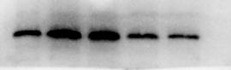

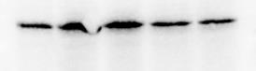

a-syn 5.27 第一批 2 可用

α-Syn-From left to right are Control, 6-OHDA, VC+6-OHDA, 0.001µM ICT+6-OHD, 0.01µM ICT+6-OHD group.

浆 内参 可用 5.28 1

核 内参 5.28 可用 .1

内 核 5.15

GAPDH-From left to right are Control, 6-OHDA, VC+6-OHDA, 0.001µM ICT+6-OHD, 0.01µM ICT+6-OHD group.

Figure 4. ICT mediates its protective effect by reducing the expression of TH protein by reducing oxidative stress.

10.27 TH 可用

nrf2 浆 第二批 1 0.1 0.01 剪

核 5.24 2 (2) 剪

TH-From left to right are Control, 6-OHDA, VC+6-OHDA, 0.001µM ICT+6-OHD, 0.01µM ICT+6-OHD group.

浆 内参 5.28可用

浆 内参 1 5.17

核 内参 5.17

GAPDH-From left to right are Control, 6-OHDA, VC+6-OHDA, 0.001µM ICT+6-OHD, 0.01µM ICT+6-OHD group.

Figure 5. ICT mediates its protective effect by changing the expression of Nrf2 related antioxidant genes.

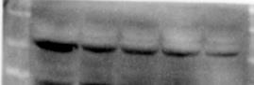

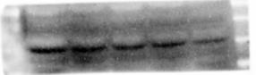

nrf2 浆 3 0.1 0.01 0.001 5.17  可用

Nrf2 Cytosol-From left to right are Control, 6-OHDA, VC+6-OHDA, 0.001µM ICT+6-OHD, 0.01µM ICT+6-OHD group.

浆 内参 5.24 可用

浆 内参 5.17 可用

核 内参 可用 5.28 .1

GAPDH-From left to right are Control, 6-OHDA, VC+6-OHDA, 0.001µM ICT+6-OHD, 0.01µM ICT+6-OHD group.

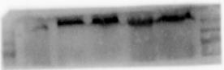

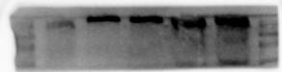

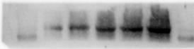

Nrf2 Nucleus-From left to right are Control, 6-OHDA, VC+6-OHDA, 0.001µM ICT+6-OHD, 0.01µM ICT+6-OHD group.

核 内参 5.17

核 内参 5.28

核 内参 5.28 可用

PNCA-From left to right are Control, 6-OHDA, VC+6-OHDA, 0.001µM ICT+6-OHD, 0.01µM ICT+6-OHD group.

HO-1 5.25 第二批 可用

HO-1 5.25 第三批 可用

HO-1 5.29 比上图

HO-1-From left to right are Control, 6-OHDA, VC+6-OHDA, 0.001µM ICT+6-OHD, 0.01µM ICT+6-OHD group.

actin 5.27 第三批 1

actin 可用

内参 actin 5.27

β-actin-From left to right are Control, 6-OHDA, VC+6-OHDA, 0.001µM ICT+6-OHD, 0.01µM ICT+6-OHD group.