Supplemental Table 1 Morphology and pathogenicity of the 15 isolates
Name | PCR results | Morphological character | Pathogenicity test
AG-1 | Stagonosporopsis cucurbitacearum | 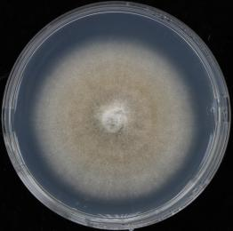 | 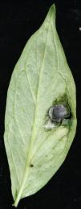 + + + +
AG-2 | Fusarium graminearum | 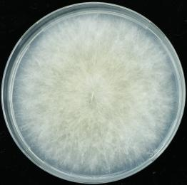 | 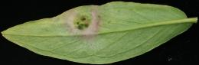 +
AG-3 | Stagonosporopsis cucurbitacearum | 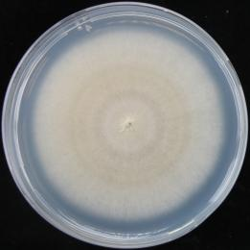 | 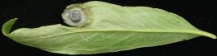 + + + +
AG-4 | Stagonosporopsis cucurbitacearum | 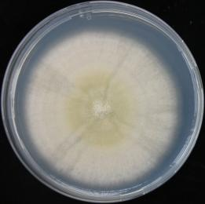 | 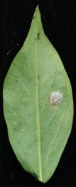 +
AG-5 | Stagonosporopsis cucurbitacearum | 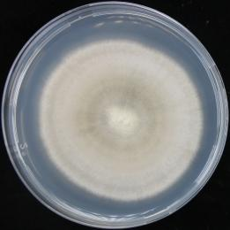 | 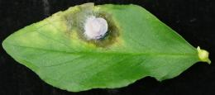 + + + + +
AG-6 | Stagonosporopsis cucurbitacearum | 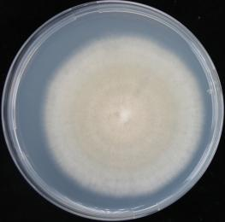 | 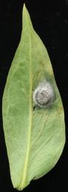 + + + +
AG-7 | Fusarium  incarnatum | 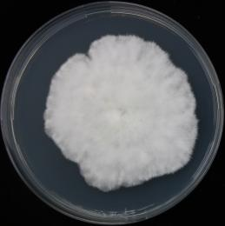 | 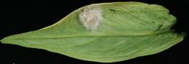 +
AG-8 | Stagonosporopsis cucurbitacearum | 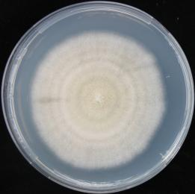 | 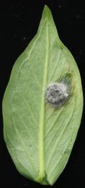 + + + +
AG-9 | Stagonosporopsis cucurbitacearum | 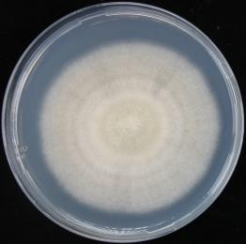 | 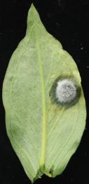 + + + +
AG-10 | Penicillium sp. |  | 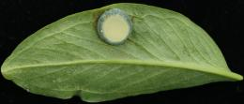 _
AG-11 | Stagonosporopsis cucurbitacearum | 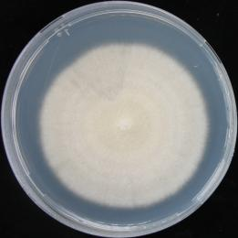 | 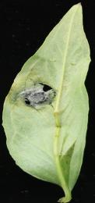 + + + +
AG-12 | Stagonosporopsis cucurbitacearum | 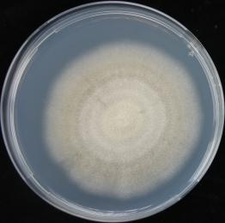 | 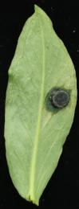 + + +
AG-13 | Stagonosporopsis cucurbitacearum | 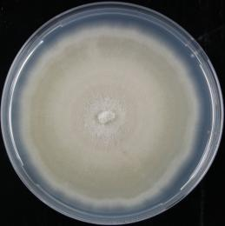 | 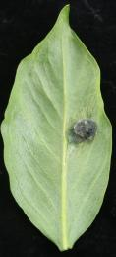 + +
AG-14 | Penicillium sp. | 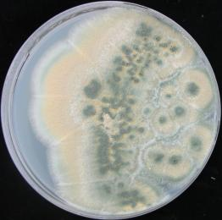 | 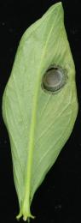 _
AG-15 | Stagonosporopsis cucurbitacearum | 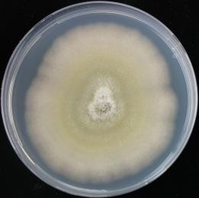 |    

