Supplementary Materials
S1 file. Occurrence points used in this study.

Table S2. Best models selected based on parameter settings in the process of model calibration, to produce final models for A. maculatum and D. andersoni. Reg. = regularization; AUC = area under the curve; ROC = receiver operating characteristic; AICc = Akaike information criterion corrected for small sample size. Best sets of environmental combinations were set 1 (PC1-PC4), set 2 (PC1-PC3), set 3 (PC1, PC2, PC4), set 4 (PC1, PC3, PC4), set 6 (PC1, PC2), and set 7 (PC1, PC3).
Feature class | Reg. multiplier | Variable set | Mean AUC ratio | partial ROC | Omission rate at 5% | AICc | Delta AICc | Parameters
Amblyomma maculatum
L, Q | 0.1 | Set 3 | 1.35 | 0 | 0.022 | 1738.395 | 0 | 6
L, Q | 0.2 | Set 3 | 1.35 | 0 | 0.022 | 1738.417 | 0.022 | 6
L, Q | 0.3 | Set 3 | 1.35 | 0 | 0.022 | 1738.443 | 0.047 | 6
L, Q | 0.1 | Set 6 | 1.35 | 0 | 0.022 | 1735.467 | 0.071 | 4
L, Q | 0.4 | Set 3 | 1.35 | 0 | 0.022 | 1738.473 | 0.077 | 6
L, Q | 0.2 | Set 6 | 1.35 | 0 | 0.022 | 1738.478 | 0.082 | 4
L, Q | 0.3 | Set 6 | 1.36 | 0 | 0.022 | 1738.49 | 0.095 | 4
L, Q | 0.5 | Set 3 | 1.35 | 0 | 0.022 | 1738.504 | 0.108 | 6
L, Q | 0.4 | Set 6 | 1.35 | 0 | 0.022 | 1738.505 | 0.109 | 4
L, Q | 0.5 | Set 6 | 1.35 | 0 | 0.022 | 1738.52 | 0.125 | 4
L, Q | 0.6 | Set 6 | 1.35 | 0 | 0.22 | 1738.537 | 0.142 | 4
L, Q | 0.6 | Set 3 | 1.35 | 0 | 0 | 1738.53 | 0.143 | 6
L, Q | 0.7 | Set 6 | 1.35 | 0 | 0.022 | 1738.556 | 0.160 | 4
L, Q | 0.7 | Set 3 | 1.35 | 0 | 0 | 1738.576 | 0.180 | 6
L, Q | 0.8 | Set 6 | 1.34 | 0 | 0.022 | 1738.576 | 0.180 | 4
L, Q | 0.9 | Set 6 | 1.35 | 0 | 0.022 | 1738.598 | 0.202 | 4
L, Q | 0.8 | Set 3 | 1.35 | 0 | 0 | 1738.618 | 0.222 | 6
L, Q | 1 | Set 6 | 1.35 | 0 | 0.022 | 1738.62 | 0.225 | 4
L, Q | 0.9 | Set 3 | 1.35 | 0 | 0 | 1783.661 | 0.265 | 6
L, Q | 1 | Set 3 | 1.35 | 0 | 0 | 1738.707 | 0.311 | 6
L, Q | 2 | Set 6 | 1.35 | 0 | 0 | 1738.925 | 0.529 | 4
L, Q, P | 2 | Set 6 | 1.37 | 0 | 0.022 | 1739.225 | 0.830 | 4
L, Q | 2 | Set 3 | 1.36 | 0 | 0 | 1739.322 | 0.927 | 6
L, Q, H | 2 | Set 3 | 1.36 | 0 | 0 | 1739.324 | 0.928 | 6
L, Q | 3 | Set 6 | 1.36 | 0 | 0 | 1739.359 | 0.963 | 4
L, Q, H | 3 | Set 6 | 1.37 | 0 | 0 | 1739.359 | 0.963 | 4
L, Q | 0.1 | Set 2 | 1.37 | 0 | 0.022 | 1739.771 | 1.376 | 6
L, Q | 0.1 | Set 1 | 1.36 | 0 | 0.022 | 1739.786 | 1.390 | 8
L, Q | 0.2 | Set 2 | 1.37 | 0 | 0.022 | 1739.788 | 1.392 | 6
L, Q | 0.3 | Set 2 | 1.36 | 0 | 0.022 | 1739.808 | 1.413 | 6
L, Q | 0.2 | Set 1 | 1.37 | 0 | 0.022 | 1739.81 | 1.415 | 8
L, Q | 0.4 | Set 2 | 1.37 | 0 | 0.022 | 1739.832 | 1.437 | 6
L, Q | 0.3 | Set 1 | 1.36 | 0 | 0.022 | 1739.839 | 1.44 | 8
L, Q | 0.5 | Set 2 | 1.37 | 0 | 0.022 | 1739.859 | 1.46 | 6
L, Q | 0.4 | Set 1 | 1.36 | 0 | 0.022 | 1739.876 | 1.48 | 8
L, Q | 0.6 | Set 2 | 1.37 | 0 | 0.022 | 1739.891 | 1.49 | 6
L, Q, H | 4 | Set 6 | 1.37 | 0 | 0 | 1739.912 | 1.51 | 4
L, Q | 4 | Set 6 | 1.37 | 0 | 0 | 1739.913 | 1.51 | 4
L, Q | 0.5 | Set 1 | 1.36 | 0 | 0.022 | 1739.914 | 1.51 | 8
L, Q | 3 | Set 1 | 1.38 | 0 | 0.022 | 1739.92 | 1.52 | 7
L, Q, H | 3 | Set 1 | 1.38 | 0 | 0.022 | 1739.925 | 1.52 | 7
L, Q | 0.7 | Set 2 | 1.37 | 0 | 0.022 | 1739.928 | 1.53 | 6
L, Q | 0.6 | Set 1 | 1.36 | 0 | 0.022 | 1739.961 | 1.56 | 8
L, Q | 0.8 | Set 2 | 1.36 | 0 | 0.022 | 1739.967 | 1.57 | 6
L, Q, P | 3 | Set 6 | 1.37 | 0 | 0.022 | 1739.967 | 1.57 | 4
L, Q, P, H | 3 | Set 6 | 1.38 | 0 | 0.022 | 1739.967 | 1.57 | 4
L, Q | 0.9 | Set 2 | 1.37 | 0 | 0.022 | 1740.009 | 1.61 | 6
L, Q | 0.7 | Set 1 | 1.37 | 0 | 0.022 | 1740.012 | 1.616 | 8
L, Q | 1 | Set 2 | 1.36 | 0 | 0.022 | 1740.053 | 1.658 | 6
L, Q | 0.8 | Set 1 | 1.37 | 0 | 0.022 | 1740.068 | 1.67 | 8
L, Q | 0.9 | Set 1 | 1.36 | 0 | 0.022 | 1740.128 | 1.733 | 8
L, Q, H | 3 | Set 3 | 1.36 | 0 | 0 | 1740.191 | 1.795 | 6
L, Q | 3 | Set 3 | 1.36 | 0 | 0 | 1740.192 | 1.796 | 6
L, Q | 1 | Set 1 | 1.36 | 0 | 0.022 | 1740.195 | 1.800 | 8
L, Q, H | 0.9 | Set 6 | 1.36 | 0 | 0.022 | 1740.289 | 1.893 | 9
Dermacentor andersoni
L, Q, H | 1 | Set 7 | 1.24 | 0 | 0.04 | 1592.484 | 0 | 5
L, Q, P | 2 | Set 4 | 1.23 | 0 | 0.04 | 1593.605 | 1.12 | 7

Figures
Fig. S3.
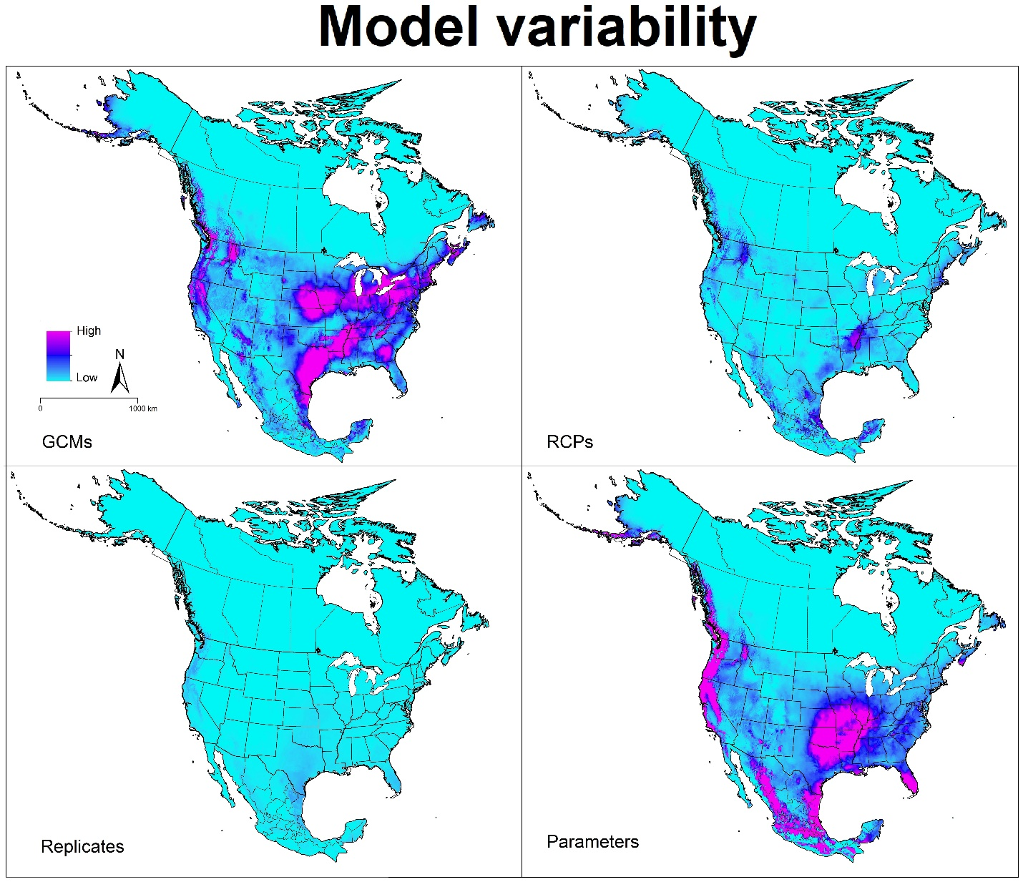
Amblyomma maculatum: Median of variance coming from replicates, parameters settings, general circulation models (GCMs) and representative concentration pathway scenarios (RCPs) in future projections.

Fig. S4.
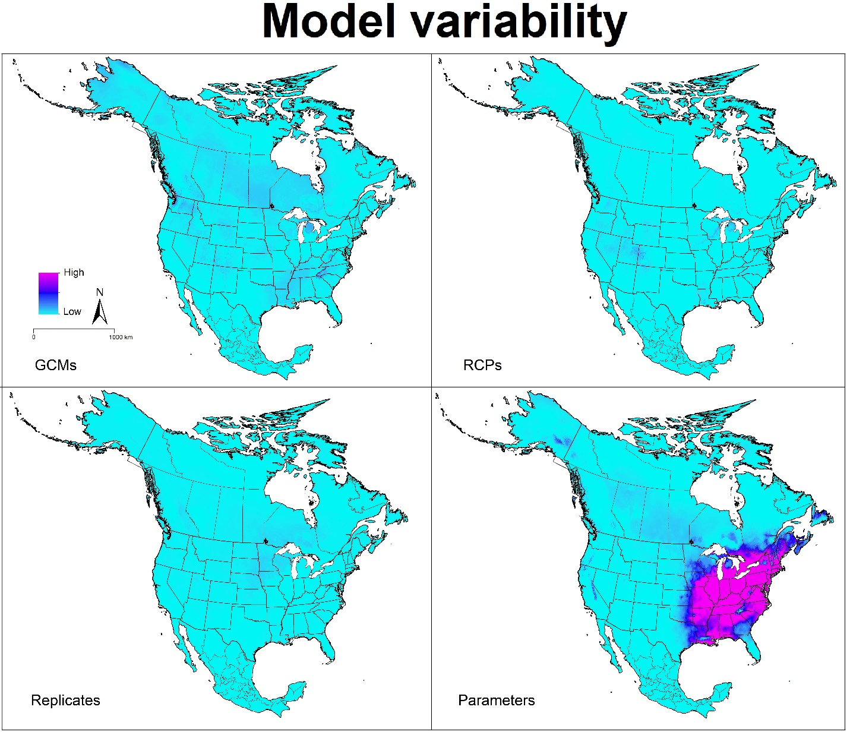
Dermacentor andersoni: Median of variance coming from replicates, parameters settings, general circulation models (GCMs) and representative concentration pathway scenarios (RCPs) in future projections.

