You can access the following link to get the raw data:
https://www.iprox.cn/page/PSV023.html;?url=1629267250633J4Ws. Password: qfHV. There is no need for a username and password. The steps are as follows:
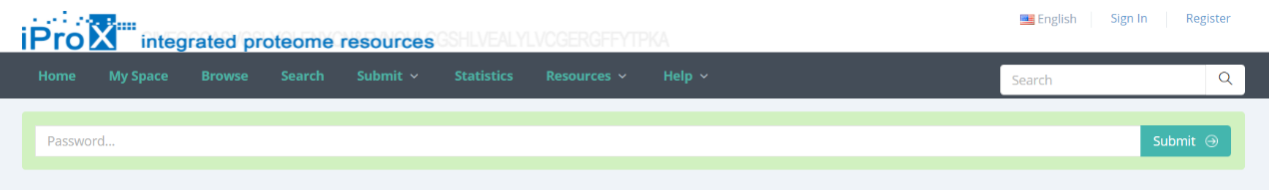
There don't need to click "sign in"

