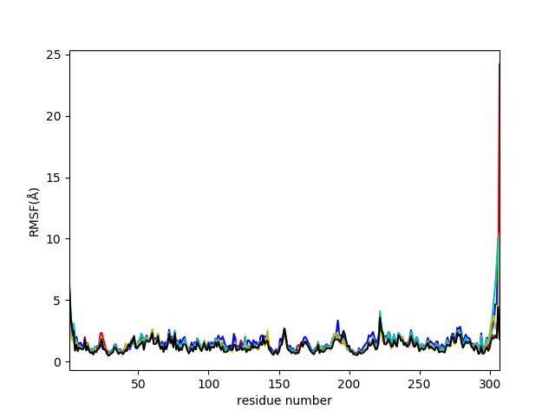

Supplementary figure 1. RMSF plot of 3CLpro complexes with ligands WS1 (red), WS4 (blue), WS7_v1 (cyan), WS7_v2 (olive), WS11 (black).

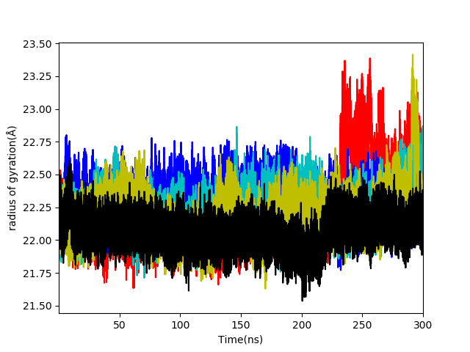

Supplementary figure 2. The radius of gyration plot of 3CLpro complexes with ligands WS1 (red), WS4 (blue), WS7_v1 (cyan), WS7_v2 (olive), WS11 (black).

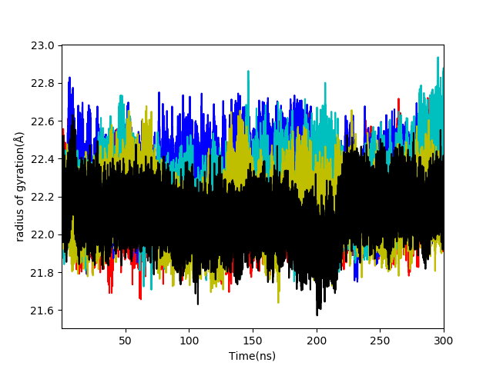

Supplementary figure 3. The radius of gyration plot of 3CLpro receptor of ligands WS1 (red), WS4 (blue), WS7_v1 (cyan), WS7_v2 (olive), WS11 (black)

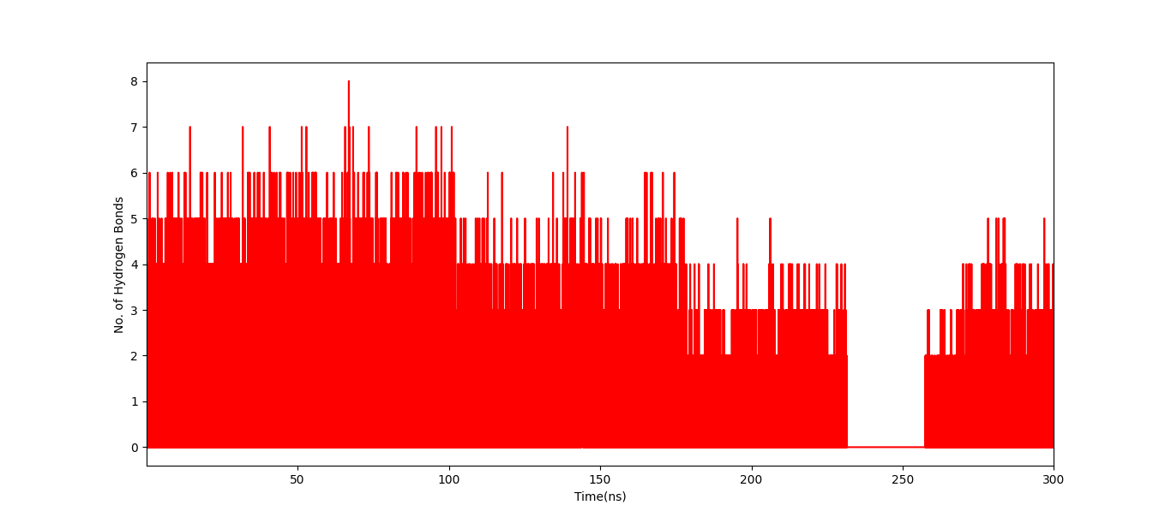

Supplementary figure 4. Number of intermolecular hydrogen bonds for the 3CLpro complexes with WS1 ligand.

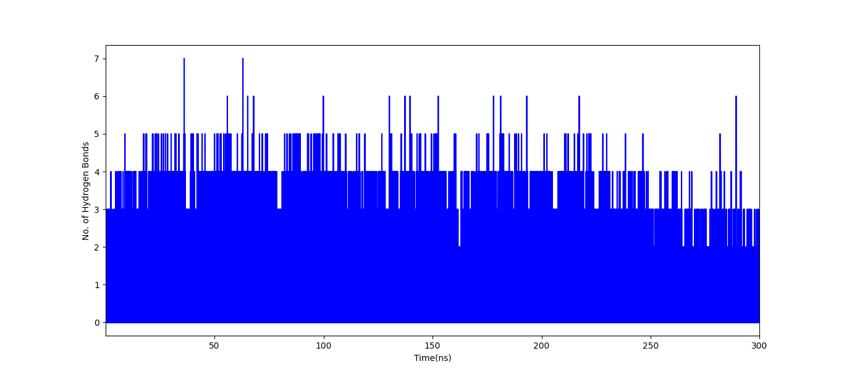

Supplementary figure 5. Number of intermolecular hydrogen bonds for the 3CLpro complexes with WS4 ligand.

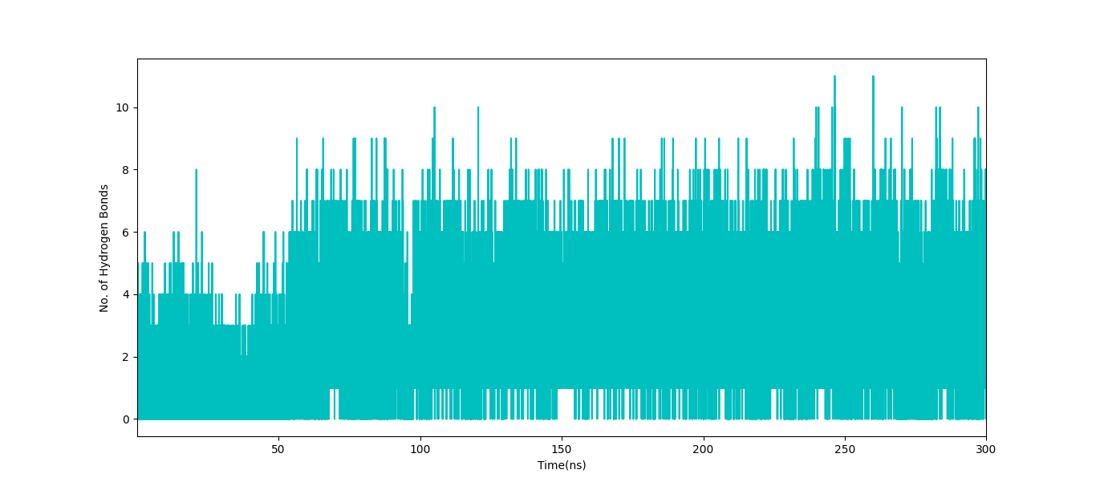

Supplementary figure 6. Number of intermolecular hydrogen bonds for the 3CLpro complexes with WS7_v1 ligand.

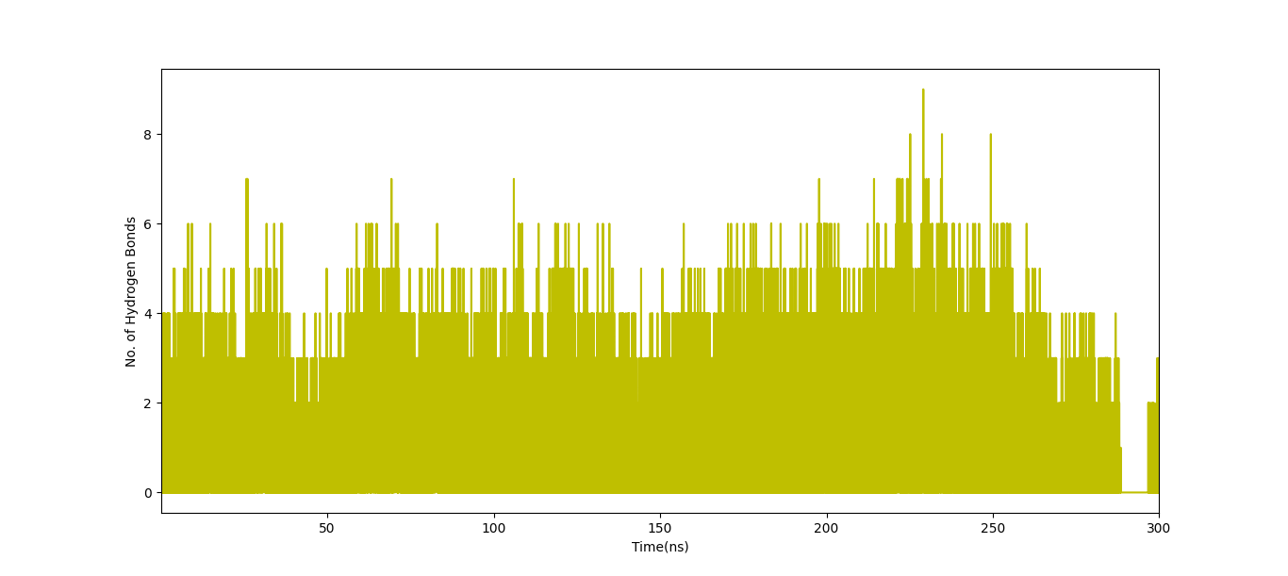

Supplementary figure 7. Number of intermolecular hydrogen bonds for the 3CLpro complexes with WS7_v2 ligand.

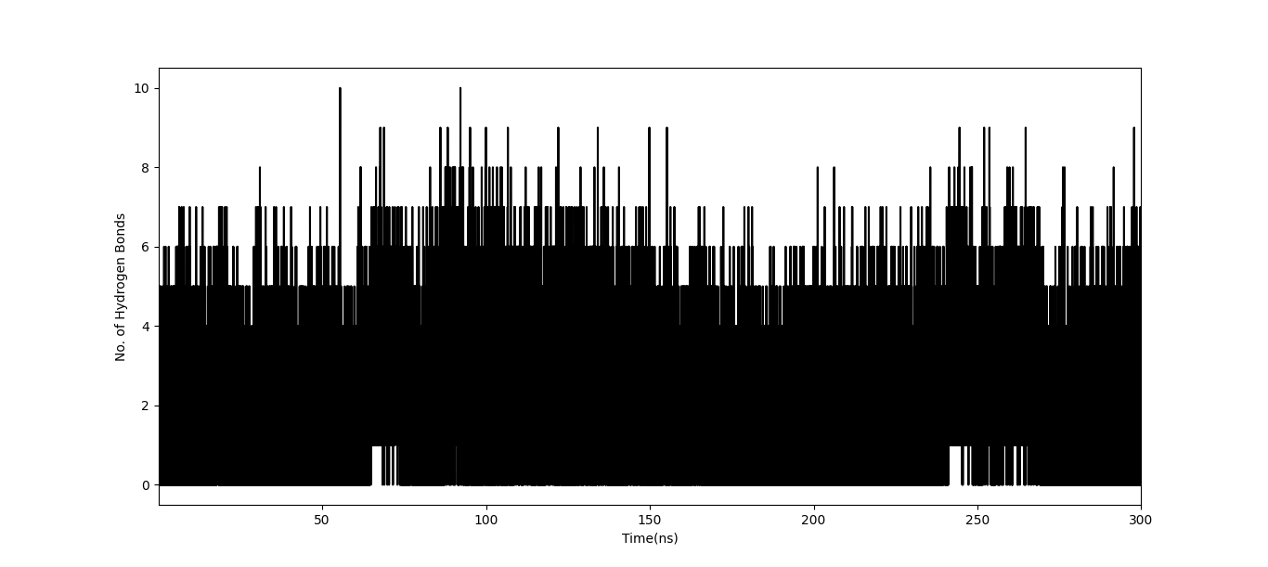

Supplementary figure 8. Number of intermolecular hydrogen bonds for the 3CLpro complexes with WS11 ligand.