Evaluation questionnaire of the crown lengthening teaching model (for students)

- Please try to answer what factors should be considered in the design before crown lengthening?

- In this picture, the 23 was a residual root and the edge of the fracture was at the same level or 1 mm below the gingival margin, which needed to receive crown lengthening surgery. The edge of the fracture should be exposed with 1 mm beyond the gingival margin postoperatively, please draw the labial incision line in the picture below (text description was allowed).
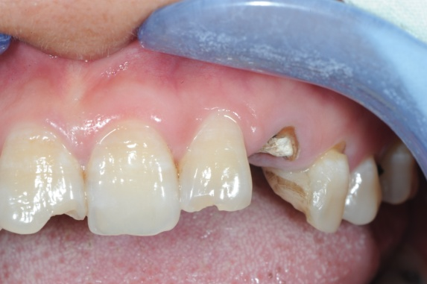 | 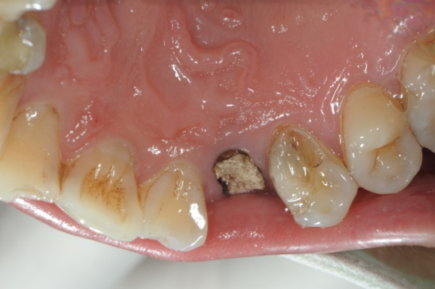

- The pictures showed the crown fracture of 25, and the edges of the fracture were 2-3 mm below the gingival margin at interproximal and palatal sites, which needed to receive crown lengthening surgery. The edge of the fracture should be exposed with 1 mm beyond the gingival margin postoperatively, please draw the incision line in the picture below (text description was allowed).
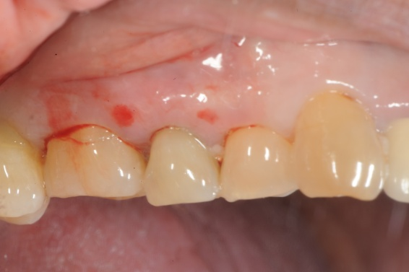 | 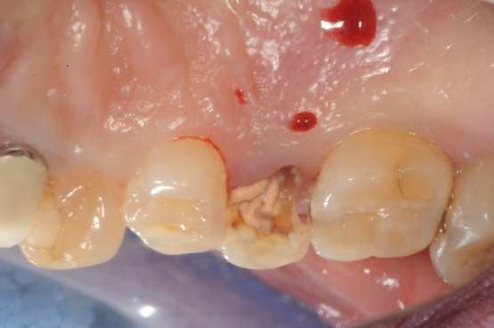

- The pictures showed the crown fracture of 47. The edges of the fracture were 2 mm below the gingival margin at the distal-buccal sides and at the same level with the gingival margin at distal side. The edge of the fracture should be exposed with 1 mm beyond the gingival margin postoperatively, please draw the incision line in the picture below (text description was allowed).
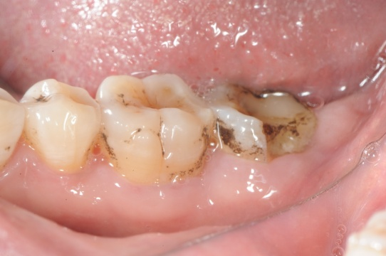 | 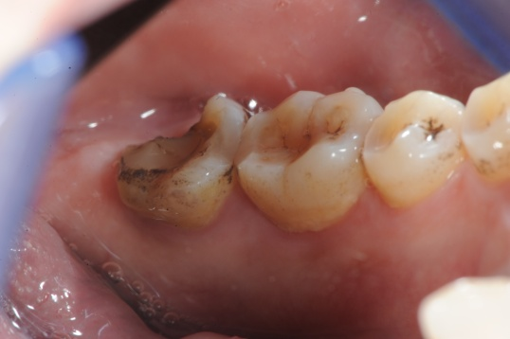

- The edge of the fracture was 2 mm beyond the alveolar crest, if the edge of the fracture should be exposed with 1 mm beyond the gingival margin after crown lengthening surgery, please give the amount of osteotomy procedures and your evidence.

- When performing the crown lengthening surgery in the esthetic area, please try to describe the ideal morphology at labial and interproximal sides after osteotomy in words or drawings.

- When performing the crown lengthening surgery in the molar area, please try to describe the ideal morphology at labial and interproximal sides after osteotomy in words or drawings.

- Please try to score how this crown lengthening surgical model and training mode help you master and understand the theory and operation of crown lengthening surgery? (VAS, after class)

10
0

- Do you have any suggestions for the surgical model？

