Supplementary materials 1

Table 1 Forward and reverse primer pairs.

Gene names | Forward | Reverse
Ptprc  Fn1  Tyrobp  Emr1  Itgb2  Itgax  Cd44  CtSS  Ly86  Aif1 | GTGCCCATCAGTTCCTTACA  TCCTGTCTACCTCACAGACTAC  TGTGGTGTCCAGTGCATATC  ATTGCGGGATTCCTACACTATC  TTTACTTGCGACCAGGACAG  GTGCCCATCAGTTCCTTACA  GCAGAAATCAAGACGTTATGGG  GACGCTTCCTATCCCTACAAAG  TGGGTCACTCTTCCGATCTTA  GGAGTTTGATCTGAATGGAAATGG | GTCAGCTCCACAGTTCTTCTC  GTCTACTCCACCGAACAACAA  GACTTAATCCTCCCACAGTCAG  TTCACCACCTTCAGGTTTCTC  GAGGAGAGATCCATGAGGTAGT  GTCAGCTCCACAGTTCTTCTC  AAGCACCACCACCAAAGA  CCAAACGGGAGCTGAATGTA  ACTCAGGGTCCTCAGAAATAGA  TTCAGCTCTAGGTGGGTCTT

Table 2 Differentially expressed genes (DEGs).

ID | FC | pValue | adj.P.Val | t value | Gene Name
ILMN_1234487  ILMN_2638914  ILMN_2433119  ILMN_1230039  ILMN_3084087  ILMN_1239102  ILMN_2826916  ILMN_1217978  ILMN_1221817  ILMN_1225835  ILMN_1236393  ILMN_2518744  ILMN_2734729  ILMN_1240846  ILMN_2885990  ILMN_1238215  ILMN_3143483  ILMN_2451022  ILMN_1216953  ILMN_2631423  ILMN_1228314  ILMN_1249498  ILMN_1237224  ILMN_1250421  ILMN_2700848  ILMN_1243407  ILMN_2618408  ILMN_1218123  ILMN_1253370  ILMN_2854943  ILMN_2840430  ILMN_2742152  ILMN_1228031  ILMN_1253304  ILMN_2711267  ILMN_2737713  ILMN_2765224  ILMN_2728270  ILMN_2675760  ILMN_1222452  ILMN_2498731  ILMN_2750053  ILMN_1225699  ILMN_1253178  ILMN_2619983  ILMN_2595200  ILMN_2609998  ILMN_2653132  ILMN_3113303  ILMN_2931918  ILMN_2974798  ILMN_1242170  ILMN_2870522  ILMN_2970473  ILMN_1233424  ILMN_1244316  ILMN_1233127  ILMN_2643470  ILMN_1256369  ILMN_1235390  ILMN_2743013  ILMN_2681516  ILMN_2764580  ILMN_2472741  ILMN_1220170  ILMN_3008858  ILMN_1253813  ILMN_2651715  ILMN_2717439  ILMN_2999439  ILMN_2932964  ILMN_2693205  ILMN_2867147  ILMN_2677231  ILMN_1221199  ILMN_2715802  ILMN_2694955  ILMN_2772077  ILMN_2649333  ILMN_2596396  ILMN_2950422  ILMN_2629395  ILMN_1220234  ILMN_3060766  ILMN_1231814  ILMN_1246861  ILMN_2623983  ILMN_2980663  ILMN_1242427  ILMN_1236718  ILMN_1217849  ILMN_1247377  ILMN_1236188  ILMN_2829262  ILMN_2821916  ILMN_2700408  ILMN_2834379  ILMN_2596346  ILMN_2619620  ILMN_2588515  ILMN_2701321  ILMN_2631161  ILMN_1259418  ILMN_2971721  ILMN_2987862  ILMN_1249378  ILMN_2656422  ILMN_2942674  ILMN_2598103  ILMN_2664224  ILMN_3115796  ILMN_2592881  ILMN_1251390  ILMN_2725927  ILMN_2776431  ILMN_2618364  ILMN_2960308  ILMN_2707017  ILMN_2706730  ILMN_2590961  ILMN_2626359  ILMN_2668536  ILMN_2720836  ILMN_2714796  ILMN_2676022  ILMN_2993221  ILMN_1248367  ILMN_1213449  ILMN_2608133  ILMN_2642681  ILMN_2866856  ILMN_2660851  ILMN_2748875  ILMN_2856588  ILMN_2660099  ILMN_1230287  ILMN_1237375  ILMN_1229573  ILMN_2776922  ILMN_2790188  ILMN_1254692  ILMN_2622500  ILMN_1252481  ILMN_2671923  ILMN_1229155  ILMN_3112334  ILMN_1249486  ILMN_2459899  ILMN_2424060  ILMN_2715840  ILMN_1219017  ILMN_2745876  ILMN_2660555  ILMN_2604029  ILMN_1246486  ILMN_2628629  ILMN_2874853  ILMN_1254256  ILMN_2697433  ILMN_1254927  ILMN_2788593  ILMN_1220939  ILMN_2473620  ILMN_2767615  ILMN_1247947  ILMN_2994744  ILMN_2710159  ILMN_1239239  ILMN_2665535  ILMN_2663211  ILMN_2699488  ILMN_2513570  ILMN_1217021  ILMN_1254577  ILMN_1248139  ILMN_2940642  ILMN_2718662  ILMN_1232716  ILMN_2776008  ILMN_2768972  ILMN_2878071  ILMN_2510694  ILMN_2616226  ILMN_1230890  ILMN_1213850  ILMN_2657478  ILMN_2603725  ILMN_1238644  ILMN_2653385  ILMN_1228320  ILMN_2733185  ILMN_2671572  ILMN_2756704  ILMN_1239729  ILMN_1218949  ILMN_2934120  ILMN_2866185  ILMN_2772595  ILMN_2710274  ILMN_3145415  ILMN_1222602  ILMN_1216880  ILMN_2488360  ILMN_2745425  ILMN_2588682  ILMN_2433213  ILMN_2485526  ILMN_2508679  ILMN_2594031  ILMN_2915232  ILMN_2437254  ILMN_2803674  ILMN_3158250  ILMN_1260456  ILMN_2955919  ILMN_2500533  ILMN_2632712  ILMN_1255834  ILMN_2513960  ILMN_1239430  ILMN_1226395  ILMN_3114585  ILMN_1251634  ILMN_2861787  ILMN_1221067  ILMN_1217389  ILMN_2609323  ILMN_2503553  ILMN_1224077  ILMN_1219946  ILMN_1238603  ILMN_2939681  ILMN_2671056  ILMN_2737685  ILMN_2678127  ILMN_2759309  ILMN_2780280  ILMN_2614966  ILMN_2675232  ILMN_1256142  ILMN_1248441  ILMN_1226619  ILMN_2597769  ILMN_2595664  ILMN_1256676  ILMN_2699531  ILMN_3052632  ILMN_3144575  ILMN_2710419  ILMN_2947526  ILMN_2716935  ILMN_2543393  ILMN_1254031  ILMN_1239386  ILMN_2910934  ILMN_2660263  ILMN_2686975  ILMN_2936118  ILMN_2592253  ILMN_2793817  ILMN_1255739  ILMN_2865335  ILMN_1259400  ILMN_2670713  ILMN_2617433  ILMN_2419146  ILMN_1223257  ILMN_2757125  ILMN_1227458  ILMN_1248994  ILMN_2716185  ILMN_2704619  ILMN_1237186  ILMN_3143604  ILMN_1249637  ILMN_2958464  ILMN_1221048  ILMN_2480682  ILMN_2718217  ILMN_2686327  ILMN_1212836  ILMN_2688894  ILMN_2621752  ILMN_2678580  ILMN_2810882  ILMN_2692723  ILMN_2634235  ILMN_2669062  ILMN_2744164  ILMN_1216871  ILMN_1212702  ILMN_2759159  ILMN_2762528  ILMN_1219978  ILMN_2774121  ILMN_1244291  ILMN_1227907  ILMN_1228654  ILMN_1242661  ILMN_2630459  ILMN_2951691  ILMN_2457571  ILMN_2719139  ILMN_2646618  ILMN_1235158  ILMN_2777498  ILMN_2814974  ILMN_2956092  ILMN_2617228  ILMN_3006219  ILMN_2727172  ILMN_2723108  ILMN_2665441  ILMN_3118707  ILMN_2517041  ILMN_2619107  ILMN_1237038  ILMN_2588244  ILMN_2825574  ILMN_3003864  ILMN_2729958  ILMN_2655024  ILMN_2785454  ILMN_2769490  ILMN_2709211  ILMN_2765741  ILMN_2723639  ILMN_1221146  ILMN_2501489  ILMN_2888834  ILMN_1230357  ILMN_1235619  ILMN_1240938  ILMN_2723305  ILMN_2599192  ILMN_2777034  ILMN_1223317  ILMN_1253659  ILMN_1231012  ILMN_2622374  ILMN_2621448  ILMN_1256989  ILMN_2693991  ILMN_2983525  ILMN_1254276  ILMN_1233989  ILMN_1230157  ILMN_3132898  ILMN_1248830  ILMN_1219574  ILMN_2698449  ILMN_3040069  ILMN_2525565  ILMN_1234223  ILMN_1238276  ILMN_2757966  ILMN_2836654  ILMN_1227951  ILMN_1230708  ILMN_2638017  ILMN_1255416  ILMN_1245246  ILMN_2529842  ILMN_2661971  ILMN_2887986  ILMN_2847144  ILMN_1256476  ILMN_2985128  ILMN_2632034  ILMN_1226839  ILMN_1241892  ILMN_2745370  ILMN_2731901 | 1.99  -2.57  -1  -1.23  1.31  1.88  1.04  -1.01  3.09  -1.59  1.11  -1.25  2.34  -1.5  -1.39  1.88  2.76  1.07  -1.05  2.82  -1.25  1.57  -1.55  2.07  1.62  -2.47  -1.4  3.5  1.4  -1.23  -1.25  1.1  -1.46  -1.35  1.26  1.01  -1.36  1.33  -1.27  -1.06  -1.38  -1.25  -1.76  -2.36  -1.05  -1.16  -1.18  2.31  -1.35  -1.05  1.15  -1.69  -1.77  1.08  -1  2.58  -1.08  1.39  -1.37  -1.13  1.08  1.56  1.18  -1.33  -1.08  1.88  1.64  1.36  1.41  -1.31  1  1.2  3.08  -1.17  -1.31  1.05  1.31  1.12  -1.36  -1.33  -1.19  -1.25  -1.34  -1.42  1.91  2.39  1.02  -1.31  -1.2  2.04  3.4  2.41  -1.04  -1.11  -1.2  -1.2  2.13  1.6  2.49  -1.04  1.2  1.79  -1.04  -1.04  -1.02  -1.2  1.68  -1.83  -1.6  -1.41  -1.09  -1.89  1.55  1.54  1.56  1.25  1.05  -1.1  -1.35  -1.01  -1.11  -1.02  1.43  2.13  -1.03  -1.12  -1.56  -1.08  -2.03  1.08  1.22  1.08  2.09  -1.21  1.03  1.25  -1.23  1.59  1.21  -1.78  1.79  -1.08  1.25  1.12  1.04  -1.36  2.8  -1.41  -1.56  1.92  -1  -1.26  2.26  -1.06  -1.32  1.1  1.11  -1.3  -1.05  -1.7  -1.34  -1.02  -1.1  -1.71  -1.32  -1.26  -1.03  -1.3  -1.79  -1.04  -1.54  -1.26  -1.04  1.4  1.26  -1.82  1.17  -1.68  -1.26  -1.67  2.86  -2.17  -1.62  -1.19  -1.98  1.87  1.18  -1.02  1.18  1.73  -1.27  1.04  -1.37  -1.33  -1.54  1.86  1.09  1.05  -1.47  1.01  1.21  2.09  -1.42  1.28  -1.68  -1.04  -1.36  1.13  -1.01  1.66  -1.02  2.14  1.1  -1.12  1.25  -1.36  1.19  1.05  -1.59  1.19  -1.46  1.02  -1.81  1.73  1.08  1.21  1.22  1.87  1.29  1.24  -1.49  2.61  1.35  2.51  -1.04  1.03  -1.06  -1.18  -2.08  1.86  -1.24  1.06  -1.37  -1.49  1.07  1.84  -1.05  -1.04  -1.31  -1.21  1.64  1.39  -1.1  1.17  1.71  1.58  -1.02  1.14  1.97  -1.22  1.49  -1.62  1.07  1.28  1.17  1.06  1.15  1.05  -1.17  -2.01  -1.7  -1.14  1.64  1.1  -1.19  1.36  1.07  -1.22  1.28  -1.01  1.62  1.2  1.33  1.04  1.16  1.64  1.28  -1.76  -1.19  1.14  1.45  1.42  -1.09  -1.07  -1.14  2.3  1.14  1.03  1.41  1.42  2.34  -1.01  1.1  1.66  -1.17  1.62  1.75  1.04  1.1  1.33  1.2  -1.36  -1.76  1.03  1.37  1.15  1.46  1.27  1.26  -1.42  2.1  1.58  1.08  1.07  1.24  -1.22  -1.1  -2.35  1.17  1.35  -1.6  -1.01  -1.21  1.13  1.02  1.4  1.84  1.39  1.26  -1.21  -1.03  1.24  1.05  1.05  1.17  1.13  1.12  -1.05  1.71  1.75  1.32  1.63  1.51  1.21  1.64  1.69  1.95  1.66  1.6  -1.06  -1.69  -1.01  -1  1.08  1.24  1.73  -1.29  1.38  1.59  1.89  -1.26  -1.21  1.14 | 1.19E-07  3.08E-07  6.31E-06  1.21E-05  2.51E-05  2.96E-05  4.49E-05  4.72E-05  4.97E-05  6.29E-05  7.08E-05  1.02E-04  1.11E-04  1.13E-04  1.22E-04  1.22E-04  1.24E-04  1.33E-04  1.34E-04  1.38E-04  1.48E-04  1.98E-04  1.98E-04  2.07E-04  2.38E-04  2.42E-04  2.49E-04  2.64E-04  2.72E-04  3.07E-04  3.12E-04  3.42E-04  3.65E-04  4.09E-04  4.61E-04  4.68E-04  4.75E-04  4.95E-04  5.69E-04  5.75E-04  6.04E-04  6.14E-04  6.20E-04  6.93E-04  7.13E-04  7.29E-04  7.40E-04  7.42E-04  7.66E-04  7.81E-04  8.00E-04  8.21E-04  9.32E-04  9.33E-04  9.37E-04  1.00E-03  1.01E-03  1.05E-03  1.13E-03  1.13E-03  1.15E-03  1.16E-03  1.17E-03  1.17E-03  1.23E-03  1.28E-03  1.28E-03  1.33E-03  1.33E-03  1.37E-03  1.44E-03  1.50E-03  1.52E-03  1.55E-03  1.56E-03  1.57E-03  1.69E-03  1.69E-03  1.71E-03  1.72E-03  1.76E-03  1.78E-03  1.85E-03  1.89E-03  1.90E-03  1.96E-03  2.04E-03  2.07E-03  2.11E-03  2.31E-03  2.34E-03  2.38E-03  2.57E-03  2.67E-03  2.75E-03  2.78E-03  2.78E-03  2.86E-03  3.05E-03  3.05E-03  3.09E-03  3.27E-03  3.31E-03  3.44E-03  3.46E-03  3.49E-03  3.50E-03  3.62E-03  3.71E-03  3.82E-03  3.88E-03  4.06E-03  4.10E-03  4.18E-03  4.21E-03  4.22E-03  4.35E-03  4.36E-03  4.61E-03  4.66E-03  4.74E-03  4.77E-03  4.89E-03  5.10E-03  5.18E-03  5.20E-03  5.23E-03  5.38E-03  5.55E-03  5.65E-03  5.93E-03  6.03E-03  6.09E-03  6.14E-03  6.18E-03  6.18E-03  6.52E-03  6.62E-03  6.64E-03  6.69E-03  6.90E-03  6.99E-03  7.06E-03  7.25E-03  7.38E-03  7.51E-03  7.54E-03  7.56E-03  7.58E-03  7.67E-03  7.74E-03  7.88E-03  7.94E-03  7.96E-03  7.97E-03  8.03E-03  8.06E-03  8.85E-03  9.25E-03  9.34E-03  9.40E-03  9.50E-03  9.53E-03  9.66E-03  9.69E-03  9.81E-03  9.85E-03  9.86E-03  9.90E-03  9.92E-03  9.93E-03  1.00E-02  1.00E-02  1.01E-02  1.02E-02  1.05E-02  1.05E-02  1.06E-02  1.06E-02  1.07E-02  1.08E-02  1.09E-02  1.12E-02  1.13E-02  1.15E-02  1.15E-02  1.17E-02  1.18E-02  1.19E-02  1.19E-02  1.20E-02  1.23E-02  1.23E-02  1.23E-02  1.24E-02  1.24E-02  1.24E-02  1.25E-02  1.25E-02  1.26E-02  1.27E-02  1.27E-02  1.29E-02  1.30E-02  1.30E-02  1.30E-02  1.31E-02  1.31E-02  1.32E-02  1.34E-02  1.35E-02  1.37E-02  1.40E-02  1.41E-02  1.44E-02  1.46E-02  1.46E-02  1.47E-02  1.47E-02  1.47E-02  1.49E-02  1.51E-02  1.52E-02  1.52E-02  1.54E-02  1.55E-02  1.57E-02  1.58E-02  1.60E-02  1.61E-02  1.61E-02  1.62E-02  1.63E-02  1.64E-02  1.65E-02  1.67E-02  1.67E-02  1.68E-02  1.69E-02  1.72E-02  1.73E-02  1.73E-02  1.73E-02  1.78E-02  1.78E-02  1.80E-02  1.81E-02  1.81E-02  1.81E-02  1.82E-02  1.83E-02  1.84E-02  1.86E-02  1.87E-02  1.88E-02  1.88E-02  1.89E-02  1.93E-02  1.93E-02  1.94E-02  1.99E-02  2.01E-02  2.01E-02  2.02E-02  2.02E-02  2.03E-02  2.05E-02  2.06E-02  2.09E-02  2.14E-02  2.16E-02  2.19E-02  2.22E-02  2.24E-02  2.29E-02  2.32E-02  2.33E-02  2.35E-02  2.36E-02  2.38E-02  2.39E-02  2.42E-02  2.46E-02  2.46E-02  2.49E-02  2.54E-02  2.54E-02  2.55E-02  2.56E-02  2.58E-02  2.61E-02  2.61E-02  2.63E-02  2.63E-02  2.65E-02  2.76E-02  2.76E-02  2.77E-02  2.79E-02  2.86E-02  2.90E-02  2.90E-02  2.91E-02  2.96E-02  2.97E-02  3.01E-02  3.01E-02  3.14E-02  3.14E-02  3.19E-02  3.23E-02  3.24E-02  3.25E-02  3.29E-02  3.30E-02  3.32E-02  3.33E-02  3.33E-02  3.34E-02  3.38E-02  3.39E-02  3.41E-02  3.45E-02  3.45E-02  3.46E-02  3.57E-02  3.58E-02  3.59E-02  3.70E-02  3.71E-02  3.72E-02  3.72E-02  3.73E-02  3.73E-02  3.80E-02  3.82E-02  3.86E-02  3.87E-02  3.95E-02  3.96E-02  3.97E-02  4.00E-02  4.02E-02  4.03E-02  4.08E-02  4.13E-02  4.15E-02  4.21E-02  4.25E-02  4.36E-02  4.39E-02  4.42E-02  4.43E-02  4.46E-02  4.54E-02  4.56E-02  4.57E-02  4.64E-02  4.68E-02  4.75E-02  4.79E-02  4.81E-02  4.82E-02  4.83E-02  4.84E-02  4.84E-02  4.86E-02  4.86E-02  4.89E-02  4.93E-02  4.96E-02  4.98E-02  4.98E-02 | 0.00367  0.00465  0.05223  0.05223  0.05296  0.05328  0.06092  0.06092  0.06092  0.06407  0.06407  0.06463  0.06463  0.06463  0.06555  0.06555  0.06555  0.06555  0.06555  0.06555  0.06607  0.06758  0.06758  0.06994  0.0719  0.07205  0.07332  0.0746  0.0746  0.07752  0.07752  0.07966  0.08032  0.0831  0.08491  0.08515  0.08555  0.08555  0.08912  0.08912  0.08912  0.08912  0.08939  0.09225  0.09363  0.09412  0.09462  0.09462  0.09486  0.09511  0.09588  0.09652  0.0992  0.0992  0.09921  0.10152  0.10152  0.10205  0.10555  0.10563  0.10679  0.10704  0.10704  0.10704  0.1078  0.10802  0.10802  0.10874  0.10874  0.10908  0.1116  0.11287  0.11306  0.11315  0.11315  0.11345  0.11753  0.11753  0.11759  0.11759  0.11759  0.11774  0.11806  0.11806  0.11806  0.11885  0.12078  0.12162  0.12318  0.12687  0.12712  0.12812  0.13294  0.13545  0.13675  0.13693  0.13693  0.13777  0.14142  0.14142  0.1423  0.14653  0.14702  0.1503  0.15083  0.1515  0.15168  0.15325  0.15468  0.1568  0.15719  0.15959  0.15979  0.16022  0.16022  0.16023  0.16168  0.16168  0.16581  0.16609  0.16738  0.16752  0.16881  0.17071  0.17124  0.17131  0.17165  0.17351  0.1736  0.17555  0.17727  0.17812  0.17874  0.17929  0.17959  0.17959  0.1834  0.18454  0.18476  0.18515  0.18646  0.18731  0.18828  0.18992  0.19158  0.19222  0.19222  0.19222  0.19223  0.1932  0.19395  0.19555  0.19632  0.19681  0.19682  0.19748  0.19748  0.20544  0.20907  0.20992  0.21071  0.21163  0.21185  0.21235  0.21253  0.21322  0.21331  0.21331  0.21331  0.21331  0.21334  0.21425  0.21425  0.21468  0.21546  0.2175  0.2178  0.21839  0.21839  0.21927  0.21953  0.22012  0.22152  0.22263  0.22349  0.22349  0.22525  0.22525  0.22603  0.22603  0.22612  0.22775  0.22777  0.22777  0.22779  0.22779  0.22779  0.22779  0.22781  0.22837  0.22904  0.22904  0.2306  0.23085  0.23085  0.23085  0.23181  0.2323  0.23254  0.23395  0.23448  0.23547  0.23682  0.23754  0.23883  0.24006  0.24012  0.24056  0.2407  0.2407  0.24172  0.24247  0.24255  0.24263  0.24278  0.24367  0.24409  0.24592  0.24667  0.24755  0.24755  0.24782  0.24785  0.24785  0.24904  0.25016  0.25049  0.2507  0.2507  0.25186  0.2521  0.2521  0.2521  0.25398  0.25407  0.25537  0.25568  0.25568  0.25569  0.25631  0.2565  0.25658  0.2583  0.25869  0.25887  0.25887  0.25937  0.26145  0.26145  0.26174  0.26507  0.26546  0.26546  0.2659  0.26618  0.26635  0.26759  0.26759  0.26845  0.26987  0.27082  0.27189  0.27329  0.27413  0.27669  0.27845  0.27845  0.27915  0.27964  0.28092  0.28115  0.28259  0.28437  0.28477  0.28546  0.28689  0.28689  0.28733  0.28733  0.28895  0.28992  0.28992  0.29087  0.29087  0.29174  0.29641  0.29683  0.29695  0.29747  0.30064  0.30232  0.30256  0.30259  0.30521  0.30521  0.30751  0.30751  0.31236  0.31241  0.31421  0.31544  0.31577  0.31591  0.31733  0.31774  0.31812  0.31836  0.31841  0.31865  0.32037  0.32062  0.32117  0.32243  0.32284  0.32284  0.32574  0.32574  0.32592  0.32901  0.32901  0.32929  0.32935  0.32946  0.32946  0.33162  0.33237  0.33308  0.33312  0.33614  0.33624  0.33671  0.33762  0.33807  0.33856  0.34016  0.34122  0.34177  0.34393  0.3447  0.34767  0.34825  0.34895  0.34923  0.34998  0.35213  0.3526  0.35281  0.35467  0.35558  0.35784  0.35866  0.35936  0.35971  0.35984  0.35988  0.35988  0.36032  0.36032  0.3611  0.36202  0.36244  0.36277  0.36295 | 3.55E+01  ######  ######  ######  1.31E+1  1.27E+1  1.18E+01  #######  1.15E+01  #######  1.08E+01  #######  9.89  -9.86  -9.71  9.71  9.68  9.55  -9.54  9.48  -9.36  8.85  -8.84  8.77  8.53  -8.51  -8.46  8.36  8.31  -8.12  -8.09  7.94  -7.84  -7.67  7.49  7.47  -7.44  7.38  -7.18  -7.17  -7.1  -7.07  -7.06  -6.9  -6.86  -6.83  -6.81  6.81  -6.76  -6.74  6.7  -6.67  -6.5  6.5  -6.49  6.4  -6.4  6.34  -6.25  -6.25  6.23  6.22  6.2  -6.2  -6.14  6.09  6.08  6.04  6.04  -6  5.94  5.89  5.88  -5.85  -5.84  5.84  5.75  5.74  -5.73  -5.73  -5.7  -5.69  -5.64  -5.61  5.61  5.57  5.53  -5.51  -5.48  5.38  5.36  5.34  -5.26  -5.21  -5.18  -5.17  5.17  5.14  5.07  -5.07  5.05  4.99  -4.98  -4.94  -4.93  -4.92  4.92  -4.88  -4.86  -4.82  -4.81  -4.76  4.75  4.73  4.72  4.72  4.69  -4.69  -4.63  -4.62  -4.6  -4.59  4.57  4.52  -4.51  -4.5  -4.5  -4.47  -4.44  4.42  4.37  4.35  4.35  -4.34  4.33  4.33  -4.28  4.26  4.26  -4.25  4.22  -4.21  4.2  4.17  4.16  -4.14  4.14  -4.13  -4.13  4.12  -4.11  -4.09  4.09  -4.08  -4.08  4.08  4.07  -3.98  -3.94  -3.93  -3.93  -3.92  -3.91  -3.9  -3.9  -3.89  -3.88  -3.88  -3.88  -3.88  -3.88  -3.87  -3.87  3.86  3.85  -3.83  3.82  -3.82  -3.82  -3.81  3.8  -3.79  -3.77  -3.75  -3.74  3.74  3.72  -3.72  3.71  3.71  -3.7  3.68  -3.68  -3.68  -3.67  3.67  3.67  3.67  -3.66  3.66  3.65  3.65  -3.64  3.63  -3.63  -3.63  -3.63  3.62  -3.62  3.61  -3.6  3.58  3.57  -3.56  3.54  -3.53  3.53  3.52  -3.52  3.52  -3.51  3.5  -3.49  3.49  3.48  3.47  3.47  3.46  3.45  3.44  -3.44  3.43  3.43  3.43  -3.42  3.41  -3.41  -3.4  -3.4  3.38  -3.38  3.38  -3.38  -3.36  3.35  3.34  -3.34  -3.34  -3.34  -3.34  3.33  3.33  -3.31  3.31  3.31  3.31  -3.3  3.28  3.28  -3.28  3.26  -3.25  3.25  3.25  3.24  3.24  3.23  3.23  -3.22  -3.2  -3.19  -3.18  3.16  3.16  -3.14  3.13  3.13  -3.12  3.11  -3.11  3.1  3.09  3.08  3.08  3.07  3.05  3.05  -3.05  -3.05  3.04  3.03  3.03  -3.03  -3.03  -3.02  2.99  2.98  2.98  2.98  2.95  2.95  -2.94  2.94  2.93  -2.93  2.91  2.91  2.88  2.88  2.87  2.86  -2.85  -2.85  2.84  2.84  2.83  2.83  2.83  2.83  -2.82  2.82  2.81  2.8  2.8  2.8  -2.77  -2.77  -2.77  2.75  2.75  -2.74  -2.74  -2.74  2.74  2.73  2.72  2.71  2.71  2.69  -2.69  -2.69  2.68  2.68  2.68  2.67  2.66  2.66  -2.64  2.64  2.62  2.61  2.61  2.6  2.6  2.58  2.58  2.58  2.57  2.56  -2.55  -2.54  -2.54  -2.54  2.54  2.53  2.53  -2.53  2.53  2.53  2.52  -2.51  -2.51  2.51 | Angpt2  Prrt4  Syt7  Hyal2  Ivns1abp  H2-Eb1  Ptpre  Hoxa5  Cd74  Mfap5  Cd180  Wnk4  H2-Aa  Fndc1  Pdlim3  Ctgf  Lat2  Vim  Prmt2  H2-Ab1  Col4a4  Plek  Kctd12  Mmp12  Arrb2  Klk10  Icam2  Aif1  Arhgap20  Gprc5a  Fam20a  Gadd45a  Dusp8  Stmn2  Krt18  Edn1  Bcam  B4galnt1  Slc52a3  Itpr2  Eln  Ptprj  Serpina1a  Aldh3a1  Sdc2  Cxx1a  Fxyd6  Clec7a  Atp2b2  Nxpe2  Lamc1  Adra2a  Plekha6  Npm1  Arhgef2  Hbb-bs  Rfwd2  Depdc7  Lynx1  Calcrl  Ncf4  Slc39a6  Parvg  Tpbgl  Tek  Ctsc  Nckap1l  Axl  Pip4k2a  Klf4  Ctps  Aspm  Tyrobp  Hist1h2bc  Ppm1f  Hmga1  Igfbp4  Bok  Rps6kl1  Grasp  Tppp  Rhoq  Serpina1e  Atl2  Ccl5  Ctss  Egr2  Aqp1  Itga9  Hbb-bt  Laptm5  Mpeg1  Twist1  Ltbp4  Nicn1  Mgll  Tgfbi  Dcn  C1qb  Phf1  Dusp6  Fcgr4  Aifm2  Fbrsl1  Per2  Bhlhe40  BC028528  Lims2  Emp2  Ephx1  Cd40  Jam2  Tbxas1  Serpina3g  C1qa  Flnc  Hspe1  Sec14l2  Ptprr  Hadh  Cds2  Efcab14  Rbm47  Coro1a  Kitl  Slc4a4  Abat  Man2c1  Rhpn2  Atf4  H2-DMa  Bcl10  Fcer1g  Gkn3  Slc25a5  Cd300ld  Scd1  Neurl3  Glrx  Fam135a  Ms4a6b  Zbtb7c  Fosl2  Ly86  Sele  Pitpnm3  Clec10a  Adamtsl4  Ace  C1qc  Dusp3  Ccm2l  Bcl2a1d  Klf2  Kcnt2  Cdh1  Eef1b2  Actl6a  Tmem184b  Ly6c1  Nos3  Epb41l4a  Clip1  Atp1b1  Sqrdl  Rrm2b  Plac9a  Ptgs1  Spon1  Stbd1  Lamb2  Rassf8  Sfxn3  AI607873  Lilr4b  St6galnac2  Myl9  Cyp1b1  Gstk1  Fam107a  Lyz1  Nme7  Dbp  Fmo5  Col4a3  Cd53  Arpc3  Marveld1  Nrg1  Cfp  Cdc42ep3  Smad1  Parm1  Kif1b  Mterf4  Hist2h3b  Btg1  Fgr  Slc9a3r2  Cstf3  Mlec  Adgre1  Ski  Rcc1  Aph1b  Klf7  Klf12  Cald1  Nrbp2  Cotl1  Fhl1  S100a9  Cxcl12  Hsd3b7  Mcam  Amigo2  Birc5  Stk17b  Car8  Mrc1  Nod2  Cd44  Gria3  Vmp1  Nme1  Pkib  Lst1  Col8a1  Vav1  Il10ra  Pcolce2  Lyz2  Lilrb4a  Mmp13  Rnf144a  Rnase6  Klk11  Rab27a  Klk8  Marcks  Hdgfrp3  Mndal  Igf2  Dhh  Ddah1  Rgs10  Epas1  Itgb4  Plec  Ecm1  Cybb  Cdca8  Klf9  Galnt15  Cd52  Bcl2a1b  Fam129b  Rpl24  Hist1h3h  Cldn15  Cd300ld3  Krt80  Prr33  Cyfip2  Actb  Ugt1a10  Ccl4  Prc1  Nuak1  Cmip  Lsr  Cc2d2a  Spint1  Gng2  Peg13  Slc43a2  Psat1  Sgms1  Tubb6  Gas6  Ptprc  Plbd1  Irf5  Cers6  Ppic  Lpl  Nrros  Pi16  Tns2  Lcp1  Hba-a1  Hist1h4a  Bmx  Appl2  Meis2  Gja1  Gmfg  Zwint  Itgb2  Cxcr4  Hist1h3e  Maml2  AB124611  Fn1  Sos2  Il1b  Klra2  Rassf4  Aurka  Fyb  Itgax  Tsc22d1  Myrip  Sla  Uhrf1  Lgals1  Fam105a  Hist1h4c  Tubb2b  Cgnl1  Hist1h3d  Il17ra  Hist2h2ab  Rab7b  C3ar1  Mxi1  Pacs1  Cytl1  Was  Apobr  Itpr1  Wasf2  Mfsd6  Ankle1  Siglece  Adgre4  Lgals3  Lamb1  Lcp2  Ndn  Adh7  Hist1h4j  Gpr65  Fam49a  Hist2h2ac  Cks1b  Rnd3  Ypel3  Hist1h2an  Hist1h2af  Hbegf  Hist2h3c1  Hist1h4f  Pld4  Hist1h2ai  Pf4  Hist1h2ap  Gcnt2  Clec4a1  Atp2a3  Ly6a  Peg3  AU021092  Gm2a  Cd300a  Hist1h2ak  Perp  Hist4h4  Dnah11  Hist1h2ad  Sod3  Sult1a1  S100a4

Table 3 GO（BP）enrichment analysis.

GO term | Count | PValue
GO:0002376~immune system process  GO:0032776~DNA methylation on cytosine  GO:0007155~cell adhesion  GO:0006335~DNA replication-dependent nucleosome assembly  GO:0045815~positive regulation of gene expression, epigenetic  GO:0051290~protein heterotetramerization  GO:0045766~positive regulation of angiogenesis  GO:0006334~nucleosome assembly  GO:0000183~chromatin silencing at rDNA  GO:0006954~inflammatory response | 31  11  32  10  10  10  14  13  10  22 | 4.74E-11  2.23E-10  3.35E-09  7.03E-09  7.03E-09  1.97E-07  4.78E-07  6.09E-07  8.04E-07  2.57E-06

Table 4 GO (CC) enrichment analysis.

GO term | Count | P Value
GO:0070062~extracellular exosome  GO:0000786~nucleosome  GO:0031012~extracellular matrix  GO:0016020~membrane  GO:0000228~nuclear chromosome  GO:0005615~extracellular space  GO:0005578~proteinaceous extracellular matrix  GO:0009986~cell surface  GO:0005576~extracellular region  GO:0005925~focal adhesion | 123  19  27  180  11  57  21  31  60  23 | 1.56E-23  9.93E-13  3.38E-11  1.24E-08  3.44E-08  2.26E-07  1.55E-06  1.71E-06  2.84E-06  3.24E-06

Table 5 GO (MF) enrichment analysis.

GO term | Count | P Value
GO:0005515~protein binding  GO:0042393~histone binding  GO:0031492~nucleosomal DNA binding  GO:0019901~protein kinase binding  GO:0043236~laminin binding  GO:0046982~protein heterodimerization activity  GO:0003779~actin binding  GO:0019899~enzyme binding  GO:0030246~carbohydrate binding  GO:0031720~haptoglobin binding | 123  14  8  22  6  24  18  19  13  3 | 1.23E-08  6.10E-07  1.01E-05  7.84E-05  1.08E-04  1.18E-04  2.39E-04  3.74E-04  0.001373  0.002062

Table 6 KEGG pathway enrichment analysis.

KEGG term | Count | P Value
mmu05322:Systemic lupus erythematosus  mmu05034:Alcoholism  mmu05150:Staphylococcus aureus infection  mmu05152:Tuberculosis  mmu04145:Phagosome  mmu05144:Malaria  mmu04514:Cell adhesion molecules (CAMs)  mmu05310:Asthma  mmu04672:Intestinal immune network for IgA production  mmu04810:Regulation of actin cytoskeleton | 29  23  10  17  15  8  14  6  7  15 | 1.34E-17  4.74E-09  3.23E-06  7.38E-06  8.84E-05  1.68E-04  1.94E-04  2.66E-04  5.55E-04  8.57E-04

Figure S1. Protein–protein interaction networks of differentially expressed genes.
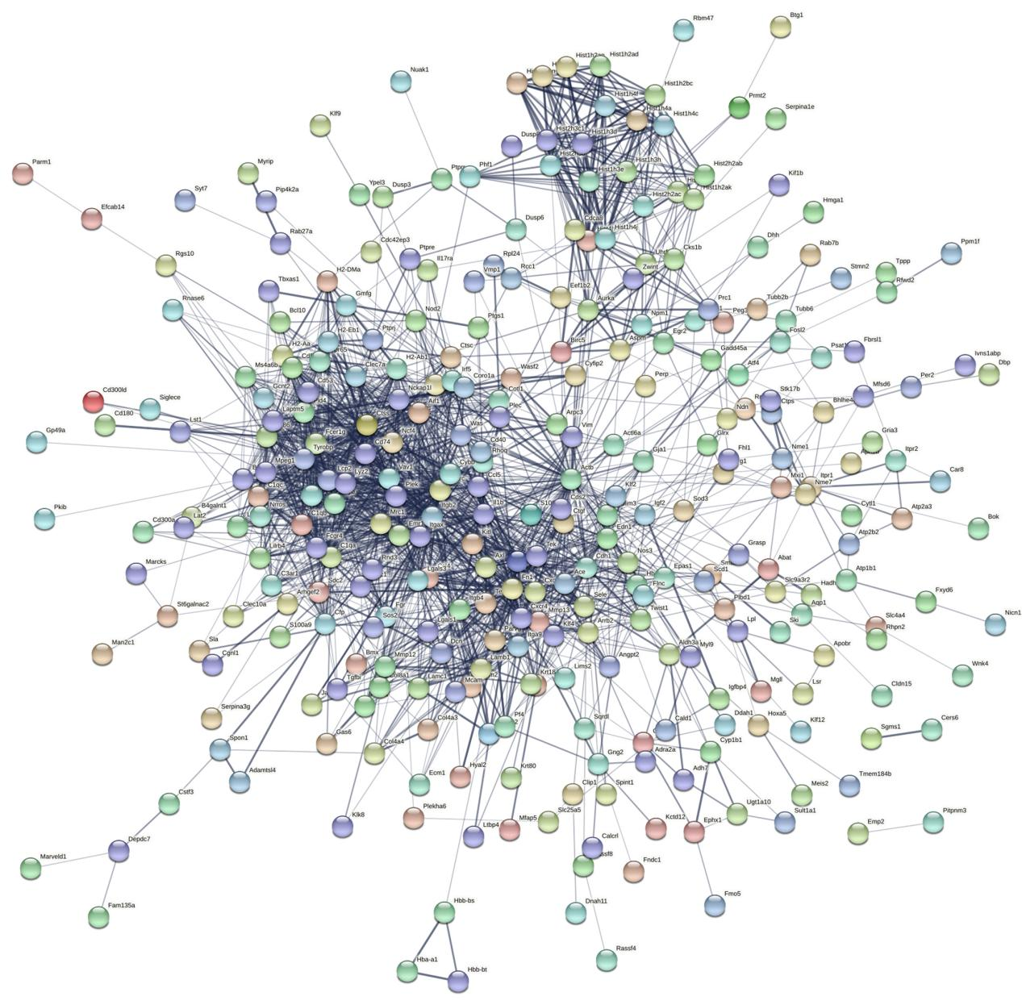
Circles represent genes, lines represent interactions between geneencoded proteins and line colors represent evidence of interactions between proteins.
Figure S2 Expression of F4/80 protein in the carotid artery 7 days after ligation by immunohistochemistry.
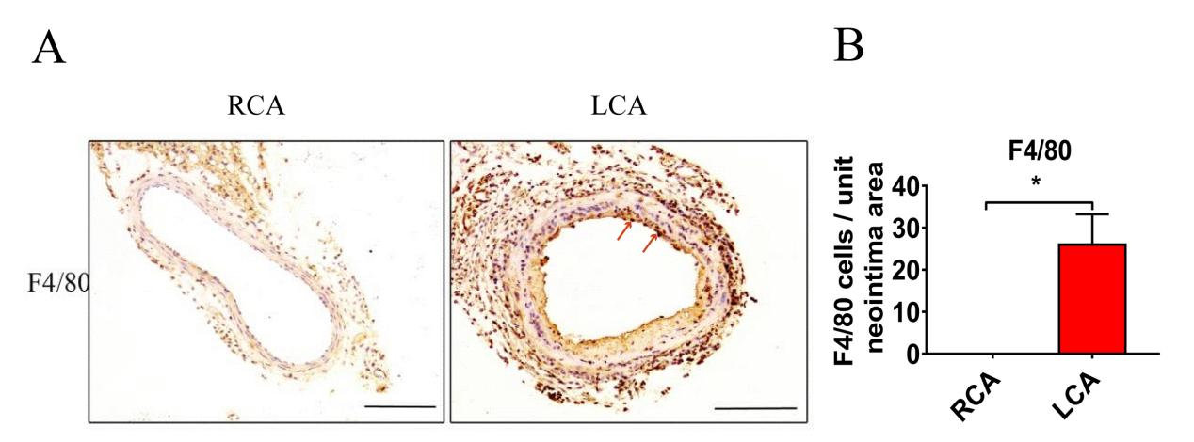
- B) Immunohistochemistry staining and quantitative analysis of F4/80 protein of carotid artery tissues. The arteries were harvested from uninjured RCA (that underwent a sham operation) and injured LCA at 7 days after surgery. The red arrows represent positive cells. Two-tailed unpaired Student’s t-test is used to compare two groups. Data are expressed as means ±SEM. n=3. *, P＜0.05; compared with the RCA group. Original magnification, 100x. Scale bar: 50 μm.

Figure S3 Changes in the expression of BRCC36 mRNA over time.
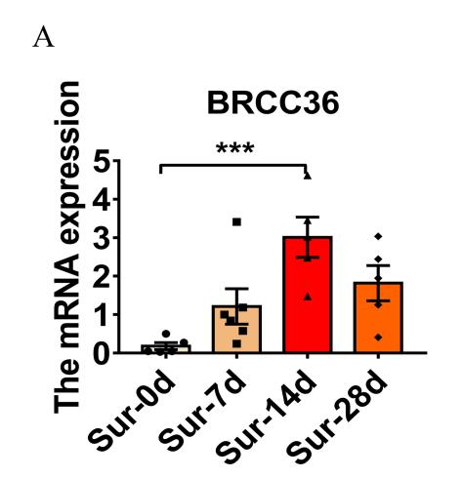

The expression changes of BRCC36 mRNA levels in mouse carotid arteries at 0 days, 7 days, 14 days and 28 days after ligation. All values have been standardized by GAPDH. Two-tailed unpaired Student’s t-test is used to compare two groups. Data are expressed as means ±SEM. n=5-6. ***, P＜0.001.

