Supplemental file
Do virgin and UV-weathered polyamide microplastics affect Daphnia magna reproduction?

Alla Khosrovyan ¹ *, Anne Kahru ^{1, 2}

1 National Institute of Chemical Physics and Biophysics, Laboratory of Environmental Toxicology, 23 Akadeemia tee, 12618, Tallinn, Estonia. Email: alla.khosrovyan@kbfi.ee
- Estonian Academy of Sciences, 6 Kohtu, 10130, Tallinn, Estonia. Email: anne.kahru@kbfi.ee

Images of polyamide particle before (virgin) and after UV-C irradiation for 26 days (UV-weathered) were taken with the help of the Zeiss Confocal laser scanning microscope LSM 800. Objective Plan-Apochromat 20x/0.8 M27. Laser wavelength 404 nm, detection wavelength 400-531 nm).
In total, 40 images of particle surfaces were scanned (20 for virgin plastics and 20 for UV-weathered ones).
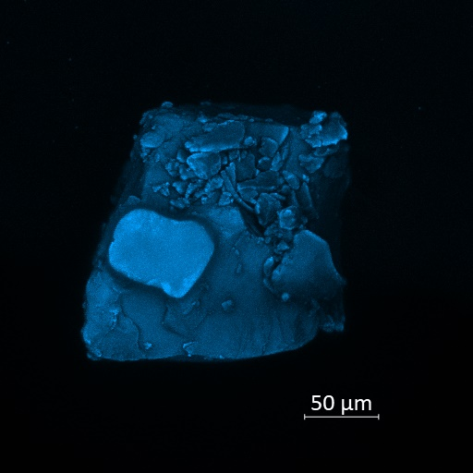
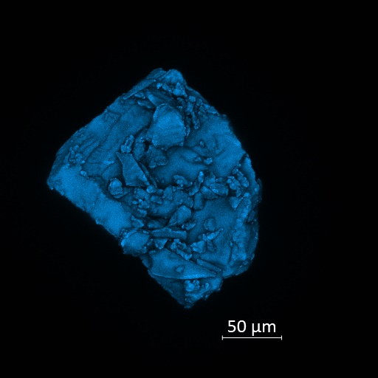
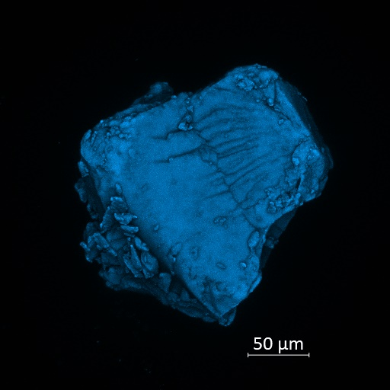
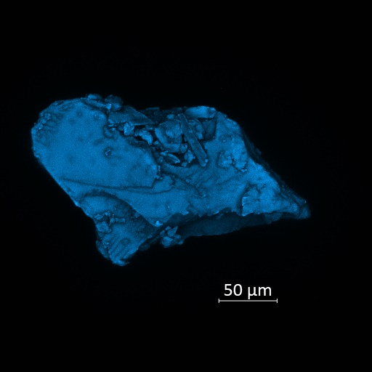
1
2
3
4

5

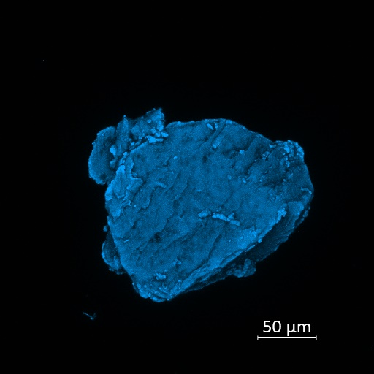
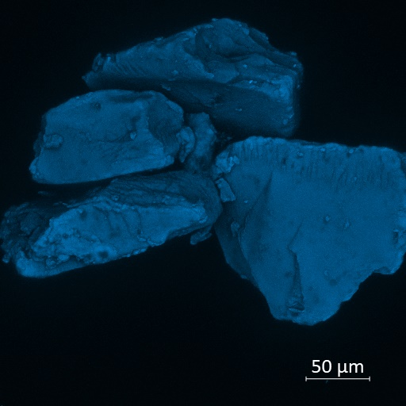
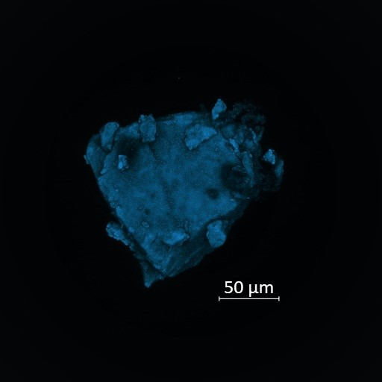
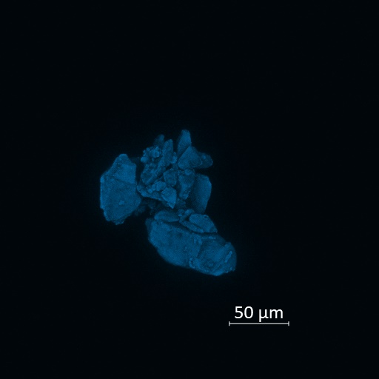
5
6
7
8

Fig. S1. Selected images of polyamide particle surface before (virgin) and after UV-C irradiation for 26 days (UV-weathered). Virgin (images 1-4), UV-weathered (images 5-8).

Table S1. Physico-chemical parameters of water from Lake Ülemiste (Estonia)

pH | Conductivity µS cm⁻¹ | Oxygen | NO₃⁻ | NO₂⁻ | NH₄⁺ mg L⁻¹ | PO₄³⁻ | TOC | TP | TN
8.55 | 393 | 10.9 | <1 | <0.003 | 0.007 | <0.02 | 11.2 | 0.032 | 1.1
TOC: total organic carbon; TP: total phosphorus; TN: total nitrogen.

Table S2. Details of the test of difference from control performed by the one-way ANOVA in R (version 4.1.3 (2022-03-10)): degrees of freedom (DF, residuals), test statistic (F value from the F test), the exact p-value (P), and effect size (Eta²). Test: OECD 211 Daphnia magna reproduction test. Significance: p>0.05.

Treatment:
virgin (PA-MP) and UV-weathered (UV-PA-MP) polyamide spiked to the natural water (Lake Ülemiste, Estonia)
 | DF | F value | P | Eta²
1st experiment
UV-PA-MP
100 mg L⁻¹ | 17 | 0.068 | 0.798 | 0.0039
300 mg L⁻¹ | 17 | 0.034 | 0.857 | 0.0019
PA-MP
100 mg L⁻¹ | 17 | 0.176 | 0.68 | 0.01
300 mg L⁻¹ | 16 | 0.23 | 0.638 | 0.014
2nd experiment
UV-PA-MP
100 mg L⁻¹ | 18 | 0.128 | 0.725 | 0.007
300 mg L⁻¹ | 18 | 0.001 | 0.98 | 3.5E-05
PA-MP
100 mg L⁻¹ | 18 | 0.038 | 0.848 | 0.002
300 mg L⁻¹ | 18 | 0.039 | 0.847 | 0.002
Treatment:
UV-weathered (UV-PA-MP) polyamide and/or surfactant Tween 20 spiked to the natural water (Lake Ülemiste, Estonia)
1st experiment
UV-PA-MP
300 mg L⁻¹
Tween 20
7 mg L⁻¹ | 18 | 2.217 | 0.154 | 0.11
Tween 20
7 mg L⁻¹ | 18 | 0.08 | 0.781 | 0.0044
2nd experiment
UV-PA-MP
300 mg L⁻¹
Tween 20
7 mg L⁻¹ | 18 | 0.001 | 0.981 | 3.2E-05
Tween 20
7 mg L⁻¹ | 18 | 0.91 | 0.353 | 0.048

