Search strategy

Research question: how does aerobic exercise affect evoked potentials obtained by EEG/MEG?

PubMed

Concept 1: Exercise
MeSH: "Exercise"[Mesh]

Concept 2: EEG
MeSH: "Electroencephalography"[Mesh]
Keywords: EEG

Concept 3: MEG
MeSH: "Magnetoencephalography"[Mesh]
Keywords: MEG

Concept 4: Evoked potentials
MeSH: "Evoked Potentials"[Mesh]
Keywords: event-related potential*

Search:

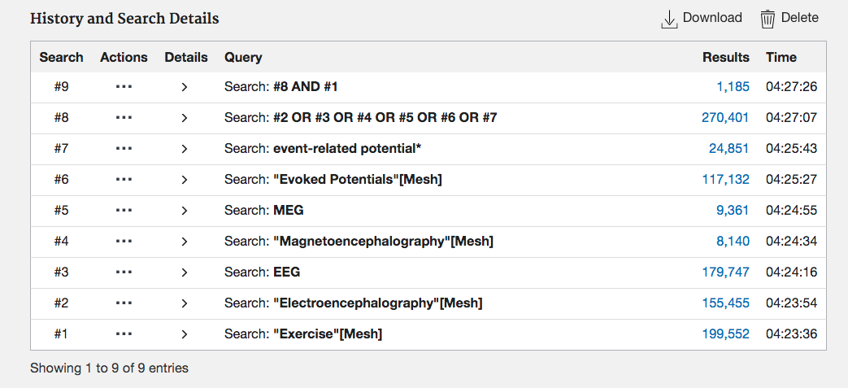

Search made 05/11/2020

Web of Science

Concept 1: Exercise
Keywords: TS=(exercise)

Concept 2: EEG
Keywords: TS=(electroencephalography) OR TS=(EEG)

Concept 3: MEG
Keywords: TS=(magnetoencephalography) OR TS=(MEG)

Concept 4: Evoked potentials
Keywords: TS=(evoked potential*) OR TS=(event-related potential*)

Search:
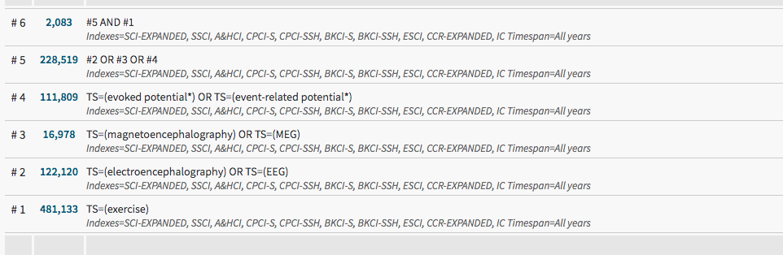

Search made 05/11/2020

Cochrane library

Concept 1: Exercise
MeSH: MeSH descriptor: [Exercise] explode all trees

Concept 2: EEG
MeSH: MeSH descriptor: [Electroencephalography] explode all trees
Keywords: EEG

Concept 3: MEG
MeSH: MeSH descriptor: [Magnetoencephalography] explode all trees
Keywords: MEG

Concept 4: Evoked potentials
MeSH: MeSH descriptor: [Evoked Potentials] explode all trees
Keywords: even-related potential
Search

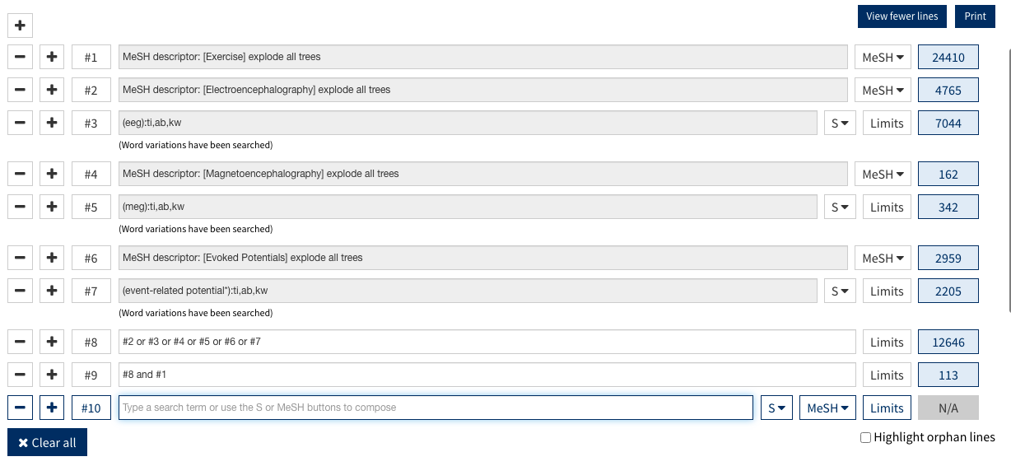

Search made 06/11/2020

Embase

Concept 1: Exercise
Subject heading: exp exercise/
Keywords: exercise.mp.

Concept 2: EEG
Subject heading: exp electroencephalography/
Keywords: electroencephalography.mp. OR EEG.mp.

Concept 3: MEG
Subject heading: exp magnetoencephalography/
Keywords: magnetoencephalography.mp OR MEG.mp

Concept 4: Evoked potentials
Subject heading: exp evoked response/ OR exp event-related potential/
Keywords: evoked potential.mp. OR event-related potential.mp.

Search:
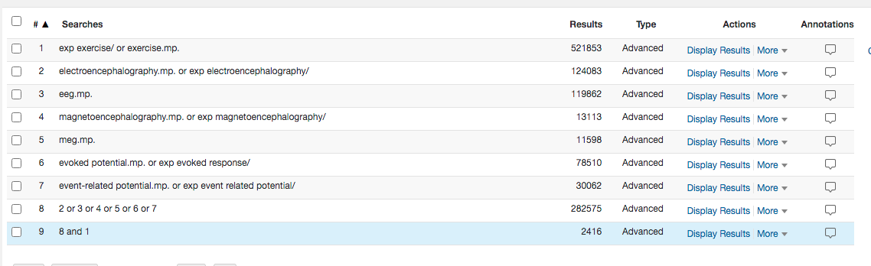

Search made 06/11/2020

