**Supplementary figures**

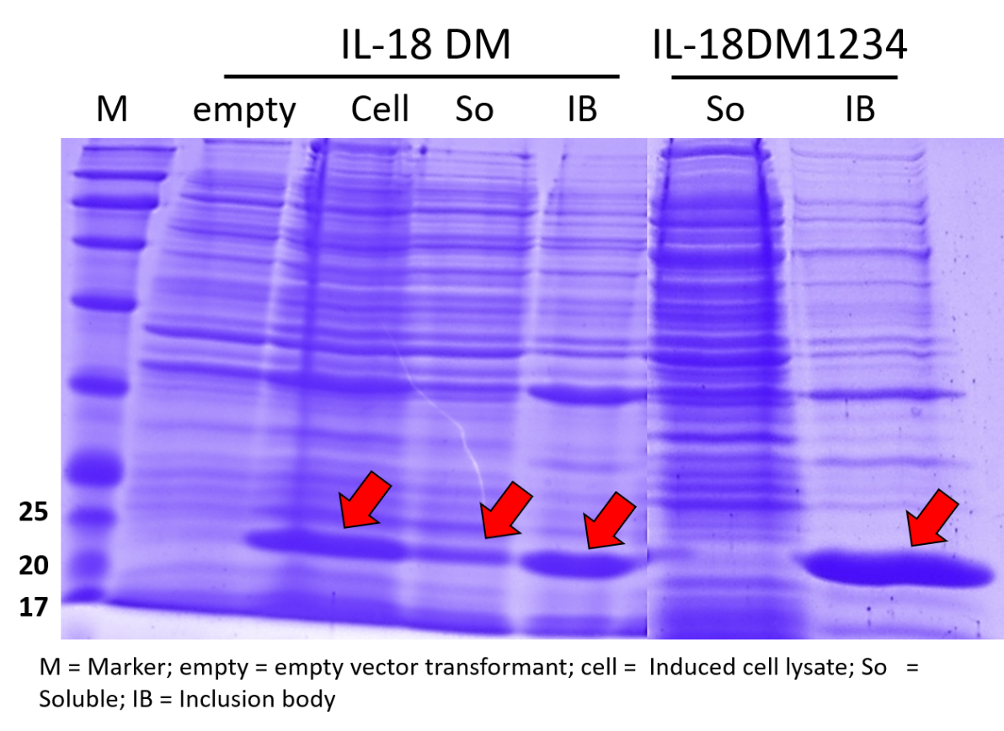

**Figure S1.** The expression of IL-18 DM and DM1234 using *E. coli* expression system.



**Aggregate form**

**Figure S2.** Western blot analysis of purified recombinant IL-18 from the previous work. An anti-human IL-18 antibody was used in this study. The arrow indicated the aggregated form of IL-18 at high concentrations.