Block_assay_statistical_analyses
Ingrid Knapp
11/05/2020
Set seed
set.seed(1234)
Load data
## site mean median lower upper
## 1 1 127.30170 130.37445 37.676936 216.9265
## 2 2 135.42016 130.63332 34.006174 236.8342
## 3 3 91.05749 93.95791 10.807228 171.3078
## 4 4 80.68854 85.06870 -13.626991 175.0041
## 5 5 106.29663 89.57705 6.275354 206.3179
## 6 6 91.30222 87.45962 -26.430945 209.0354
Plots_Net_growth
#Boxplot-a more familiar output, but not in publication
# All sites
#boxplots_all_sites <- ggplot(data=df.g) +
# geom_boxplot(aes(x=site, y=PercentNetGrowth, fill=site)) +
# facet_wrap(vars(species)) +
# labs(x="Site", y="Percent net growth") +
# theme_classic() +
# scale_fill_brewer(palette = "Spectral", direction = -1)+
# geom_jitter(aes(x=site, y=PercentNetGrowth))
#boxplots_all_sites
#violin plot
# Flip axes
violin_all_sites_flipped <- ggplot(data = df.g, aes(y = site, x = PercentNetGrowth, fill = site, draw_quantiles)) +
geom_violin(position = position_nudge(x = 0, y = 0), alpha=0.7) +
geom_point(aes(x = PercentNetGrowth), position = position_jitter(width = 0.15), size = 1.4) +
expand_limits(y = 5) +
guides(fill = guide_legend(reverse = TRUE)) +
facet_wrap(vars(species)) +
labs(x="% Net Growth", y="Site") +
scale_color_brewer(palette = "Spectral",direction = -1) +
scale_fill_brewer(palette = "Spectral", direction = -1)+
theme_classic()+
raincloud_theme
violin_all_sites_flipped
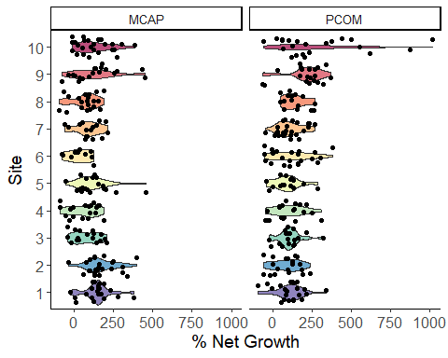
MCAP_stats_Net_growth
# Sites seperated (10 sites total)
lm.growth.MCAP <- lmer(PercentNetGrowth ~ site + (1| genotype), data = subset(df.g,species=="MCAP"))
summary(lm.growth.MCAP)
## Linear mixed model fit by REML ['lmerMod']
## Formula: PercentNetGrowth ~ site + (1 | genotype)
## Data: subset(df.g, species == "MCAP")
##
## REML criterion at convergence: 2271.5
##
## Scaled residuals:
## Min 1Q Median 3Q Max
## -2.2858 -0.6679 -0.0124 0.5877 3.4471
##
## Random effects:
## Groups Name Variance Std.Dev.
## genotype (Intercept) 640.9 25.32
## Residual 9071.8 95.25
## Number of obs: 197, groups: genotype, 9
##
## Fixed effects:
## Estimate Std. Error t value
## (Intercept) 140.70 22.12 6.361
## site2 29.28 27.67 1.058
## site3 -70.87 30.41 -2.331
## site4 -79.52 29.97 -2.653
## site5 -25.01 29.92 -0.836
## site6 -108.93 36.47 -2.987
## site7 -60.15 30.86 -1.949
## site8 -71.79 29.58 -2.427
## site9 -11.53 29.46 -0.391
## site10 -16.27 27.67 -0.588
##
## Correlation of Fixed Effects:
## (Intr) site2 site3 site4 site5 site6 site7 site8 site9
## site2 -0.679
## site3 -0.615 0.494
## site4 -0.630 0.502 0.454
## site5 -0.626 0.503 0.456 0.461
## site6 -0.510 0.411 0.372 0.379 0.381
## site7 -0.605 0.485 0.438 0.445 0.448 0.367
## site8 -0.637 0.510 0.460 0.471 0.472 0.388 0.453
## site9 -0.637 0.509 0.461 0.471 0.469 0.385 0.455 0.477
## site10 -0.680 0.543 0.490 0.502 0.501 0.411 0.486 0.511 0.509
Anova(lm.growth.MCAP, type = 3)
## Analysis of Deviance Table (Type III Wald chisquare tests)
##
## Response: PercentNetGrowth
## Chisq Df Pr(>Chisq)
## (Intercept) 40.459 1 2.008e-10 ***
## site 33.986 9 8.983e-05 ***
## ---
## Signif. codes: 0 '***' 0.001 '**' 0.01 '*' 0.05 '.' 0.1 ' ' 1
#normality/HOV
resid_panel(lm.growth.MCAP, plots = "default", type = NA, bins = 30,
smoother = FALSE, qqline = TRUE, qqbands = FALSE, scale = 1,
theme = "bw", axis.text.size = 10, title.text.size = 12,
title.opt = TRUE, nrow = NULL)
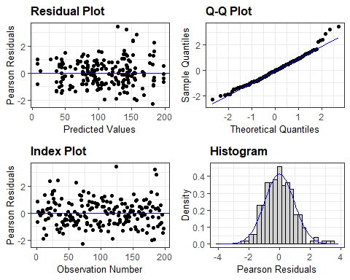 Porites_compressa_Net_Growth
# Sites seperated (10 sites total)
lm.growth.PCOM <- lmer(sqrt(PercentNetGrowth) ~ site + (1| genotype), data = subset(df.g,species=="PCOM"))
## Warning in sqrt(PercentNetGrowth): NaNs produced
## Warning in sqrt(PercentNetGrowth): NaNs produced
## Warning in sqrt(PercentNetGrowth): NaNs produced
summary(lm.growth.PCOM)
## Linear mixed model fit by REML ['lmerMod']
## Formula: sqrt(PercentNetGrowth) ~ site + (1 | genotype)
## Data: subset(df.g, species == "PCOM")
##
## REML criterion at convergence: 951.9
##
## Scaled residuals:
## Min 1Q Median 3Q Max
## -2.6595 -0.5437 -0.0219 0.4929 4.4194
##
## Random effects:
## Groups Name Variance Std.Dev.
## genotype (Intercept) 2.896 1.702
## Residual 14.129 3.759
## Number of obs: 176, groups: genotype, 9
##
## Fixed effects:
## Estimate Std. Error t value
## (Intercept) 11.0055 1.0411 10.571
## site2 -1.2182 1.3069 -0.932
## site3 -0.0462 1.2871 -0.036
## site4 -0.0367 1.2645 -0.029
## site5 -0.5096 1.3935 -0.366
## site6 0.4623 1.2578 0.368
## site7 -1.1221 1.1479 -0.978
## site8 0.3725 1.3026 0.286
## site9 3.8157 1.2238 3.118
## site10 4.6992 1.1940 3.936
##
## Correlation of Fixed Effects:
## (Intr) site2 site3 site4 site5 site6 site7 site8 site9
## site2 -0.555
## site3 -0.572 0.451
## site4 -0.579 0.456 0.472
## site5 -0.523 0.411 0.427 0.433
## site6 -0.572 0.456 0.462 0.471 0.425
## site7 -0.631 0.501 0.512 0.519 0.469 0.519
## site8 -0.554 0.439 0.449 0.455 0.413 0.454 0.499
## site9 -0.593 0.469 0.481 0.489 0.443 0.485 0.533 0.471
## site10 -0.606 0.480 0.492 0.499 0.452 0.495 0.546 0.480 0.513
Anova(lm.growth.PCOM, type = 2)
## Analysis of Deviance Table (Type II Wald chisquare tests)
##
## Response: sqrt(PercentNetGrowth)
## Chisq Df Pr(>Chisq)
## site 49.543 9 1.313e-07 ***
## ---
## Signif. codes: 0 '***' 0.001 '**' 0.01 '*' 0.05 '.' 0.1 ' ' 1
#normality/HOV
resid_panel(lm.growth.PCOM, plots = "default", type = NA, bins = 30,
smoother = FALSE, qqline = TRUE, qqbands = FALSE, scale = 1,
theme = "bw", axis.text.size = 10, title.text.size = 12,
title.opt = TRUE, nrow = NULL)
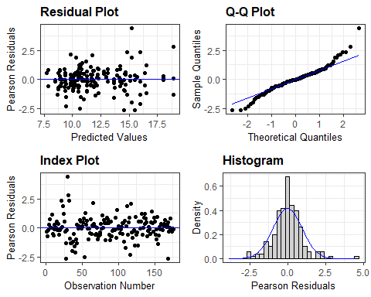
Survivorship
MCAP_Survivorship
## Generalized linear mixed model fit by maximum likelihood (Laplace
## Approximation) [glmerMod]
## Family: binomial ( logit )
## Formula: alive_2 ~ site + (1 | genotype)
## Data: subset(df.survivorship.outplantalive, species == "MCAP")
## Control: glmerControl(tolPwrss = 0.001, optimizer = "nloptwrap")
##
## AIC BIC logLik deviance df.resid
## 281.6 321.1 -129.8 259.6 256
##
## Scaled residuals:
## Min 1Q Median 3Q Max
## -4.4745 -0.5518 0.3233 0.5951 1.5229
##
## Random effects:
## Groups Name Variance Std.Dev.
## genotype (Intercept) 0.3641 0.6034
## Number of obs: 267, groups: genotype, 9
##
## Fixed effects:
## Estimate Std. Error z value Pr(>|z|)
## (Intercept) 2.0904 0.6599 3.168 0.001536 **
## site2 1.2099 1.1970 1.011 0.312120
## site3 -1.8106 0.7352 -2.463 0.013791 *
## site4 -0.4987 0.8427 -0.592 0.554023
## site5 -0.9201 0.7904 -1.164 0.244410
## site6 -2.6281 0.7672 -3.425 0.000614 ***
## site7 -1.5003 0.7513 -1.997 0.045823 *
## site8 -1.5860 0.7336 -2.162 0.030628 *
## site9 -0.4121 0.8390 -0.491 0.623359
## site10 0.5136 0.9683 0.530 0.595801
## ---
## Signif. codes: 0 '***' 0.001 '**' 0.01 '*' 0.05 '.' 0.1 ' ' 1
##
## Correlation of Fixed Effects:
## (Intr) site2 site3 site4 site5 site6 site7 site8 site9
## site2 -0.495
## site3 -0.816 0.445
## site4 -0.706 0.388 0.635
## site5 -0.754 0.414 0.679 0.589
## site6 -0.788 0.426 0.710 0.610 0.652
## site7 -0.792 0.434 0.712 0.618 0.660 0.686
## site8 -0.815 0.446 0.734 0.635 0.679 0.707 0.712
## site9 -0.707 0.389 0.634 0.552 0.589 0.610 0.620 0.635
## site10 -0.613 0.337 0.551 0.480 0.512 0.529 0.538 0.551 0.481
## Warning: 'r.squaredGLMM' now calculates a revised statistic. See the help page.
## Warning: The null model is correct only if all variables used by the original
## model remain unchanged.
## R2m R2c
## theoretical 0.2521079 0.3266327
## delta 0.1855130 0.2403519
PCOM_Survivorship
glm1.survival.PCOM <- glmer(alive_2 ~
site + (1|genotype),
data = subset(df.survivorship.outplantalive, species=="PCOM"),
family = binomial (link = "logit"),
control = glmerControl(tolPwrss=1e-3, optimizer = "nloptwrap"))
## Warning in checkConv(attr(opt, "derivs"), opt$par, ctrl = control$checkConv, :
## Model failed to converge with max|grad| = 0.02784 (tol = 0.002, component 1)
summary(glm1.survival.PCOM)
## Generalized linear mixed model fit by maximum likelihood (Laplace
## Approximation) [glmerMod]
## Family: binomial ( logit )
## Formula: alive_2 ~ site + (1 | genotype)
## Data: subset(df.survivorship.outplantalive, species == "PCOM")
## Control: glmerControl(tolPwrss = 0.001, optimizer = "nloptwrap")
##
## AIC BIC logLik deviance df.resid
## 216.8 255.0 -97.4 194.8 226
##
## Scaled residuals:
## Min 1Q Median 3Q Max
## -4.1660 0.2778 0.3567 0.4169 0.8544
##
## Random effects:
## Groups Name Variance Std.Dev.
## genotype (Intercept) 0.1236 0.3516
## Number of obs: 237, groups: genotype, 9
##
## Fixed effects:
## Estimate Std. Error z value Pr(>|z|)
## (Intercept) 1.97012 0.62621 3.146 0.00165 **
## site2 -0.04324 0.88561 -0.049 0.96106
## site3 -1.01188 0.76251 -1.327 0.18450
## site4 -0.27744 0.82696 -0.335 0.73725
## site5 -1.21787 0.76952 -1.583 0.11351
## site6 0.39643 0.96397 0.411 0.68089
## site7 -0.28566 0.78939 -0.362 0.71745
## site8 0.72801 1.20144 0.606 0.54455
## site9 0.04981 0.88075 0.057 0.95490
## site10 0.50014 0.97031 0.515 0.60624
## ---
## Signif. codes: 0 '***' 0.001 '**' 0.01 '*' 0.05 '.' 0.1 ' ' 1
##
## Correlation of Fixed Effects:
## (Intr) site2 site3 site4 site5 site6 site7 site8 site9
## site2 -0.683
## site3 -0.792 0.565
## site4 -0.731 0.526 0.602
## site5 -0.784 0.554 0.644 0.593
## site6 -0.626 0.447 0.515 0.477 0.508
## site7 -0.765 0.552 0.631 0.585 0.621 0.499
## site8 -0.502 0.354 0.412 0.379 0.409 0.326 0.398
## site9 -0.687 0.501 0.567 0.528 0.557 0.450 0.553 0.357
## site10 -0.624 0.457 0.515 0.481 0.505 0.409 0.503 0.323 0.457
## optimizer (nloptwrap) convergence code: 0 (OK)
## Model failed to converge with max|grad| = 0.02784 (tol = 0.002, component 1)
r.squaredGLMM(glm1.survival.PCOM)
## Warning: The null model is correct only if all variables used by the original
## model remain unchanged.
## R2m R2c
## theoretical 0.08595059 0.11905087
## delta 0.04017875 0.05565191

