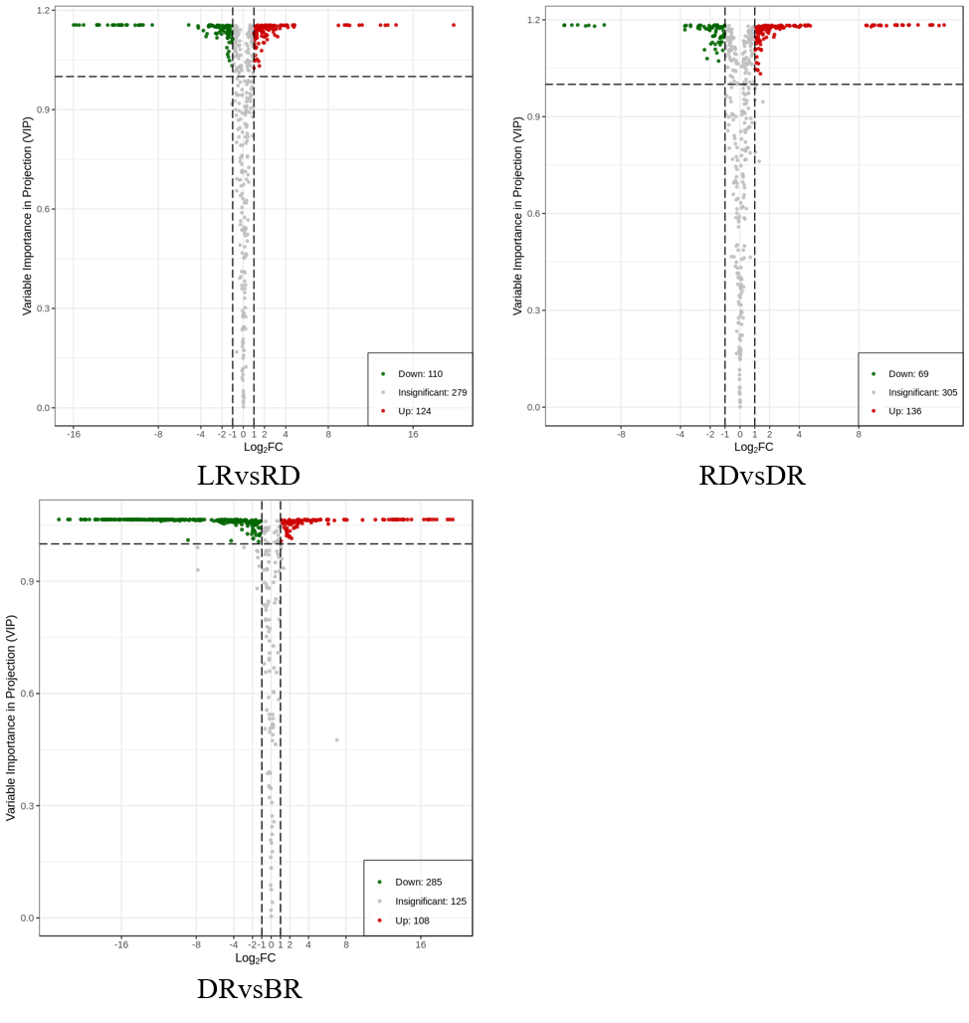

**Figure S1** **Volcano map of differential metabolites between groups.** Red dots indicate up-regulated metabolites, and green dots indicate down-regulated metabolites.