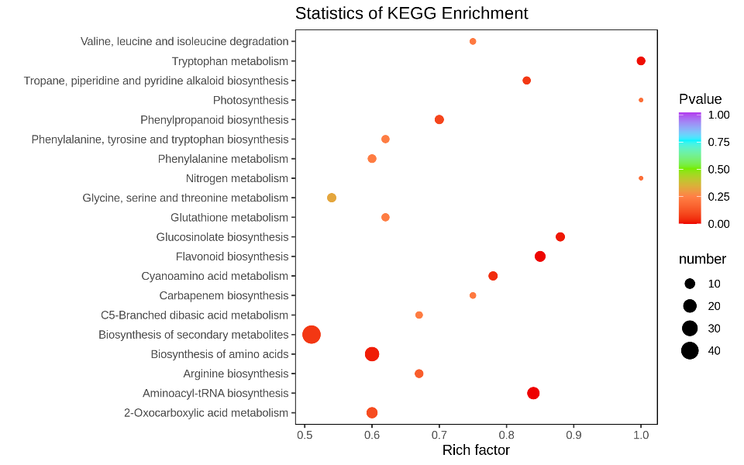

LR vs RD

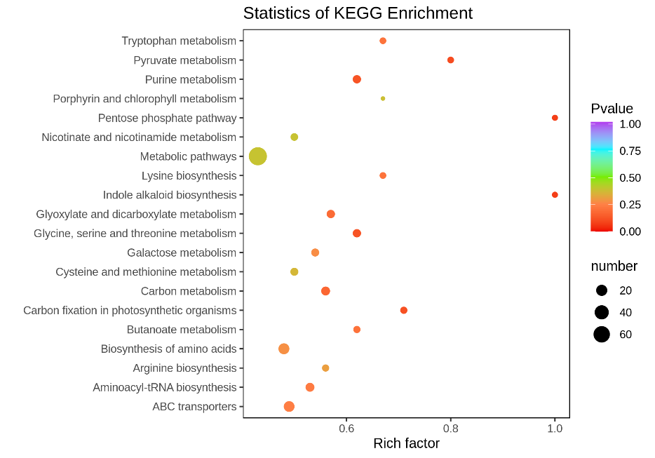

RD vs DR

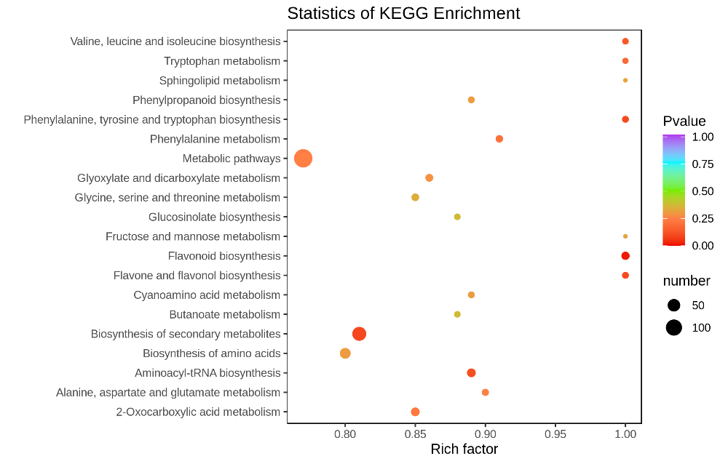

DR vs BR

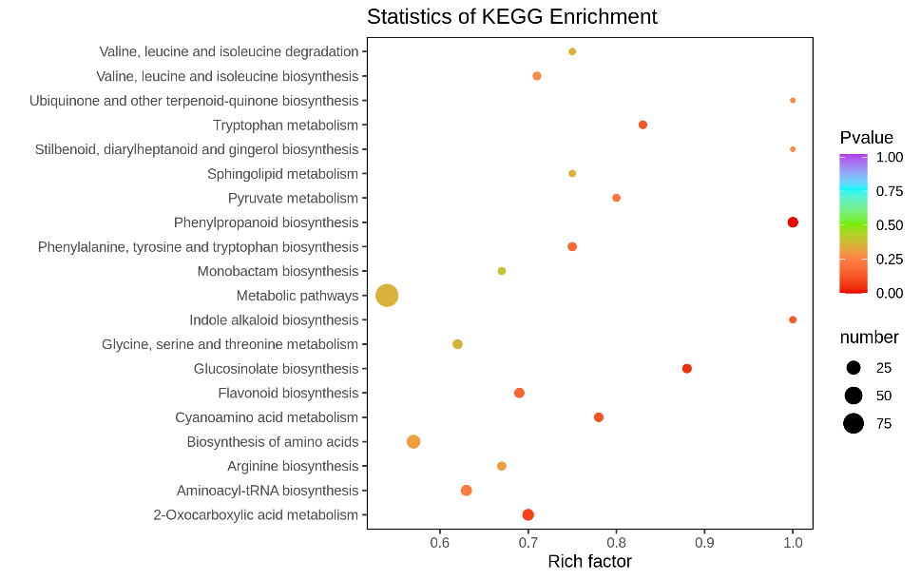

LR vs DR

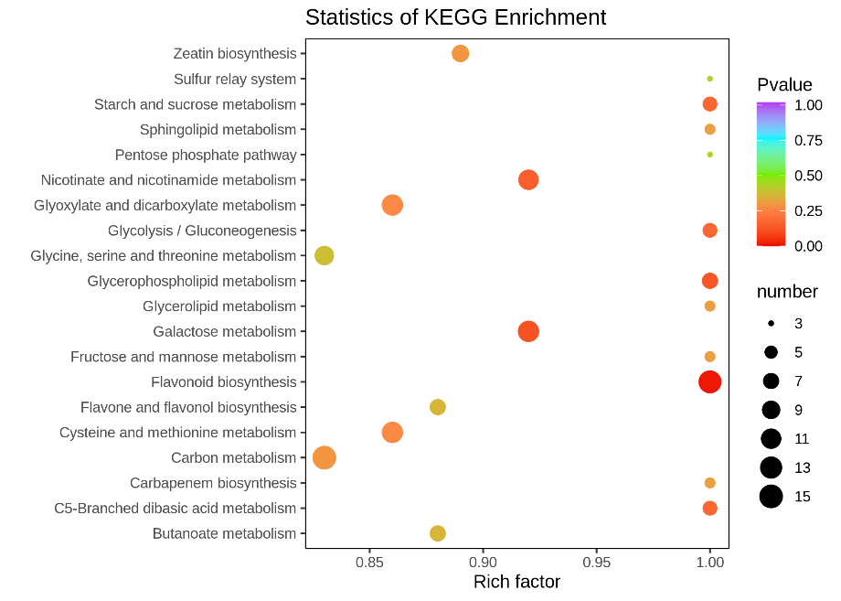

LR vs BR

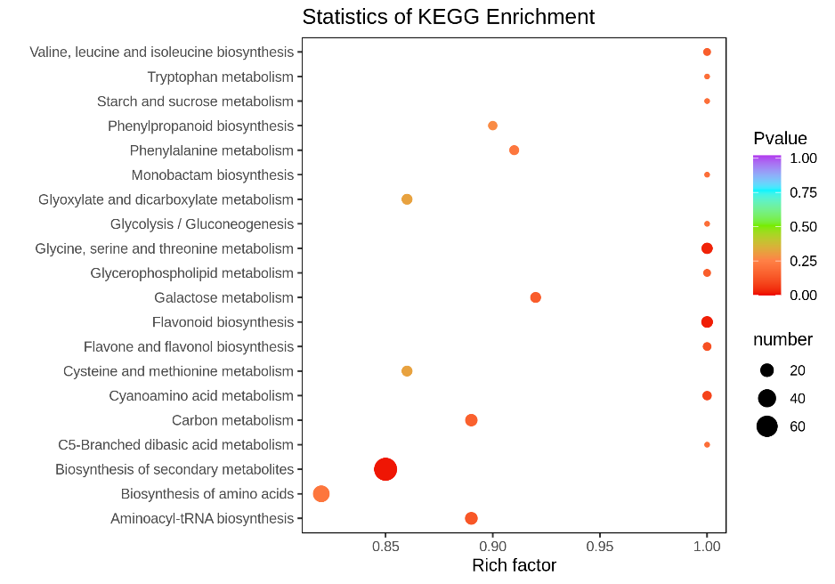

RD vs BR

**Figure S2** **KEGG enrichment of differential metabolites between groups.** The color and size indicate the p-value and the number of DAMs, respectively.