Supplementary Information: Han et al. 2022. Insert article citation once approved for publication.

Tables:

Table S1. Colony sample size (n) by species, treatment, and response variable.
 |  | Treatments
Species | Variable | A | N | NH | H
L. scutaria | Survivorship | 29 | 29 | 20 | 30
 | Partial Mortality/Bleaching | 29 | 29 | 20 | 30
 | DTB | 0 | 0 | 17 | 30
 | Visual Assessment | 29 | 29 | 20 | 30
 | Calcification (≤ 50%) | 29 | 29 | 17 | 30
 | Calcification | 29 | 29 | 20 | 30
M. capitata | Survivorship | 23 | 29 | 19 | 29
 | Partial Mortality/Bleaching | 23 | 29 | 19 | 29
 | DTB | 0 | 0 | 17 | 29
 | Visual Assessment | 23 | 29 | 19 | 29
 | Calcification (≤ 50%) | 23 | 29 | 17 | 28
 | Calcification | 23 | 29 | 19 | 29
P. acuta | Survivorship | 29 | 29 | 19 | 29
 | Partial Mortality/Bleaching | 29 | 29 | 19 | 29
 | DTB | 0 | 0 | 17 | 27
 | Visual Assessment | 29 | 29 | 19 | 29
 | Calcification (≤ 50%) | 29 | 29 | 16 | 23
 | Calcification | 29 | 29 | 19 | 29

Table S2. Mean nutrients concentrations (µM) of three reference nutrient sample locations: South Kāne‘ohe Bay, Intake Pipe, and ambient nutrient treatment mesocosms (A)). Samples were taken during the acclimation and experimental heating phase.
Location | Phosphate | N+N | Ammonia
South Bay | 0.13 ± 0.03 | 0.04 ± 0.01 | 0.06 ± 0.03
Intake Pipe | 0.64 ± 0.42 | 0.31 ± 0.13 | 0.13 ± 0.07
Mesocosms (A) | 0.18 ± 0.02 | 0.14 ± 0.02 | 0.18 ± 0.03

Table S3. Pairwise comparisons of mean concentrations (µM) of nitrate+nitrite, ammonium, and phosphate between treatment groups by phase.
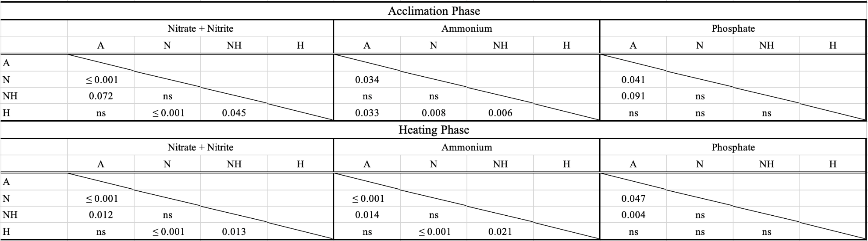

Table S4. Mean flow rate (sec/10L) with SE for each treatment group.
A | N | NH | H
46.82 ± 1.90 | 48.49 ± 0.70 | 48.49 ± 0.70 | 46.61 ± 2.91

Table S5. Mean peristaltic pump rate (sec/mL) with SE for each treatment group.
A | N | NH | H
46.82 ± 1.90 | 48.49 ± 0.70 | 48.49 ± 0.70 | 46.61 ± 2.91

Table S6. Survivorship (%) of coral colonies by species and treatment groups at the end of the 31 days of the heating phase.
 | L. scutaria | M. capitata | P. acuta
A | 100% | 100% | 100%
N | 100% | 100% | 100%
NH | 85% | 95% | 84%
H | 100% | 100% | 86%

Table S7. Mean partial mortality (%) ± SE of coral colonies at the end of the heating phase by species and treatment groups.
 | L. scutaria | M. capitata | P. acuta
A | 0 | 0.65 ± 0.65 | 0
N | 0 | 0 | 0
NH | 15.50 ± 8.16 | 17.90 ± 6.24 | 21.30 ± 8.55
H | 0.17 ± 0.17 | 8.62 ± 3.79 | 22.40 ± 7.06

Table S8. Post hoc pairwise comparisons of partial bleaching (%) between treatment groups by species at the end of the heating phase. Bolded p-values denote statistically significant differences.
 | L. scutaria |  | M. capitata |  | P. acuta
Comparison | z-ratio | p-value | z-ratio | p-value | z-ratio | p-value
A - H | -13.481 | ≤0.001 | -12.127 | ≤0.001 | -9.577 | ≤0.001
A - N | 0.000 | 1.000 | 0.000 | 1.000 | -0.093 | 1.000
A - NH | -4.002 | ≤0.001 | -7.747 | ≤0.001 | -7.421 | ≤0.001
H - N | 13.481 | ≤0.001 | 12.666 | ≤0.001 | 9.449 | ≤0.001
H - NH | 4.104 | ≤0.001 | 1.301 | 1.000 | 0.406 | 1.000
N - NH | -4.002 | ≤0.001 | -7.932 | ≤0.001 | -7.334 | ≤0.001

Table S9. Mean ± SE days to bleaching (DTB), calculated as individual colony partial bleaching ≥ 95%, for NH and H treatment groups by species.
 | L. scutaria | M. capitata | P. acuta
NH | 20.5 ± 1.3 | 23.3 ± 1.2 | 20.9 ± 0.9
H | 16.4 ± 0.8 | 19.9 ± 0.7 | 18.2 ± 0.7

Table S10. Mean ± SE days to mortality (DTM), calculated as individual colony partial mortality ≥ 95%, for NH and H treatment groups by species. No mortality was recorded in A and N treatment groups.
 | L. scutaria | M. capitata | P. acuta
NH | 40.90 ± 5.75 | 36.80 ± 3.28 | 37.80 ± 2.61
H | 38.70 ± 7.86 | 40.70 ± 3.26 | 37.10 ± 2.66

Table S11. Post hoc pairwise comparisons of mean change in calcification rate (mm/day) between treatment groups by species. Bolded p-values denote statistically significant differences.
Comparison | Estimate | SE | df | t-ratio | p-value
L. scutaria
A - H | 0.994 | 0.321 | 874 | 3.102 | 0.012
A - N | 0.215 | 0.322 | 862 | 0.667 | 0.505
A - NH | 0.642 | 0.353 | 682 | 1.817 | 0.139
H - N | 0.779 | 0.321 | 874 | 2.431 | 0.046
H - NH | 0.352 | 0.352 | 688 | 1.001 | 0.381
N - NH | 0.427 | 0.353 | 682 | 1.208 | 0.341
M. capitata
A - H | 1.362 | 0.336 | 770 | 4.060 | ≤0.001
A - N | -0.065 | 0.334 | 780 | -0.194 | 0.846
A - NH | 0.779 | 0.364 | 641 | 2.137 | 0.049
H - N | 1.427 | 0.324 | 849 | 4.408 | ≤0.001
H - NH | 0.584 | 0.355 | 676 | 1.645 | 0.120
N - NH | 0.843 | 0.353 | 682 | 2.386 | 0.035
P. acuta
A - H | 2.054 | 0.334 | 780 | 6.150 | ≤0.001
A - N | 0.166 | 0.322 | 862 | 0.514 | 0.607
A - NH | 0.705 | 0.358 | 664 | 1.970 | 0.074
H - N | 1.889 | 0.334 | 780 | 5.654 | ≤0.001
H - NH | 1.349 | 0.369 | 626 | 3.660 | ≤0.001
N - NH | 0.539 | 0.358 | 664 | 1.507 | 0.159

Table S12. Chi-squared results from Day 12 of heating phase.
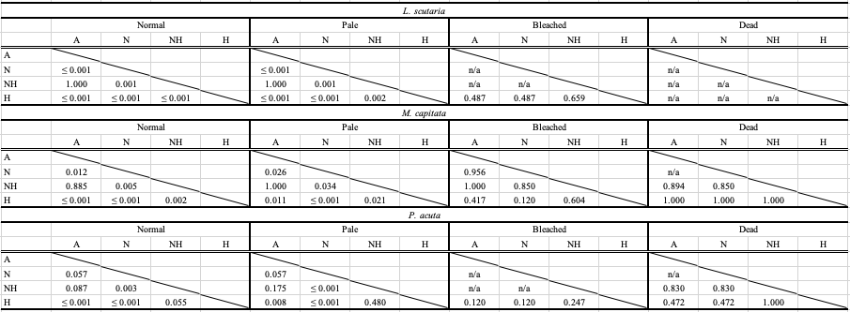

Table S13. MCA contribution plots of all variable levels at Day 12.
 |  | Dimension 1 |  |  | Dimension 2
 | Coordinate | Contribution (%) | cos² | Coordinate | Contribution (%) | cos²
A | -0.264 | 1.115 | 0.025 | -0.633 | 9.088 | 0.144
N | -1.105 | 20.180 | 0.460 | 0.344 | 2.776 | 0.045
NH | 0.070 | 0.056 | 0.001 | -0.007 | 0.001 | 0.000
H | 1.297 | 28.145 | 0.644 | 0.269 | 1.718 | 0.028
Ls | 0.086 | 0.153 | 0.004 | -0.922 | 24.763 | 0.437
Mc | 0.046 | 0.042 | 0.001 | 0.496 | 6.900 | 0.119
Pd | -0.133 | 0.356 | 0.009 | 0.453 | 5.863 | 0.102
Normal | -0.804 | 21.728 | 0.811 | 0.074 | 0.265 | 0.007
Pale | 0.945 | 21.046 | 0.571 | -0.504 | 8.490 | 0.162
Bleached | 1.615 | 5.951 | 0.102 | 2.520 | 20.568 | 0.249
Dead | 1.138 | 1.230 | 0.021 | 3.808 | 19.570 | 0.232

Table S14. Chi-squared results from end of heating phase (Day 31).
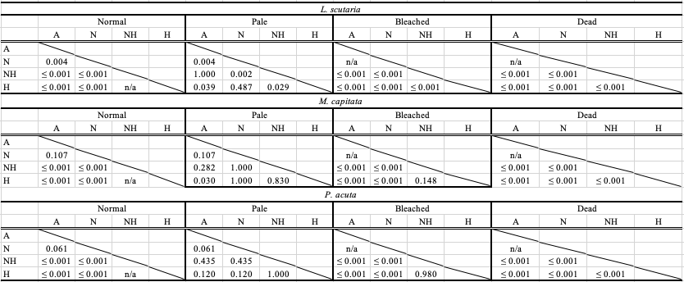

Table S15. MCA contribution plots of all variable levels at the end of heating phase (Day 31).
 |  | Dimension 1 |  |  | Dimension 2
 | Coordinate | Contribution (%) | cos² | Coordinate | Contribution (%) | cos²
A | -0.824 | 8.953 | 0.236 | 0.950 | 17.274 | 0.314
N | -1.004 | 14.266 | 0.386 | -0.864 | 15.324 | 0.286
NH | 0.955 | 8.604 | 0.206 | 0.562 | 4.328 | 0.072
H | 1.122 | 18.019 | 0.490 | -0.391 | 3.183 | 0.060
Ls | -0.050 | 0.043 | 0.001 | 0.533 | 7.239 | 0.149
Mc | 0.095 | 0.148 | 0.004 | -0.352 | 2.924 | 0.058
Pd | -0.039 | 0.027 | 0.001 | -0.211 | 1.113 | 0.023
Normal | -0.972 | 22.736 | 0.841 | -0.322 | 3.627 | 0.093
Pale | -0.170 | 0.151 | 0.003 | 2.397 | 43.430 | 0.652
Bleached | 1.120 | 23.077 | 0.705 | -0.237 | 1.503 | 0.032
Dead | 1.079 | 3.977 | 0.083 | -0.106 | 0.055 | 0.001

Figures:

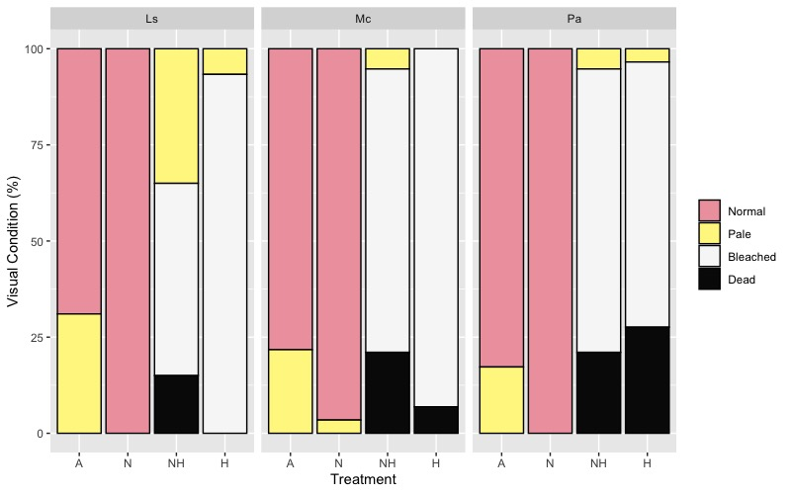
Figure S1. Percentage (%) of colonies that were either normal, pale, bleached, or dead by
treatment group and species at the end of the heating period (Day 31).
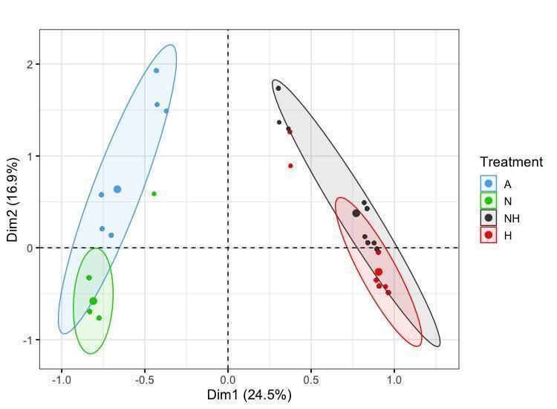
Figure S2. MCA plot of treatment, species, and visual assessment data from the end of the
heating period (Day 31). Treatment group centroids are shown along with corresponding 95% CI ellipses.

