Supplementary Information

Article title:
Effect of School-based Neuromuscular Training on Fundamental Movement Skills and Physical Fitness in Children: A Systematic Review
Authors:
Junlei Lin¹, Ruofei Zhang², Jie Shen¹, Aiguo Zhou¹

Affiliation:
1 School of Strength and Conditioning Training, Beijing Sport University, Beijing, China
2 School of Sport competition, Beijing Sport University, Beijing, China

Corresponding author:
Aiguo Zhou¹
No. 48 Xinxi Street, Beijing, China
Email address: 296485225@qq.com
ORCID: https://orcid.org/0000-0003-0926-139X

Contents:
1. Full electronic search strategy for PubMed

2. Full electronic search strategy for web of science

3. Full electronic search strategy for Medline

4. Full electronic search strategy for Cochrane
1. Full electronic search strategy for Pubmed:
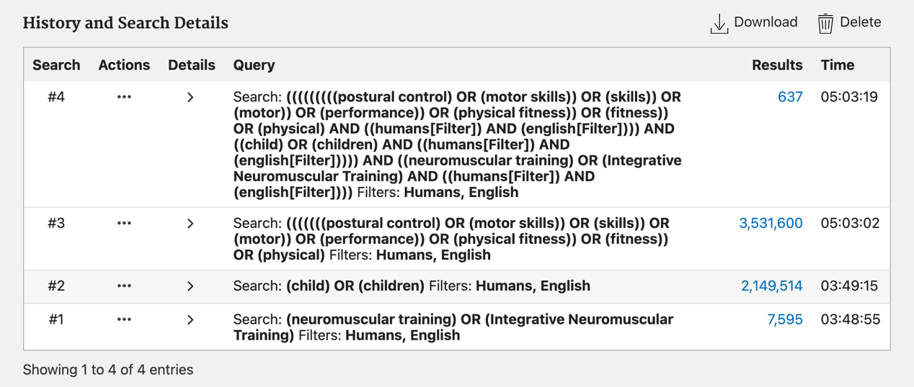

- Full electronic search strategy for WoS:

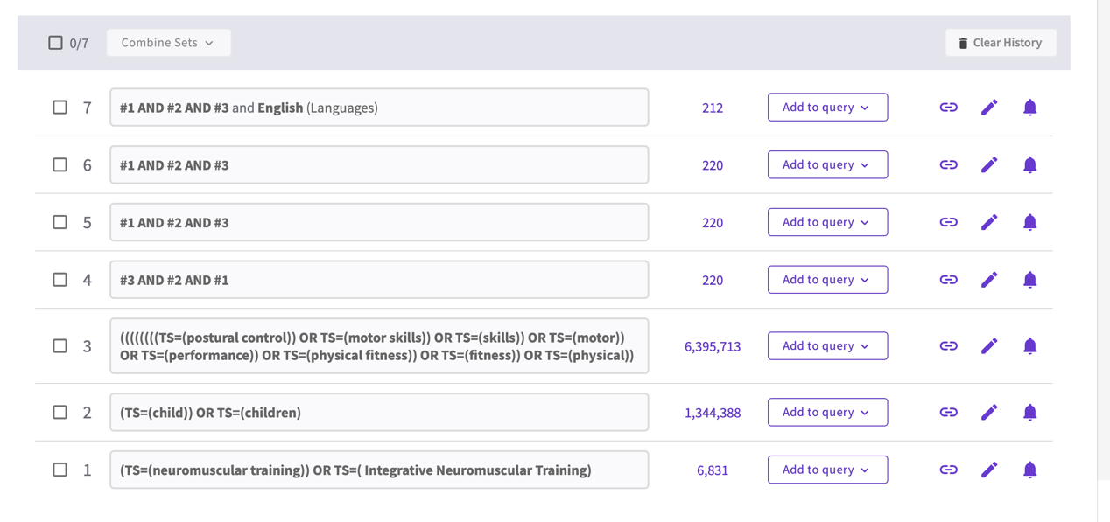

- Full electronic search strategy for MEDLINE:


- Full electronic search strategy for Cochrane:
