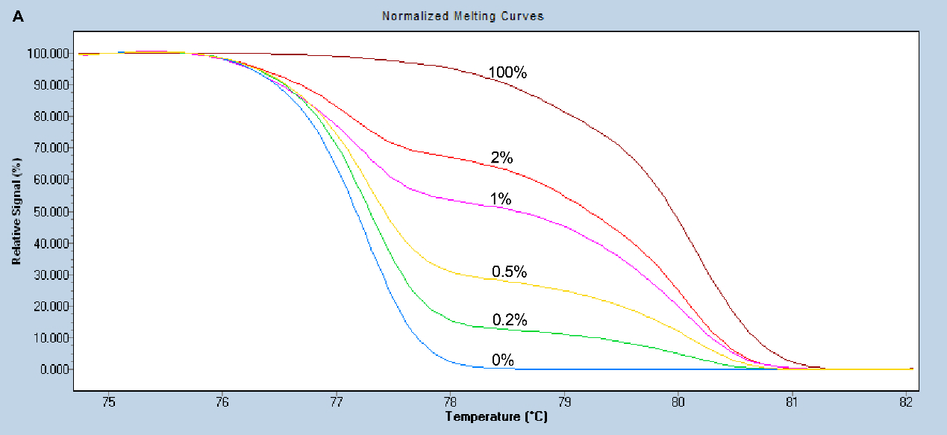

**Figure S1.** Normalized melting curves of the MS-HRM assay for *EPHA5*.

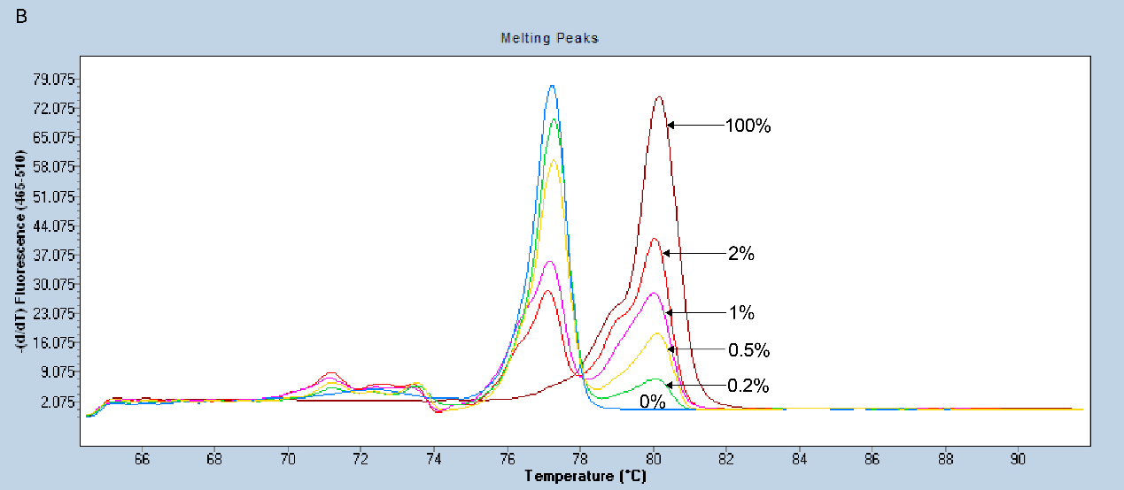

**Figure S2.** Melting peaks of the MS-HRM assay for *EPHA5*.