Target gene name: Sema3a
Gene Sequence Number: NM_017310.1
Gene: 29751

Carrier information
Carrier Name: WZ032
Component order：pAAV-H1-shRNA-CAG-tdTomato-WPRE-SV40pA
Cloning site：BsaI
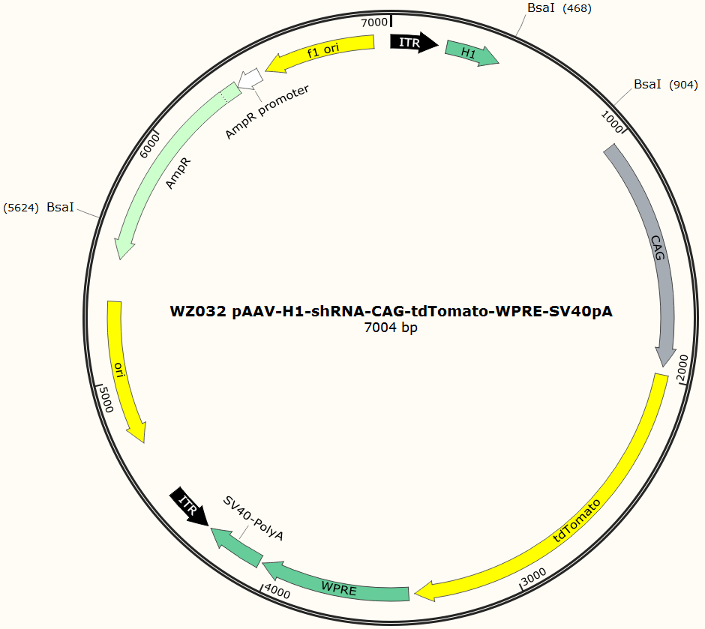
To further verify the impact of Sema3A post SCI, we designed 6 sets of SNCA-shRNA sequence plasmids with GFP fluorescent tags, and integrated them into an adenoassociated virus (AAV), then transfected them into HEK293 cells to observe the degree of translated. We utilize fluorescence attenuation detection co-transfect 293T cells in vitro with the interference group, the interference control sample wy2884-2889, the interference control sample WY1720 and the overexpressed sample WY2890. It was found that the negative control WY1720 of the interference target had no ability to knock-down, while the target sequences of WY2886, WY2887 and WY2889 in the experimental group had a strong knock-down ability (Fig. 5c). Western blotting was further used to check the efficiency of each target and the result displayed WY2887 had the least amount of protein as well as the best interference effect (Fig. 5b). Therefore, we considered wy2887 is the most suitable one among the six sequences of wy2884- 2889. Hence, we chose wy2887 to package AAV2/9-U6-shRNA (Sema3A)- CAG-tdtomato for the following experiment.
Primer sequence
Y2884-1 | TCCCCGGAAAGAACAATGTGCCAATTCAAGAGATTGGCACATTGTTCTTTCCTTTTT
Y2884-2 | TCTAAAAAAGGAAAGAACAATGTGCCAATCTCTTGAATTGGCACATTGTTCTTTCCG
Y2885-1 | TCCCCGCCATCCAATTTGCACCTATTTCAAGAGAATAGGTGCAAATTGGATGGCTTTTT
Y2885-2 | TCTAAAAAAGCCATCCAATTTGCACCTATTCTCTTGAAATAGGTGCAAATTGGATGGCG
Y2886-1 | TCCCCGCCTGAAGATGACAAAGTATTTCAAGAGAATACTTTGTCATCTTCAGGCTTTTT
Y2886-2 | TCTAAAAAAGCCTGAAGATGACAAAGTATTCTCTTGAAATACTTTGTCATCTTCAGGCG
Y2887-1 | TCCCCGCTAGAATAGGTCAGATATTTCAAGAGAATATCTGACCTATTCTAGCTTTTT
Y2887-2 | TCTAAAAAAGCTAGAATAGGTCAGATATTCTCTTGAAATATCTGACCTATTCTAGCG
Y2888-1 | TCCCCGCAATGGAGCTTTCTACTATTCAAGAGATAGTAGAAAGCTCCATTGCTTTTT
Y2888-2 | TCTAAAAAAGCAATGGAGCTTTCTACTATCTCTTGAATAGTAGAAAGCTCCATTGCG
Y2889-1 | TCCCCGGATGAGTTCTGTGAACAATTCAAGAGATTGTTCACAGAACTCATCCTTTTT
Y2889-2 | TCTAAAAAAGGATGAGTTCTGTGAACAATCTCTTGAATTGTTCACAGAACTCATCCG

