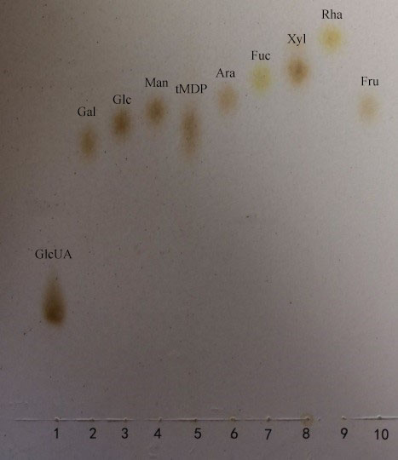

Fig. S1 TLC of the total polysaccharides from the rhizome of *M. dauricum*. 1. GlcUA；2. Gal；3. Glc；4. Man；5. The total polysaccharides from the rhizome of *M. dauricum* (tMDP)；6. Ara；7. Fuc；8. Xyl；9. Rha；10. Fru