Supplementary Data S9. Results of beta regressions for acoustic activity of seven orthopteran species in tropical Andes of Colombia.

Results top-ranked model (π = 76.2%) for detections of Sp1 (Gr2)

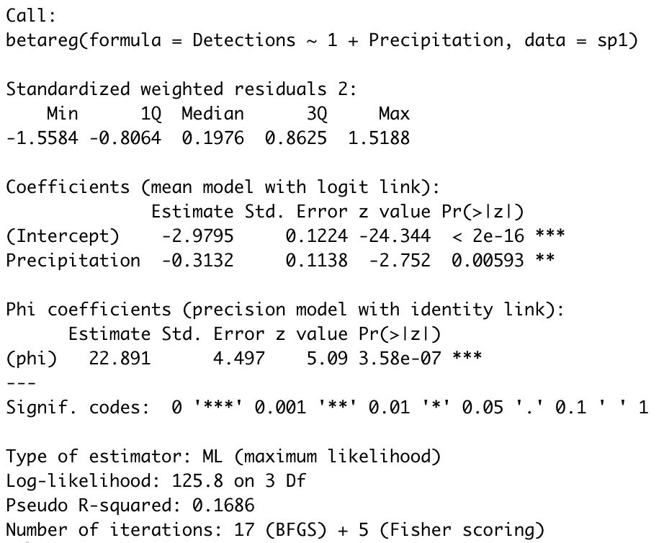

Results top-ranked model (π = 94.8%) for detections of Sp2 (Gr4)

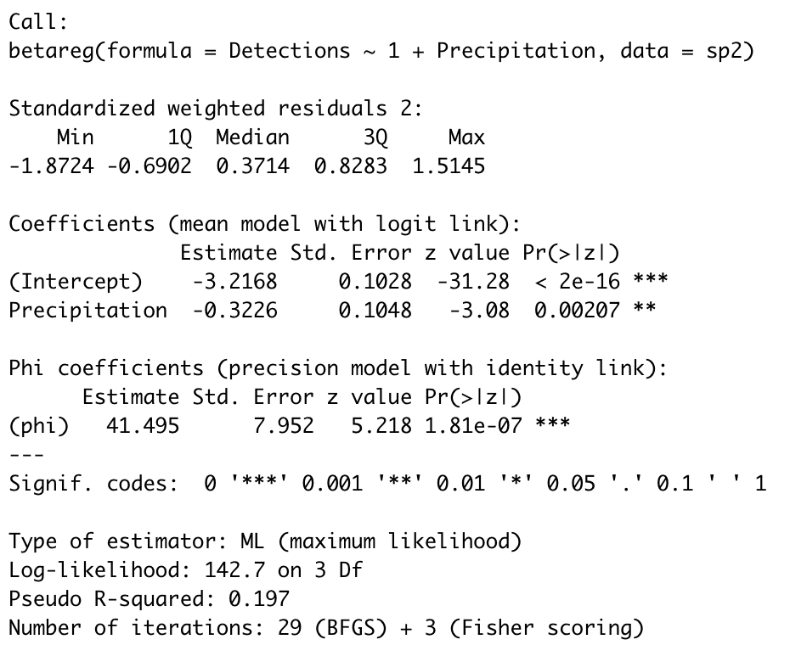

Results top-ranked model (π =82.39%) for detections of Sp3 (Gr8)
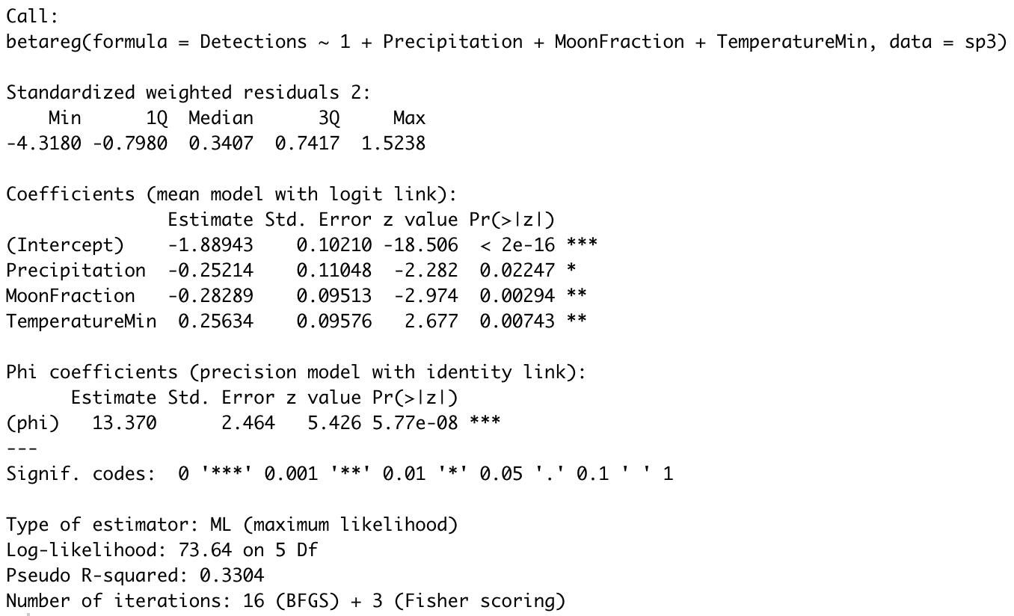

Results top-ranked model (π = 30.22%) for detections of Sp4 (Gr12)

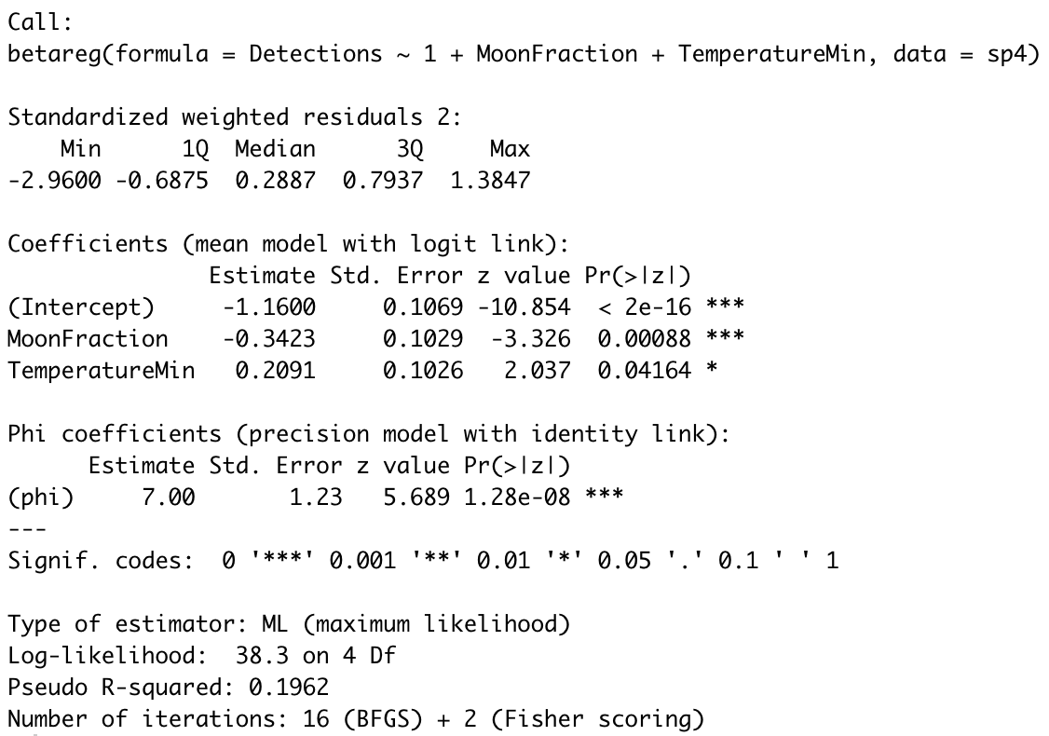

Results top-ranked model (π = 56.80%) for detections of Sp5 (Gr13)

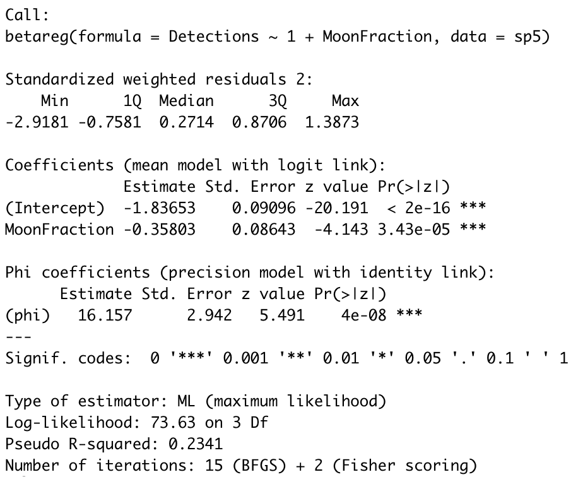

Results top-ranked model (π = 62.30%) for detections of Sp6 (Gr20)

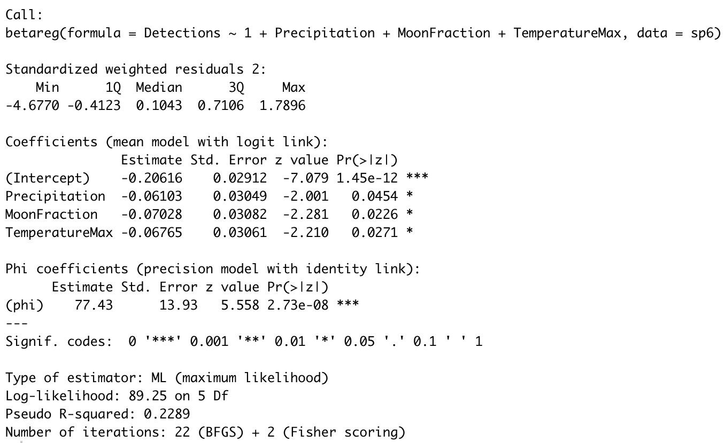

Results top-ranked model (π = 61.67%) for detections of Sp7 (Gr22)

