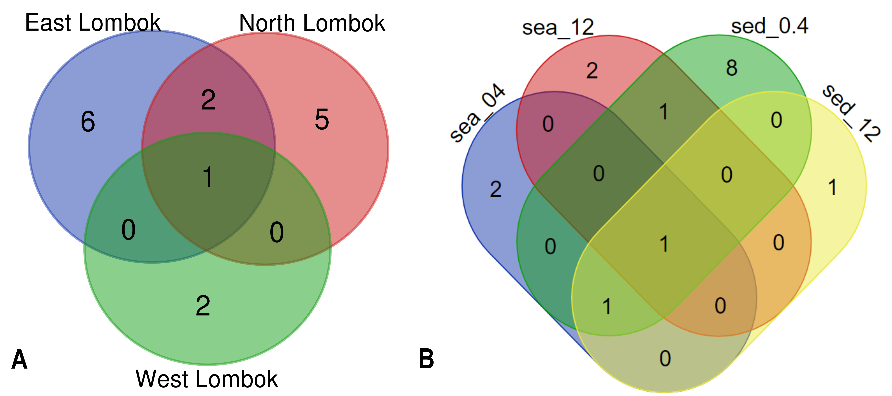

Venn diagram of Symbiodiniaceae subclades around Lombok by: (A) coastal area and (B) method (sample type-filter pore size combination). For a more detailed explanation of this figure, see table below. Sample labels: sea = seawater sample; sed = sediment sample; _0.4 and _12 indicate the pore size of the filter (in μm).

Detailed explanation of unique elements at Venn diagram.
Figures | Intersection | Total | Elements
Fig. 4A | East_Lombok /North_Lombok/West_Lombok | 1 | C.sym1
 | East_Lombok /North_Lombok | 2 | G.sym4
 |  |  | D.sym2
 | East_Lombok | 6 | D.sym6
 |  |  | C.sym8
 |  |  | C.sym7
 |  |  | Csym16
 |  |  | C.sym17
 |  |  | C.sym10
 | North_Lombok | 5 | C.sym12
 |  |  | D.sym19
 |  |  | D.sym22
 |  |  | C.sym15
 |  |  | B.sym20
 | West_Lombok | 2 | S.sym21
 |  |  | C.sym5
Fig. 4B | sea_0.4/sea_12/sed_0.4/ sed_12 | 1 | D.sym2
 | sea_0.4/sed_0.4/sed_12 | 1 | C.sym1
 | sea_12/sed_0.4 | 1 | G.sym4
 | sea_0.4 | 2 | D.sym19
 |  |  | C.sym16
 | sea_12 | 2 | H.sym12
 |  |  | D.sym6
 | sed_0.4 | 8 | C.sym7
 |  |  | C.sym17
 |  |  | C.sym5
 |  |  | D.sym22
 |  |  | C.sym15
 |  |  | B.sym20
 |  |  | S.sym21
 |  |  | C.sym10
 | sed_12 | 1 | C.sym8

