**Raw Data**

**Figure 1**

**（C）Colony Formation Assay**

**DU145** 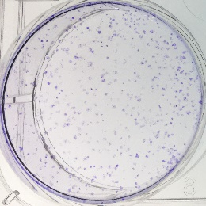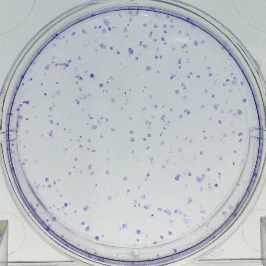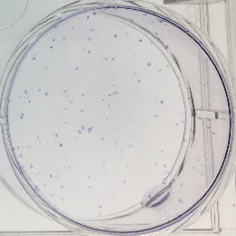

**PC3** 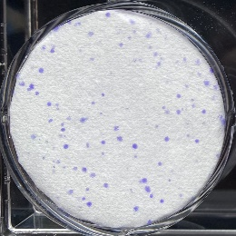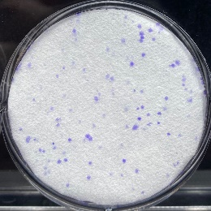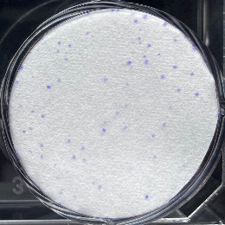

**（D）Western Blotting**

**DU145**

Ki67 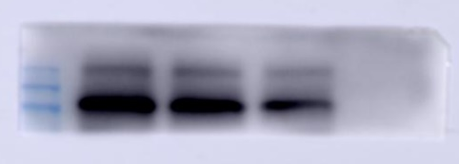

GAPDH 

**PC3**

Ki67 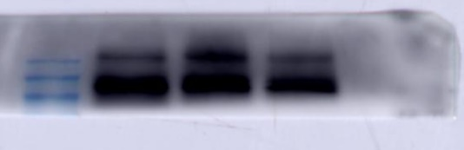

GAPDH 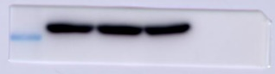

**(E) Immunofluorescence Analysis**

**DU145 (Ki67)**

Control  

Sophocarpine  

**PC3 (Ki67)**

Control  

Sophocarpine  

**Figure 2**

**(A) Flow Cytometry Analysis**

**DU145** 

**PC3 **

**（B）Western Blotting**

**DU145**

Bcl-2 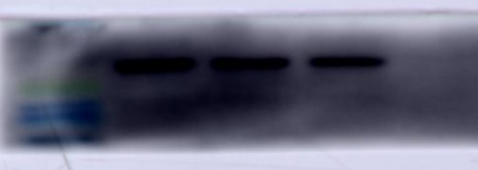

Bax 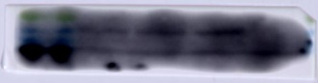

GAPDH 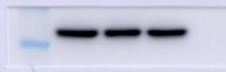

**PC3**

Bcl-2 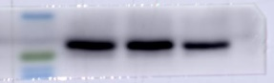

Bax 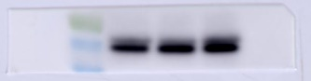

GAPDH 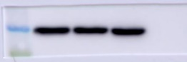

**Figure 3**

**（A）Wound Healing Assay**

**DU145**

0 h 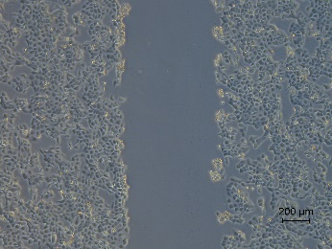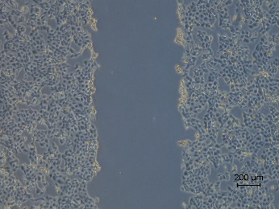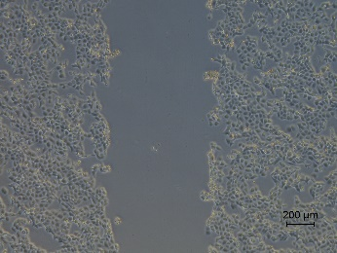

48h 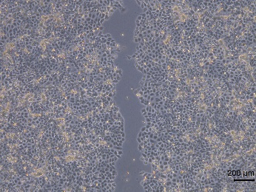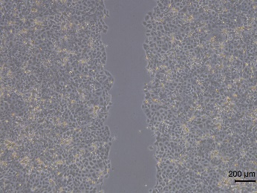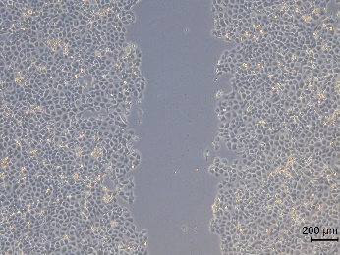

**PC3**

0 h 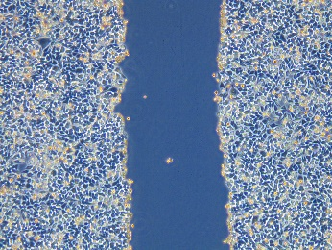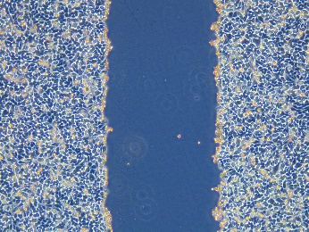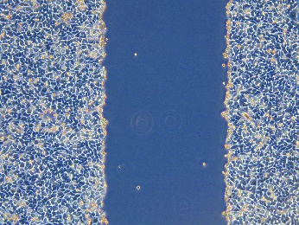

48h 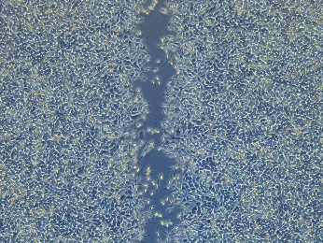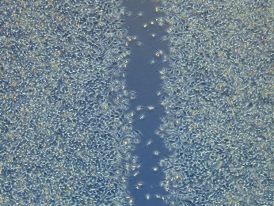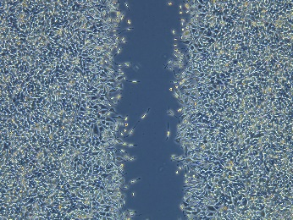

**（B）Transwell Invasion Assay**

**DU145** 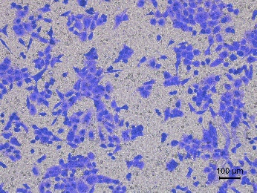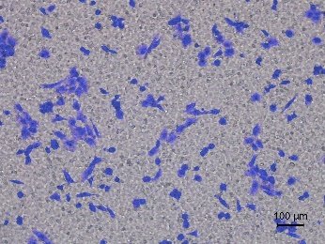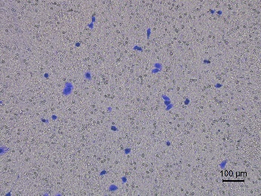

**PC3** 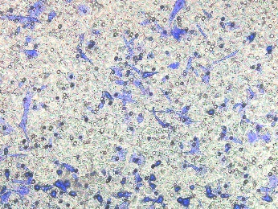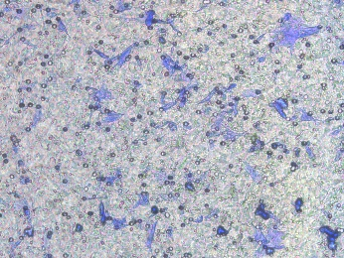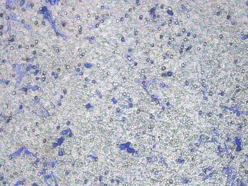

**Figure 4**

**（A）Western Blotting**

**DU145**

α-SMA 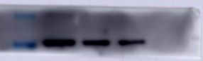

N-cadherin 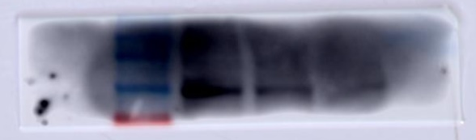

Collagen I 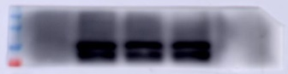

GAPDH 

**PC3**

α-SMA 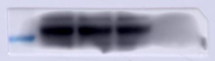

N-cadherin 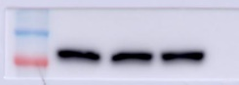

Collagen I 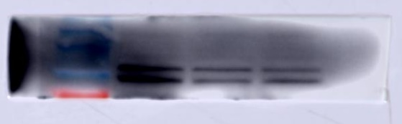

GAPDH 

**(B) Immunofluorescence Analysis**

**DU145 (N-cadherin)**

Control  

Sophocarpine  

**PC3 (N-cadherin)**

Control  

Sophocarpine  

**DU145 (Collagen I)**

Control  

Sophocarpine  

**PC3 (Collagen I)**

Control  

Sophocarpine  

**Figure 5**

**（A）Western Blotting**

**DU145**

PI3K 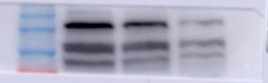

AKT 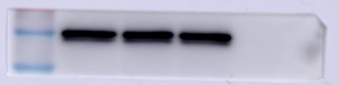

p-AKT 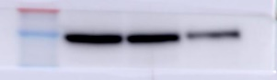

mTOR 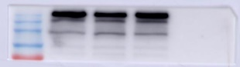

p-mTOR 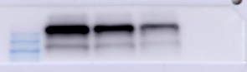

GAPDH 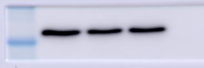

**PC3**

PI3K 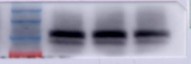

AKT 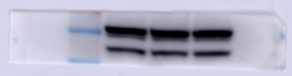

p-AKT 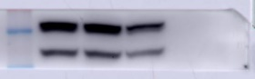

mTOR 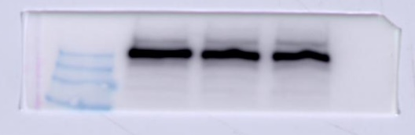

p-mTOR 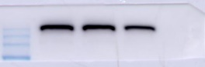

GAPDH 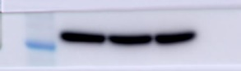

**(B) Immunofluorescence Analysis**

**DU145 (p-mTOR)**

Control  

Sophocarpine  

**PC3 (p-mTOR)**

Control  

Sophocarpine  

**(C) Molecular docking**

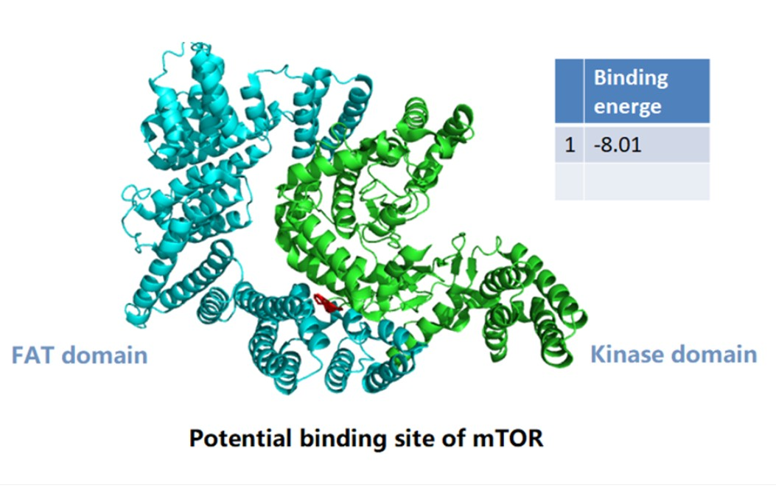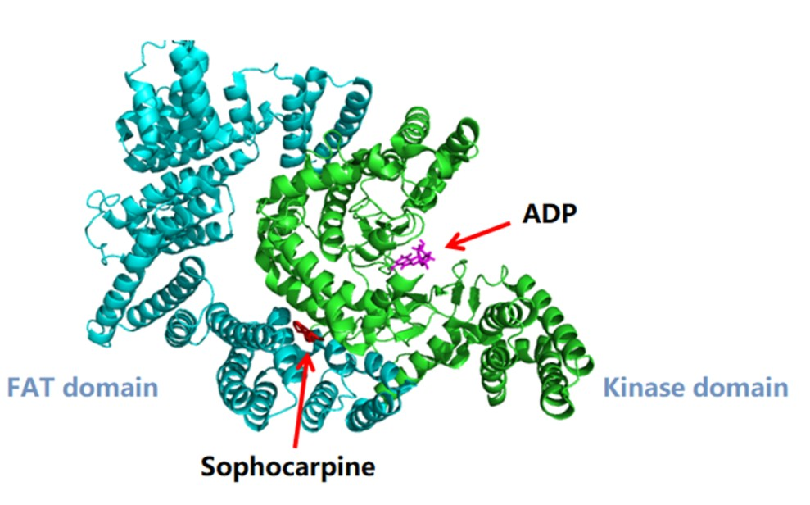

**Figure 6**

**(A) Appearance of tumor**



**(D) Western Blotting**

**Tumor**

PI3K 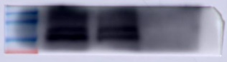

AKT 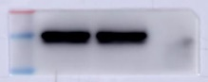

p-AKT 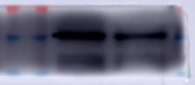

mTOR 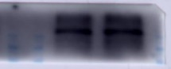

p-mTOR 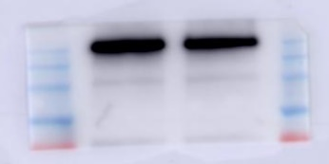

GAPDH 