Figure1

BRCA-1PKM2B-actin



Figure2

HK2IDH1b-actin

Figure3

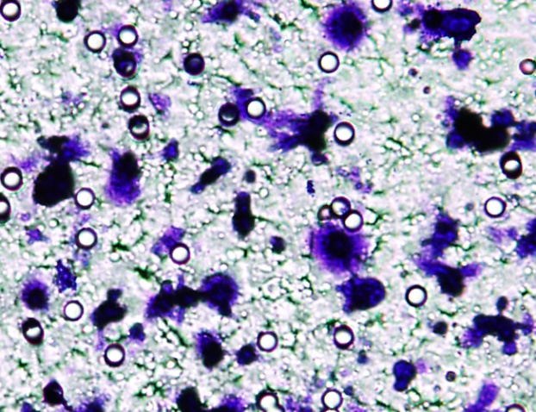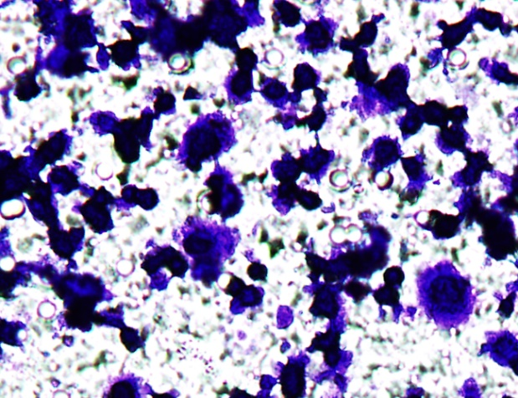

Figure5

p-aktt-aktb-actin

Figure6

paktt-aktb-actin

Figure8

