Phylogenetic relationships. Our phylogenetic analysis (Fig. 1) shows that the new species is sister to a clade consisting of Hyloscirtus criptico Coloma et al. (2012), H. larinopygion (Duellman, 1973), H. lindae (Duellman & Altig,1978), H. pacha (Duellman & Hillis, 1990), H. pantostictus (Duellman & Berger, 1982), H. princecharlesi Coloma et al. (2012), H. psarolaimus (Duellmn & Hillis, 1990), H. ptychodactylus (Duellman & Hillis, 1990), H. staufferroum (Duellman & Coloma, 1993) and , H. tigrinus Mueses-Cisneros & Anganoy-Criollo (2008). Genetic distances (mitochondrial 16S percent differences calculated from uncorrected p values between the new species and the most closely related Hyloscirtus are given in Table 1; genetic distances between the new species and its closest relative were 2.2-2.9% to H. tigrinus and 2.6-2.8% to H. ptychodactylus.

Figure 1: Evolutionary relationships of species in the Hyloscirtus larinopygion group, based on the mitochondrial gene 16S under ML criterion. Clade support (bootstrap %) are in blue. The new species is in red.
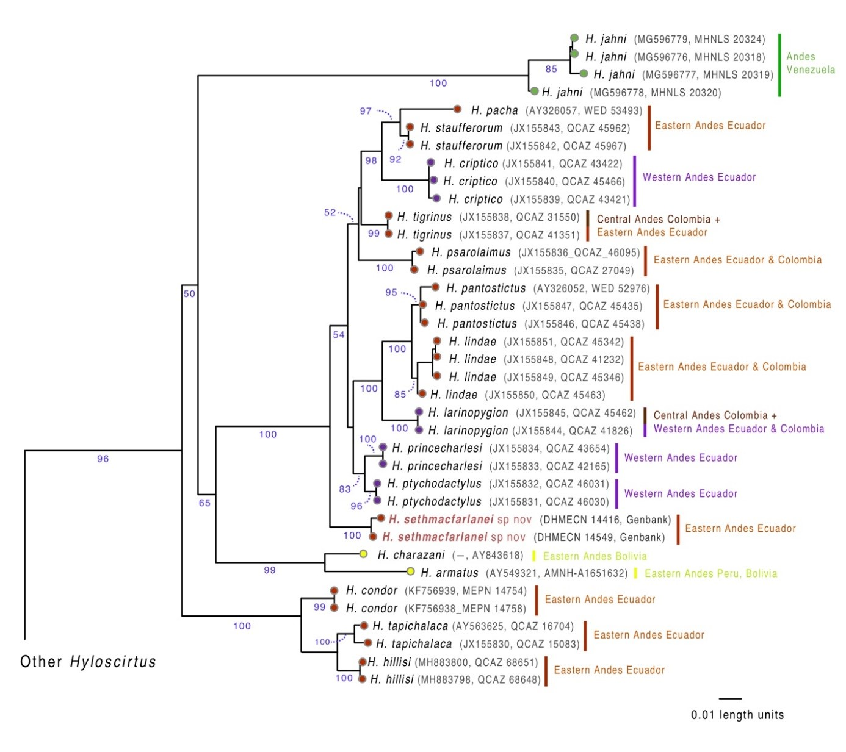

Table 1. Genetic distances (mitochondrial 16S) between Hyloscirtus sethmacfarlanei sp. nov. and its most closely related congeners. Values are presented as percent distances calculated from uncorrected p values.

 | H. condor  (n = 2) | H. hillisi  (n = 5) | H. pacha  (n = 1) | H. larinopygion (n = 2) | H. lindae (n = 4) | H. pantostictus (n = 3) | H. tapichalaca  (n = 2) | H. ptychodactylus (n = 2) | H. princecharlesi (n = 2) | H. psarolaimus (n = 2) | H. tigrinus (n = 2) | H. staufferorum (n = 2) | H. sethmacfarlanei sp nov (n = 2)
H. condor | 0.0
H. hillisi | 3.8–4.1 | 0.0–0.1
H. pacha | 10.2–10.5 | 11.3–11.4 | 0.0
H. larinopygion | 9.6–9.8 | 10.2–10.4 | 4.6 | 0.0
H. lindae | 10.1–10.8 | 11.0–11.7 | 4.6–5.3 | 2.6–3.1 | 0.0–0.5
H. pantostictus | 10.4–10.8 | 11.1–11.5 | 4.7–4.8 | 2.7–2.8 | 6.0–14.0 | 0.0–0.1
H. tapichalaca | 3.7–4.0 | 2.7–3.1 | 11.0–11.1 | 10.1–10.4 | 10.9–11.4 | 11.1–11.4 | 0.6
H. ptychodactylus | 9.5–9.6 | 10.2–10.5 | 3.8 | 2.9–3.0 | 2.9–3.6 | 3.1–3.2 | 10.1–10.2 | 0.0
H. princecharlesi | 9.7–9.9 | 10.8–11.0 | 4.3 | 3.2 | 3.3–3.6 | 3.4–3.6 | 10.6–10.7 | 1.3 | 0.0
H. psarolaimus | 10.8–11.1 | 11.3–11.7 | 4.2–4.5 | 4.8–5.0 | 4.5–5.4 | 4.8–5.2 | 11.2–11.4 | 3.6–3.8 | 3.8–4.1 | 0.3
H. tigrinus | 9.8–10.1 | 10.5–10.9 | 3.1–3.2 | 3.9–4.0 | 3.9–4.6 | 4.0–4.2 | 10.5–10.8 | 2.6 | 2.8–2.9 | 3.0–3.3 | 0.0
H. staufferorum | 9.6–10.1 | 10.6–11.1 | 1.8 | 4.2–4.4 | 4.0–4.7 | 4.1–4.3 | 10.6–10.8 | 2.8–2.9 | 3.3–3.4 | 3.4–3.7 | 2.7–2.8 | 0.0
H. sethmacfarlanei sp nov | 9.3–9.5 | 9.2–9.6 | 3.7–3.9 | 2.9–3.5 | 3.7–4.6 | 3.5–3.7 | 9.4–9.9 | 2.6–2.8 | 3.1–3.3 | 3.1–3.3 | 2.2–2.9 | 3.5–4.0 | 0.4

