**Supplementary images, pre and post coral reef collapse, San Pedrito Reef**

San Pedrito Reef pre collapse, images span from 2006-2008.

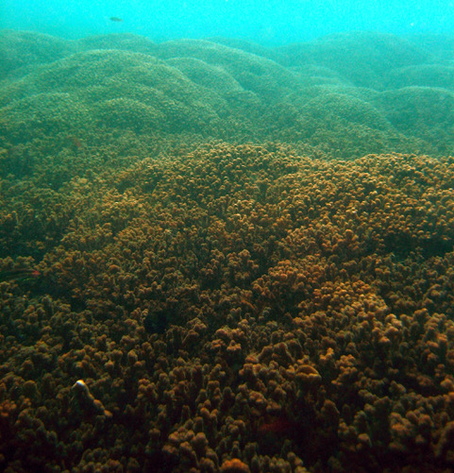

San Pedrito Reef post collapse, images from 2017

Harmful Algal Blooms (HAB) and cyanobacteria in Sector Marino; (a) aerial photo of HAB taken 24th February 2012 (ca. 1000m altitude) by Luciano Capelli, (b) carpet of cyanobacteria on a sand substrate, Sector Marino, taken May 2009 by Carlos Jimenez, (c) HAB in the water column at Golondrina taken 31st March 2017.